CHARLOTTE JACKSON FINE ART
PRESENTS:

Winston Roeth: solo exhibition
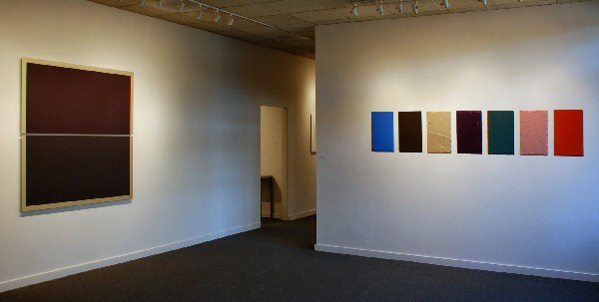
Dark Circles, 2007 tempera on Dibond 40 x 40 inches WR0020
October 12 through November 2, 2007
Take a good look at a Winston Roeth painting and you’ll note first its basic reductivist elegance. Often based on a grid or circular system that is nearly hidden under layers of pigment, the artist’s impulse toward order is evident. Roeth’s palette tends to the synthetic; that is, his colors are not necessarily based on those found in nature. Considering all this, the viewer may be surprised to learn that one of Roeth’s early influences, growing up in the Midwest and looking at art books, was the 16th-century portrait painter Hans Holbein. Although Roeth spent a great deal of time at the Art Institute of Chicago, he says that viewing art in texts allows for “you to make up a lot in your mind—the imagination is a very important part of [my art making].” Through his imagination, Roeth began to consider the most critical foundations of painting.
Roeth lays down flat water-based pigment directly onto a honeycombed, lightweight panel. First, however, he sits and doodles, “thinking out loud” as he refers to it, and under all the layers of color, that architectural footprint from his drawing remains. A beautiful example of the artist’s working method is Empire, in the Panza Collection, in which a barely-there grid supports the sky-blue monochromatic painting. In fact, the respected Albright-Knox Gallery of Art in Buffalo will host an exhibition of selected works from the Panza Collection, slated to open November 16; six of Roeth’s paintings are to be included in the show.
Many of the artists in Dr. and Mrs. Giuseppe Panza di Biumo’s internationally respected collection have had a profound effect on Roeth’s development as a painter of what one critic called “hard-core abstraction…known for its James Turrell-like luminosity.” But then, says Roeth, “Everything influences me: time and space, photography, Garo Antreasian’s prints, John Kacere.” (Kacere taught painting at the University of New Mexico during Roeth’s stint here; the artist now lives in Beacon, New York, home of the Dia Art Foundation’s renowned museum of reductive and minimalist art.) He states about an early Ad Reinhardt exhibition,”I didn’t know what it was, but I knew it was something.” Roeth has always loved Kenneth Noland’s circles and the way that Morris Louis’s poured paintings allow light to penetrate into the fabric of the canvas. Overall, though, It was Agnes Martin’s small intricate grids that “blew his mind;” they continue to linger in his consciousness today. One of the benefits of living in Beacon, he says, is seeing all of Martin’s retrospective shows: “It’s only now that I am beginning to understand how unbelievably complicated, deep and sensitive some of those paintings are.”
As with Martin’s paintings, the grid forms a structure for Roeth’s practice, which he describes as exploratory, working “on the fly” from the bottom up, layering as he discovers the next thing. “I’m interested in light, turning it into a surface…and then it dissolves the surface, leaving space for contemplation.” After he’s drafted his basic form, he feels free to investigate its possibilities, to “begin to see what it is about: horizontality, verticality, space, the center point, beyond the edges. I don’t like making decisions about composition. When I begin I don’t really know where it will end.”
For this exhibition at Charlotte Jackson Fine Art, the artist is working on Dibond, aluminum sheets bonded to tight foam core. Only about 3 millimeters thin, the works seem to float on the wall. Roeth has been making paintings in “parts,” diptychs with the working titles Split Square: Day and Night; and Light Circles, Dark Circles. Another piece is stacked totemically in a vertical composition. Finally, there is his Santa Fe Assembly, a row of seven slate shingles, each a different color, each unit distinctive both visually and physically, texturally and dynamically. Like the subatomic structure of a Holbein portrait, perhaps: infinite in rich opportunities for color, light, and composition.
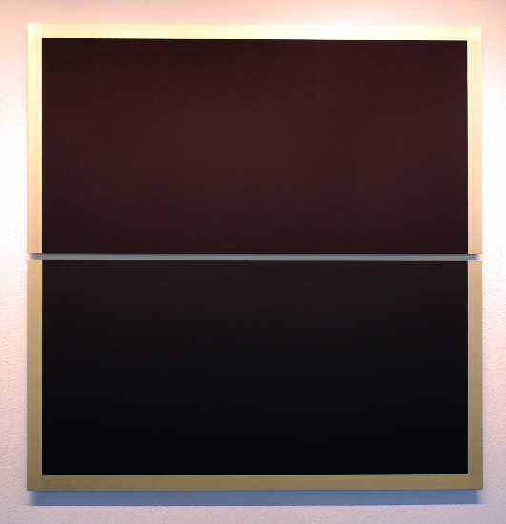
Split Square, 2007
tempera on Dibond
61 x 60 inches
WR0017
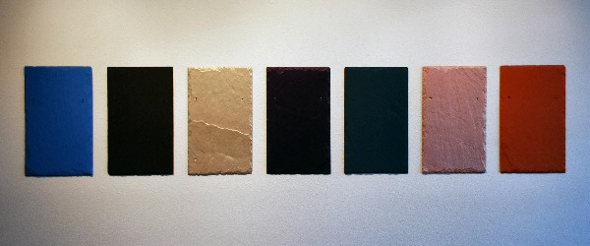
Santa Fe Assembly, 2007
tempera on slate
20 x 100 inches
WR0019

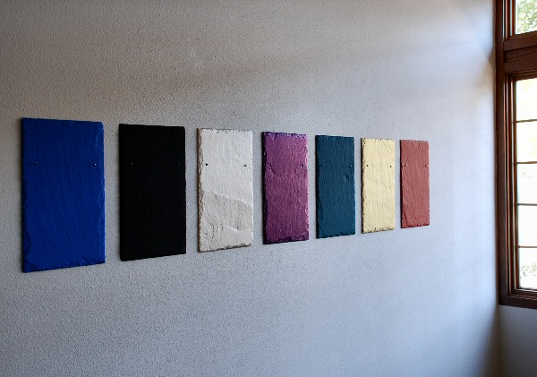
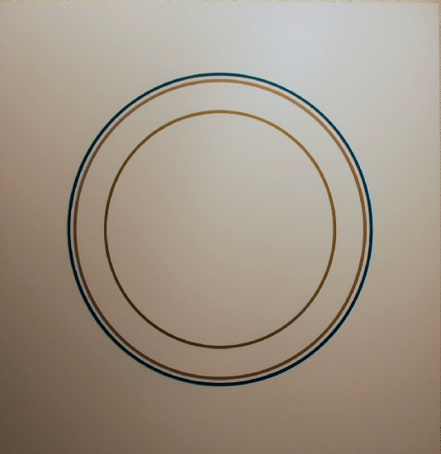
If I Were You, 2005
Polyurethane and pigments on Dibond
30" x 30"
WR022
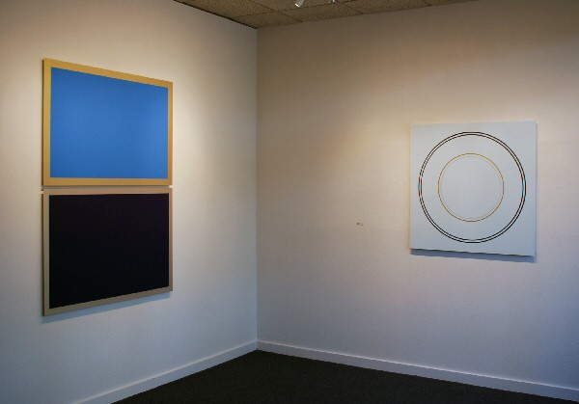

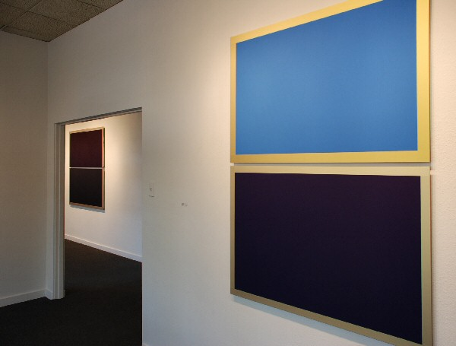
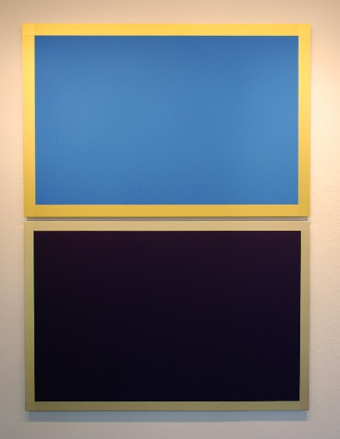
Day and Night, 2007
tempera on Dibond
65 x 48 inches
WR0018
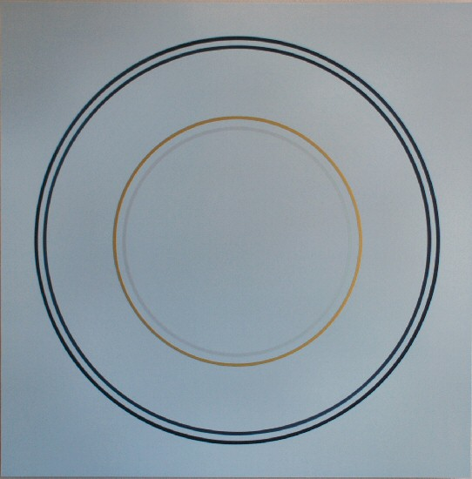
Light Circles, 2007
tempera on Dibond
40 x 40 inches
WR0021
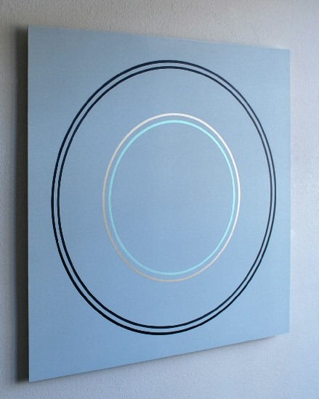
Light Circles, 2007 (detail)
tempera on Dibond
40 x 40 inches
WR0021
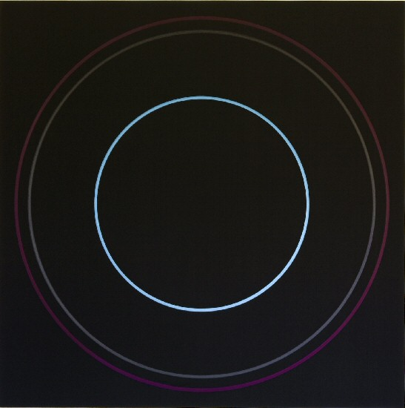
Dark Circles, 2007
tempera on Dibond
40 x 40 inches
WR0020
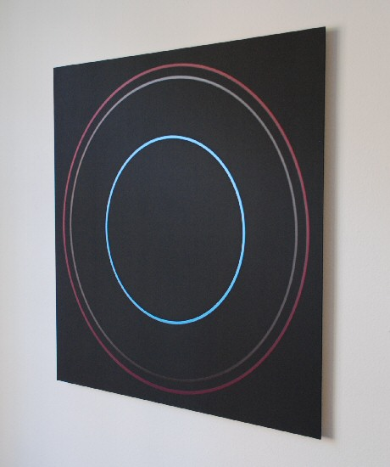
Dark Circles, 2007 (detail)
tempera on Dibond
40 x 40 inches
WR0020
Born in Chicago, 1945
Lives and works in New York City
SOLO EXHIBITIONS
2002 New Painting, Stark Gallery, New York
2001 Palazzo Ducale di Sassuolo Paintings, Stark Gallery, New York
Palazzo Ducale di Sassuolo, Sassuolo, Italy
2000 Gallerie Vera Munro, Hamburg
Stark Gallery, New York
1999 Angles Gallery, Santa Monica, CA
1998 Artothek, Cologne
1997 Stark Gallery, New York
1996 Galerie Vera Munro, Hamburg
1995 Recent Paintings, Stark Gallery, New York
1993 Paintings, Stark Gallery, New York (cat.)
Drawings, Galleri Ars Nova, Goteborg, Sweden
1992 Stark Gallery, New York
1991 Galleri Ars Nova, Goteborg, Sweden
1990 Stark Gallery, New York
1989 Invitational Exhibition, Griffin McGear Gallery, New York
1988 Stark Gallery, New York
1980 The Ben Shahn Gallery, William Patterson College, Wayne, New Jersey
SELECTED GROUP EXHIBITIONS
2002 Galerie Vera Munro, Hamburg, Germany
Nusser & Baumgart Contemporary, München, Germany
Niklas von Bartha, London, England
2001 Radical Painting, curated by Nino Weinstock, Villa Aichele, Städtische Galerie, Lörrach, Germany
1999 Then & Now, The Work Space, New York; curated by Theresa Chong
1998 Andrew Jenson Gallery, Auckland, New Zealand
1997 Andrew Jensen Gallery, Wellington, New Zealand
Drawing From Life, Stark Gallery, New York
Projected, Stark Gallery, New York
1996 La Collezione Panza di Biumo. Artist degli anni '80 e '90, Museo di Arte Moderna e
Contemporanea di Trento e Roverto, Palazzo delle Albere, Trento (catalogue)
White, Howard Scott-M13 Gallery, New York
Drawings, Galerie Art In, Nuremburg, Germany
1995 Color: Sign, System, Sensibility, Stark Gallery, New York; curated by Richard Kalina
The Panza di Biumo Donation, Museo Cantonale d'Arte, Lugano, Switzerland
1994 The Constructive Vocabulary: An American Vision, Galerie Dr. Istvan Schlegl, Zurich
X-Sightings, Anderson Gallery, Buffalo, New York
Collector's Choice: Natalie and Irving Forman, Charlotte Jackson Gallery, Santa Fe
Ars Nova Galleri, Goteborg, Sweden
1993 Uses of Geometry: Winston Roeth, Cary Smith, Stephen Westfall, etc., Snyder Fine Arts, New York (cat.)
Supervision: Jo Baer, Ollie Baertling, Helmut Federle, Mary Heilmann, Yves Klein, Olivier
Mosset, Walter Obholzer, Steven Parrino, David Reed, Winston Roeth, Günter Umberg, Michael Venezia, Raum fur neue Kunst, Rolf Hengesbach, Wuppertal, Germany
Sublime Presence: Stuart Arends, Madeline O'Connor, Florence Pierce, Winston
Roeth, Center for Contemporary Arts of Santa Fe
Contemporary Drawing--Part II, Arena, New York
1992 7-NY: Directions in Abstract Painting, Studio A, Museum Moderner Kunst, Otterndorf, Germany (cat.)
Painting, Stark Gallery, New York
Cultural Fabrication, John Good Gallery, New York
1991 Abstraction: Recent Prints, Betsy Senior Contemporary Prints, New York
1991 The Process of Looking, Stark Gallery, New York
Geometric Considerations, Capital Cities/ABC, New York; project of the Art Advisory Service of the Museum of Modern Art, New York; Sandra Lang, Director
Paper Trail, Stephen Rosenberg Gallery, New York
1990 Opening Group Exhibition, Stark Gallery, New York
Cruciform, Stark Gallery, New York
1989 M-13 Gallery, New York
An Extraction of Form, Robeson Center Gallery, Rutgers University, Newark, New Jersey; curated by Alison Weld
Three Artists Who Work With Slate, Stark Gallery, New York
Small Works on Paper, Susanna Sheffield Gallery, Houston, Texas
Pastel Drawings, Islip Museum, Islip, New York; curated by Karen Shaw
1986 Slate, An installation at Springs Industries; project of the Art Advisory Service,
Museum of Modern Art, New York; Sandra Lang, director
1982 Fifth Anniversary Show, The Drawing Center, New York
1979 Invitational Exhibition, Susan Caldwell Gallery, New York
1978 The Drawing Center, New York
INSTALLATIONS
1995 Light/Body--Dark/Body, collaboration with Susan Osberg, dancer/choreographer; Dia
Center for the Arts and Unga Atalante, Goteborg, Sweden
Light/Body, collaboration with Susan Osberg, dancer/choreographer; Dia Center for the Arts, New York
1993 Light installation, Stark Gallery, New York (with solo exhibition)
1992 Mercury, Light installation, Stark Gallery (Annex), New York
1991 Intricacies, collaboration with Susan Osberg, dancer/choreographer and Susanne
Poulin, lighting designer; Unga Atalante, Goteborg, Sweden and the Dia Art Foundation, New York
1989 Light Paintings, Stark Gallery, New York
1988-9 Collaboration with Susan Osberg, dancer/choreographer; Malcolm Goldstein, violinist/composer; and Susanne Poulin, lighting designer; Dia Art Foundation, New York
Post Revolutionary Girl, collaboration with Muna Tseng, choreography and Susanne
Poulin, lighting design; Whitney Museum Theater, Equitable Center and the Mulberry Street Theater, New York and the Place Theater, London
1986 Intuition, collaboration with Susan Osberg, choreographer and James Tenney, composer; Riverside Dance Festival, New York
1985 Eden, collaboration with Susan Osberg, choreographer; AGLAIA Foundation, Middle Collegiate Church, New York
1983 Collaboration with Elena Alexander's MAD ALEX Co., P.S. 122, New York
BIBLIOGRAPHY
Anderson, Jack, "A Medley of Emotions, A Potpourri of Movements," The New York Times (2 December 1995).
Avgikos, Jan, "Secrets Lie on the Surface of Things," essay in Winston Roeth. New York: Stark Gallery and Galleri Ars Nova, 1993.
Brody, Jackie, "Winston Roeth, The Containment Monotypes," The Print Collector's Newsletter, Vol. XXII No. 6 (January-February 1992).
______, Review of Winston Roeth, exh. cat.," The Print Collector's Newsletter, Vol. XXIV No. 6 (January-February 1994).
Castenfors, Marten, "Winston Roeth at Galleri Ars Nova," Goteborgs-Posten (16 March 1991).
Karmel, Pepe, "Color," The New York Times (21 July 1995).
______, "Winston Roeth," The New York Times (3 November 1995).
Koplos, Janet, "Winston Roeth at Stark," Art in America (December 1995).
Marchetti, Corinne, "Au Royaume du Minimal," Beaux Arts (Paris) No. 131 (February 1995).
Nicholson, Adam, "Bambi in the Lion's Den," Modern Painters (London) (Winter 1994).
Poerschke, Ralf, "Für die Ewigkeit: Neue Bilder von Winston Roeth in der Vera Munro Galerie," Hamburger Rundschau No. 20 (9 May 1996).
Raynor, Vivien, "Abstract Forms in a Pair of Shows," The New York Times (25 June 1989).
Saxon, Erik, "Six Painters," Appearances No. 11 (Fall 1984) p. 35.
Welish, Marjorie, "Winston Roeth," Tema Celeste (April-May 1992) p. 92.
Westfall, Stephen, "Winston Roeth at Stark," Art in America Vol. 79, No. 5 (May 1991).
PUBLIC COLLECTIONS
Artothek, Cologne
Museo Cantonale d'Arte, Panza Collection, Lugano, Switzerland
Benesse House Naoshima Contemporary Art Museum, Benesse Island, Japan
FAI Foundation; Panza Collection, Varese, Italy
Yves Klein Foundation, Tucson, Arizona
Utah Museum of Fine Arts, Salt Lake City, Utah
San Jose Museum of Contemporary Art, San Jose, CA
Studio A - Museum Moderner Kunst Landkreis Cuxhaven, Germany
Fogg Art Museum, Harvard University Art Museums, Cambridge, Mass.

© 2007

Charlotte Jackson Fine Art, Inc.

200 West Marcy Street, Suite 101, Santa Fe, New Mexico 87501
Telephone: 505.989.8688 Fax: 505.989.9898
cjfa@charlottejackson.com - www.charlottejackson.com

