CHARLOTTE JACKSON FINE ART PRESENTS:

RONALD DAVIS
UNIDENTIFIED FLOATING OBJECTS



February 28 - March 31, 2014
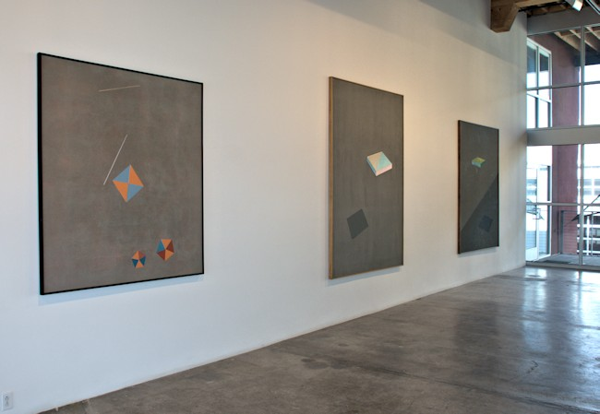

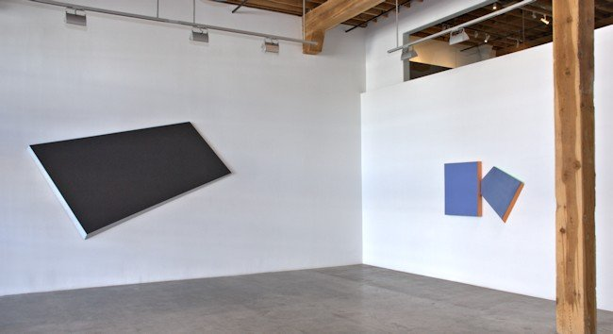
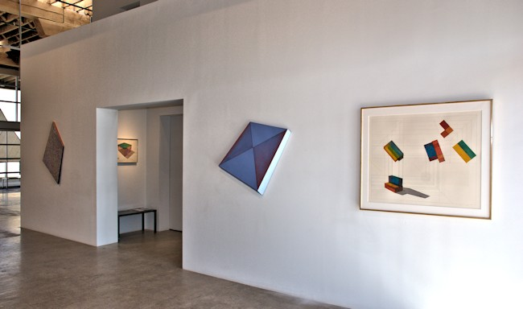


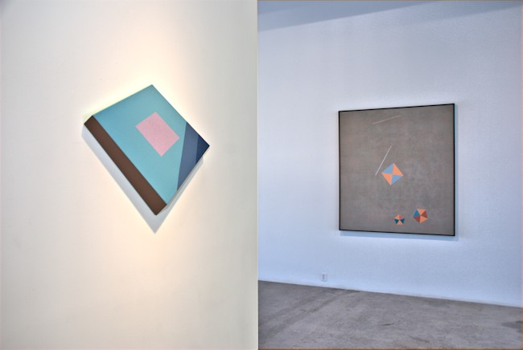
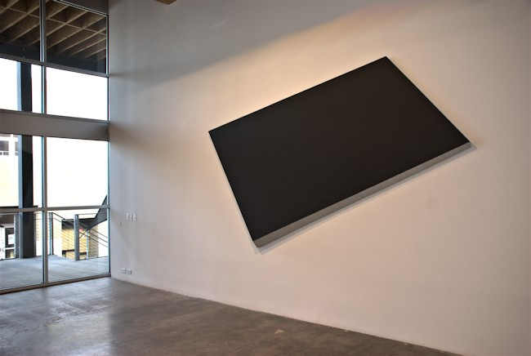

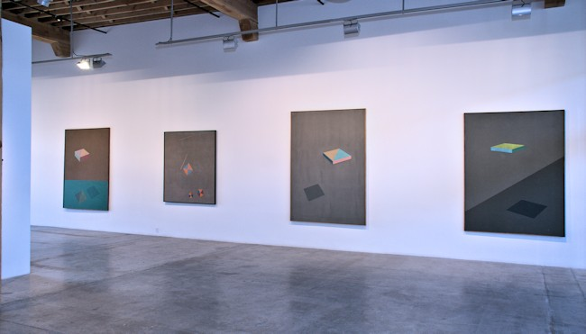
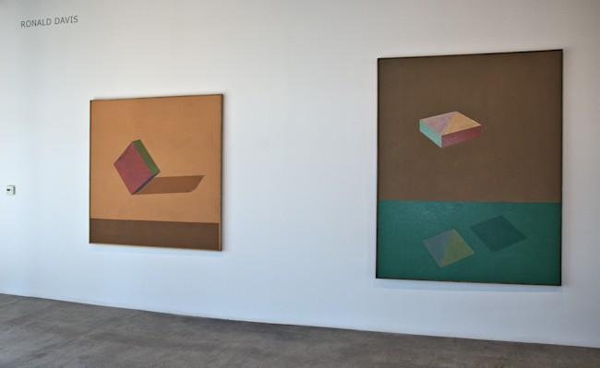

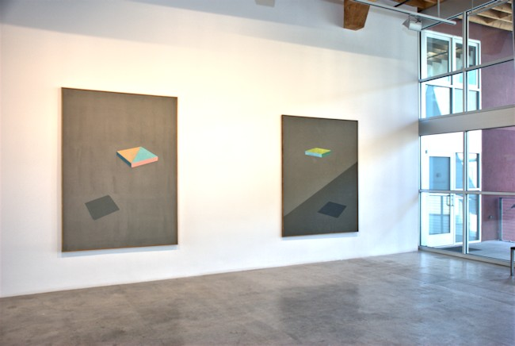
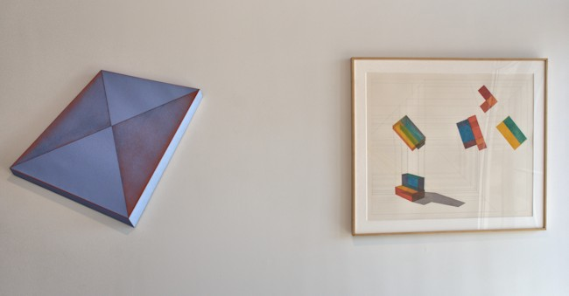

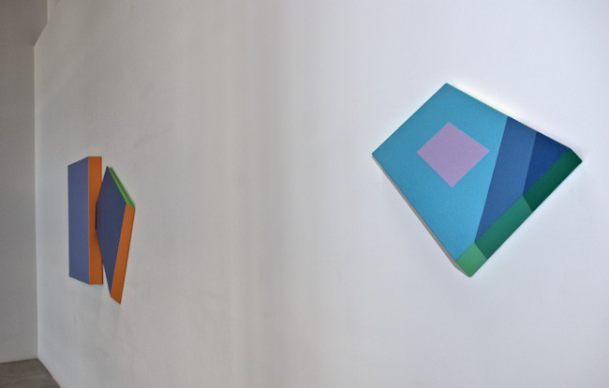
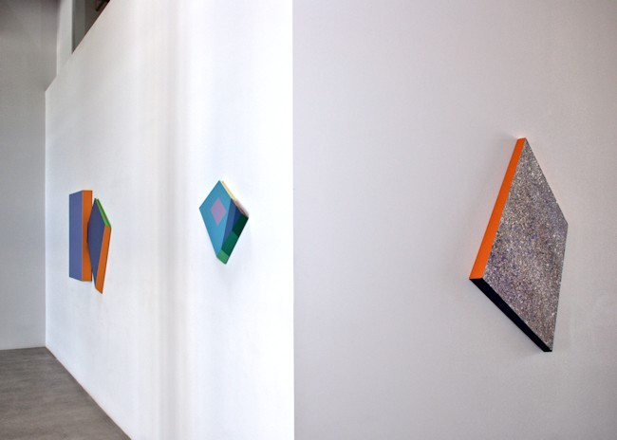
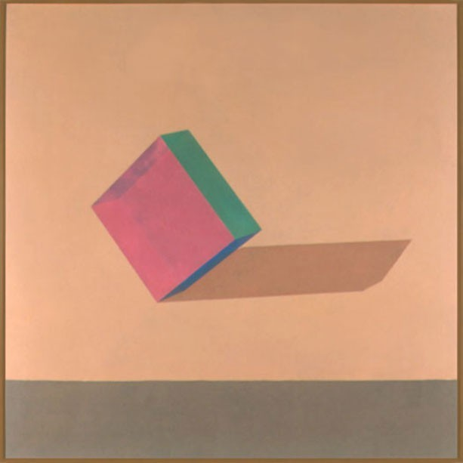
Yoder, 1979
Cel-Vinyl Acrylic on Canvas
66 x 66 inches
ROND0048

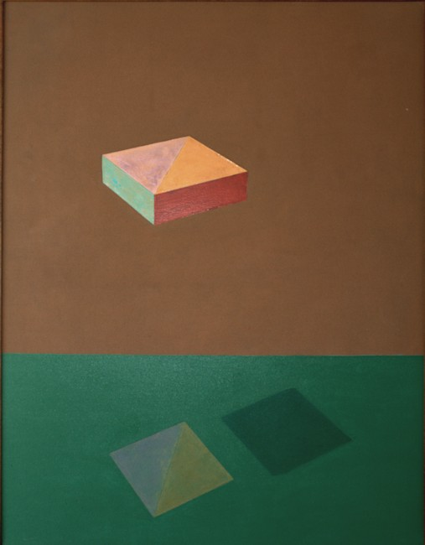
Stroner, 1978
Cel-Vinyl Acrylic on Canvas
84 x 66 inches
ROND0050

Square, Two Pentagons and Lines, 1980
Cel-Vinyl Acrylic on Canvas
67 x 61 inches
ROND110
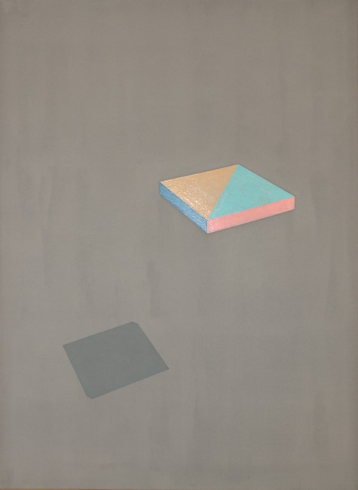
Lamont, 1978
Cel-Vinyl Acrylic on Canvas
90 x 66 inches
ROND0049
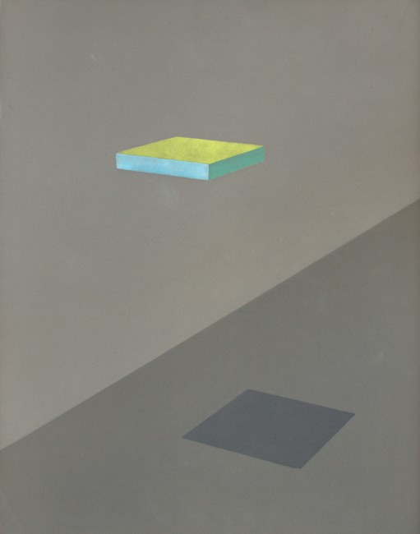
Platte, 1979
Cel-Vinyl Acrylic on Canvas
84 x 65 inches
ROND103
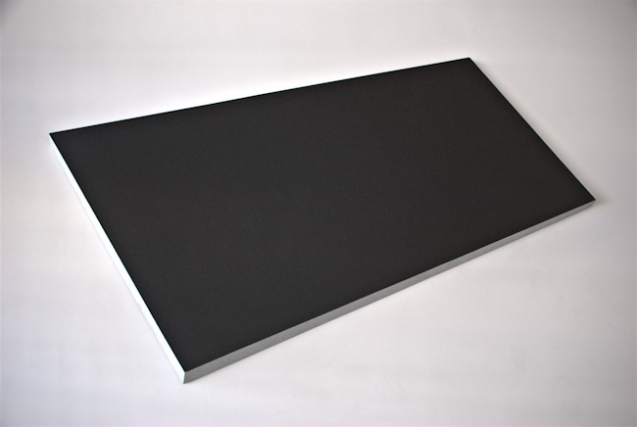
Large Black Slabette, 1985
Cel-Vinyl Acrylic on canvas
113 1/2 x 68 3/4 x 5 1/4 inches
ROND123
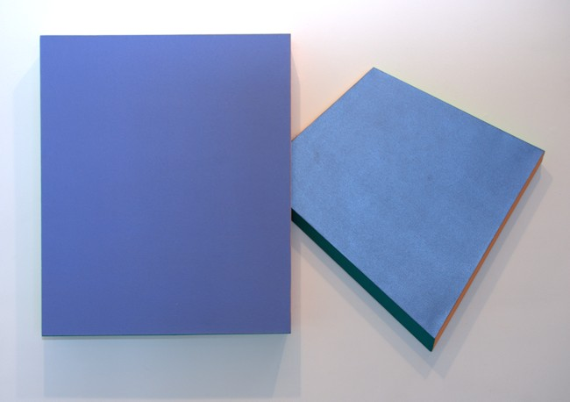

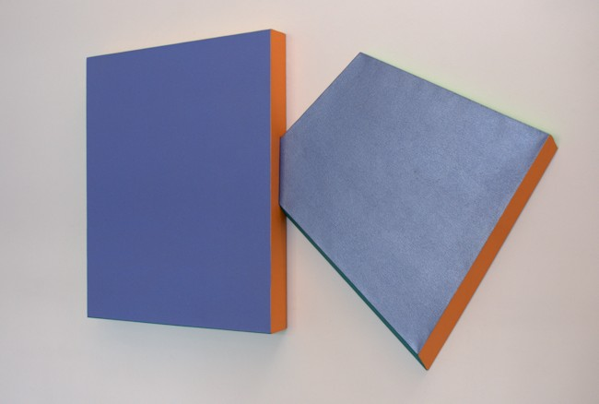
Two Sapphire Slabettes, 1985
Cel-Vinyl Acrylic on canvas 39 x 63 x 4 inches ROND122
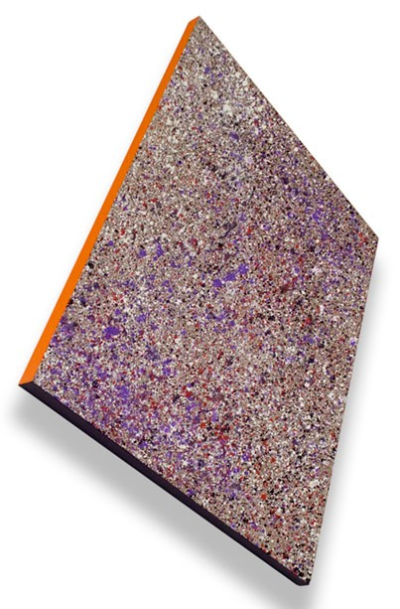
Theta Splatter Slabette, 1985
Cel-Vinyl Acrylic on canvas 46 x 31 inches ROND120
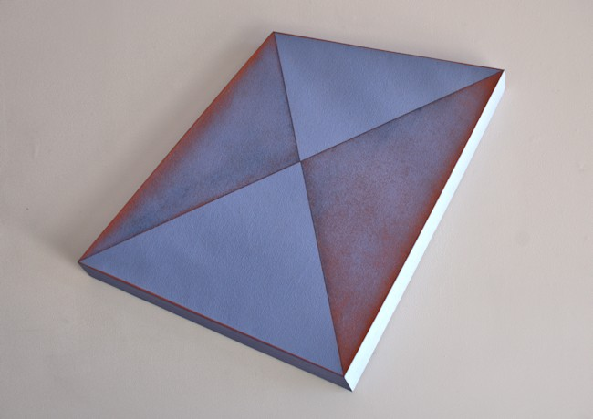
Lavender Diagonal Slabette, 1985
Cel-Vinyl Acrylic on canvas
28 1/2 x 33 x 2 3/4 inches
ROND121
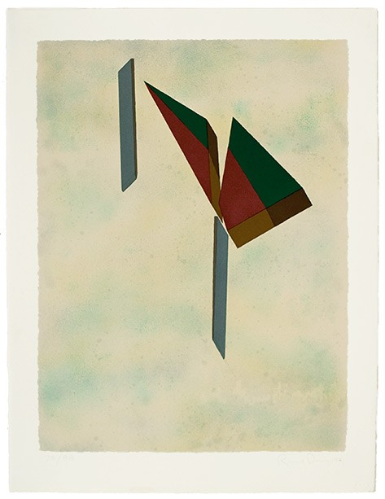
Isoseles and Two Wedges, 1981
15 color Wasserman Silkscreen on Arches
35 x 27 1/2 inches
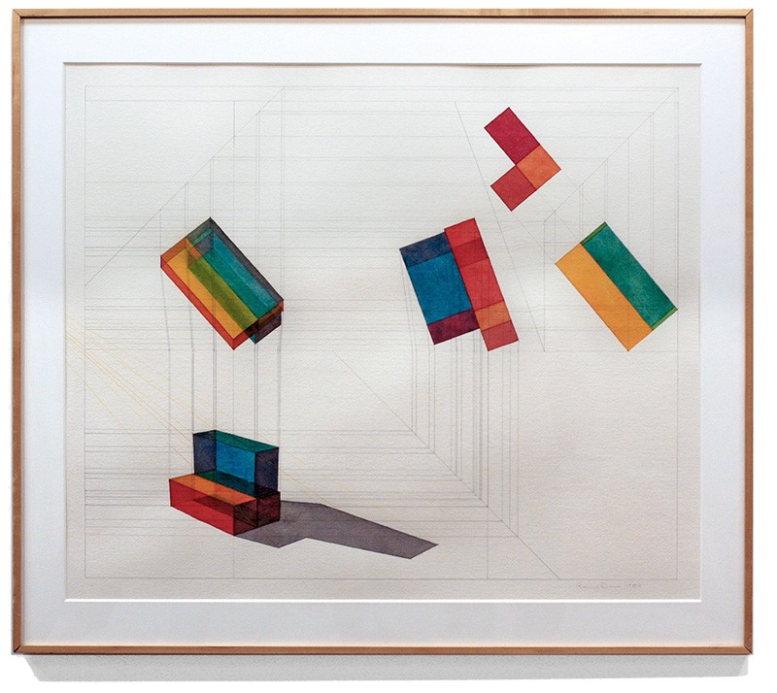
Three Block- Deep L, 1980
Watercolor and pencil on Arches paper
39 1/2 x 45 1/2 inches
ROND114
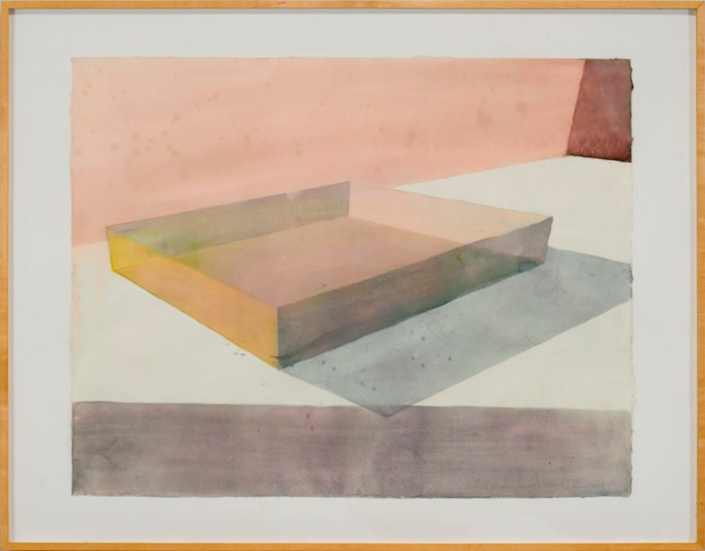
Wyoming Slab II, 1974,
Water Colour on Paper, Framed,
28 x 36 inches
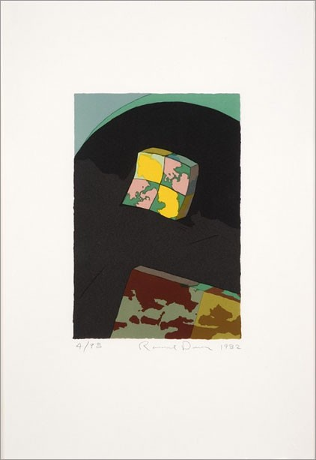
Lens and Slab, 1982
12 Color Wasserman Silksceen on Arches 25 1/2 x 18 inches ROND112
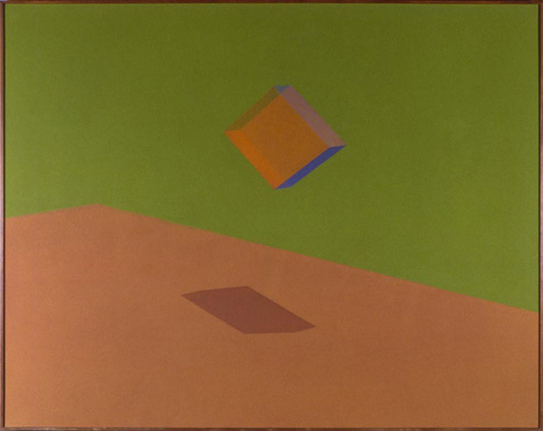
Gebo, 1979
Cel-Vinyl Acrylic on Canvas
66 x 84 inches
ROND104
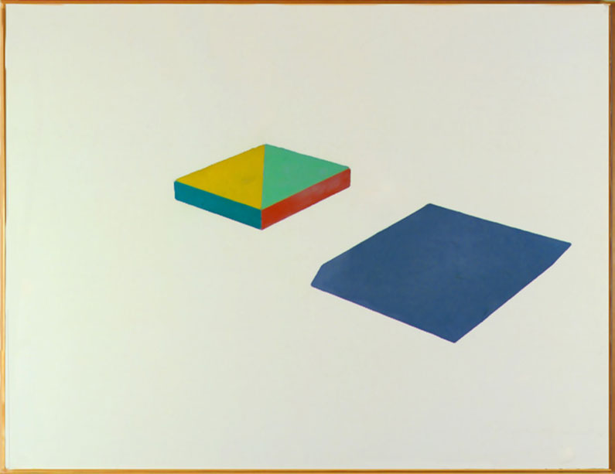
Opal, 1978
Cel-Vinyl Acrylic on Canvas
66 x 86 inches
ROND105
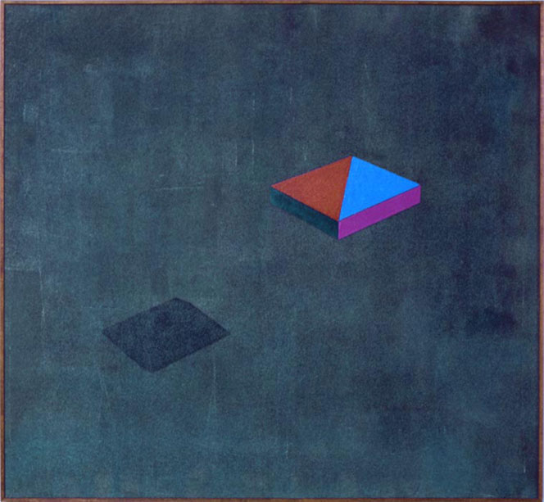
Slater, Cel-Vinyl
Acrylic on Canvas
66 x 71 inches
ROND107

Square, Triangle and Lines, 1980-1981
Cel-Vinyl Acrylic on Canvas
52 x 59 inches
ROND108
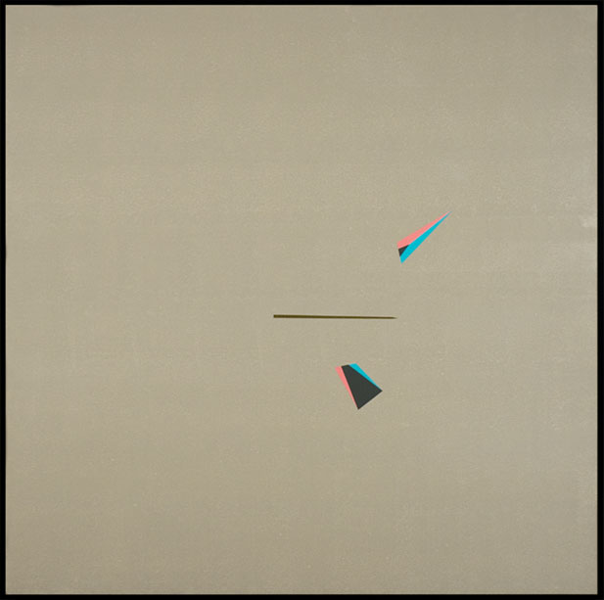
Split Isosceles and Line on Tan, 1980-1981
Cel-Vinyl Acrylic on Canvas
59 x 60 inches
ROND109
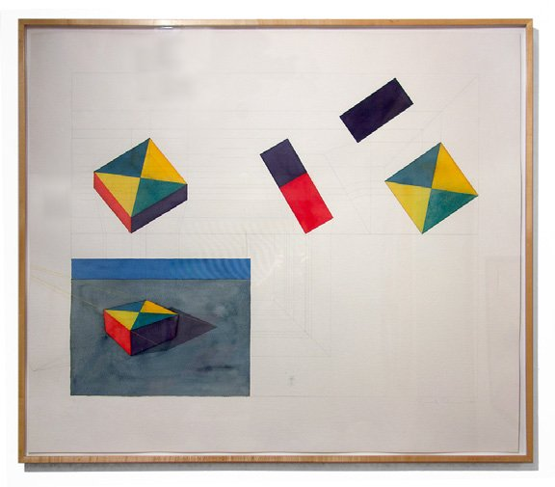
Slab Rotation, 1980
Gouache on paper
37 3/4 x 43 1/4 inches
ROND113
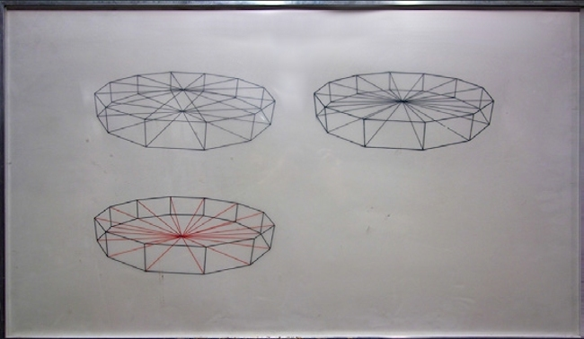
Three Dodecagons, 1972
Ink on mylar
21 x 36 inches
ROND116
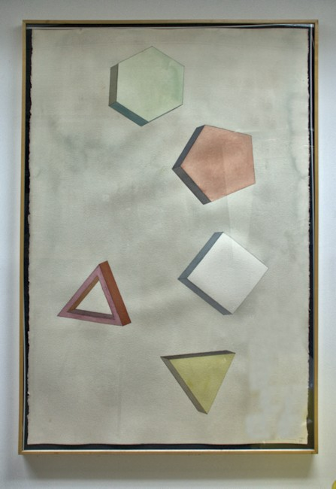
Watercolor 17, 1980
Watercolor on Arches paper, 300 lb
60 x 40 inches
ROND117
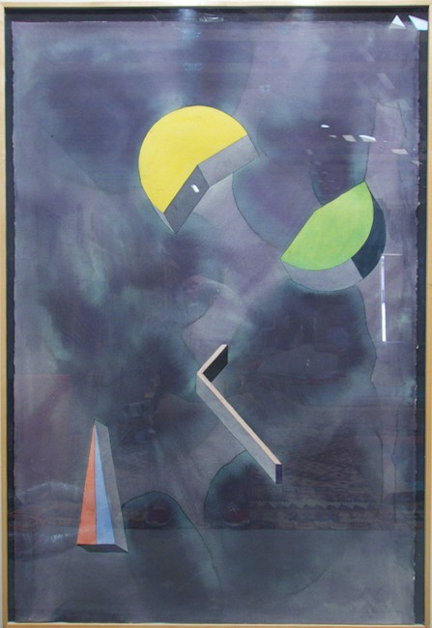
Four Shapes, Watercolor #33, 1980
Watercolor on Arches paper, 300 lb.
60 x 40 inches
ROND118

© 2014

Charlotte Jackson Fine Art, Inc.

In the Railyard at:

554 S. Guadalupe, Santa Fe, New Mexico 87501
Telephone: 505.989.8688 Fax: 505.989.9898
cjfa@charlottejackson.com - www.charlottejackson.com

