CHARLOTTE JACKSON FINE ART PRESENTS:

Winston Roeth: New Paintings

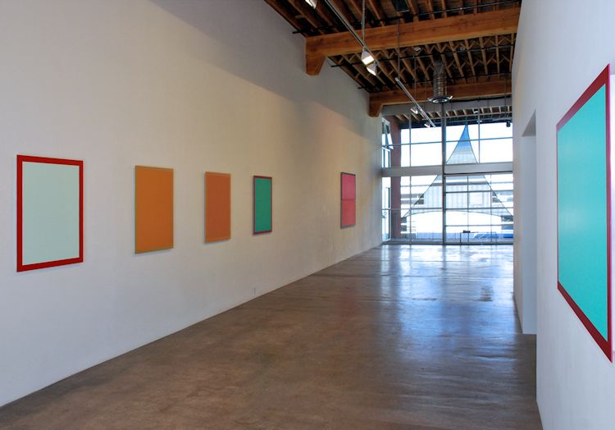

October 5-November 1, 2012
Blue vibrates. Orange hums. Green ebbs. Walking into the quiet of the gallery, you might feel as if the echo of a conversation that had been going on just before you entered lingers in the space. Presences, creatures, each of the eight pieces in New Paintings by Winston Roeth, with its characteristic painted border and its mutable interior color (or colors), quickly begins to speak again, this time to the viewer, drawing them into orbit. Spend time with a piece, moving back and forth to experience the way color, light, and shadow play and shift within it, and the whisper may very well turn into conversation.
Roeth, whose work has found a home in some of the most prestigious collections around the world, from the Albright Knox to the Panza Collection, has spent decades refining ways to release color inside of pigment. Although he has been called “… probably the best color-painter in New York,” (by critic Michael Brennan), it is not questions of color that drive Roeth’s work. And sitting with the living, breathing color of Roeth’s paintings, it might seem ironic when he says, “I’m not really interested in color.” What does interest him is not color problems, but rather light and pigment.
This is not so hard to understand, because light is clearly integral to these works, essential to the way they are seen and experienced. While light travels faster at the edges of these paintings, speeding around the painted “frames,” it slows and seeps into the dry, matt space of the interiors, which catch and hold both light and shadow (which, as Roeth says, is inseparable from light). In a matter of seconds the viewer can watch as a dense pool of deepening blue lolling at the bottom corner of a piece lifts free and opens outward into the violet range, as a cloud passes across the sun.
An intimate knowledge of the pigments is also apparent. Roeth uses pure pigments in a water-based polyurethane dispersion. Over the years Roeth has worked with a plethora of pigment types and shades, from ancient traditional powders made from stone to cutting-edge colors only available because of new developments in chemistry. Each pigment has its own unique qualities, structure, and character. For Roeth, “Each pigment holds knowledge, knowledge there to be revealed.” Applied layer after layer, the pigments build in a complex, if microscopic, architecture. The way they form, the patterns they make, will determine the way light will bend and refract as it penetrates the surface. However, for all the technique and knowledge required in their making, these works are neither mechanical, nor cerebral, they are visceral.
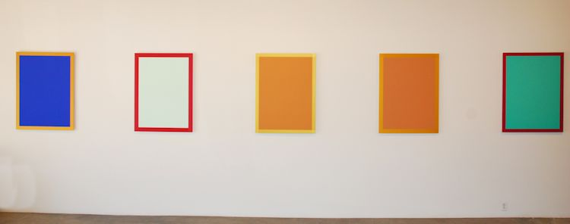

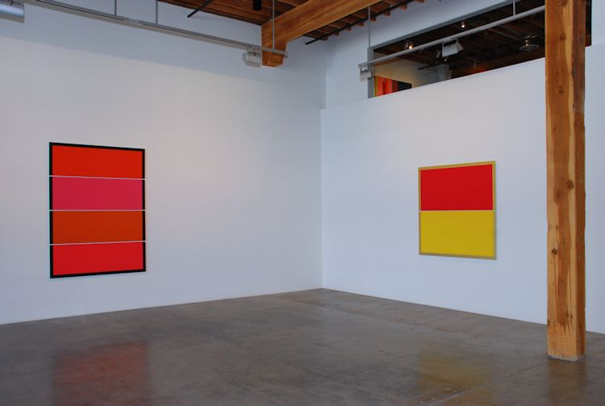
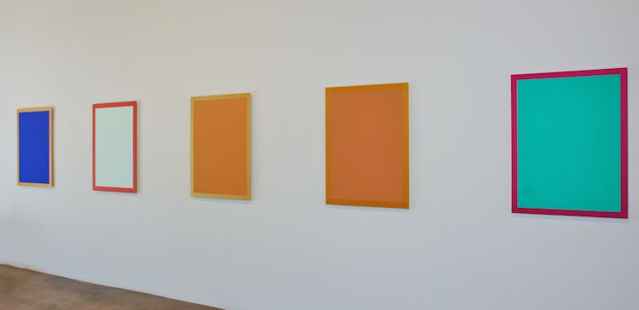

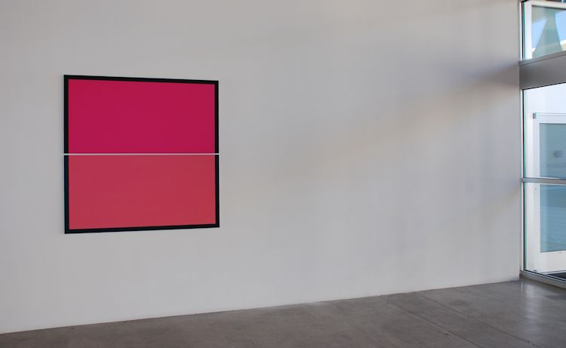

Following photos, courtesy Tom Moore:
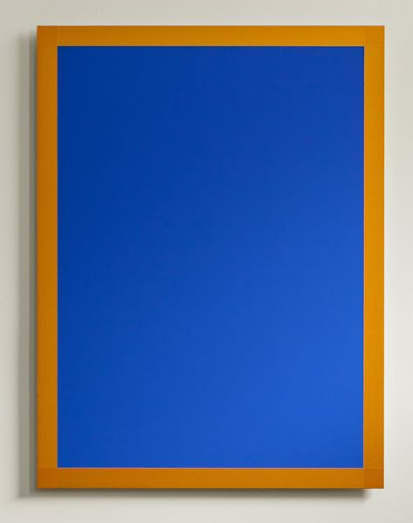
Portrait in Blue, 2012
Pigment and polyurethane on Dibond
40 x 30 inches
WR014
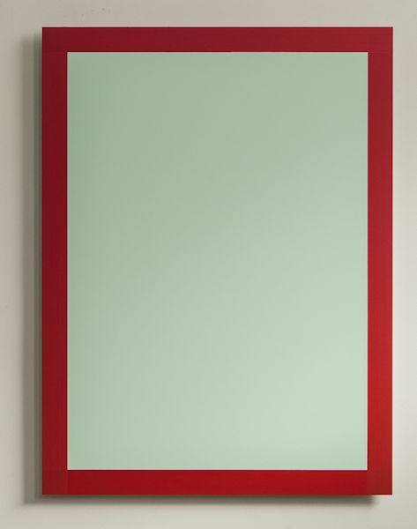
Portrait in Light, 2012
Pigment and polyurethane on Dibond
40 x 30 inches
WR01

Portrait in Transparent Orange, 2012
Pigment and polyurethane on Dibond
40 x 30 inches
WR013
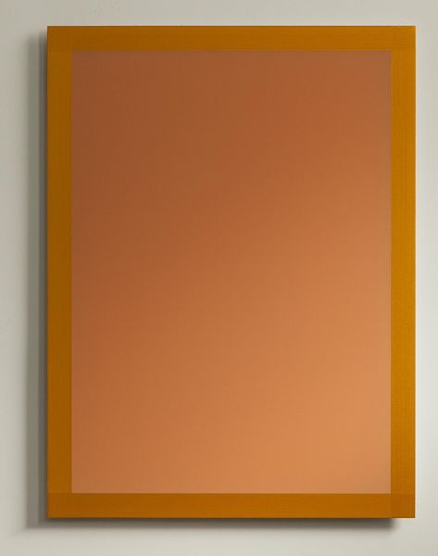
Portrait in Transparent Red, 2012
Pigment and polyurethane on Dibond
40 x 30 inches
WR016
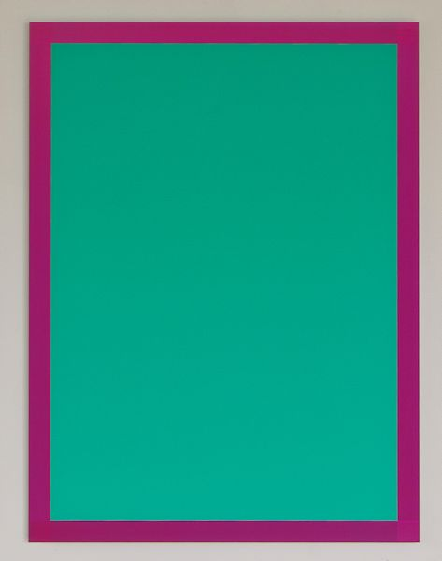
Portrait in Green, 2012
Pigment and polyurethane on Dibond
40 x 30 inches
WR015
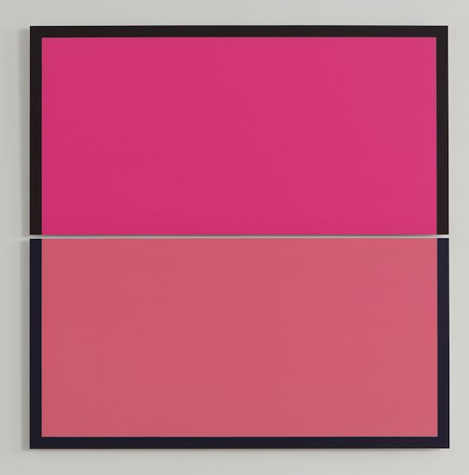
Split Pink Square, 2012
Pigment and polyurethane on Dibond
60 x 60 inches
WR011
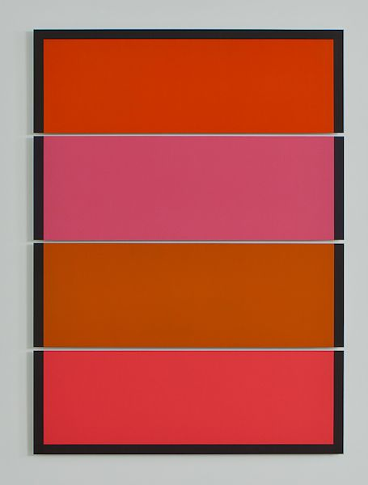
Split Decision, 2012
Pigment and polyurethane on Dibond
83 x 60 inches
WR018
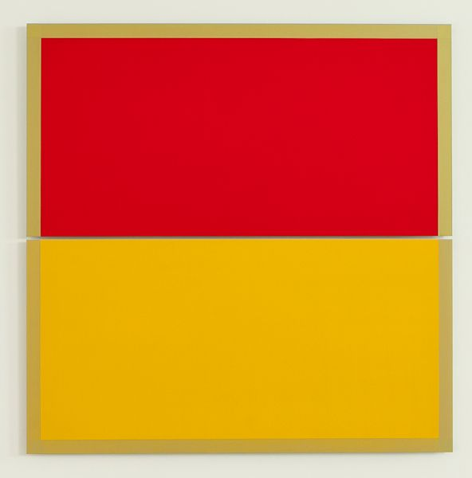
Sense of Purpose, 2012
Pigment and polyurethane on Dibond
60 x 60 inches
WR010
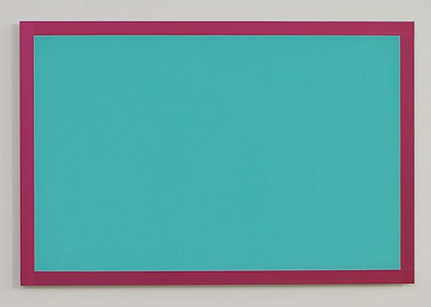
Blue Green Space Painting, 2012
Pigment and polyurethane on Dibond
32 x 48 inches
WR012

© 2012

Charlotte Jackson Fine Art, Inc.

In the Railyard at:

554 S. Guadalupe, Santa Fe, New Mexico 87501
Telephone: 505.989.8688 Fax: 505.989.9898
cjfa@charlottejackson.com - www.charlottejackson.com

