CHARLOTTE JACKSON FINE ART PRESENTS

WILLIAM METCALF
POINT OF VIEW
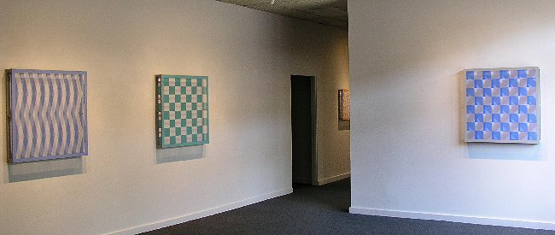

July 1 - July 23, 2005
What happens when a classically trained artist discovers a new world of materials and modern techniques? William Metcalf has taken full advantage of the dual nature of his formidable collection of skills to produce an intriguing new body of work using translucent polyester fabric stretched over hardwood frames and painted with acrylic.
One of the first works in this series is a 20” square frame, almost three inches deep, with wide open slits in the side panels that allow light to enter the piece from all sides. Translucent polyester fabric (Metcalf calls it “your grandmother’s sheers”) is stretched across the front of the frame, and approximately vertical graphite stripes are applied by hand. A thin, rigid panel covering the back of the frame echoes this pattern, but with enough variation to set up an interference pattern when the viewer moves from side to side in front of the painting, giving the impression of vertical movement in the painting itself. Metcalf refers to this effect as “visually kinetic.”
According to Metcalf, the key to producing this effect is the translucency of the fabric. “The warp and weft of the fabric actually form a tiny grid, though it’s too small for our eyes to register,” he explains. “Light and color can pass through these tiny holes, however, and it becomes difficult to determine exactly where the surface is. This ambiguity becomes an important element in the work, and can be used in all kinds of ways.”
Interference patterns have been used previously with materials such as Plexiglas, but polyester fabric gives a much softer surface and allows for a range of surprising effects. Metcalf’s fluency with such modern techniques as computer modeling also multiply the possibilities by letting him see specific effects before they are subjected to the arduous process of fabrication. Extremely precise outcomes can be achieved in this way.
The importance of precision, and of the passage of color through the tiny “grid,” becomes apparent in another piece in the series, in which the gray stripes on the fabric are complemented with a smaller central section of bright red stripes on the back panel. The central section undergoes constant color and shape changes as the viewer changes position in front of the painting. When the viewer is at a certain angle to the surface, the central section, which is actually part of the back panel, “pops out” and appears to float in front of the forward plane of the painting.
A third piece, in which the front fabric panel has been left entirely unpainted, features scrumbled paint application with nebulous edges on the back panel. The color, a soft but intense light blue, appears to float somewhere within the frame, but its exact location is impossible to determine. The depth changes as the viewer changes position. The interior space within the frame is an important part of the painting as a whole, as it is in all the work in this series.
This work continues a progression in Metcalf’s painting over the past decade. He was already experimenting with including interior space as part of a painting in the early 90s. The uneven edges of his late 90s monochromatic gesso paintings hinted at the floating field of color in the monochromatic pieces in this new body of work. The new geometric pieces hark back to his recent, more sculptural paintings using the same polyester fabric. “I don’t really want to be a sculptor, though,” he says. “I’m fascinated by form and by all things three-dimensional, but I want to use them in two-dimensional, painterly ways.” The bonus for the viewer is that Metcalf’s work bridges not only the second and third dimensions, but the fourth as well, as the viewer takes them through time – the fourth dimension – by moving through the exhibition space and discovering a wealth of paintings hidden within the frame of a single work.
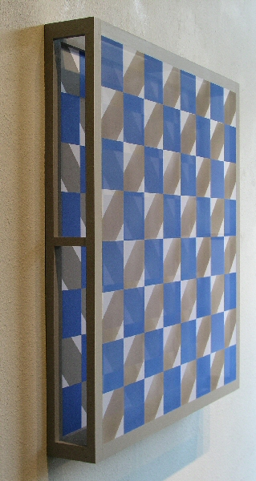
Infinity Series #9 (detail)
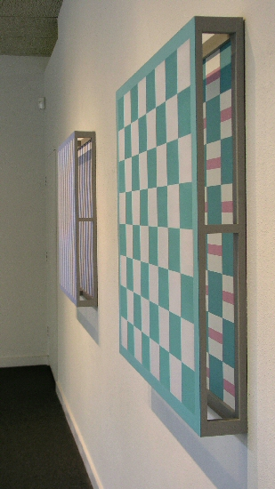
Infinity Series #5 and #6 (detail)
MAIN GALLERY:

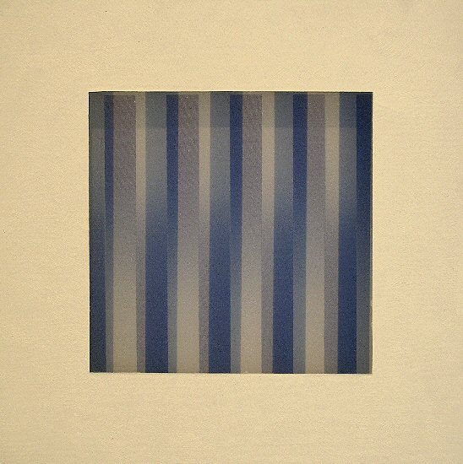
Maquette #2, 2005
14 ½” sq. x 1”
Acrylic, Polyester fabric, Gatorfoam
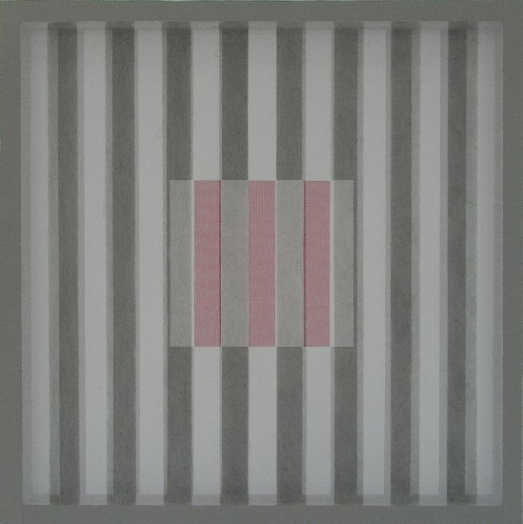
Infinity Series #2, 2005
18.1/4” sq x 2.3/4”
Acrylic, Polyester fabric, graphite, Gatorfoam
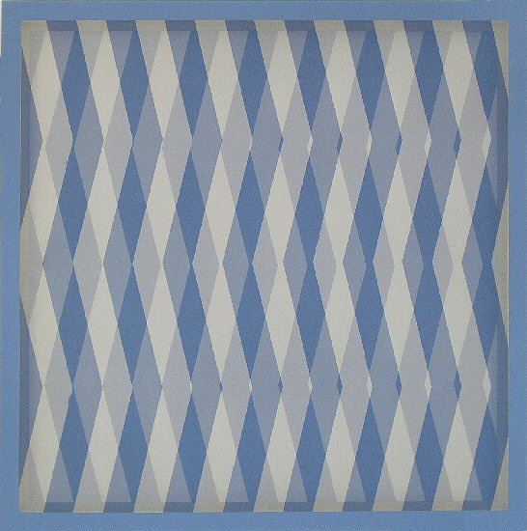
Infinity Series #5, 2005
36” sq. x 4 3/8”
Acrylic, Polyester fabric, Gatorfoam
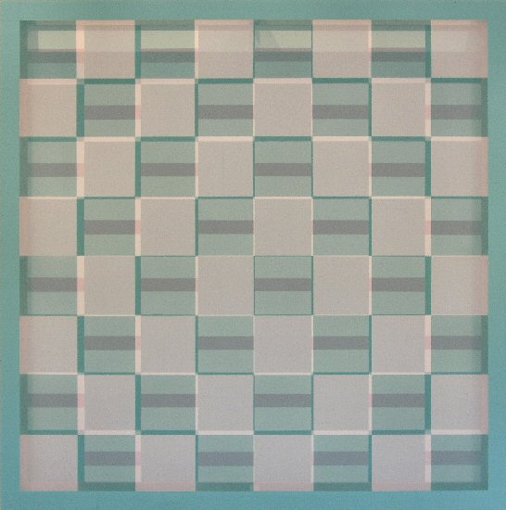
Infinity Series #6, 2005
36” sq. x 4 3/8”
Acrylic, Polyester fabric, Gatorfoam
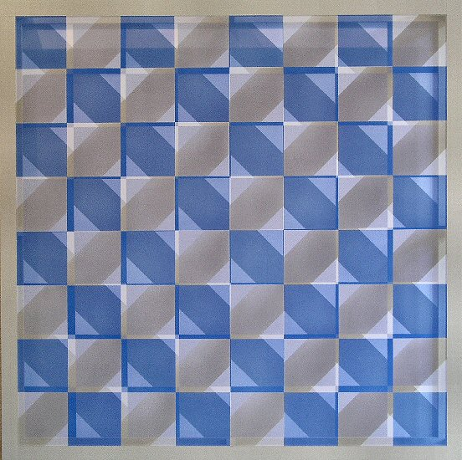
Infinity Series #9, 2005
36” sq. x 4 3/8”
Acrylic, Polyester fabric, Gatorfoam
HALLWAY:
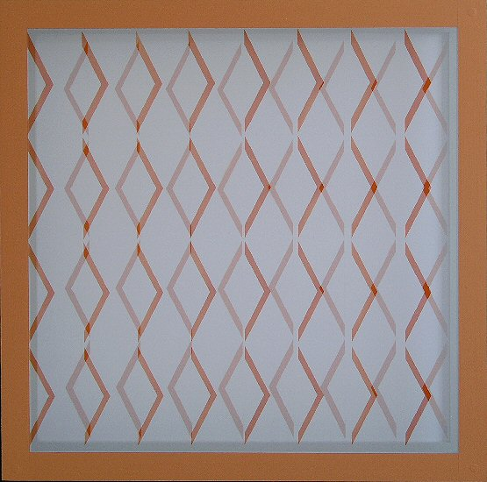
Infinity Series #11, 2005
24” sq. x 3 1/4”
Acrylic, Polyester fabric, Gatorfoam
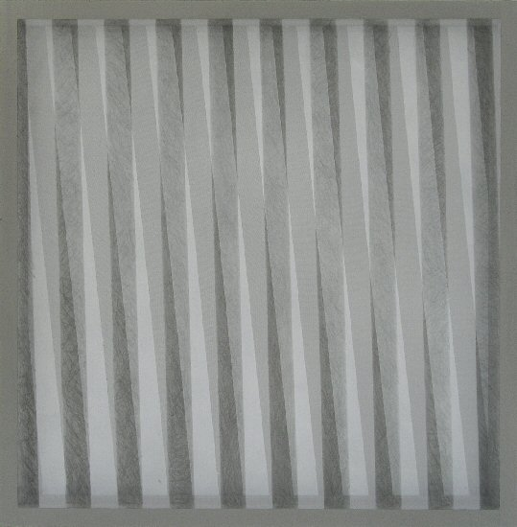
Infinity Series #3, 2005
19 1/2” sq. x 2 3/4”
Acrylic, Polyester fabric, graphite, Gatorfoam
GALLERY II:

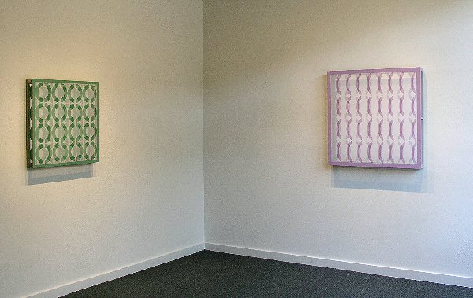

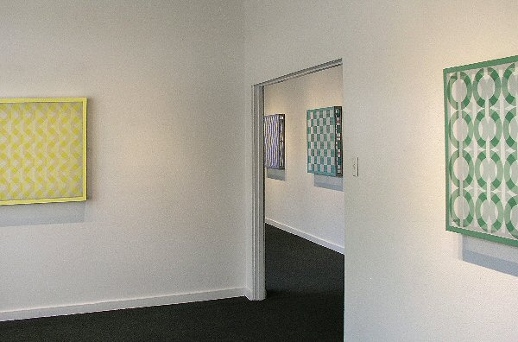
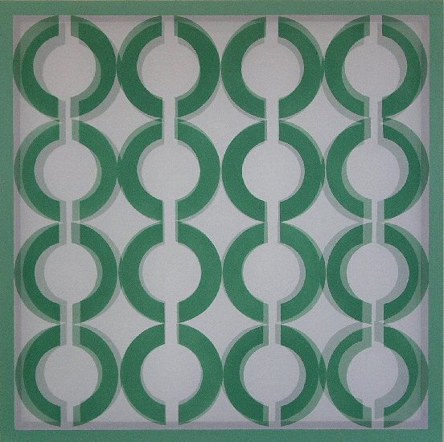
Infinity Series #10, 2005
28”sq. x 3 ¼”
Acrylic, Polyester fabric, Gatorfoam
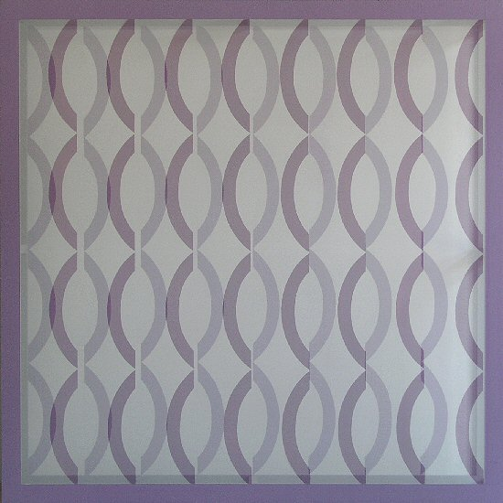
Infinity Series #7, 2005
36” sq. x 4 3/8
Acrylic, Polyester fabric, Gatorfoam
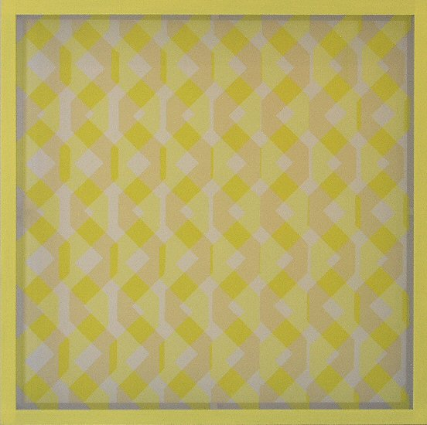
Infinity Series #8, 2005
36” sq. x 4 3/8
Acrylic, Polyester fabric, Gatorfoam
WILLIAM METCALF

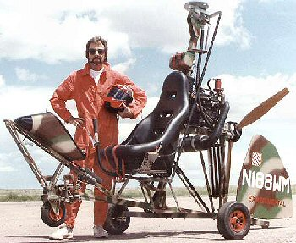

William Metcalf has always liked making things with his hands. From the time he could hold a pencil, he began to draw, and soon he progressed to building intricate models, mostly of anything that moves through space. As an adult, Metcalf moved from model airplanes to home-built aircraft, and ultimately to a form of artwork that essentially works as a craft for navigating perceptual space.
Metcalf identifies all these activities, as well as preferred recreational activities such as flying an airplane, riding a motorcycle, skiing and diving, as manifestations of his desire to experience the physical sensation of moving through three-dimensional space. In his artwork, this interest translates into a persistent involvement with issues involving light and space; in his latest work, movement is an important ingredient as well.
Sculptural paintings made on translucent polyester stretched on shaped frames, these pieces hark back to Metcalf’s early fascination with the spatial dynamics of fabric stretched over the frame of an airplane wing. In the meantime, formal training (a B.A. in Art from California State University at Fullerton), the acquisition of highly developed drafting skills, and a long and varied career as a painter have given Metcalf the necessary expertise to transform his interest in these issues into original and compelling works of art.
Although Metcalf’s painting style has, by his own description, evolved through a number of permutations roughly approximating the history of art, he sees the polyester work as the culmination of his ability to extract an individual style from the specific influences he has chosen. The idea to use polyester came as something of an epiphany. As he was reading a description of a Robert Ryman painting done on polyester, it occurred to him that this would be the ideal material for achieving the quasi-sculptural painting mode that he was seeking. Never one to lose time, Metcalf ran right out to the fabric store and began a phase of his career that has produced an important innovation in painting: the incorporation of interior space into what has heretofore remained primarily an opaque, flat medium.
The polyester paintings hang flat against the wall, but their shapes and composition offer the viewer a complex experience of light, space and movement. As a highly refined exploration of space and light, they provide the viewer with a series of sails for cruising the perceptual realm.
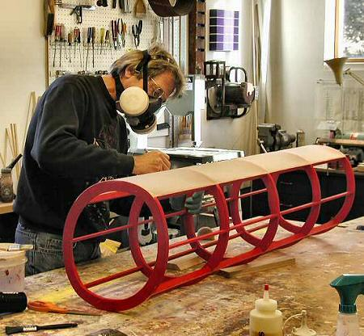

Born 1945
EDUCATION
A.A. Art, Orange Coast College, Costa Mesa, CA
B.A. Art, California State University at Fullerton, CA
SELECTED SOLO EXHIBITIONS
2005 Point of View, Charlotte Jackson Fine Art, Santa Fe, NM
2002 Bending Space, Charlotte Jackson Fine Art, Santa Fe, NM
2000 Charlotte Jackson Fine Art, Newport Beach, CA
1997 Charlotte Jackson Fine Art, Santa Fe, NM
1995 Charlotte Jackson Fine Art, Santa Fe, NM
1992 Wade Wilson Gallery, Chicago, IL
1992 Campbell Gallery, Los Angeles, CA
1989 Sena Galleries West, Santa Fe, NM
1988 Sena Galleries West, Santa Fe, NM
SELECTED GROUP EXHIBITIONS
2005 William Metcalf, Chuck Close, Roy Lichtenstein, Trinity Gallery, Atlanta, Ga.
2004 Trinity Gallery, Atlanta Ga.
2003 I-25 Sangro De Cristo Arts & Conference Center, Pueblo CO
2003 THE SHOW: A Southwest Juried Exhibition. Museum of Fine Arts, Santa Fe, NM
2002 LOOKING BACK, Museum of Fine Arts, Santa Fe, NM
2001 Site Unseen, Site Santa Fe, Santa Fe, New Mexico
2000 TERM LIMITS, Museum of Fine Arts, Santa Fe NM
2000 Fair and Square, The Governor’s Gallery, Santa Fe, NM
Galerie Rotloff, Karlsruhe, Germany
Charlotte Jackson Fine Art, Santa Fe, NM
Robert McClain Gallery, Houston, TX
Galeria Joan Prats, New York, NY
Gallery K, Washington D.C.
Allene Lapides Gallery, Santa Fe, NM
Collector’s Choice: Homage to Paint, Surface: A Step Beyond, Charlotte Jackson Fine Art
The Watermedia U.S. Open, F.A.C.E.T., Taos, NM
The Spirit In Art, Holfelder Gallery, Taos, NM
1984 Print & Drawing Show, Stables Gallery, Taos, NM
The Indian in Art, Stables Gallery, Taos, NM
Taos Today, Stables Gallery, Taos, NM
Taos Connections Gallery, Denver, CO
Beverly Gordon Fine Art, Dallas, TX
New Gallery, Houston, TX
Tavelli Gallery, Aspen, CO
Village Voice Gallery, Paris, France
SELECTED PUBLIC AND PRIVATE COLLECTIONS
The Museum of Fine Arts, Santa Fe, NM
Dr. & Mrs. Irving and Natalie Forman
IBM, Dallas, TX
United Bank, Dallas, TX
Allyen & Bacon Publishing, Boston, MA
Coppens Records, Amsterdam, Netherlands
Atlantic Records, Los Angeles, CA
DMB&B, Los Angeles, CA
John Wolcott Associates, Culver City, CA
Mason Hirst, Reston, VA
The Murrel Company, Newport Beach, CA
Searles Partners, Irvine, CA
Turner Development, Newport Beach, CA
Land Plan Design Group, Newport Beach, CA
Action Media Group, Woodland Hills, CA
Mr. Gene Hackman, Santa Fe, NM
MC Hammer, San Francisco, CA
Mr. Mark Spitz, Los Angeles, CA
Mr. Bobby Unser, Albuquerque, NM
Captain Alan Villiers, Los Angeles, CA
Captain Irving Johnson, Los Angeles, CA
Captain Dwight Long, Los Angeles, CA

BIBLOGRAPHY
Sarah S. King, Santa Fe Summer Preview, Art In America, June/July, 2005
Arden Reed, William Metcalf, Bending Space, THE Magazine, September, 2002
New American Paintings, 2003, Issue #48 juried exhibition
New American Paintings, 2001, Issue #36 juried exhibition
Tobin, Robert, “William Metcalf - Return to Color,” THE Magazine, 10/95.
King, Leslie, “Fabric Bridges World Between Painting, Sculpture - Metcalf’s Art Explores New Regions,” Pasatiempo, The New Mexican, 8/25/95.
Adlmann, Jan Ernst, “Going Mainstream,” Art In America, 01/95.
Clemmer, David, “Short Reviews,” The Magazine, 10/94.
Armitage, Diane, “Artist’s Rebirth Energetic, Alive In Fresh Exhibit,” The Albuquerque Journal, 9/22/94.
Bensley, Lis, “Reaching Into Unchartered Spaces,” Pasatiempo, The New Mexican, 9/16/94.
Balsamo, Dean, “The Space Between, new constructions,” Pasatiempo, The New Mexican, 9/94.
Balsamo, Dean, “Sculpture, William Metcalf.” Pasatiempo, The New Mexican, 10/92.
McCracken, David, Chicago Tribune, 04/91.

© 2005, Charlotte Jackson Fine Art
All Rights Reserved

Charlotte Jackson Fine Art

200 West Marcy Street, Suite 101

Santa Fe, New Mexico 87501

Phone: 505.989.8688
Fax: 505.989.9898

www.charlottejackson.com

Photography and CD production – William Metcalf

