CHARLOTTE JACKSON FINE ART PRESENTS:

FLORENCE PIERCE: In The Light

September 5 - 30, 2014

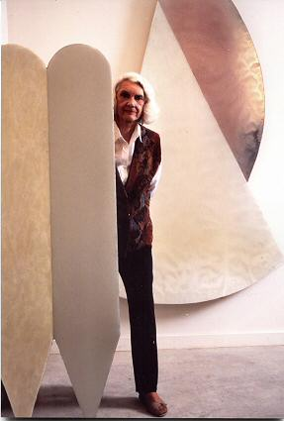

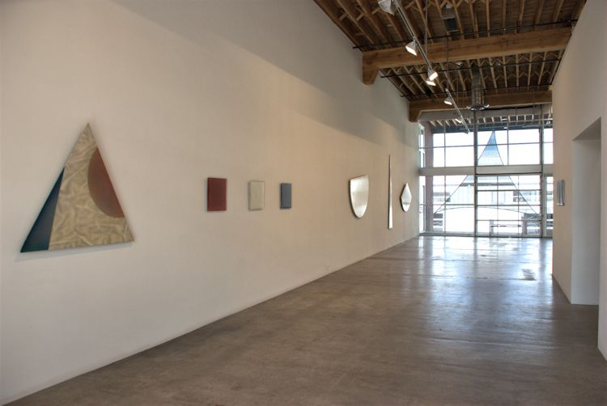

Light in all its guises and subtleties--bright or fleeting, lustrous or dim, the éclat of a spark or the smolder of a color from the depths—this is the subject matter Florence Miller Pierce has come to be known for in her art. A survey of work from across several decades, In the Light will include numerous permutations of this fascination with light—including works from the late 1960’s through the early 2000’s.

Born in 1918 in Washington, D.C., Miller Pierce’s interest in art began at an early age. She studied with a private tutor, May Ashton, at fifteen. It was Ashton who introduced Miller Pierce to The Phillips Collection, considered the first museum of Modern Art in America. Later she studied at the studio school there. At the tender age of eighteen, Miller Pierce set out for Taos, New Mexico to study art with Emil Bisttram. Influenced by the Transcendentalism, Theosophy, and Kandinsky’s seminal Concerning the Spiritual in Art, Miller Pierce found herself in a heady atmosphere that nevertheless did not stint on physical discipline. Students were expected to maintain the studio, stoke the woodstove, and to work eight hours a day. Miller Pierce, along with her husband Horace Pierce, briefly joined Bisttram and Raymond Jonson’s famous Transcendental Painters Group. Miller Pierce was one of only two women (the other was Agnes Pelton) in the group, and by far the youngest member.

Miller Pierce’s early work was primarily organic geometric forms in paint on canvas. Even in what survives of these early works, with their luminous and light-tinted depths, Miller Pierce’s interest in light can be seen. Later, Miller Pierce went on to work with ink on rice paper and to sculpt in stone and balsa wood. These pieces retain the organic and geometric forms of those early years, and they are infused with a gravity and totemic quality which resonates on a visceral level.

However, the work which Miller Pierce is perhaps best known for her resin pieces—a medium which she discovered by accident. Pouring resin in her studio one day, she spilled a few drops onto a piece of foil. She was fascinated by the play of light within the resin. This discovery led to years of trial and refinement as she continually developed new methods of pouring and shaping resin onto mirrored Plexiglas. Her fascination with geometric forms continued. Many of the resin works from the 1980’s include sculptural forms—triangles, fans, lozenges, circles. She also developed multiple ways to manipulate the surface of the pieces—creating matte or gloss finishes, and smooth, stippled, or even folded surfaces. The elegant white pieces were Miller Pierce’s own favorites—with their quiet and meditative quality and subtle play of light. The color works are like gems in which the brilliant range of tones, from black-blues to cool purples to deep pinks become infused with an almost living luminescence.

There has been a recent resurgence of interest in Miller Pierce’s work. She has been selected for inclusion this summer in the SITE Santa Fe Biennial and in the Western Light, Ecstatic Landscapes exhibition at the Sun Valley Center for the Arts in California. In addition, in 2015, Miller Pierce will be honored with a Survey Exhibition at the Harwood Museum. Miller Pierce’s work has been included in prestigious collections and exhibitions around the world, including The Corcoran, The Albright-Knox, The New Mexico Museum of Fine Arts, The Tucson Museum of Art, The Sasebo Museum in Japan, and The Phillips Collection.

In the Light offers viewers the opportunity to see a selection of Miller Pierce’s work in juxtaposition. Whether a square window of brilliant color or a luminous white sculptural form—each piece will draw the viewer into the contemplation of light.

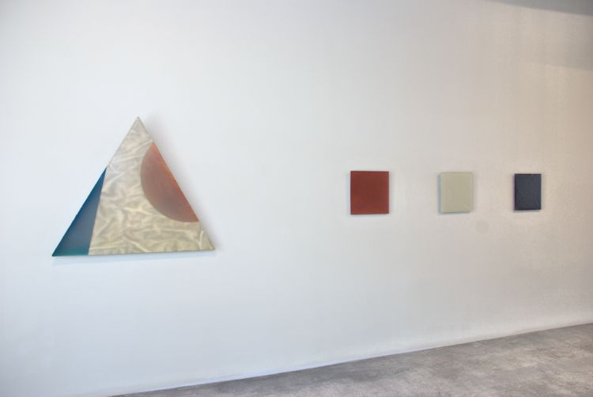

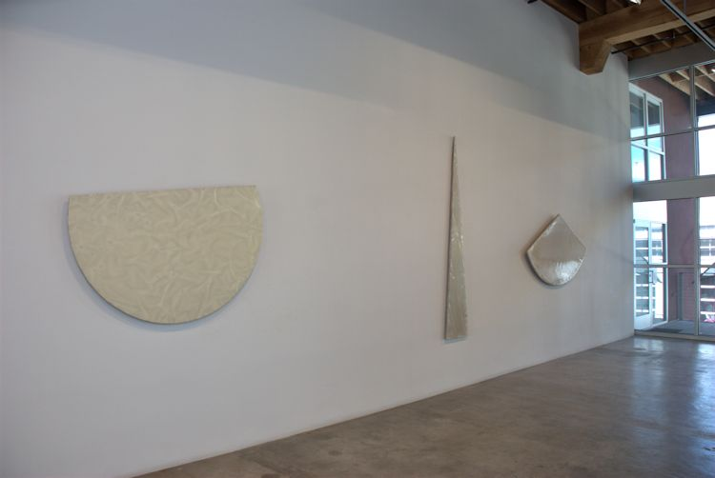

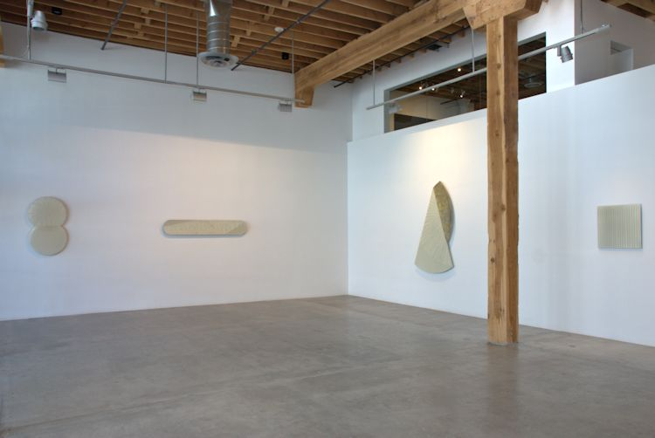

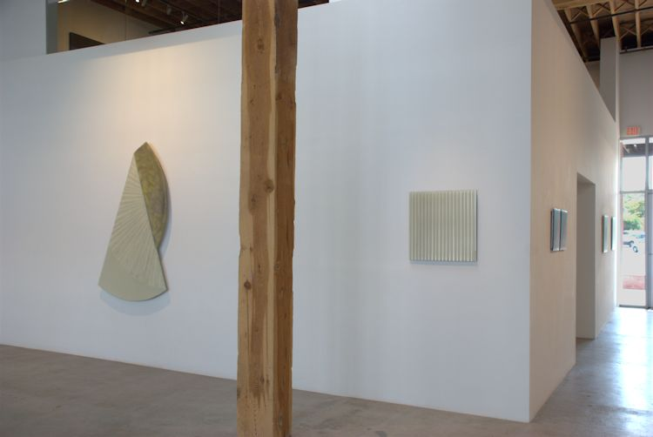

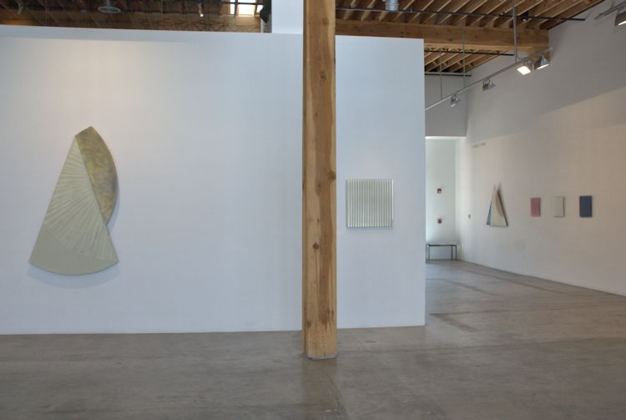

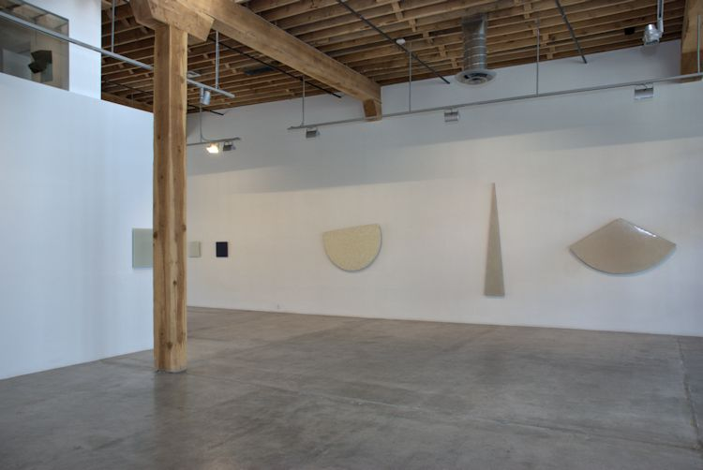

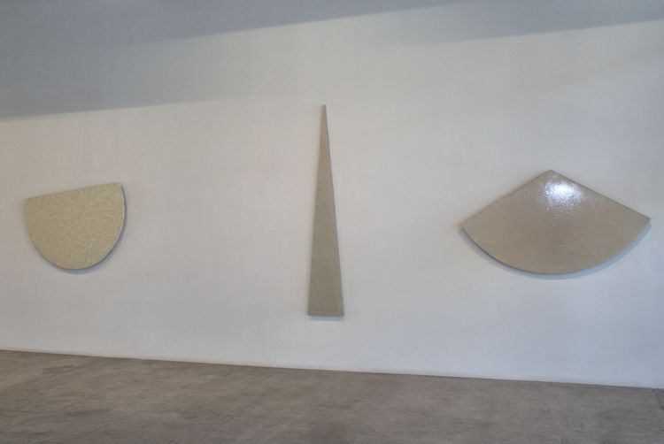

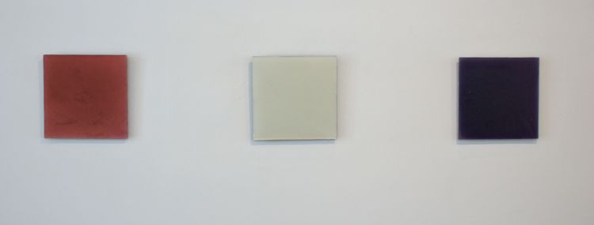

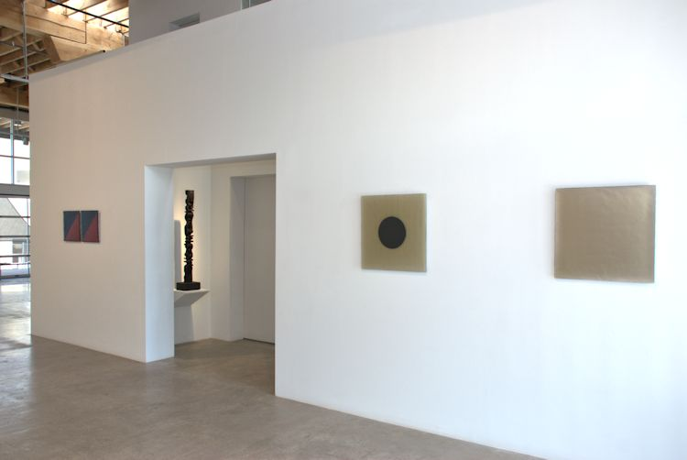

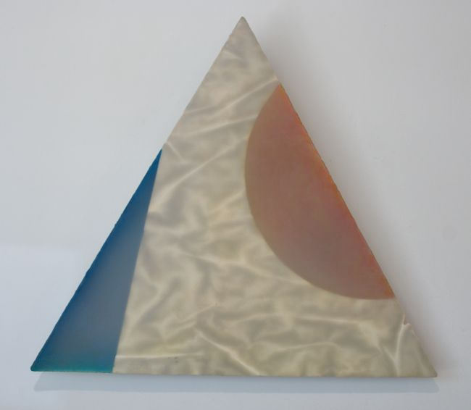

Peak #8, 1983   
Resin Relief  
48 x 41 inches  
FP0085_SM

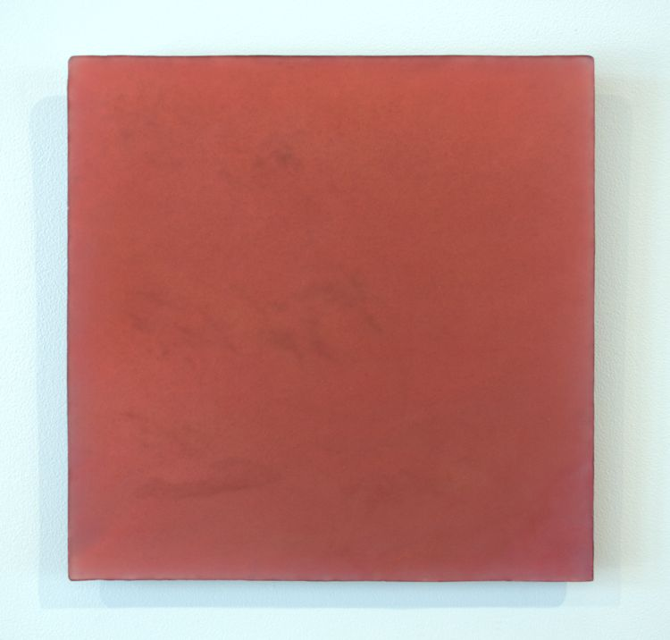

Untitled (Squared Pink), 1997   
Resin Relief  
16 x 16 inches  
FP-JB01

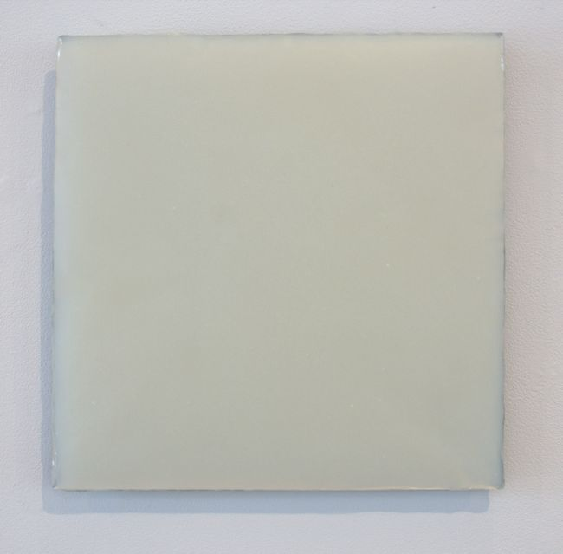

Untitled #627 (Turquoise Tint Cloud), 9/25/2003   
Resin Relief  
16 x 16 inches  
FP174_SM

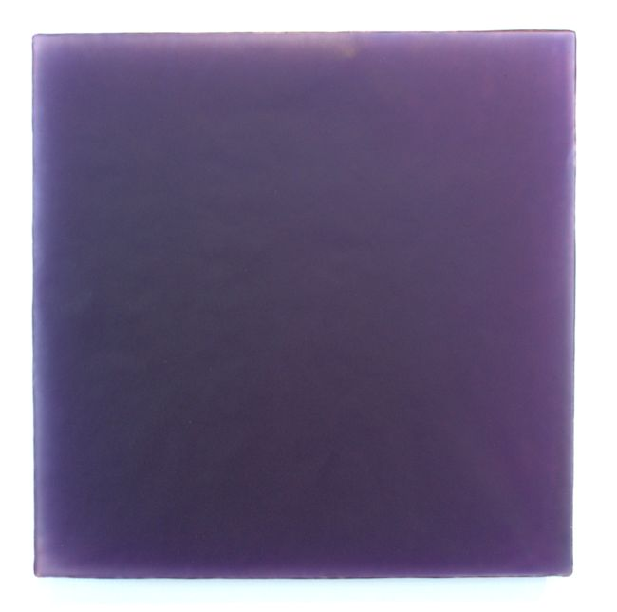

Untitled #643, 3.4.04, 2004   
Resin Relief  
16 x 16 inches  
Signed on Verso   
FP0070_SM

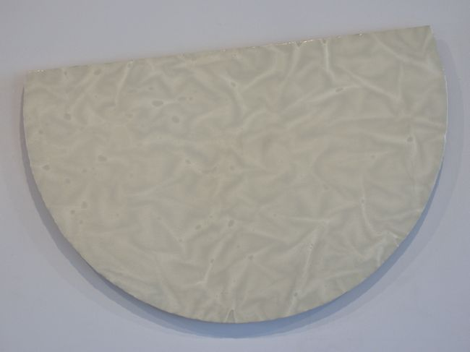

Untitled, #43, 1985, 1985   
Resin Relief  
57 x 39 inches  
FP0088

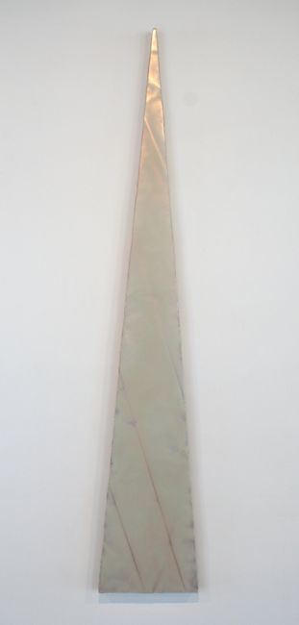

Spire #1, 1985   
Resin relief  
96 x 16 inches  
FP0175_SM

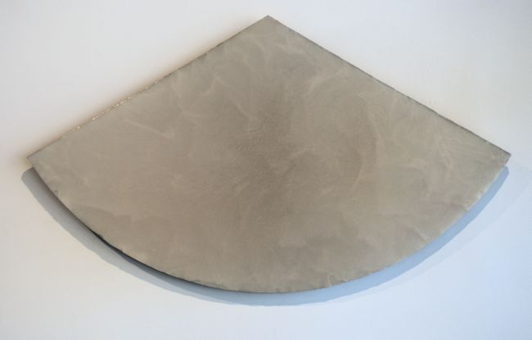

Untitled, 1989   
Resin Relief  
70 x 40 inches  
Signed on Verso   
FP0096

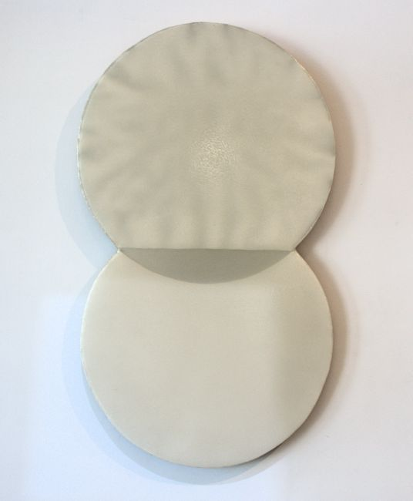

Untitled, 09/19/1986   
Resin Relief  
42 x 24 inches  
FPE030

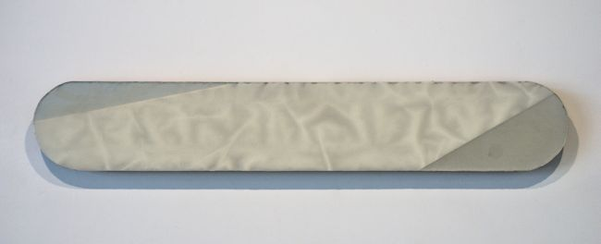

Horizontal Cylinder, 10.1986   
Resin Relief  
72 x 12 inches  
Inscribed on recto by the artist   
FP0089

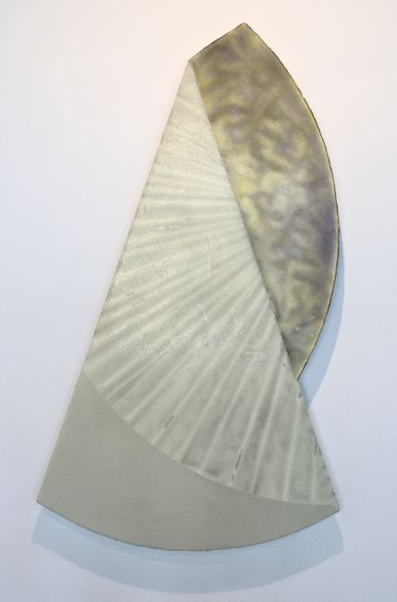

Untitled, 1985   
Resin Relief  
70 x 30 inches  
inscribed on recto: signed "Florence M. Pierce"  
FP0086

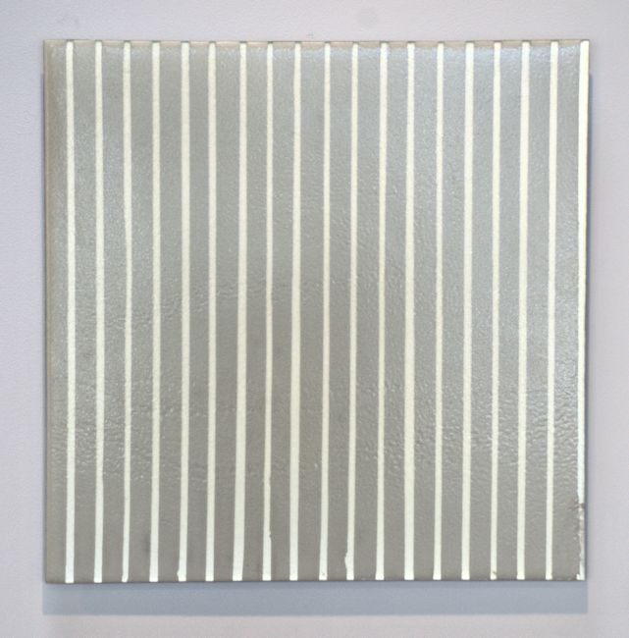

Untitled #47, 12.25.1994   
Resin Relief  
24 x 24 inches  
FP-M0012-SM

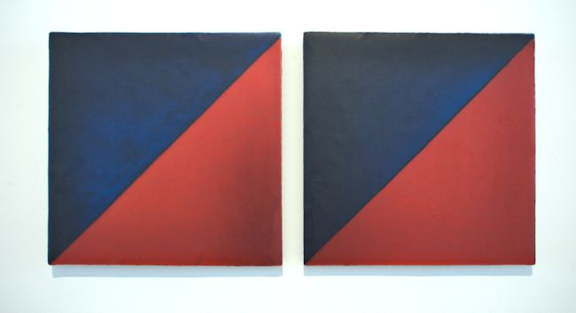

Untitled #370, 9.6.99   
Resin Relief  
36 x 16 inches  
FP0100_SM

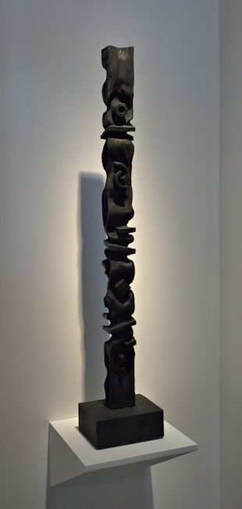

Untitled, 1967   
Balsa Wood  
52 x 10 x 8 inches  
Inscribed on bottom: Signed "Florence Pierce 1967"  
FP168

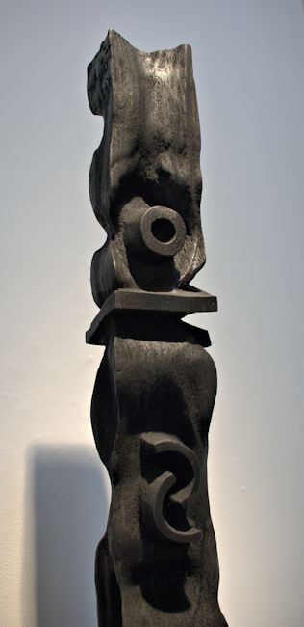

Untitled, 1967 (Detail)  
Balsa Wood  
52 x 10 x 8 inches  
Inscribed on bottom: Signed "Florence Pierce 1967"  
FP168

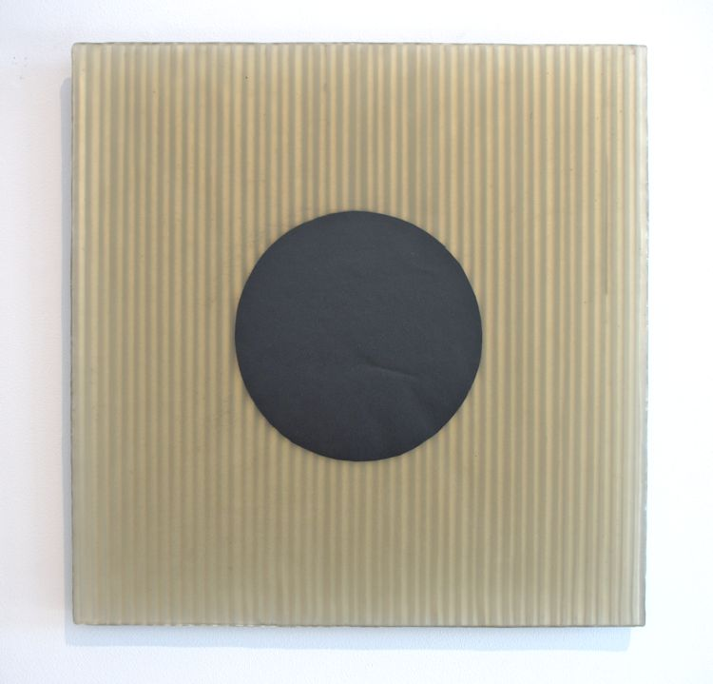

Untitled #598, 2002  
Resin Relief  
24 x 24 inches  
Promised Museum Gift

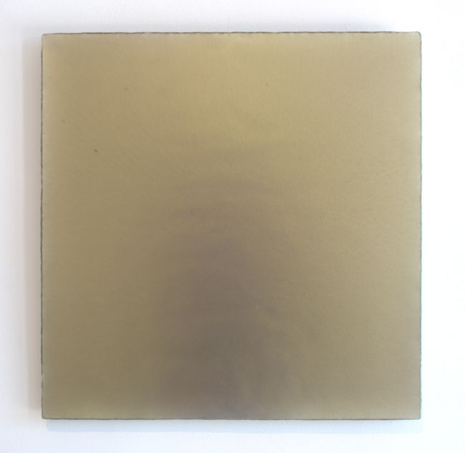

Untitled #553, 9/8/2001   
Resin Relief  
24 x 24 inches  
FP567-JG_SM

# © 2014

# Charlotte Jackson Fine Art, Inc.

## In the Railyard at:

## 554 S. Guadalupe, Santa Fe, New Mexico 87501

Telephone: 505.989.8688 Fax: 505.989.9898

cjfa@charlottejackson.com - www.charlottejackson.com