CHARLOTTE JACKSON FINE ART
PRESENTS:

Helen Pashgian
New Work
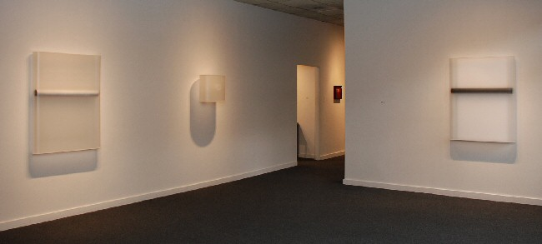
June 5 - June 30, 2009
Looking at Helen Pashgian’s recent works, I realize that I don’t want to know how they were constructed, how she achieved this or that effect, or what materials she used. Granted, these pieces insistently provoke such questions, but I would rather suspend my inquiry because the key to Pashgian’s art lies in its mystery. Better as the poet John Keats said of Shakespeare, better “to remain in uncertainties, mysteries, and doubts, with no irritable reaching after fact or reason.” Better to let each work create its own world, to entice us without giving up its secrets.
Mining the post-minimal tradition, true to industrial materials like polyester resin and sheet metal, Pashgian explores the territory between two and three dimensions. She restricts her vocabulary to clear and simple geometric figures and forms—curves, circles, parallel lines—a pared down, abstract version of Ferdinand Léger’s visual language. These forms she suspends in nebulous atmospheres, making you wonder how much of what you see is real and how much illusory. Or whether that question even makes sense, since everything seems at once palpable and ghostly, tantalizingly out of reach.
Sometimes Pashgian’s new work behaves like objects. They hover in front of the wall without visible attachment, their sides wrapping seductively away from us. Other times they act like windows through which we perceive shapes- - sharp or fuzzy, approaching or receding. Sheets of metal cascade down like sheets of water art-deco style. Motion approaches stillness, or stillness seems about to bestir itself. In any case, the work changes dramatically as we move around it. What looks from head on like a dark or a platinum band becomes, when seen at an angle, a tube disclosing a luminous but indeterminate glow. What seen head on looks like a floating black circle appears, when viewed obliquely, to tunnel back to an unknowable source. To experience this show, then, is to engage the body along with the eye.
Almost half a century ago Helen Pashgian began working in the California Light and Space movement, alongside artists like Peter Alexander, Larry Bell, Laddie John Dill, Robert Irwin, Craig Kauffman and DeWain Valentine.
Arden Reed
Arthur and Fanny Dole Professor of English
Pomona College
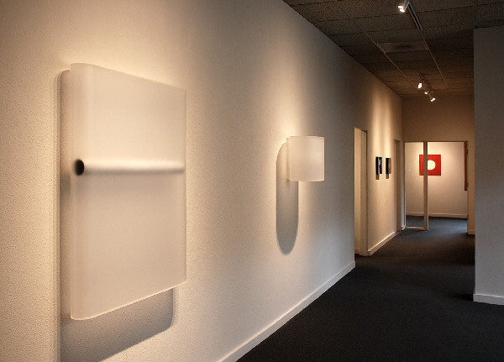

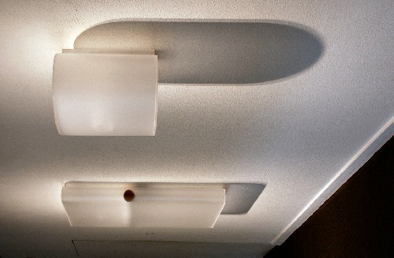
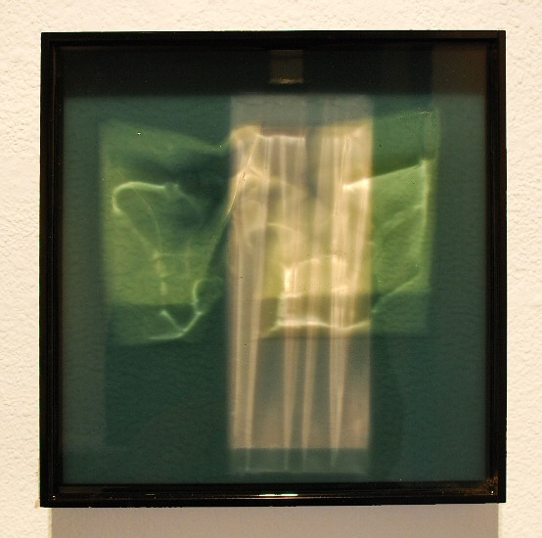
Untitled, 2009
cast industrial material
12 x 12 x 2 inches HP0018
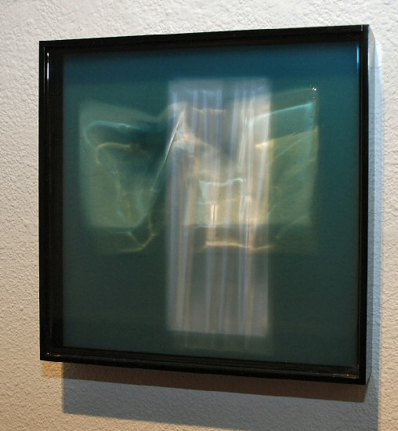
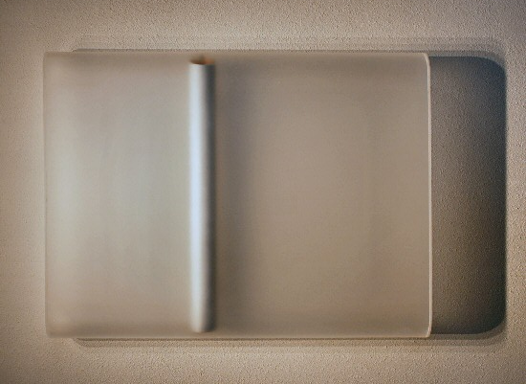
Untitled #8, 2006
cast industrial material
45 x 34.5 x 5.5 inches HP007
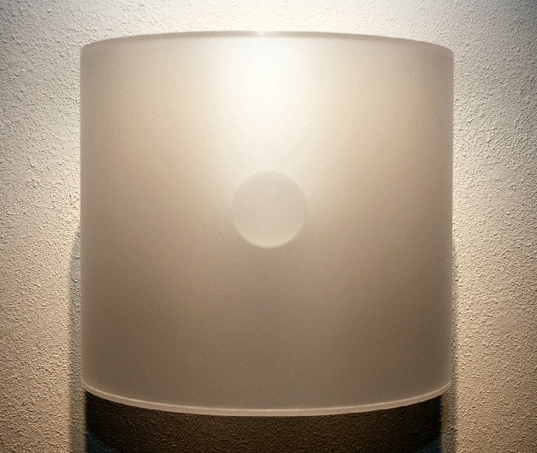
Untitled, 2007
cast industrial material
21 x 14.5 x 18 inches HP001
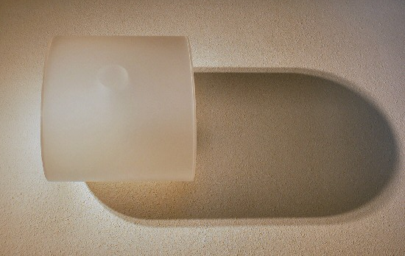
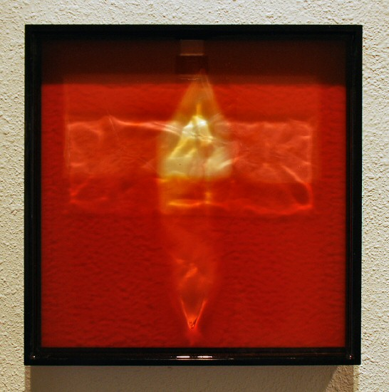
Untitled, 2009
cast industrial material
12 x 12 x 2 inches HP0016
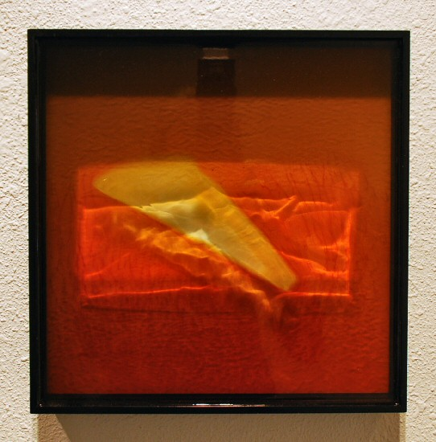
Untitled, 2009
cast industrial material
12 x 12 x 2 inches HP0015
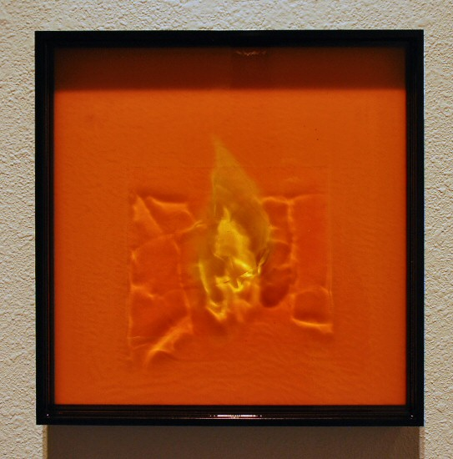
Untitled, 2009
cast industrial material
12 x 12 x 2 inches HP0010
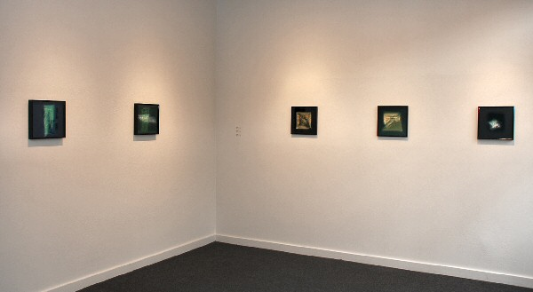

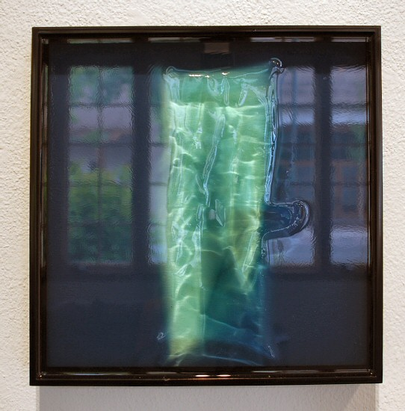
Untitled, 2009
cast industrial material
12 x 12 x 2 inches HP0022
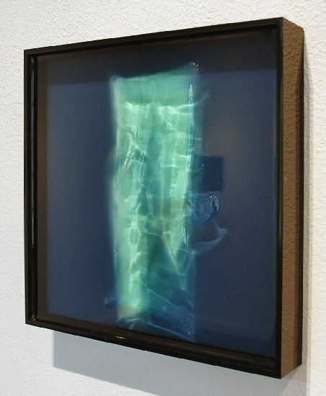
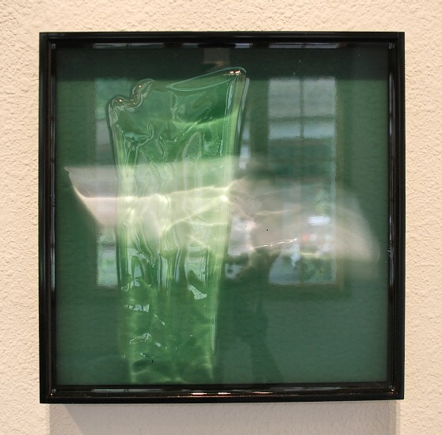
Untitled, 2009
cast industrial material
12 x 12 x 2 inches HP0023
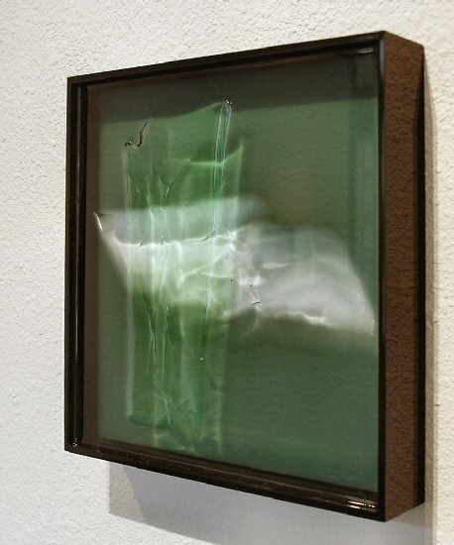
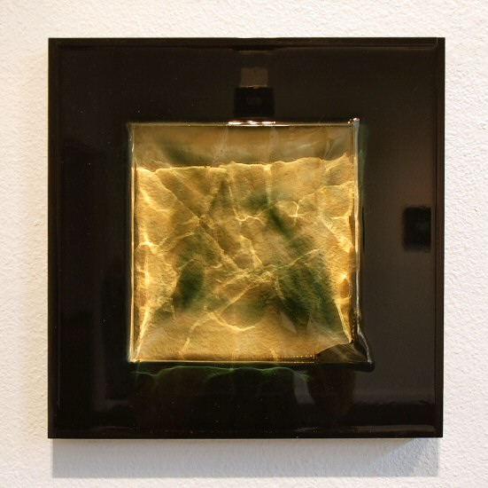
Untitled, 2009
cast industrial material
12 x 12 x 2 inches HP0021
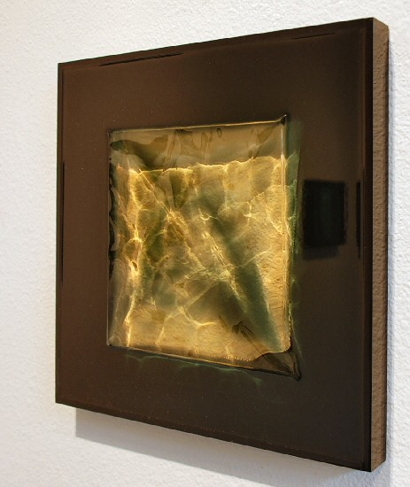
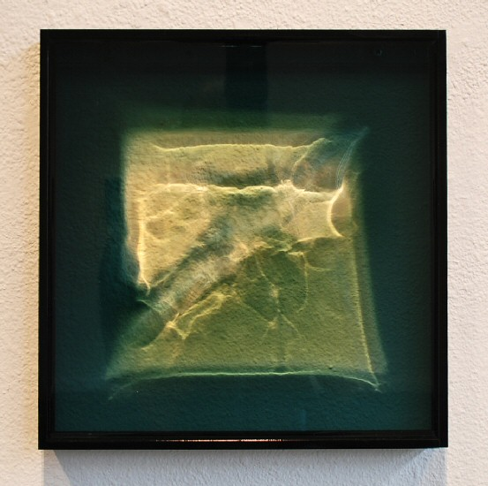
Untitled, 2009
cast industrial material
12 x 12 x 2 inches HP0020
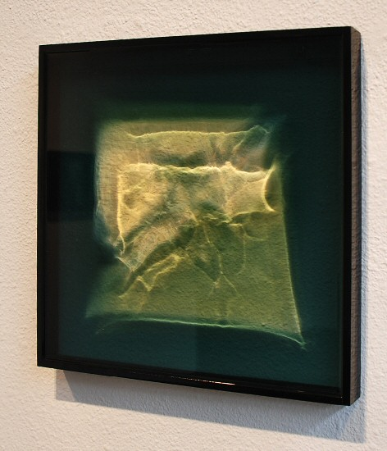
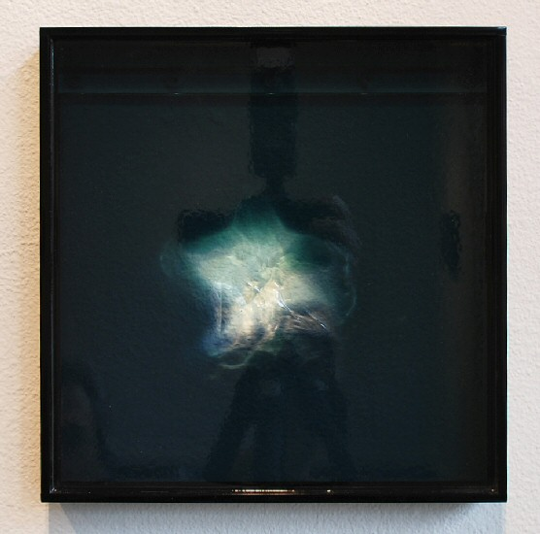
Untitled, 2009
cast industrial material
12 x 12 x 2 inches HP0019
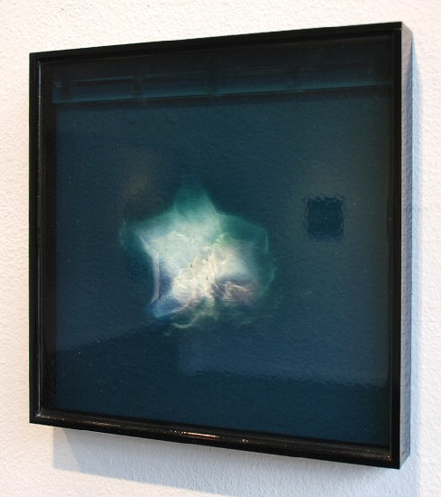
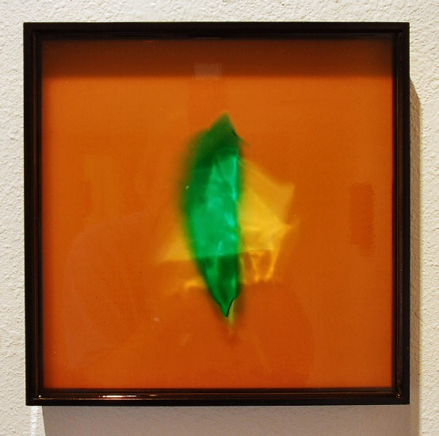
Untitled, 2009
cast industrial material
12 x 12 x 2 inches HP0014
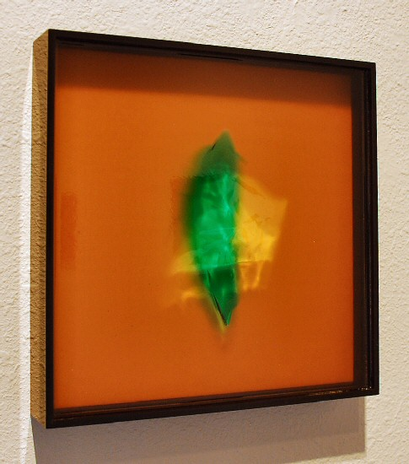
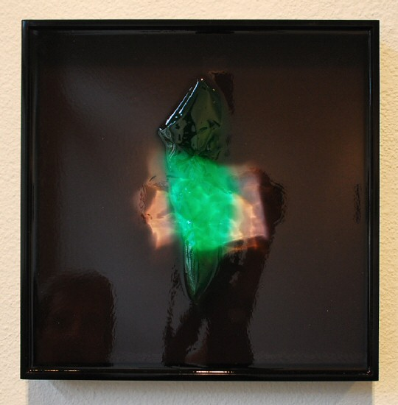
Untitled, 2009
cast industrial material
12 x 12 x 2 inches HP0024
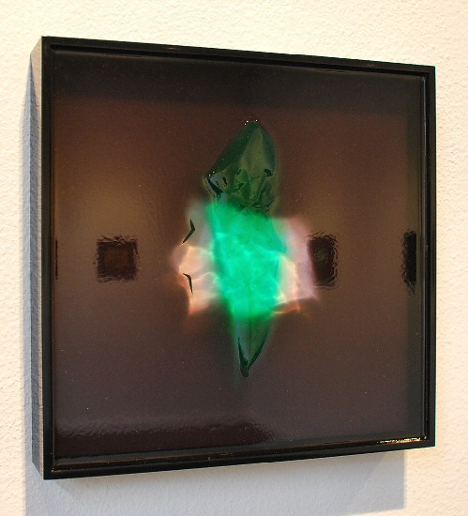
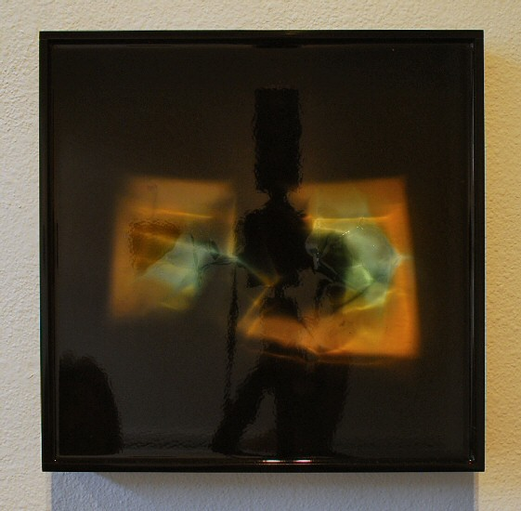
Untitled, 2009
cast industrial material
12 x 12 x 2 inches HP0017
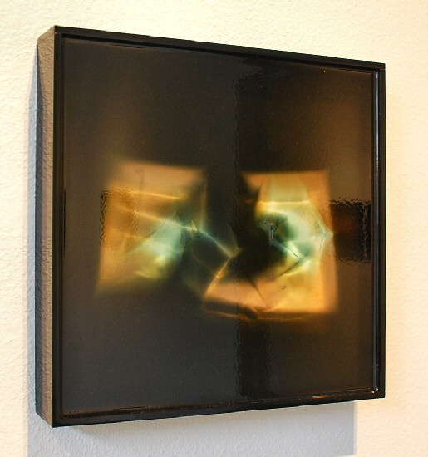
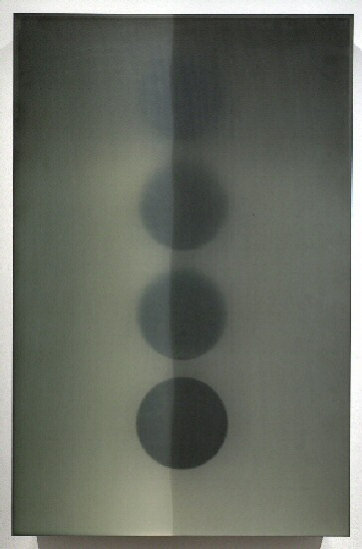
Untitled #6, 2006
Industrial Epoxy
61 x 39 x 7 1/2 inches HP005
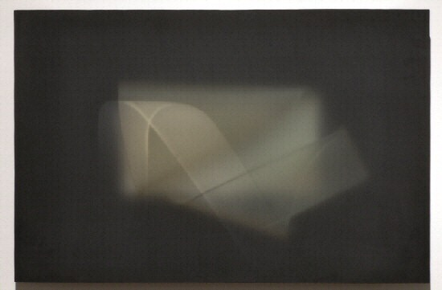
Untitled #5, 2006
Industrial Epoxy
30 x 45 x 4 3/4 inches HP008
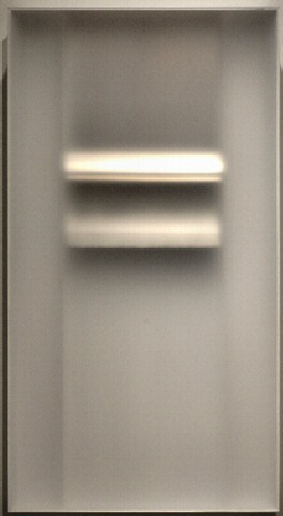
Untitled #11, 2006
Industrial Epoxy and aluminum
56 x 30 1/4 x 5 inches HP003
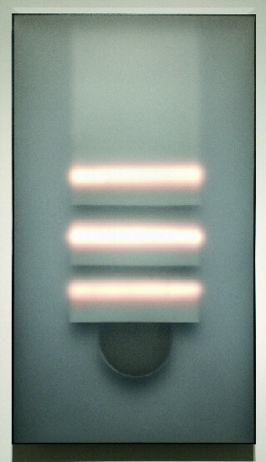
Untitled #4, 2006
Acrylic, Industrial Epoxy, and Copper
61 x 34 x 5 1/2 inches HP004
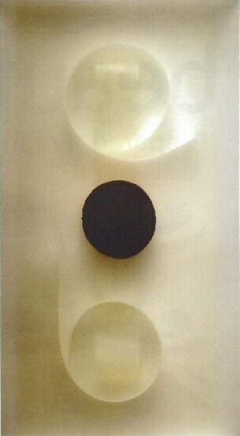
Untitled #10, 2006
Mixed Media
61 x 34 x 5 inches HP009

© 2009

Charlotte Jackson Fine Art, Inc.

200 West Marcy Street, Suite 101, Santa Fe, New Mexico 87501
Telephone: 505.989.8688 Fax: 505.989.9898
cjfa@charlottejackson.com - www.charlottejackson.com

