CHARLOTTE JACKSON FINE ART

PRESENTS:

OBJECTS of DESIRE
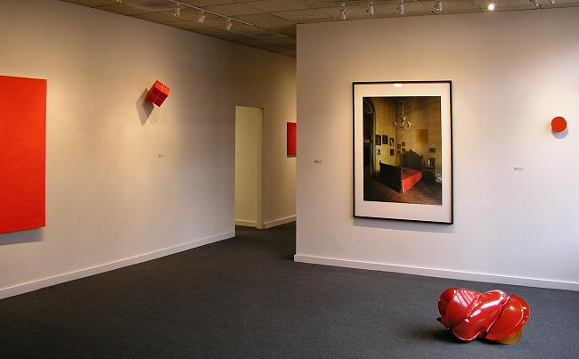
Joe Barnes, John Beech, Alfonso Fratteggiani Bianchi, Mark Cole,
Anne Cooper, Tony Delap, Michael Eastman, Dante Marioni, Lies Kraal, William Metcalf, Winston Roeth, Phil Sims, Eric Tillinghast, Jeremy Thomas, Clark Walding, Susan York

February, 2005
MAIN GALLERY:

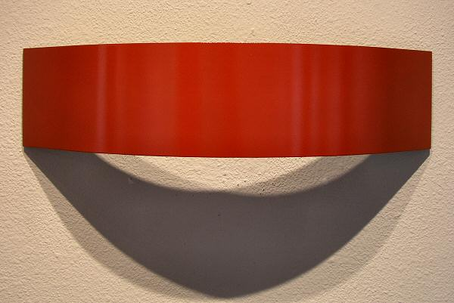
Eric Tillinghast
Strawberry, 2003
Enameled Steel
5 1/2 x 22 x 6 inches
ET001

Alfonso Fratteggiani Bianchi
#207 Rojo
Pigment on Limestone
12 x 11 x 1 inches
AFB007
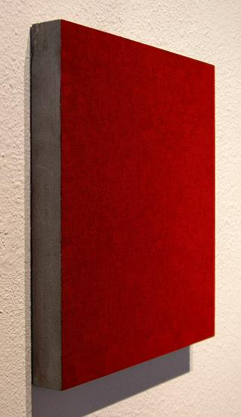
Alfonso Fratteggiani Bianchi
#207 Rojo
Pigment on Limestone
12 x 11 x 1 inches
AFB007
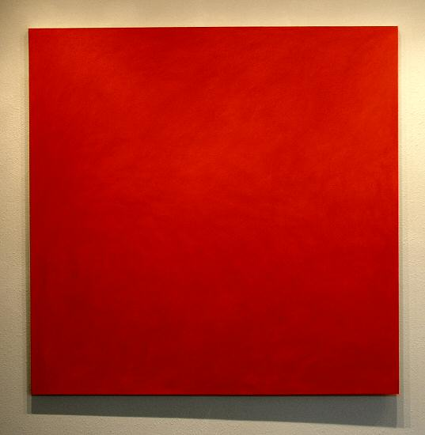
Joe Barnes
Napthol Red Medium, 1999
Acrylic on canvas
60 x 60 inches
JBAR0011
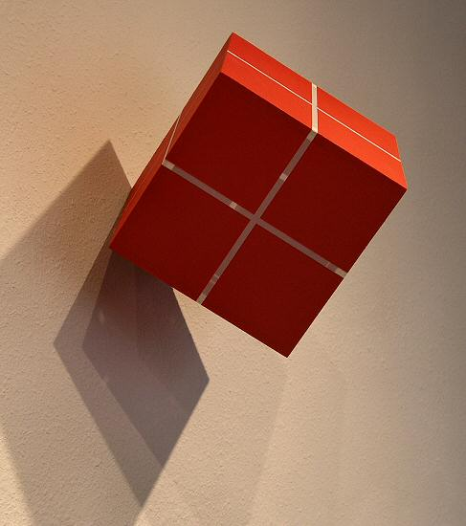
William Metcalf
Cube Suspended From a Point (Red), 2005
Acrylic on Polyester fabric
8 x 8 x 8 inches
WM0020
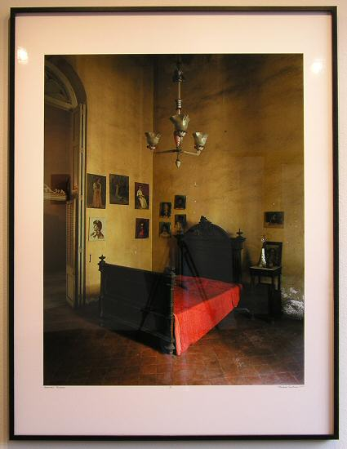
Michael Eastman
Mercedes' Bedroom 6/10
Chromogenic C-type print
66 x 48 inches
ME0039
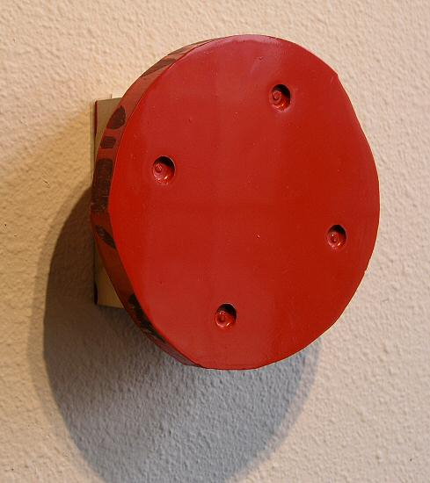
John Beech
RP#106, 2002
Plex, enamel, plywood, rotating hardware
7 x 7 x 3 inches
JB0013
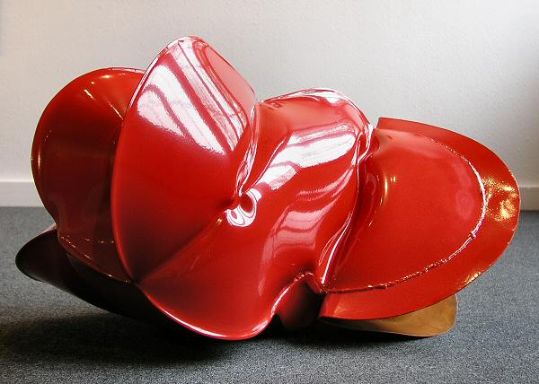
Jeremy Thomas
Bristol Red, 2004
Forged mild steel & powdercoated enamel
27 x 17 x17 inches
JT0027
HALLWAY:

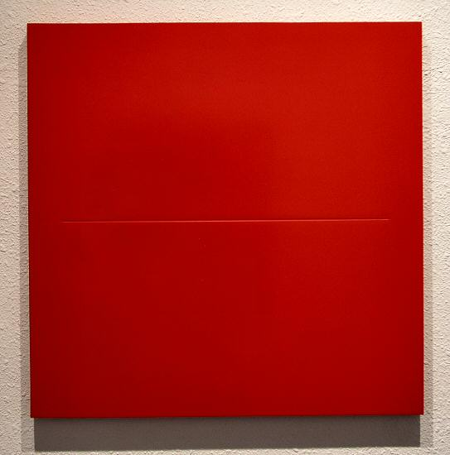
Lies Kraal
02-4, 2002
Acrylic, wax, hardboard panel
23 x 23 inches
LK001
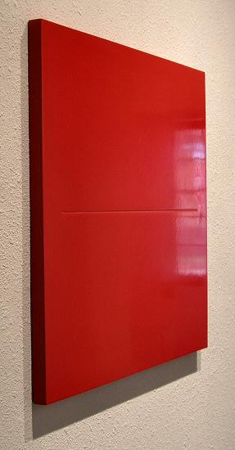
Lies Kraal
02-4, 2002
Acrylic, wax, hardboard panel
23 x 23 inches
LK001
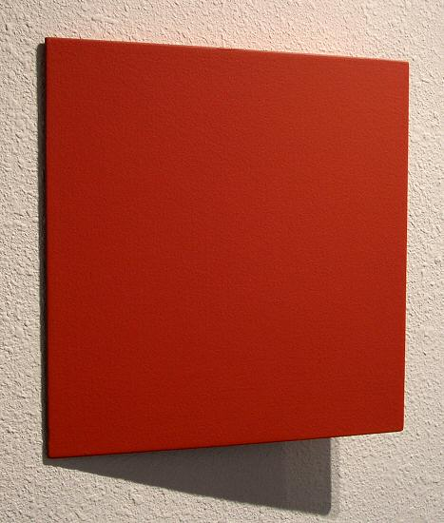
Tony Delap
The Jumping Ace, 2002
Acrylic on aluminum, wood
11 3/4 x 11 1/2 x 2 inches
TD0011
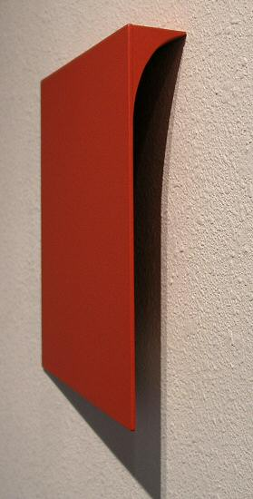
Tony Delap
The Jumping Ace, 2002
Acrylic on aluminum, wood
11 3/4 x 11 1/2 x 2 inches
TD0011
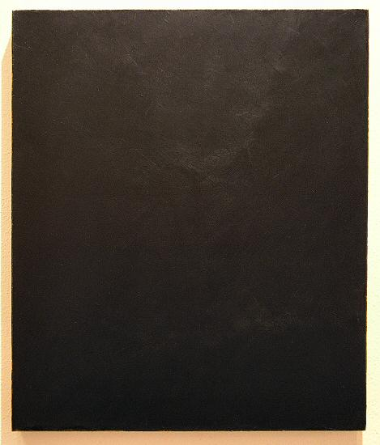
Clark Walding
Painting of Black, 2002
Oil, alkyd, wax, canvas
24 x 20 inches
CW009
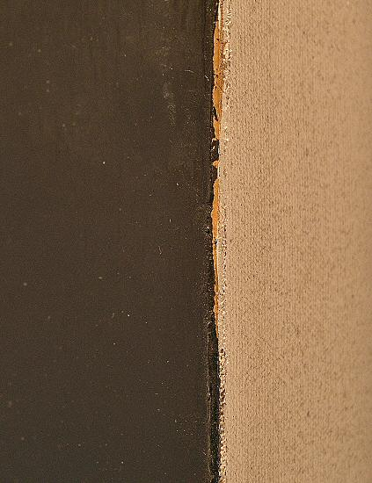
Clark Walding
Painting of Black, 2002
Oil, alkyd, wax, canvas
24 x 20 inches
CW009
(Detail)
GALLERY II:

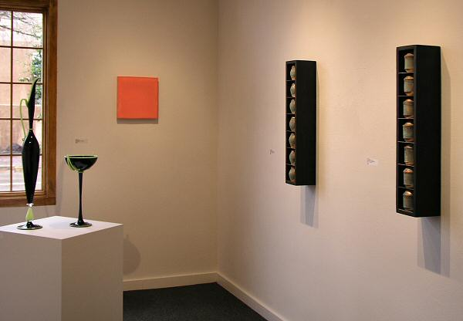

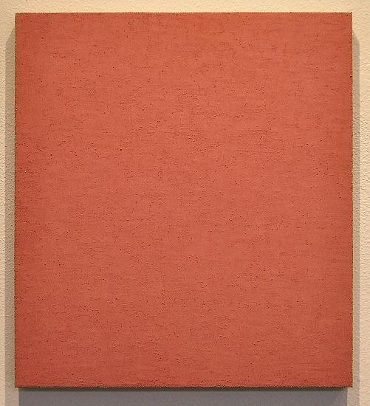
Phil Sims
Untitled Pink #494, 2003
Oil on linen on stretcher
20 x 18 inches
PS004
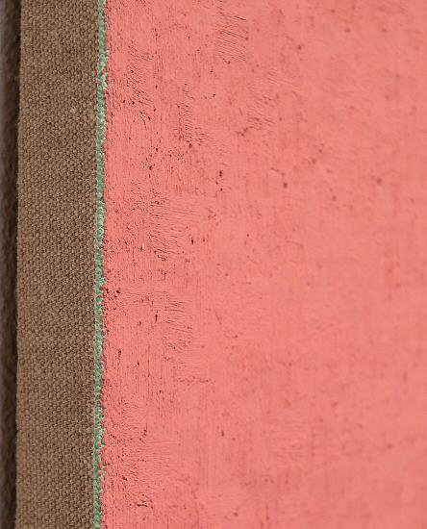
Phil Sims
Untitled Pink #494, 2003
Oil on linen on stretcher
20 x 18 inches
PS004
(Detail)
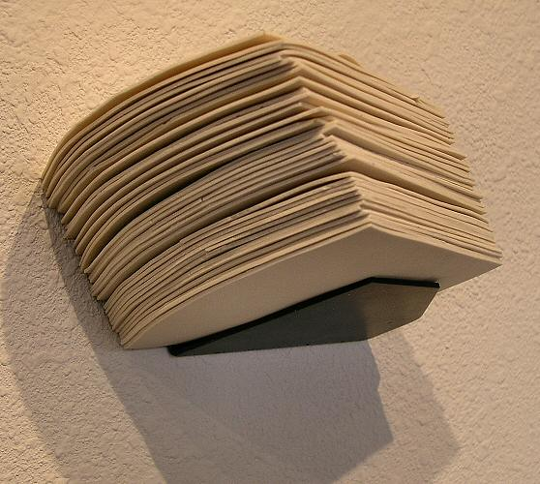
Susan York
Tilting Stack, 2004
Porcelain, steel
4 x 8 x 6 inches
SY009
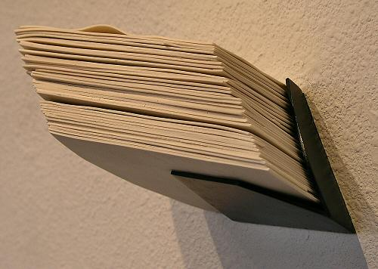
Susan York
Tilting Stack, 2004
Porcelain, steel
4 x 8 x 6 inches
SY009
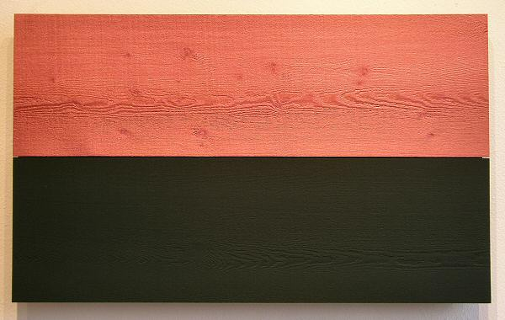
Winston Roeth
Cedar Landscape (Violet), 2003
Tempera on solid Cedar
22 x 36 inches
WR001
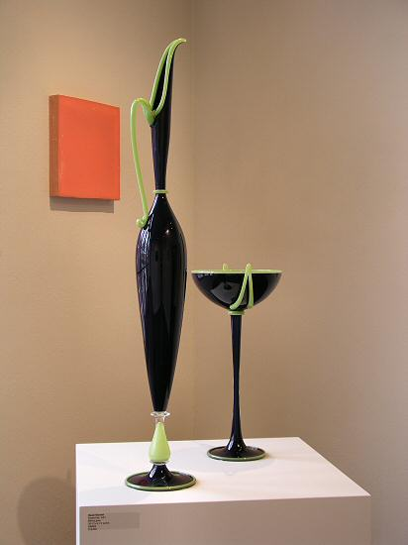
Dante Marioni
Purple Pair, 2001
Blown glass
38 1/2 x 6 1/2 inches
DM004
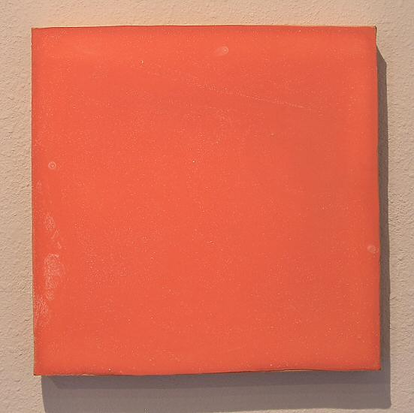
Mark Cole
Untitled, 2003
Polyurethane plastic with pigment
14 x 14 inches
MC0022
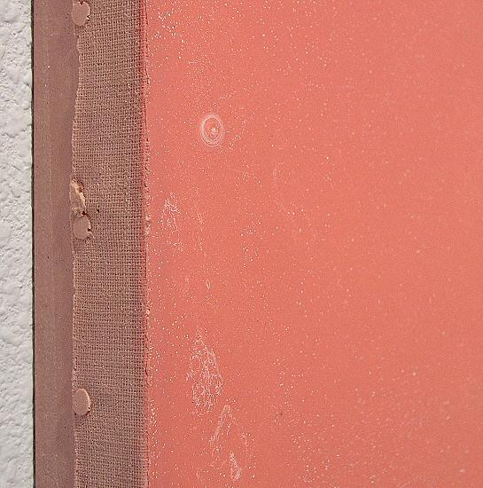
Mark Cole
Untitled, 2003
Polyurethane plastic with pigment
14 x 14 inches
MC0022
(Detail)
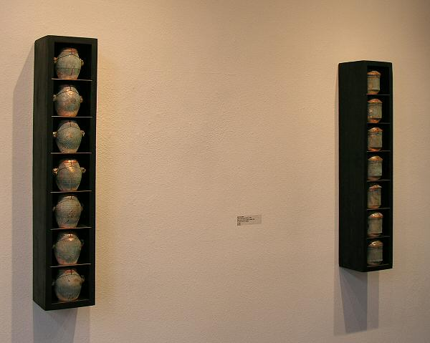
Anne Cooper
Urna i and Urna ii
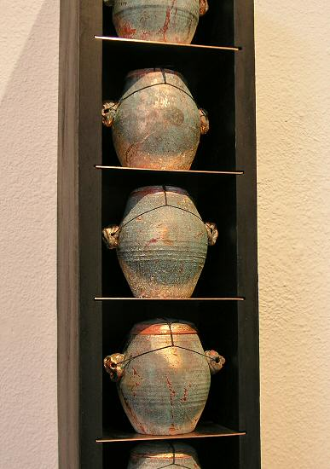
Anne Cooper
Urna i (red bowl series), 2004
Pine, gesso, clay, copper, copper leaf
31 1/4 x 6 x 5 3/4 inches
AC005
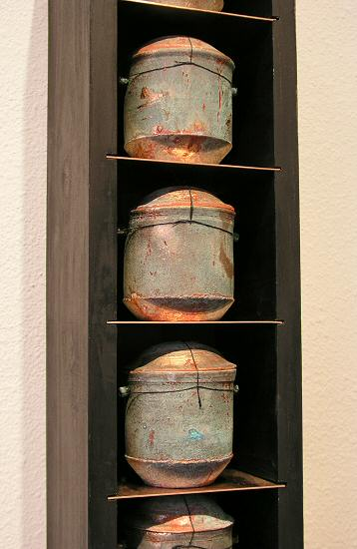
Anne Cooper
Urna i i(red bowl series), 2004
Pine, gesso, clay, copper, copper leaf
31 1/4 x 6 x 5 3/4 inches
AC006
© 2005, Charlotte Jackson Fine Art
All Rights Reserved

Charlotte Jackson Fine Art

200 West Marcy Street, Suite 101

Santa Fe, New Mexico 87501

Phone: 505.989.8688
Fax: 505.989.9898

www.charlottejackson.com

Photography and CD production – William Metcalf

