CHARLOTTE JACKSON FINE ART
PRESENTS:

MADE IN MIAMI:
Elliot Norquist and Eric Tillinghast

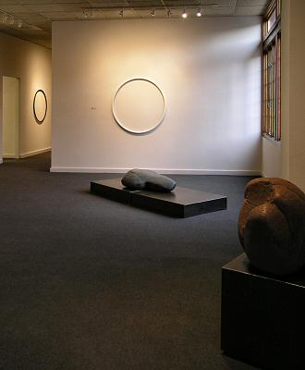

April 8 - April 30, 2005
Made in Miami may conjure up images of Latino rock bands or tourists’ t-shirts, but the Miami we’re concerned with here is in the far northern reaches of New Mexico. It consists mainly of a post office in a trailer, and P.O. Box addresses there tend to run in the single digits. What it lacks in urban buzz, this Miami more than makes up for in ravishing beauty. Located at the intersection between dramatic mountain landscapes and the stark sweep of the eastern plains, its profound quiet and strong sense of place make it an ideal setting for an artist’s work.
Through a coincidence of personal circumstances, Elliot Norquist and Eric Tillinghast have used the same studio in Miami to produce work for Made in Miami, the upcoming two-person exhibition at Charlotte Jackson Fine Art. The two sculptors first met in the mid-nineties, when Norquist, then on the faculty at College of Santa Fe, was assigned to mentor Tillinghast as he began to develop work that combined steel and water. Norquist had produced steel/water pieces in the 70s; the two artists also shared a minimalist aesthetic and a penchant for turning out meticulous work that exploited the clean lines and surfaces of steel.
In the intervening years, Norquist has concentrated on public and private commissions and site-specific sculptural installations; Tillinghast has continued his work combining water and steel, and in 2003 was chosen for a prestigious residency at Kohler in Wisconsin. This winter the two began collaborating on two-person shows, and Norquist’s Miami studio was chosen as a base of operations for producing the work.
Both artists have long been concerned with the elemental, ranging from referencing or even altering existing landscape, to examining the properties of water, to playing archetypal shapes and patterns off against the surface qualities of materials.
In Made in Miami, Elliot Norquist exhibits a series of large steel and stone floor sculptures that form a striking contrast between the clean, icy surface quality of steel boxes and the rough shapes of large river rocks. He describes them as a juxtaposition of organic and man-made shapes and notes that the pieces are derivative of the relationship of horizon, plane and surface in the Miami landscape. Most of the stones come from the Chama River. Norquist laughingly admits that he’s a rock fanatic and that these large stones have been included in several studio moves. His understanding of and affinity for these materials is made obvious by the “rightness” of the way in which they are combined in this series.
Eric Tillinghast’s delicate steel wall sculptures approach the elemental from another direction. The elemental nature of the circle is one of the most difficult subjects in art. Tillinghast has responded to this challenge by sharply reducing the mass of that most massive of materials, steel, and by breaking the circle into segments with the use of color. Perfectly round, perfectly smooth ropes of steel are shaped into circles or ovals; in some pieces segments are painted in contrasting colors, allowing the viewer to experience both the unbroken flow of the circle and the discrete nature of its separate parts. Shadow is another important element in these pieces, literally underlining the curve. Also included in this body of work is a series of drawings that command the viewer’s attention with their simplicity and elegance.
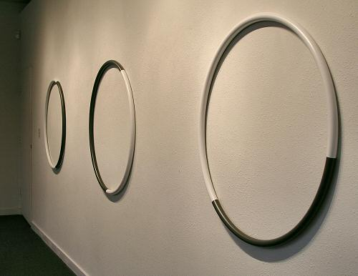

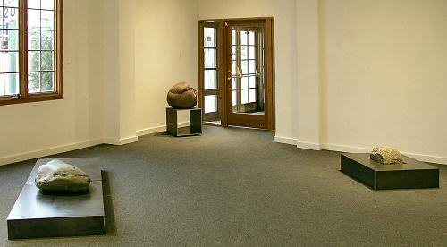
MAIN GALLERY:
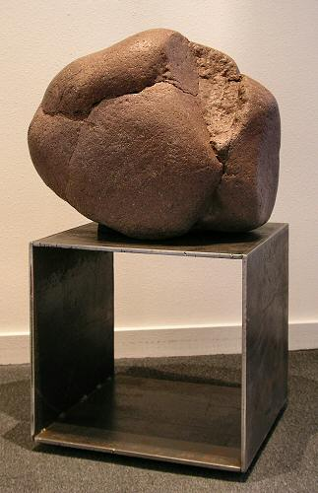
Elliot Norquist
Comparison of Shapes, September 2005
Steel and stone
18 x 18 x 38 inches
EN008
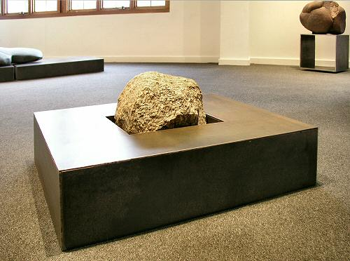
Elliot Norquist
Bench Mark, March 2005
Steel and stone
36 x 30 x 13 inches
EN0012
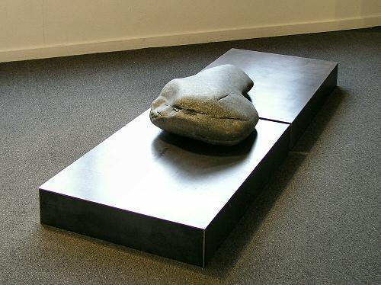
Elliot Norquist
Rock Bridge, September 2005
Steel and stone
84 x 30 x 24 inches
EN009
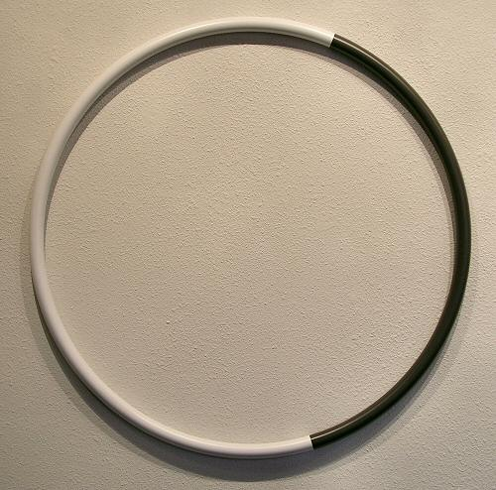
Eric Tillinghast
Ring #8, 2005
Painted steel
36 x 36 x 1 1/4 inches
ET0022
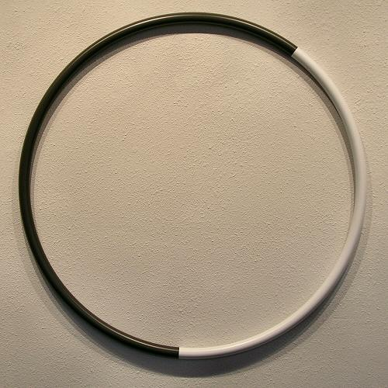
Eric Tillinghast
Ring #9, 2005
Painted steel
36 x 36 x 1 1/4 inches
ET0023

Eric Tillinghast
Ring #10, 2005
Painted steel
36 x 36 x 1 1/4 inches
ET0024

Eric Tillinghast
Ring #4, 2004
Painted steel
42 x 42 x 1 1/4 inches
ET0019
HALLWAY:
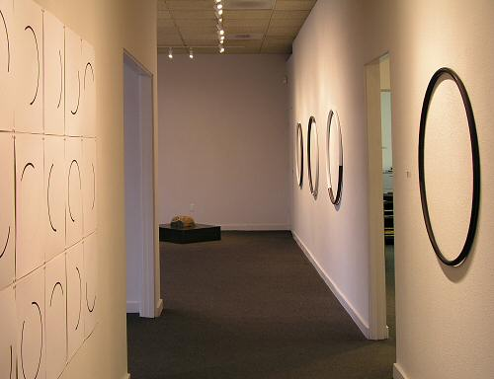
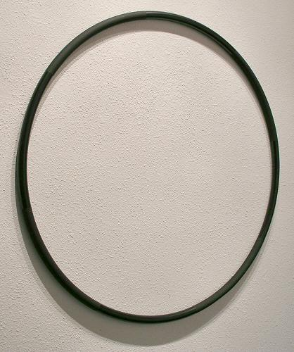
Eric Tillinghast
Ring #5, 2005
Painted steel
36 x 36 x 1 inches
ET0020
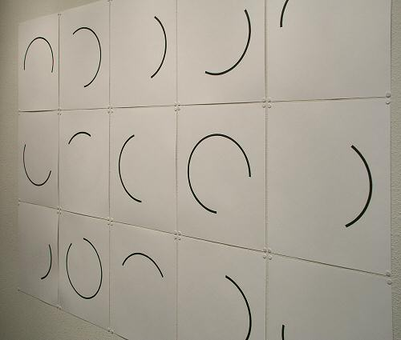
Eric Tillinghast
Section Drawings, 2004
Ink, graphite on paper
51 1/2 x 69 1/2 inches
ET0025
GALLERY II:
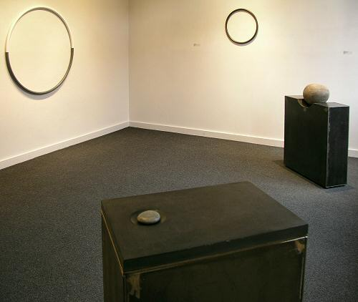
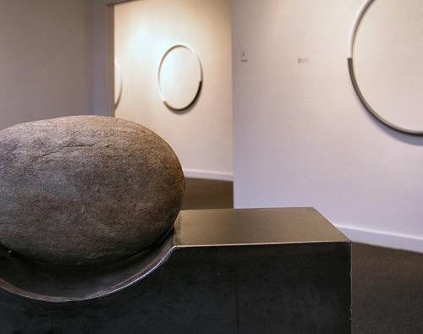
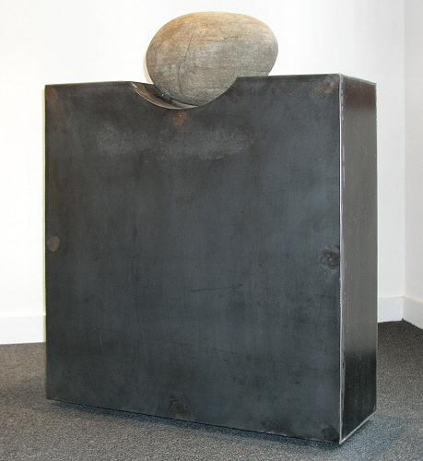
Elliot Norquist
Stone Notch, March 2005
Steel and stone
30 x 8 1/2 x 36 inches
EN0013
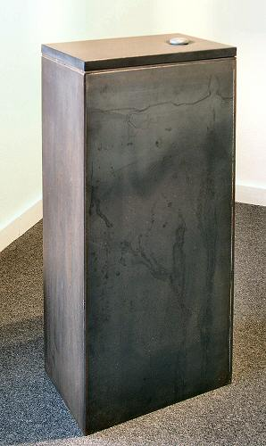
Elliot Norquist
Large Piece for a Small Stone, September 2005
Painted steel and stone
18 x 12 x 38 inches
EN0011
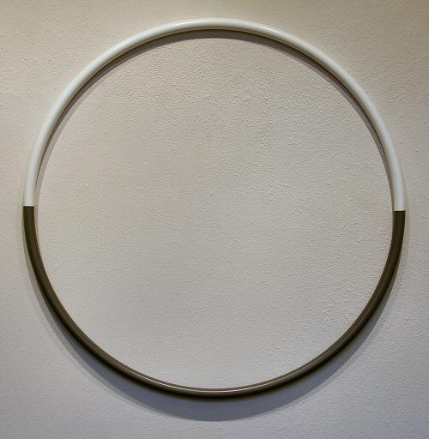
Eric Tillinghast
Ring #6, 2005
Painted steel
42 x 42 x 1 1/4 inches
ET0021
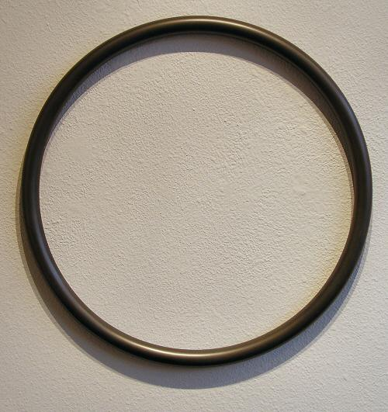
Eric Tillinghast
Ring #7, 2004
Painted steel
19 x 19 x 1 inches
ET0017
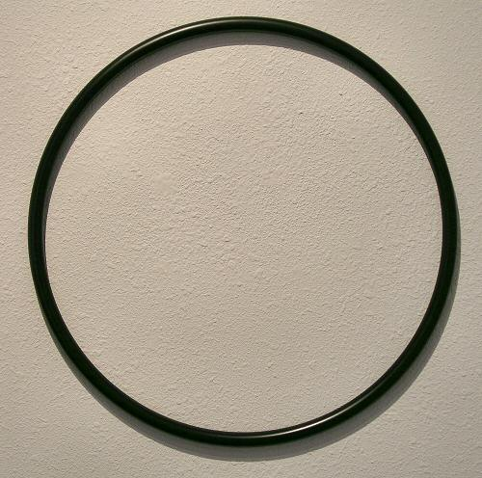
Eric Tillinghast
Ring #3, 2004
Painted steel
20 x 20 x 3/4 inches
ET0018

 | ELLIOT NORQUIST  ERIC TILLINGHAST
Miami is a tiny ranching community at the far northern edge of New Mexico. The lone structure in "town" is the post office, housed in a trailer. The population consists of ranchers working huge spreads (hundreds of thousands of acres), one artist (Elliot Norquist), one teacher (his wife) and their 12-year-old son. The Norquists live on a 60-acre former dairy farm set exactly at the intersection of the mountains and the eastern plains. When he looks out from his studio, Elliot sees the horizon some 80-90 miles away, and nothing man-made in between. Many artists would miss the bright lights and collegial stimulation of the city, but for Elliot Norquist, this setting provides the ideal inspiration for his work. Not surprisingly, that work is minimalist in character and reflects the pure beauty of the uncluttered landscape.
Norquist's love of wide-open spaces began early in life. He grew up in rural Kansas and developed an early love of "looking out and seeing all that sky." His father was a sailor, and family vacations were sailing trips on large bodies of water such as Lake Michigan or even the ocean. Elliot was soon enthralled by the feeling of openness, of "being out there," of the elemental pull of the landscape and horizon. That fascination grew into a lifelong interest in the outdoors. Climbing, mountaineering, exploring and skiing have all claimed a large place in his life. At present he is head instructor for cross-country Nordic skiing at the Angel Fire resort, and he is also fond of scaling the 1500-foot rise directly behind his house. He says, "I'm out in the landscape all the time."
Elliot credits his thorough knowledge of the outdoors with helping him develop the sense of space and proportion that is so important in his work. An early interest in Asian art and his later discovery of the work of Agnes Martin were both influences in this particular aspect of making sculpture. He notes that in Asian painting, space is often confined and defined by objects. In his present work, Norquist prefers not to use objects, so space must be defined using other methods. The search for those methods is part of the fun of making art. In one group of wall sculptures in Miami Work, the upcoming exhibition at Charlotte Jackson Fine Art, the square front surface of each piece will be divided in two, the top half a slightly different texture from the bottom half. There is no line separating the two halves; they simply meet. So while there is a subtle suggestion of horizon, and by extension of landscape, the piece expresses the essence of these elements rather than trying to represent them in any literal or symbolic way.
This willingness to wrestle with elemental artistic problems that are as big and rugged as the great outdoors, while at the same time producing sculpture that is as fine and delicate as a spider web, is essential to Elliot Norquist's work. It is hardly surprising that the original idea for the pieces in Miami Work came to him while he was making sheet metal valentines.

Looking at Eric Tillinghast’s clean, reductive sculptures, one would not guess that his early interest in art, in his teens, focused on realistic, figurative drawings. The precision and carefully developed detail of these early works has carried through in his present work, however, in the form of meticulous execution and careful attention to every aspect of design.
At the age of sixteen Tillinghast attended Virginska Konst Skolan, an international art school in Orebro, Sweden. After a year’s study he returned to the United States with a strong determination to pursue his career as an artist. His drawings soon garnered him gallery representation in California, and his work began to move increasingly toward a minimalist sensibility. He gradually removed all figurative perspective from his work, eventually leaving only stark, active lines of the color of steel. Moving into working with steel seemed a natural progression. Once engaged with this new material, he felt that he had found his form.
Working with steel allowed him to explore his ideas about line and space more succinctly, and he began making box-like constructions of varying sizes and finishes and engraving them with geometrically ordered lines and patterns. These works first appeared as singular objects, but soon he began to create pieces with multiple components, often arranged in a grid. His first major installation piece was a large grid that sat on the floor. Viewers could walk into the grid; and as they engaged with the piece, shapes that appeared uniform from a distance emerged as subtly different. From a distance the shapes in the grid appeared uniform, but as the viewer began to engage with the piece, walking into it and around the objects, it became clear that each of them was subtly different.
When asked what his use of grids meant to him, Tillinghast responded by saying, “I am interested in us as percievers, how the mind takes things apart and puts things back together and then gives us something to perceive.”
As Tillinghast’s work with steel began to evolve, cylindrical shapes appeared and he began to incorporate water into his pieces. His interest was no longer just with space and line, but also with light and liquid; steel cylinders and cubes housed this new element. A more recent installation piece took place in the bed of a river, where Tillinghast sank dark-finished steel cylinders into the earth until their lips were level with the ground, allowing the water of the river to fill and flow over them.
At the age of 30, Eric Tillinghast has already established himself as an accomplished artist with a clear direction to his work. In 2004 he received a prestigious residency at art/INDUSTRY in Kohler, Wisconsin. The elegance and precision of the brass and steel work he produced during his stay at Kohler demonstrates his maturity as an artist.
© 2005, Charlotte Jackson Fine Art
All Rights Reserved

Charlotte Jackson Fine Art

200 West Marcy Street, Suite 101

Santa Fe, New Mexico 87501

Phone: 505.989.8688
Fax: 505.989.9898

www.charlottejackson.com

Photography and CD production – William Metcalf

