CHARLOTTE JACKSON FINE ART
PRESENTS

William Metcalf
The Infinity Series
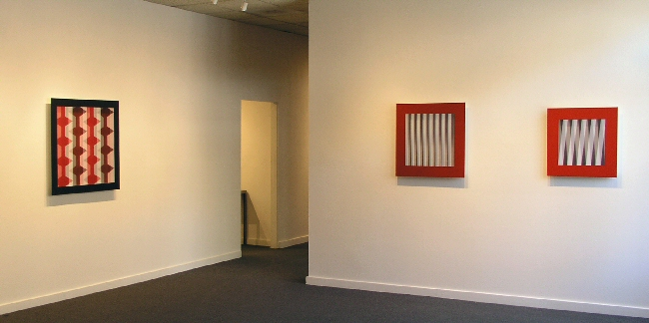
July 5th - July 31
July 5 - July 31, 2008
There is no first experience of a painting from William Metcalf’s Infinity Series—or rather that first impression is so quickly contradicted, or amended, by a second view, then a third, that it is impossible to pin down.
A piece seems to be painting, then sculpture, then something that is both or neither. One looks beyond a piece’s surface composition of shapes and colors, falls through them, and then wonders exactly where the surface of the piece actually is.
Constructed painstakingly of carefully machined aluminum or wood in a picture-box format, these pieces create a relationship between front and back planes by the use of a translucent piece of polyester fabric stretched over the front plane. In earlier work from this series, Metcalf painted or pierced the front panel, allowing forms and
shadows to interact with the blank plane behind. In these new works the interaction is enriched by adding painted compositions to the back panel as well. Simple patterns and colors become complex, deep, variable, elusive as the front and back planes communicate with each other and the light. Colors and patterns shift surprisingly, irresolvable, as the viewer moves.
The Infinity Series is the culmination of a lifetime of artistic investigation for Metcalf; a journey which he says follows the history of art. Classically trained in drawing and painting, Metcalf worked through many modes of expression, bumping up against the question of two-dimensionality in painting. His passion for flying and for building his own airplanes made a preoccupation with the perception of three-dimensional space natural for him.
Having worked with translucent polyester fabric in making airplanes, he began to explore its possibilities for painting. Polyester is like no other material, says Metcalf. Unlike opaque canvas or hard Plexiglas, polyester’s weave of microscopic transparent fibers makes it particularly soft and unreadable. In the works of the Infinity Series it provides the perfect medium for Metcalf’s study of light, space, volume, pattern, and perception.
In fact, as one spends more time with these pieces, one realizes that every element of them is perfectly suited to the whole effect. The materials balance with the precision of fabrication, the architecture of the pieces with the composition of forms and colors. The questions these works provoke and even the skill and history of Metcalf himself are served impeccably by the materials used.
With this exhibition we find a coherent and thoughtful body of work about movement through space, perception through time by an artist in the fullness of his powers. Here a mastery and perfect exploitation of materials have led to work which challenges the viewer to be patient, to allow their experience to go beyond first thoughts, letting it continue unfixed, mysterious, infinite.
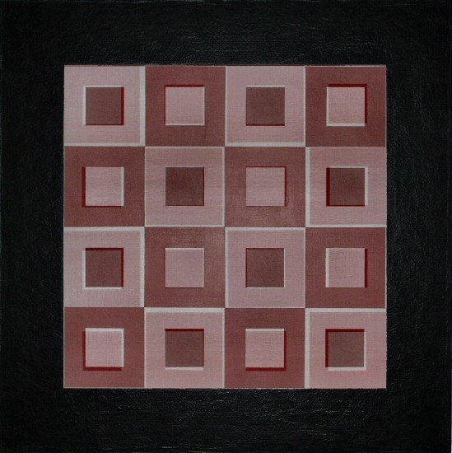
Infinity Series #37, 2008
28"x28"x2/38"
Acrylic, Polyester fabric, wood, DiBond 150WM
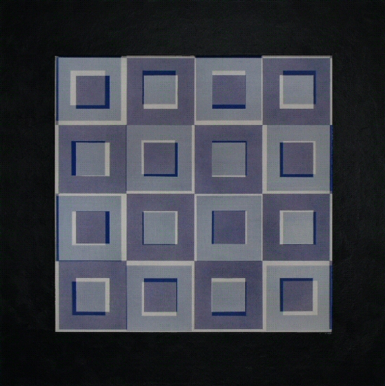
Infinity Series #36, 2008
28"x28"x2/38"
Acrylic, Polyester fabric, wood, DiBond 149WM
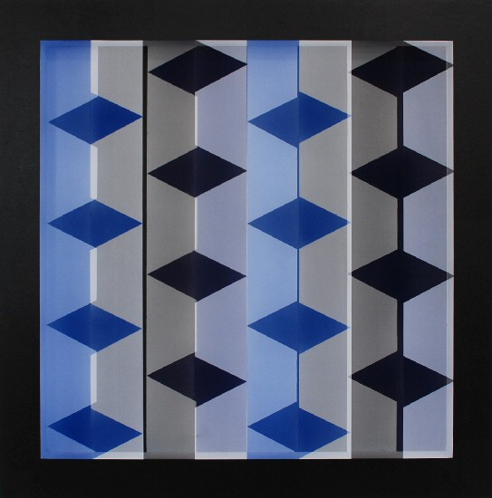
Infinity Series #38, 2008
36"x36"x2/38"
Acrylic, Polyester fabric, wood, DiBond 153WM
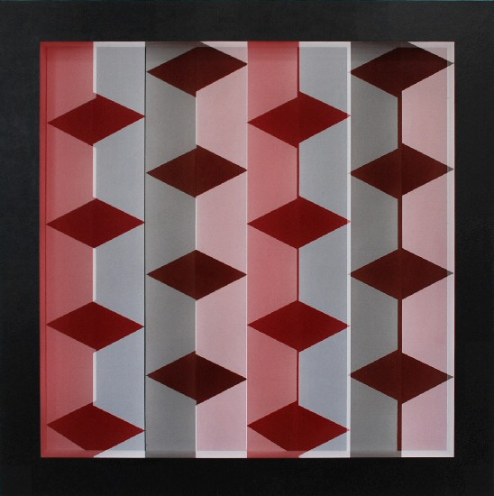
Infinity Series #39, 2008
36"x36"x2/36"
Acrylic, Polyester fabric, wood, DiBond 154WM
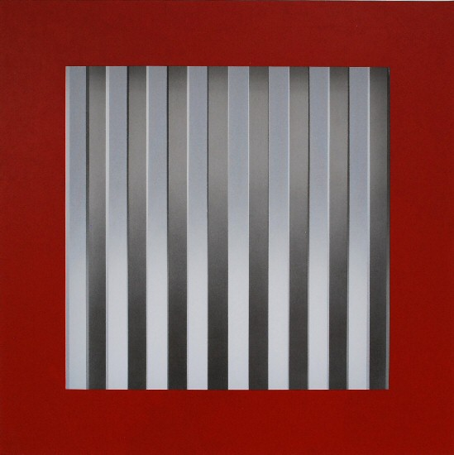
Infinity Series #44, 2008
28"x28"x2/38"
Acrylic, Polyester fabric, wood, DiBond 162WM
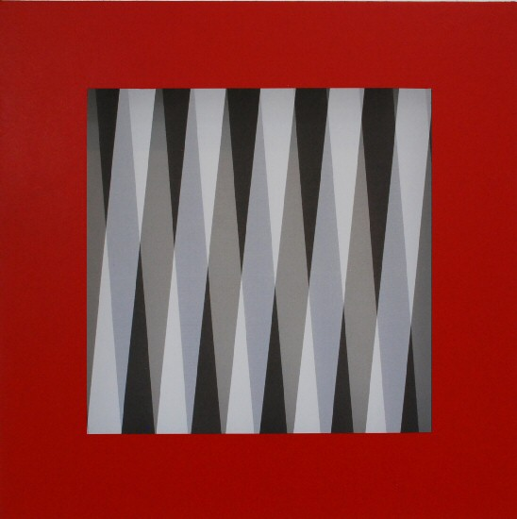
Infinity Series #47, 2008
24"x24"x2/38"
Acrylic, Polyester fabric, wood, DiBond 165WM
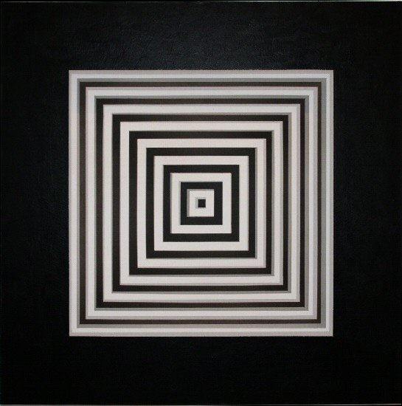
Infinity Series #48, 2008
24"x24"x2/38"
Acrylic, Polyester fabric, wood, DiBond 151WM
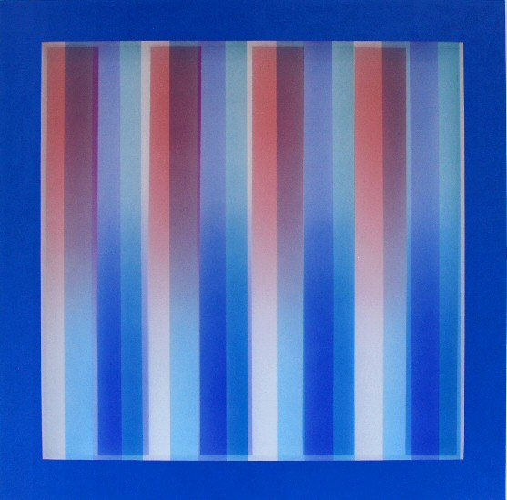
Infinity Series #42, 2008
36"x36"x2/38"
Acrylic, Polyester fabric, wood, DiBond 160WM
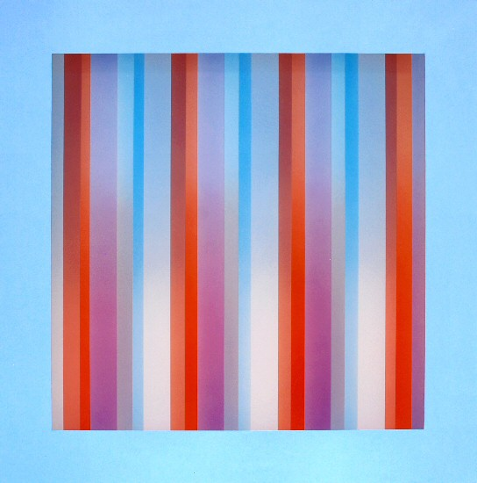
Infinity Series #43, 2008
36"x36"x2/38"
Acrylic, Polyester fabric, wood, DiBond 161WM
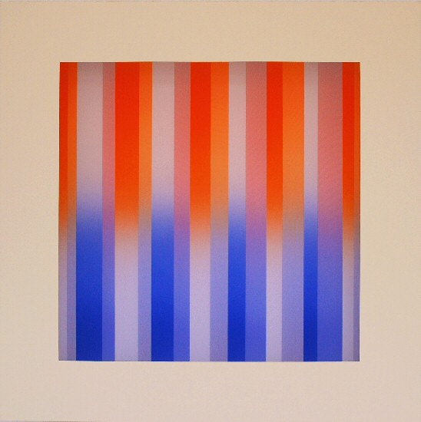
Infinity Series #46, 2008
28"x28"x2/38"
Acrylic, Polyester fabric, wood, DiBond 164WM
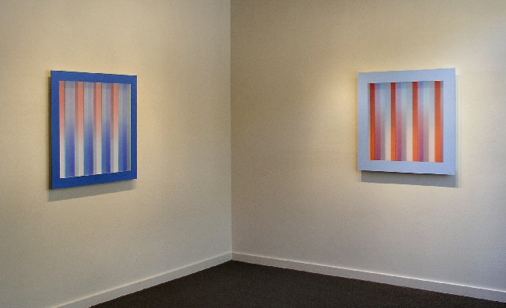
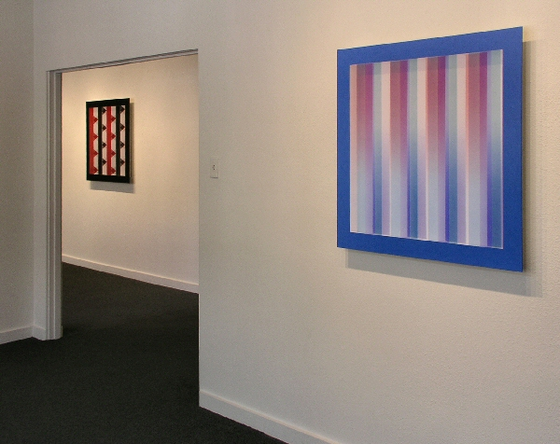
Born 1945
EDUCATION
A.A. Art, Orange Coast College, Costa Mesa, CA
B.A. Art, California State University at Fullerton
SELECTED SOLO EXHIBITIONS
2007 Galeria Kreisler, Madrid Spain
2005 Roy Lichtenstein, Chuck Close, William Metcalf, Trinity Gallery, Atlanta, GA
2005 Point of View, Charlotte Jackson Fine Art, NM
2002 Bending Space, Charlotte Jackson Fine Art, NM
2000 The Space Between, Charlotte Jackson Fine Art, Newport Beach, CA
1997 Charlotte Jackson Fine Art, Santa Fe, NM
1995 Charlotte Jackson Fine Art, Santa Fe, NM
1992 Wade Wilson Gallery, Chicago, IL
1989 Sena Galleries West, Santa Fe, NM
1988 Sena Galleries West, Santa Fe, NM
SELECTED GROUP EXHIBITIONS
2007 How the West is One, Museum of Fine Arts, Museum of New Mexico
2006 Biennial Southwest, Albuquerque Museum of Art & History, Albuquerque, NM
2006 Art & Architecture Tour - In conjunction with the Orange County Museum of Art, Laguna Beach, CA
2006 Site Unseen, Site Santa Fe, Santa Fe, New Mexico
2006 Inside Eight, Center for Contemporary Art, Santa Fe, NM
2005 Back to Basics, Charlotte Jackson Fine Art, Santa Fe, NM
2004 Trinity Gallery, Atlanta Ga.
2003 I-25 Sangro De Cristo Arts & Conference Center, Pueblo CO
2003 THE SHOW: A Southwest Juried Exhibition. Museum of Fine Arts, Museum of New Mexico
2002 LOOKING BACK, Museum of Fine Arts, Museum of New Mexico
2001 Site Unseen, Site Santa Fe, Santa Fe, New Mexico
2000 TERM LIMITS, Museum of Fine Arts, Museum of New Mexico
2000 Fair and Square, The Governor’s Gallery, Santa Fe, NM
Galerie Rotloff, Karlsruhe, Germany
Charlotte Jackson Fine Art, Santa Fe, NM
Robert McClain Gallery, Houston, TX
Galeria Joan Prats, New York, NY
Gallery K, Washington D.C.
Allene Lapides Gallery, Santa Fe, NM
Taos Connections Gallery, Denver, CO
Beverly Gordon Fine Art, Dallas, TX
New Gallery, Houston, TX
Tavelli Gallery, Aspen, CO

SELECTED PUBLIC AND PRIVATE COLLECTIONS
Albright Knox Art Gallery, Buffalo, NY
Collection Panza di Biumo, Varese, Italia
The Museum of Fine Arts, Santa Fe, NM
IBM, Dallas, TX
United Bank, Dallas, TX
Allyen & Bacon Publishing, Boston, MA
Coppens Records, Amsterdam, Netherlands
Atlantic Records, Los Angeles, CA
DMB&B, Los Angeles, CA
John Wolcott Associates, Culver City, CA
Mason Hirst, Reston, VA
The Murrel Company, Newport Beach, CA

BIBLOGRAPHY
Of Art and Airplanes: A Conversation with William Metcalf, Museum of New Mexico (video interview)
Joseph Traugott, The Art of New Mexico - How The West is One, The Museum of New Mexico, 2007
Sarah S. King, Santa Fe Summer Preview, Art In America, June/July, 2005
Arden Reed, William Metcalf, Bending Space, THE Magazine, September, 2002
New American Paintings, 2003, Issue #48 juried exhibition
New American Paintings, 2001, Issue #36 juried exhibition
Tobin, Robert, “William Metcalf - Return to Color,” THE Magazine, 10/95.
King, Leslie, “Fabric Bridges World Between Painting, Sculpture - Metcalf’s Art Explores New Regions,” Pasatiempo, The New Mexican, 8/25/95.
Adlmann, Jan Ernst, “Going Mainstream,” Art In America, 01/95.
Clemmer, David, “Short Reviews,” The Magazine, 10/94.
Armitage, Diane, “Artist’s Rebirth Energetic, Alive In Fresh Exhibit,” The Albuquerque Journal, 9/22/94.
Bensley, Lis, “Reaching Into Unchartered Spaces,” Pasatiempo, The New Mexican, 9/16/94.
Balsamo, Dean, “The Space Between, new constructions,” Pasatiempo, The New Mexican, 9/94.
Balsamo, Dean, “Sculpture, William Metcalf.” Pasatiempo, The New Mexican, 10/92.
McCracken, David, Chicago Tribune, 04/91.

© 2008

Charlotte Jackson Fine Art, Inc.

200 West Marcy Street, Suite 101, Santa Fe, New Mexico 87501

Telephone: 505.989.8688 Fax: 505.989.9898
cjfa@charlottejackson.com - www.charlottejackson.com

