CHARLOTTE JACKSON FINE ART
PRESENTS

MARCH MADNESS!
A Group Show
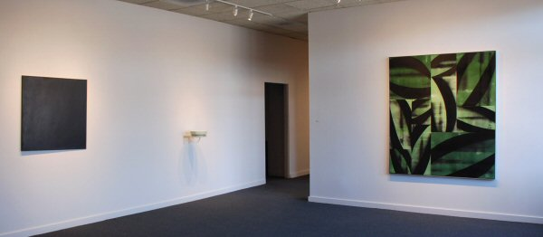
March 2007
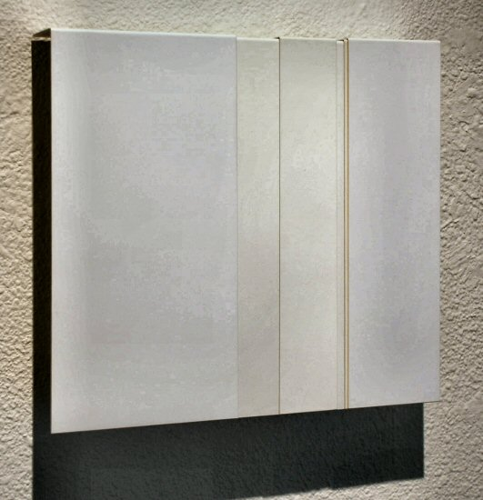
ERIC TILLINGHAST
Hanging Panels #17 (White), 2007
Painted steel, 10” x 11 ¾” x 2”, ET0039
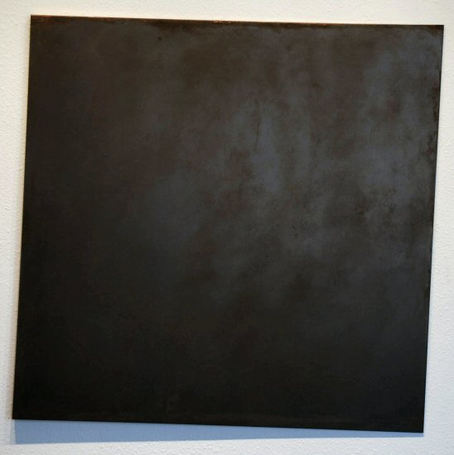
CONSTANCE DEJONG
Square XXI, 1992
Copper, wood, 36 x 36 x 1, CD006
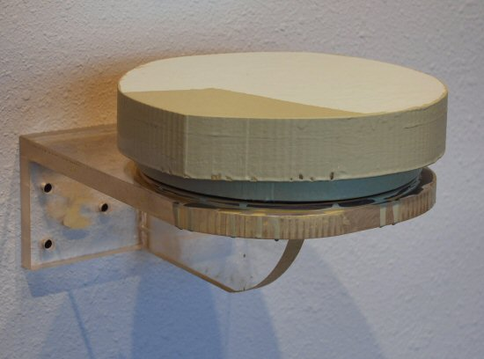
JOHN BEECH
Rotating Painting #178, 2005
Enamel, Plexiglass, rotating hardware, JB0063
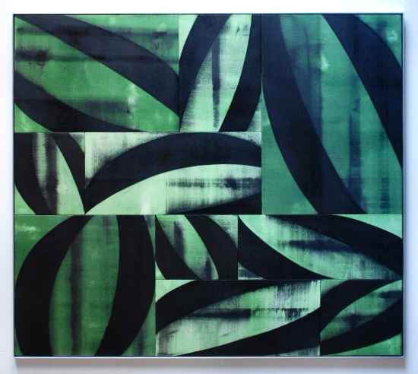
CHARLES ARNOLDI
Wilder (07.17), 2007
Acrylic on canvas, 82 ¾” x 66 ¾”, CA0021
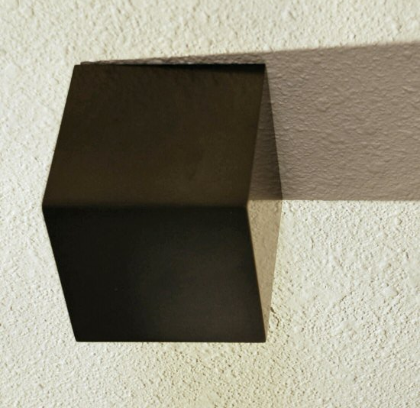
SUSAN YORK
Untitled (graphite cube), 2006
Graphite, 4 ¼” x 4 ¼” x 4 ¼, SY0025
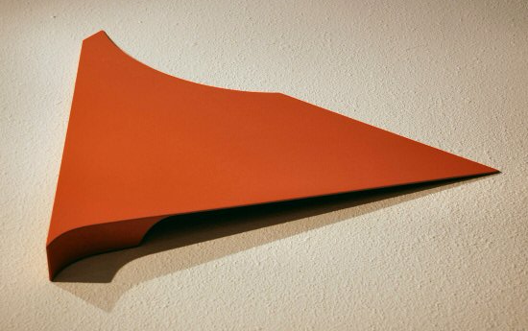
TONY DELAP
Albaka, 2002
Acrylic on Aluminum, Wood, 26” x 24” x 2 3/8”, TD0015
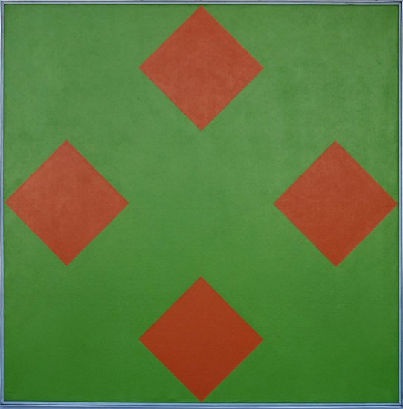
FREDERICK HAMMERSLEY
A Part, #5, 1966
Oil on linen, 40” x 40”, FH189
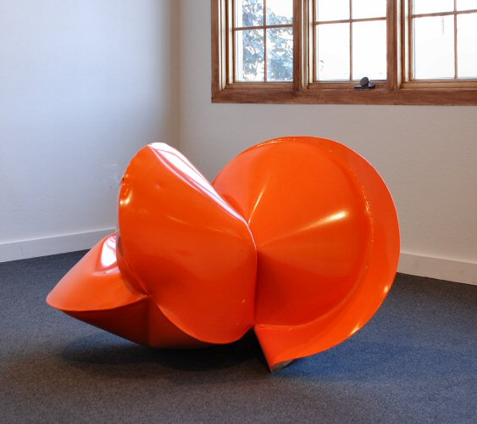
JEREMY THOMAS
NMDOT Orange, 1/2007
Forged mild steel and powder coat, 26 ½” x 44” x 26”, JT0081
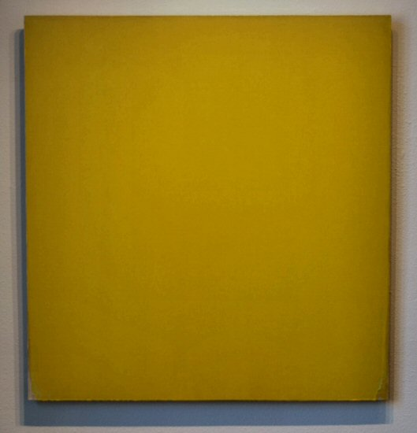
JOSEPH MARIONI
Yellow Painting, 2003
Acrylic on Linen on Stretcher. 36” x 34”, JMAR009
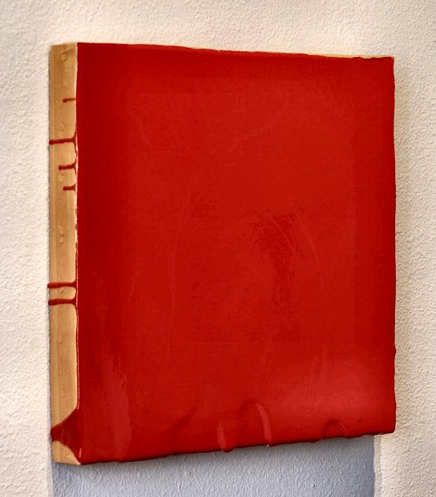
MARK COLE
Untitled, 2005
Polyurethane plastic with pigment, 14” x 14”, MC0024

© 2007

Charlotte Jackson Fine Art, Inc.

200 West Marcy Street, Suite 101, Santa Fe, New Mexico 87501
Telephone: 505.989.8688 Fax: 505.989.9898
cjfa@charlottejackson.com - www.charlottejackson.com

