CHARLOTTE JACKSON FINE ART
PRESENTS:

JEREMY THOMAS: Implements
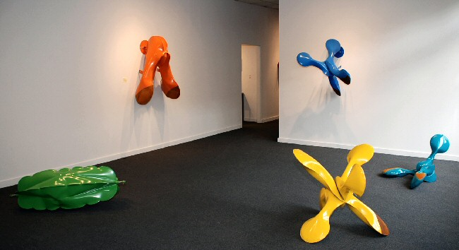
August 8 - September 1, 2008
Spend some time with any number of sculptures by Jeremy Thomas and one begins to see everything in them. The pieces lend themselves to adjectives, to similes, to theoretical leaps. Solid as they are they still seem to rest at some ineffable point between chance and intention, lighthearted and serious, feminine and masculine. With their brilliant colors from a child’s paint box they look like toys scattered across the floor. With their smooth soft surfaces, dimples, and surprising curves they are highly erotic.
Thomas’ work contains paradox. His sculptures are made of steel, cut, welded, and folded into geometrical shapes. The metal is heated to well over 2,000 degrees at which point the metal becomes as supple and elastic as clay. Thomas then inflates the forms with air (here chance comes into action as metal and air interact). The final pieces are powder-coated in slick colors from industrial tractor, lawn-mower, and implement manufacturers that contrast with the surface of suede-like rust patina that Thomas adds to one or more side of each piece. Many of the new pieces, using implement colors, hang on the wall and have taken on a more functional form which again teases at the idea of form, object, utility, and metaphor. The end results are seductive works that call out to be touched.
Although there are many ideas and theories that can be explored in discussing these objects: alchemy and the elements (these are mixtures of all four—earth, air, fire, and water), their play on desire as non-gender-specific, the ironic use of industrial tractor colors on sensual organic forms, Thomas believes that ideas and theories come after the fact. As he says, “Art making is a happy medium between play and reason.”
His own background perhaps adds to the balance of simple complexity found in his work. Thomas has been making art since he was a kid, in a multiplicity of mediums including printmaking, drawing, and painting. The story of how he came to sculpture is just as rich as his works—after a year at the College of Santa Fe studying painting he was moving out of the dorms and left his box of paints and brushes out by his car. They were stolen. The next semester he took a sculpture class and never looked back. As filled to the brim with art history and theory as any modern artist, it is life rather than theory Thomas says, that ultimately influences his work.
Life—which takes us back to how these pieces so simply and easily lead the viewer toward wild and conflicting responses. This exhibition provides the opportunity to walk among these sculptures that delicately balance that happy confluence of “play and reason.”
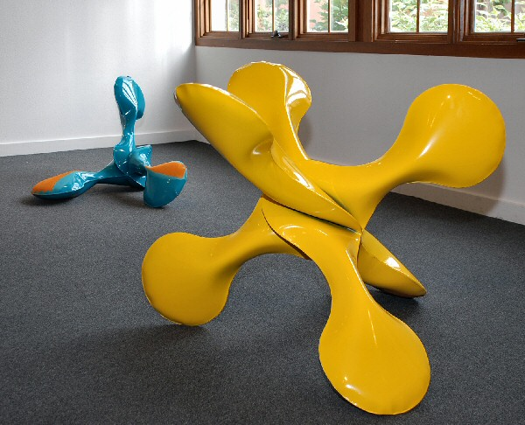
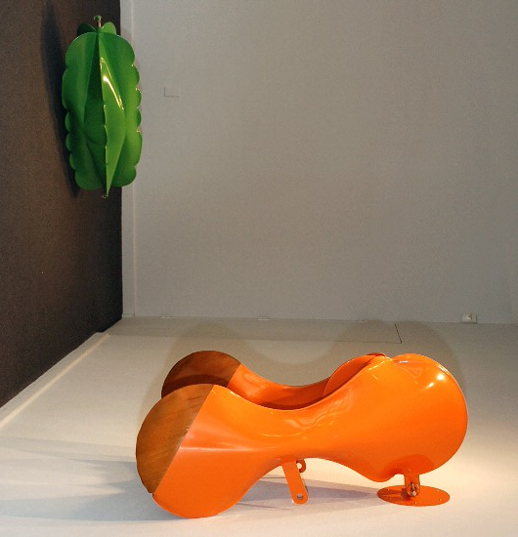
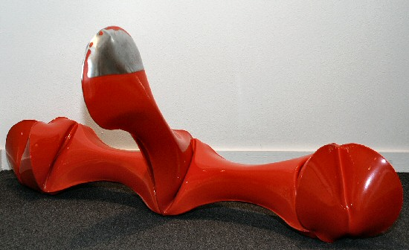
Sunflower Red, 2008
forged mild steel and powder coat
23 1/2 x 53 x 11 inches JT151
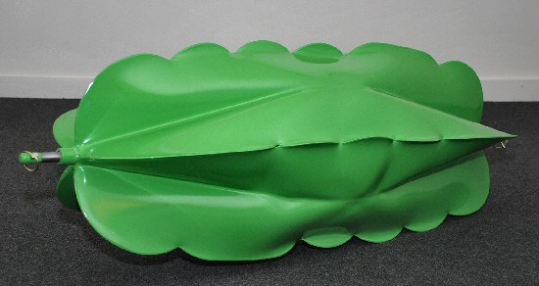
Aitchison Green, 2008
forged mild steel and powder coat
18 x 55 x 18 inches JT149
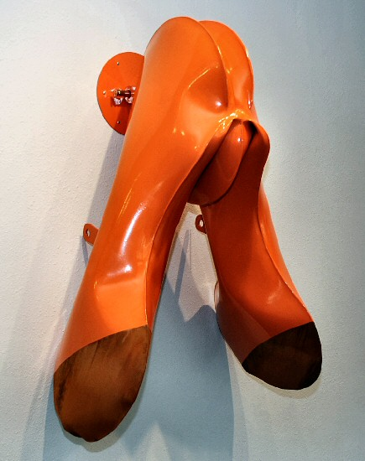
Crust Buster Orange, 2008
forged mild steel and powder coat
46 x 29 x 18 1/2 inches JT145
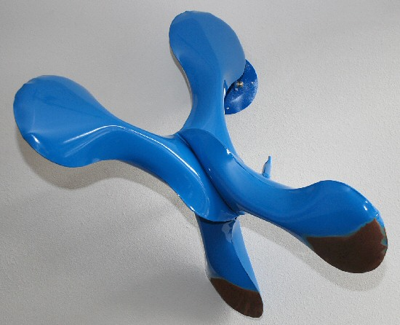
Kinze Blue, 2008
forged mild steel and powder coat
38 x 40 x 27 inches JT147
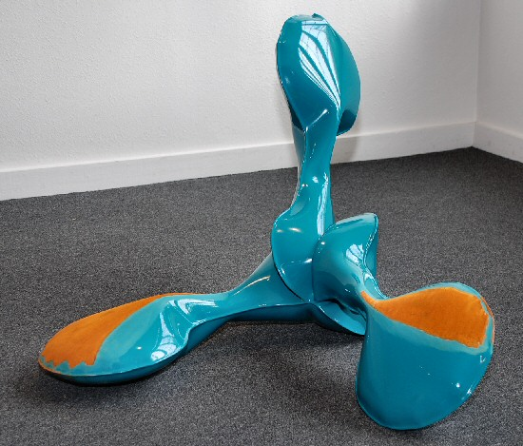
Marliss Blue, 2008
forged mild steel and powder coat
24 x 36 1/2 x 33 1/2 inches JT148
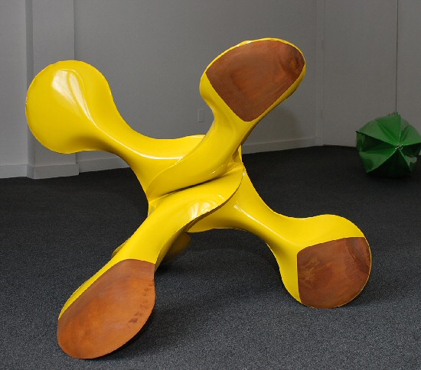
Aitchison Yellow, 2008
forged mild steel and powder coat
29 1/2 x 31 x 34 inches JT150
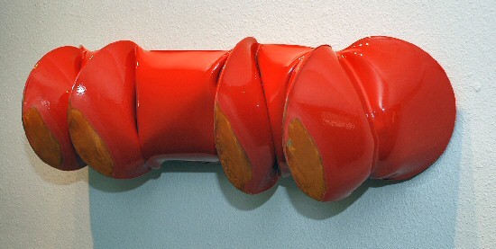
Brillion Red, 2008
forged mild steel and powder coat
11 x 36 1/2 x 11 1/2 inches JT152

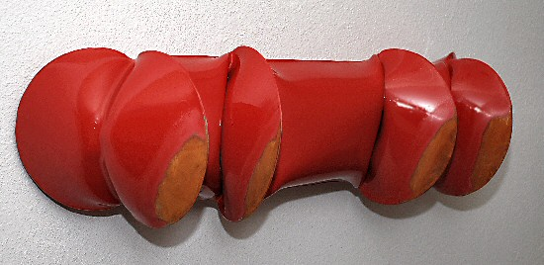
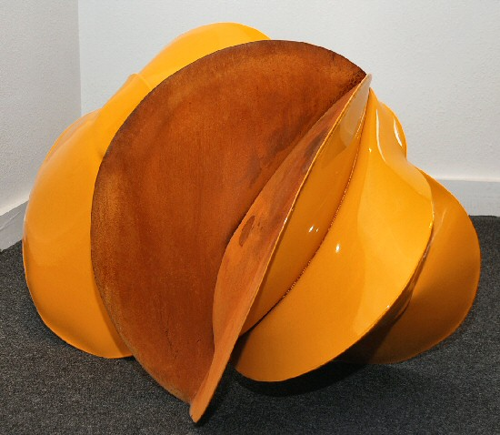
Kuhn Yellow, 2008
forged mild steel and powder coat
21 1/2 x 32 1/2 x 21 inches JT153
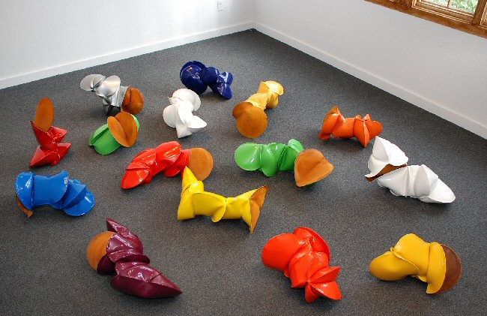
Various Titles, forged mild steel and powder coat, dimensions vary
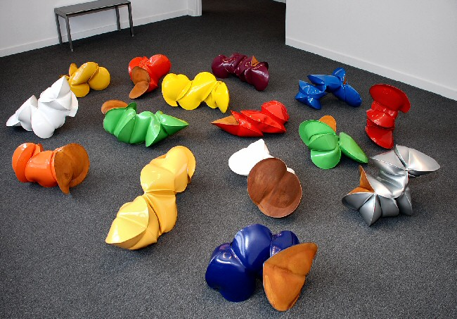
At the Charlotte Jackson Project Space:

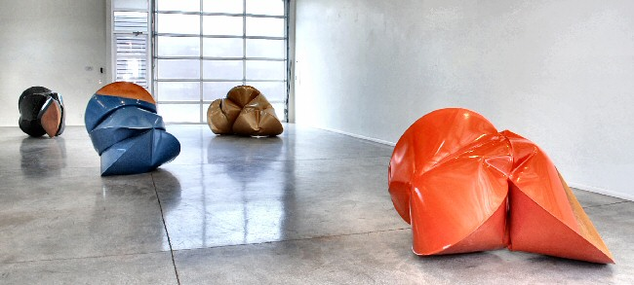

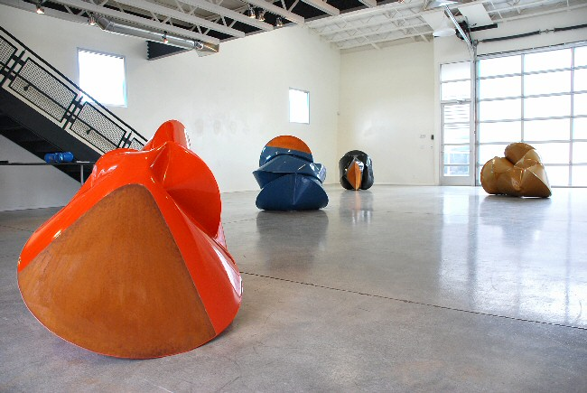

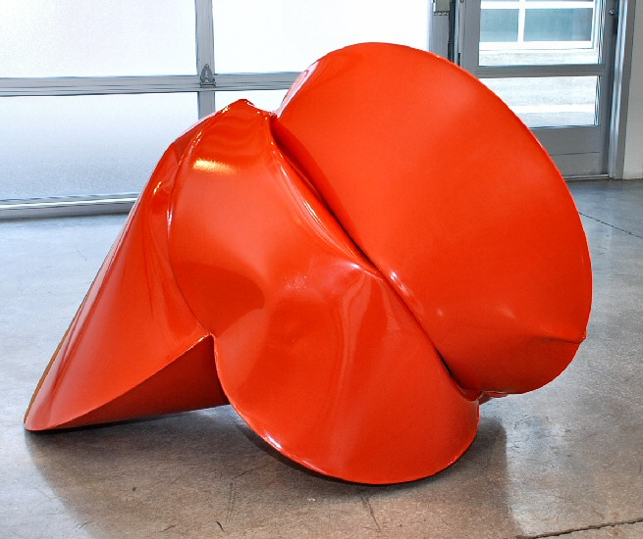
Tye Orange, 2008
forged mild steel and powder coat
38 x 59 x 44 inches JT160
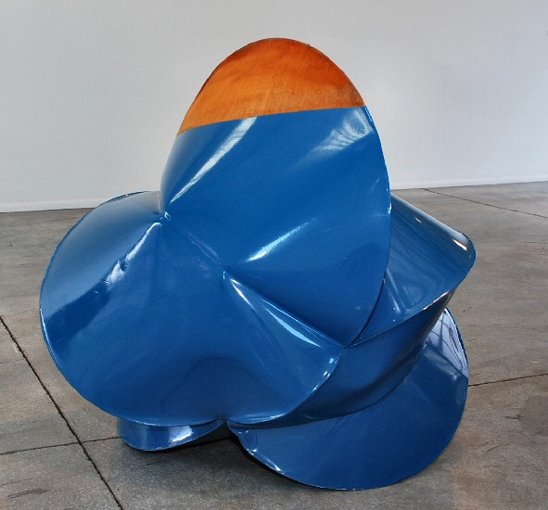
Suk-up Blue, 2008
forged mild steel and powder coat
40 x 71 x 52 inches JT162
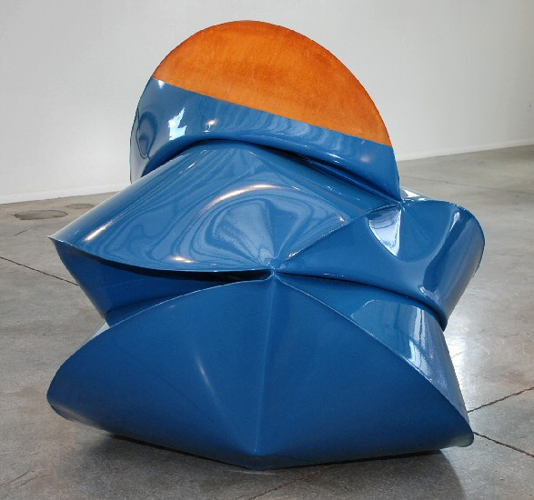
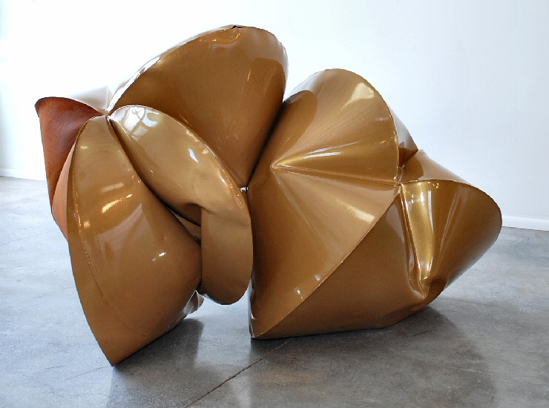
International Gold, 2008
forged mild steel and powder coat
70 x 43 x 42 JT165
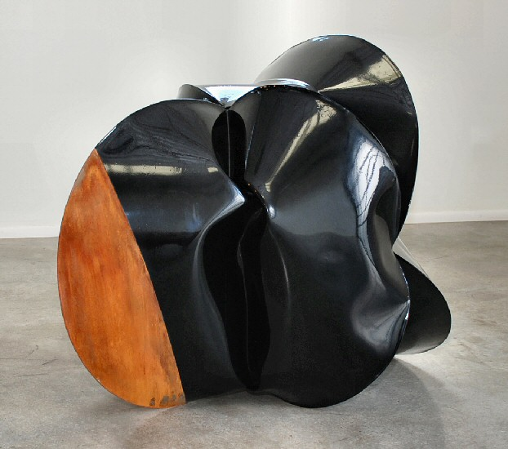
Yetter Black, 2008
forged mild steel and powder coat
36 x 47 x 41 1/2 inches JT161
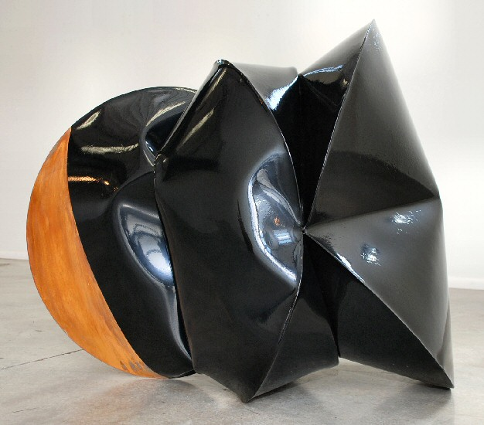
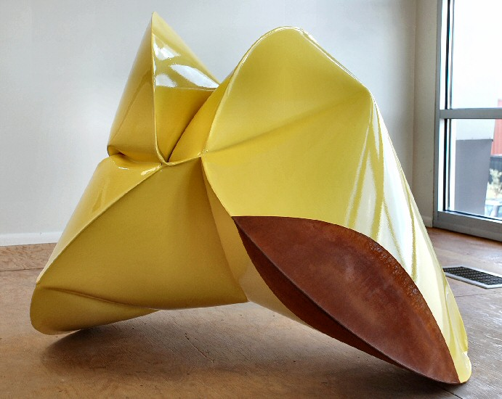
Ezeeon Yellow, 2008
forged mild steel and powder coat
40 x 47 x 40 inches JT159
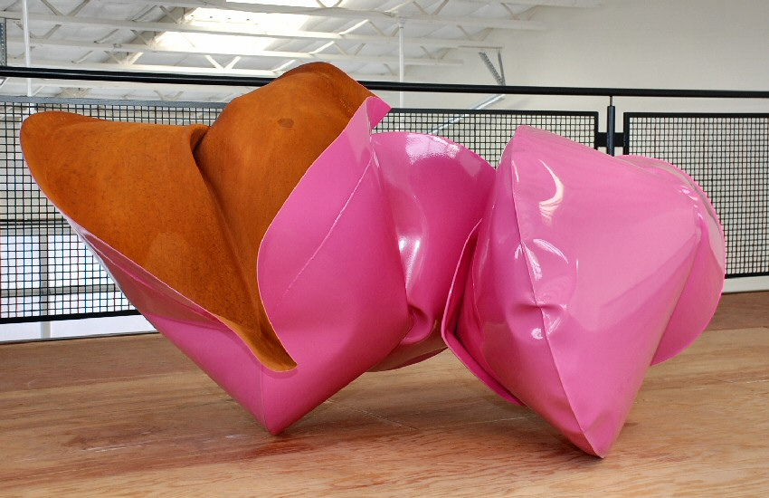
Stieger Panther Pink, 2008
forged mild steel and powder coat
40 x 71 x 52 inches JT163

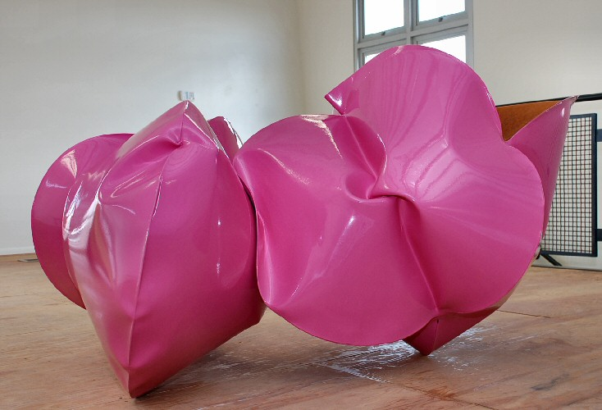
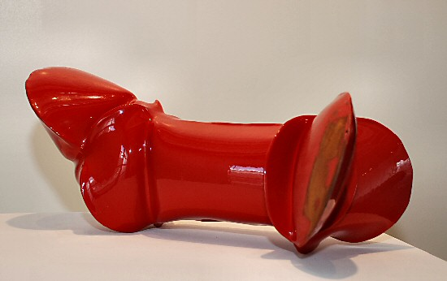
Hiniker Red, 2008
forged mild steel and powder coat
11 x 7 x 9 inches JT156

© 2008

Charlotte Jackson Fine Art, Inc.

200 West Marcy Street, Suite 101, Santa Fe, New Mexico 87501
Telephone: 505.989.8688 Fax: 505.989.9898
cjfa@charlottejackson.com - www.charlottejackson.com

