CHARLOTTE JACKSON FINE ART

PRESENTS

JEREMY THOMAS: Inflatables
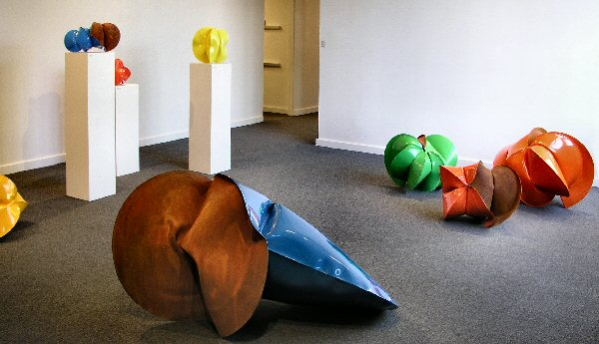
MAY 5 - MAY 28, 2006

These sculptures capture you. Jeremy Thomas, who first and foremost thinks of himself as a “maker of objects,” brings new work to his first solo exhibition in Santa Fe. At first one is arrested by the work, particularly the larger pieces, in their presence. The intense, slick primary colors of the pieces can initially divert from the intimacy of the forms. Then you are drawn in again.
The contrasts intrigue: steel, considered hard, angular and rigid, is inflated into forms utterly belying that nature: organic, fluid, even delicate. Curves, dimples, ripples, creases, make these sculptures highly sensual and suggestive objects. The pigments themselves are a form of contrast, bright colors used by tractor manufacturers placed on these organic-seeming shapes. And again there is the contrast between the bold, shiny colors and the suede-like rust that Thomas always includes on one surface. Once caught, you are drawn into the minute details, a curve here, a ripple there. You follow one slope and notice it’s context, the way the light hits it, and you follow it toward another fold. You note the way a deep crease in the steel disappears into darkness.
Thomas, who studied studio art at the College of Santa Fe and interned with master blacksmith Tom Joyce, says that he “stumbled across the technique” that he uses for making these forms. He was using this blacksmithing method as a demo for his students and saw how it could be made more complex. His interest grew and he began to work with the process in late 2003. Sheets of steel are cut out into forms (these pieces are all based on the geometry of the circle) that are welded together, bent, folded, and welded again. The forms are put into the forge and heated to over 2,800 degrees Fahrenheit at which point the steel becomes malleable and workable almost like clay. It is removed from the forge and quickly inflated with pressurized air. The pressurized air fills and expands the supple steel, “growing” it into the desired shape.
You’ll notice titles on the work like John Deere Green, Ford Blue, or Caterpillar Yellow. The titles come from the colors that Thomas obtains from among the various pigments used by tractor manufacturers. To Thomas, the use of these colors (from such a masculine and imposing source as giant farm equipment) on his curving, sensuous forms is an example of what he thinks art is about: the science of play. Once the pieces are coated with color he takes them back to his shop where he patina’s the uncolored surface so it becomes rusted to a beautiful suede finish. Accomplishing the rust-surface that he wants has taken much experimentation and time. He would, he says, in the end prefer to leave the pieces outside in the elements to rust over time, but in New Mexico’s dry climate that could take quite a while.
There is something rather alchemical about these pieces that are a mixture of the four elements: metal, air, fire, and water (used to quench the steel). Strenuous work with heavy materials in an extreme environment yield works of sensual and even erotic beauty. Softly curving shapes grow out of steel by a process that does not involve direct human touch but rather the pressure of air.
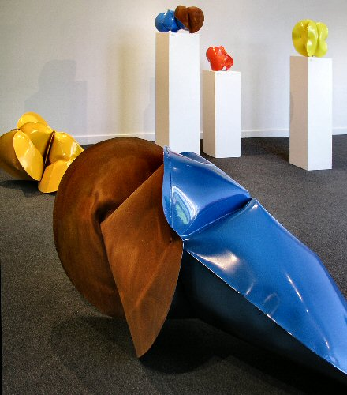

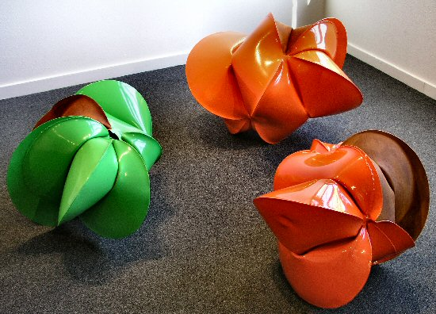
MAIN GALLERY:
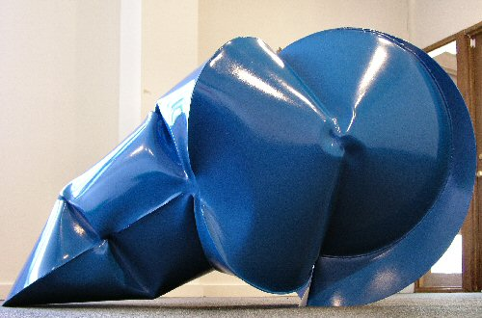
Ford New Holland Blue, 2006
Forged Mild Steel & Powder Coat, 29” x 54” x 29”, JT0054
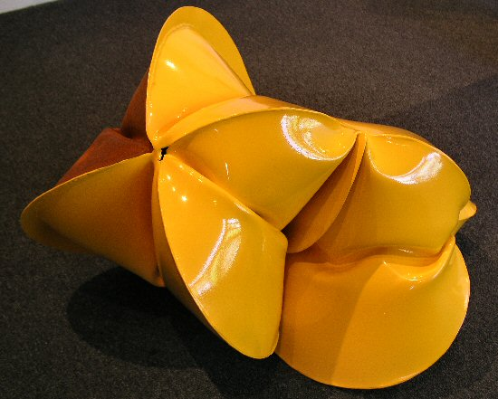
Chamberlain Yellow, 2006
Forged Mild Steel & Powder Coat, 21 ½” x 32” x 23”, JT0058
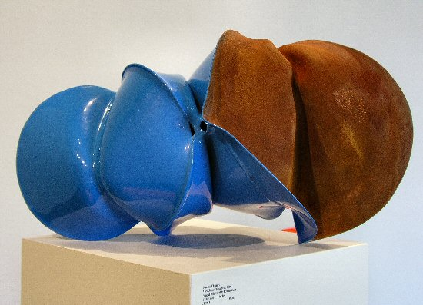
Ford Super Dexta Blue, 2006
Forged Mild Steel & Powder Coat, 11 ½” x 20” x 11”, JT0051
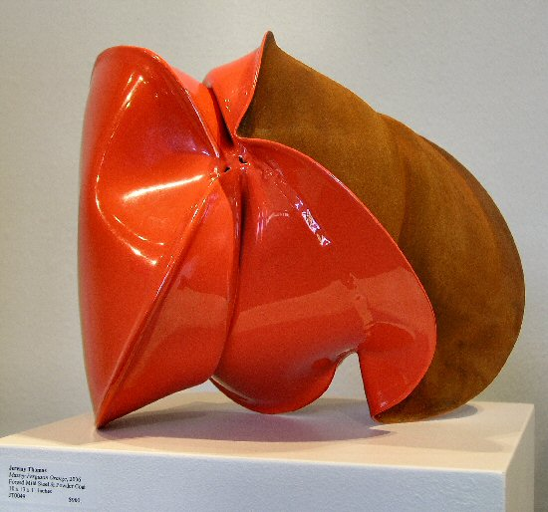
Massey Ferguson Orange, 2006
Forged Mild Steel & Powder Coat, 10” x 13” x 11”, JT0049
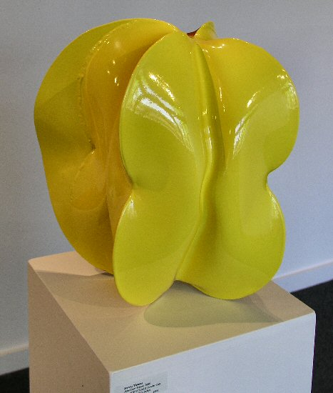
John Deere Yellow, 2006
Forged Mild Steel & Powder Coat, 14” x 11 ½” x 12 ½”, JT0053
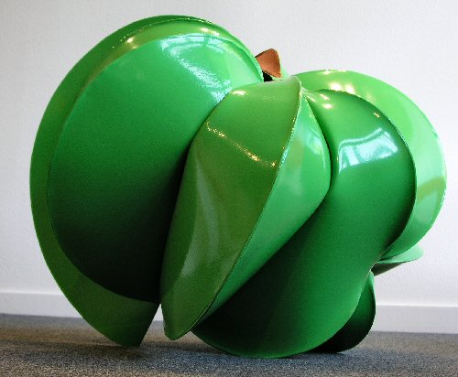
Deutz Green, 2006
Forged Mild Steel & Powder Coat, 21” x 30” x 23”, JT0059
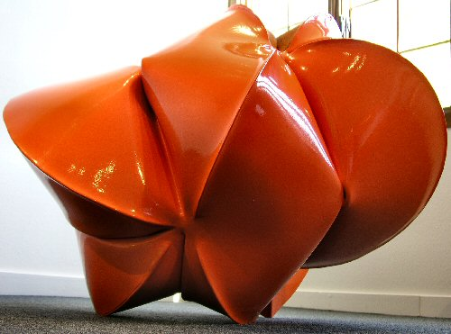
Agco Allis Orange, 2006
Forged Mild Steel & Powder Coat, 28” x 36” x 28”, JT0055
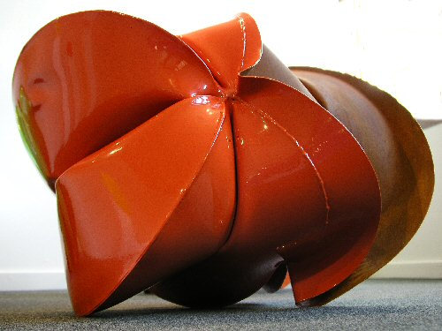
Holder Orange, 2006
Forged Mild Steel & Powder Coat, 19” x 25” x 21”, JT0041
HALLWAY:

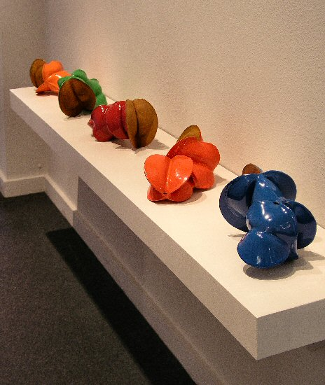
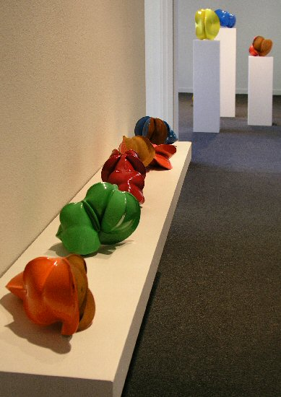
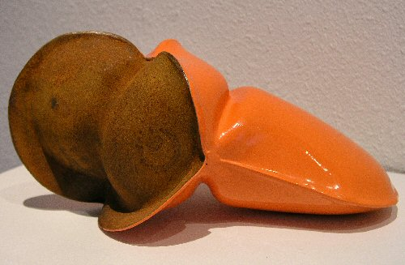
Same Orange, 2006
Forged Mild Steel & Powder Coat, 5 ½” x 11 ½” x 5 ½”, JT0065
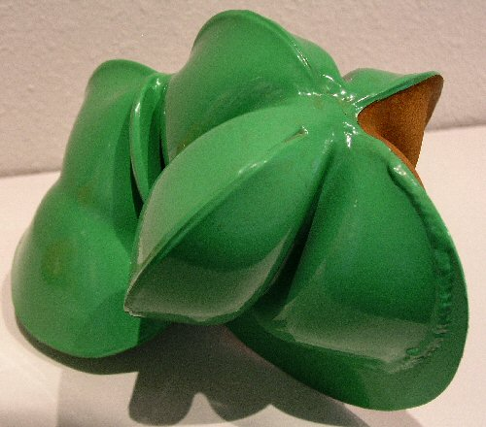
MB-Trac Green, 2006
Forged Mild Steel & Powder Coat, 6 ½” x 6” x 6 ½”, JT0060
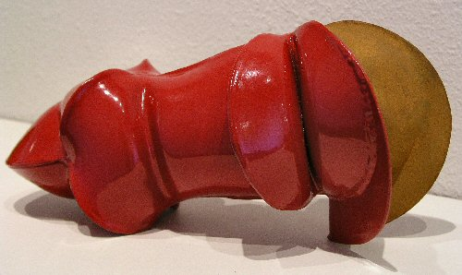
McCormack Red, 2006
Forged Mild Steel & Powder Coat, 6” x 12” x 5 ½”, JT0064
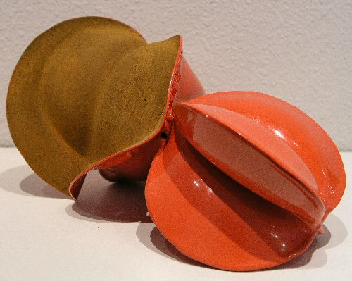
Koiti Orange, 2006
Forged Mild Steel & Powder Coat, 5” x 10 ½” x 6 ½”, JT0061
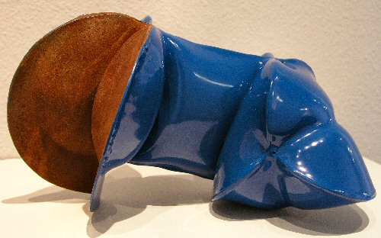
Patz Blue, 2006
Forged Mild Steel & Powder Coat, 6” x 11” x 6”, JT0062
GALLERY II:

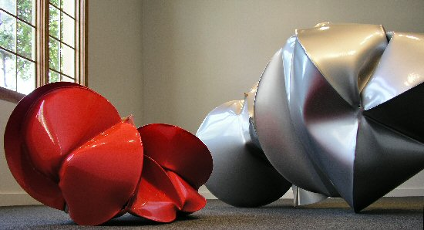

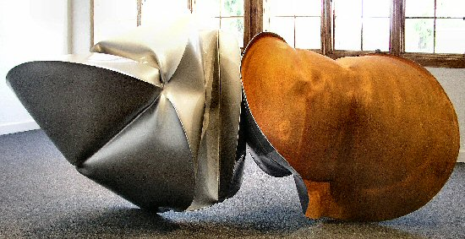
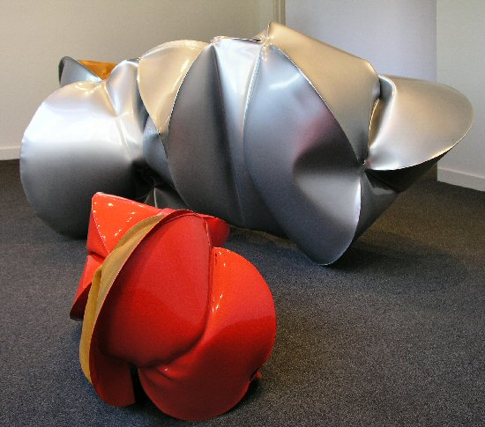
White Silver, 2006 (with Branson Red)
Forged Mild Steel & Powder Coat, 38 ½” x 81” x 35”, JT0066
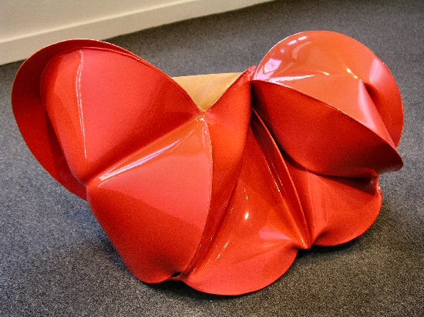
Branson Red, 2006
Forged Mild Steel & Powder Coat, 20” x 38” x 19”, JT0057
JEREMY THOMAS

Admirers of Jeremy Thomas’ sculpture should be grateful to a thief. Thomas came to the College of Santa Fe to study Studio Arts as a painter and printmaker, both of which he had been doing since high school, even apprenticing with a master printmaker in his native Oklahoma. However one semester while moving out of his dormitory, boxes and bags of his possessions piled around as he loaded them into his truck, the wooden box which held all of his brushes and painting supplies, went missing. One moment it was on the curb, the next it was gone. Thus ended Thomas’ career as a painter. The next semester he took a sculpting class and never really turned back.
While Thomas is happy to converse about theory and concept, he is most content thinking of himself as a maker of objects rather than as an “Artist.” To him the label of “artist” is a mantle placed onto a person by society, and one which in the current day has as much to do with pop trends and market trends as it does with the production of great work. He is insistent that making objects is an impulse that all humans have, though perhaps in varying degrees and expressed in different ways. Some people make pies or spread-sheets, some make books or sculptures.
It is the pragmatic that draws Thomas. Asked about his influences he asserts that his primary influences do not come from the realm of art but rather from everyday living. “I don’t eat, sleep, and breathe art,” he comments, though with the caveat that when an opportunity arises he does take advantage of seeing what new ideas his contemporaries are exploring. His discovery of metal-working arose in a similar, practical, way. Thomas had been sculpting with stone and asked someone to show him how to forge his own chisel. This was the start of his exploration of forging techniques and after a time he gave up working with stone to work full time with metal. One of the key aspects of blacksmithing that intrigued Thomas was that it was the first process that he had tried that he really felt he had to work at, that posed a challenge not easily solved. He interned with Tom Joyce (recipient of a MacArthur genius grant) and later worked in Santa Fe as a blacksmith creating items as diverse as fireplace screens and light fixtures, but always continuing to make the objects of “art”.
His current sculpting technique of inflating steel forms was something he stumbled upon while doing a demo for one of his sculpture classes. He became fascinated with the possibilities and ability to make the work more complex. Steel, Thomas says, is quite malleable and actually a lot like clay (though admittedly it only exhibits those characteristics at upwards of 2800 degrees Fahrenheit.) Thomas welds forms together than he can then heat and inject with pressurized air, inflating, or “growing” them into their final shape. The final pieces contain paradox: metal molded by air, sensual forms in forceful fetish-finish primary colors gleaned from tractor manufactures. These sculptures are changeable (as one continuously finds new approaches in their creases, angles, and wrinkles); they allow a dialogue between viewer and work much in the way Thomas says he engages in an ongoing dialogue, a give and take, with his materials. As he says, “Art is the science of play,” a creed that Thomas seems to take to heart, both in his work and in his life.

© 2006

Charlotte Jackson Fine Art, Inc.

200 West Marcy Street, Suite 101, Santa Fe, New Mexico 87501
Telephone: 505.989.8688 Fax: 505.989.9898
www.charlottejackson.com

Photography & CD Production:
William Metcalf

