CHARLOTTE JACKSON FINE ART
PRESENTS

JAMES HOWELL:
TEN GREYS
September 17 - October 4 2004

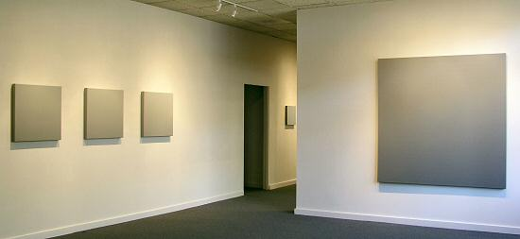

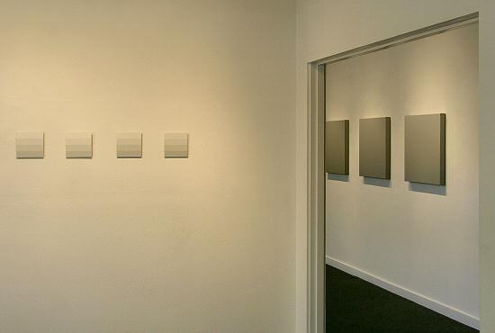
Mention of Eadweard Muybridge's Nineteenth Century stop-action photography of the figure in motion brings his groundbreaking collotypes immediately to mind. New York artist James Howell is engaged in creating an entirely abstract version of the same principle, exploring the movement of gradations of gray between the poles of light and dark.
The title of this exhibition refers not to the number of paintings to be shown, but to the larger body of work, Series Ten, to which these pieces belong. This series, begun in 1996 and continuing into the present and future, is full of surprises. Comprised solely of works in shades of gray, the work and the series might be expected to be static and predictable. Not so. When the artist speaks about this series, the conversation is mostly about movement, and the spaciousness of mind that can result from exploring infinite possibilities within a framework of deliberately self-imposed limits.
The series to date comprises several hundred works, each a part of an overall scheme of mathematically derived variations of the proportion of light and dark in a given piece. Over the past four years, Howell has concentrated on producing four-part progressions of paintings, discrete series in themselves, that embody a wider movement than is possible within the confines of a single canvas. These sub-series in turn form part of the overall movement of the larger body of work.
He notes that in this part of the larger series, he has also focused on the midrange, eliminating the extremes closer to black and white. According to Howell, the middle is where the action is. He notes that while we tend to think of the extremes as more exciting, it is actually the middle where almost everything happens. "In between black and white is visual reality. In between the 1 and 0 is the computer's territory of information. In between past and future is now. In between birth and death is life. 'In between' is a location of time, knowledge, mind."
Howell's exploration of this "in-between" has been a long and productive one. His work has been exhibited widely in the United States and Europe, and has a loyal following of collectors who appreciate the quiet intensity of these exceptional paintings.
MAIN GALLERY:

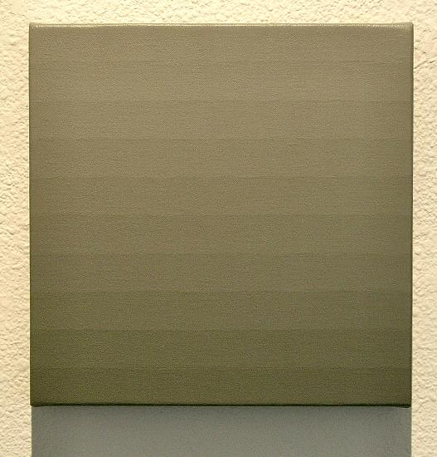
48.17 02/28/04, 2004
Acrylic on canvas, 10” x 10”, JH0013
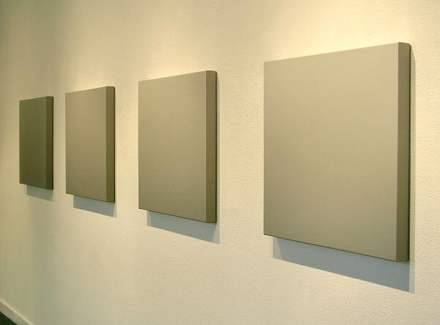
Progression 68.70 - 78.41 12/16/02, 2002
Acrylic on canvas, 25” x 25” ea., JH0012
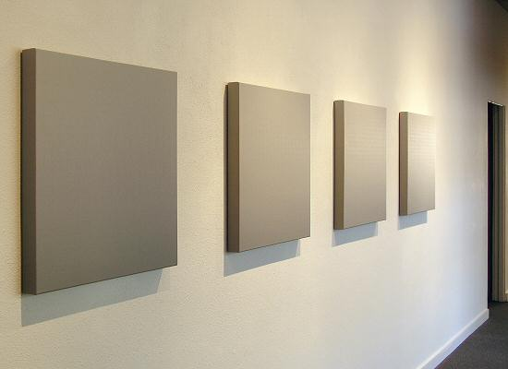
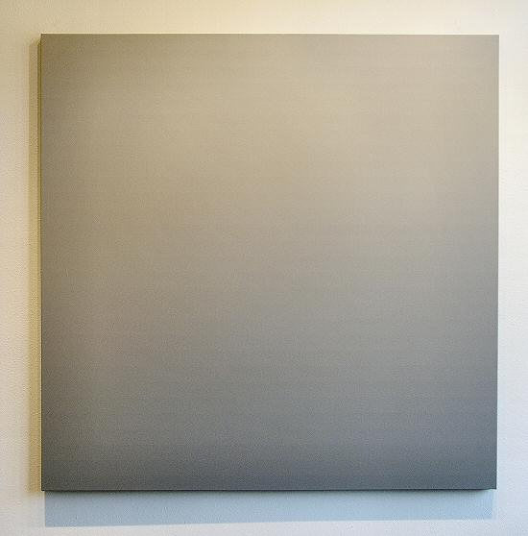
52.71 01/16/01, 2001
Acrylic on canvas, 66” x 66”, JH0015
HALLWAY:
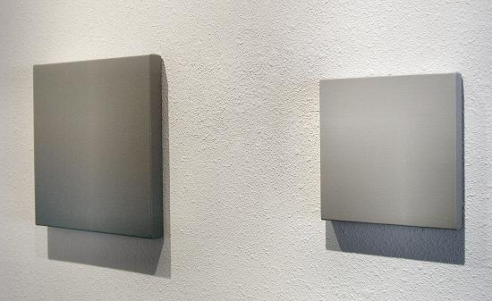
48.17 02/25/04, 2004
Acrylic on canvas, 15½” x 15½”, JH0016

68.70 04/27/04, 2004
Acrylic on canvas, 10” x 10”, JH0017
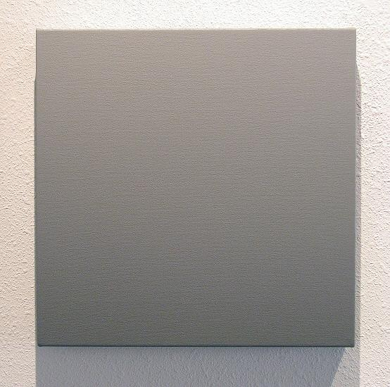
48.17 02/25/04, 2004
Acrylic on canvas, 15½” x 15½”, JH0016
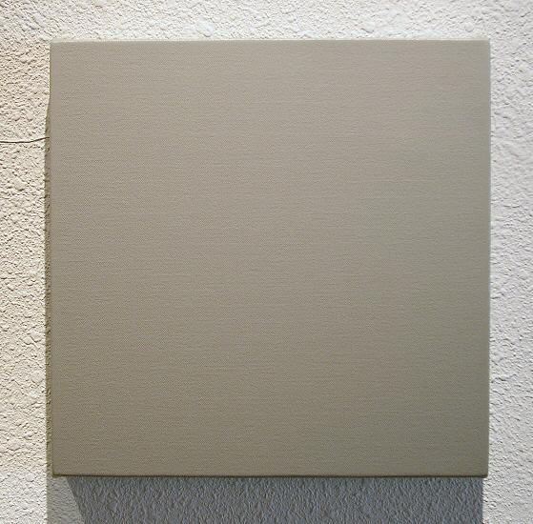
68.70 04/27/04, 2004
Acrylic on canvas, 10” x 10”, JH0017
GALLERY II:
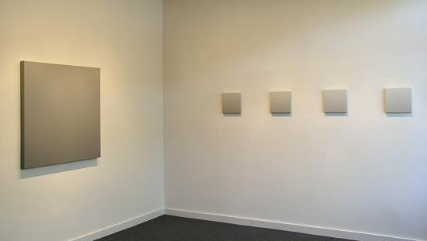
61.14 04/07/01 and Progression 83.80 - 90.25 07/01/02

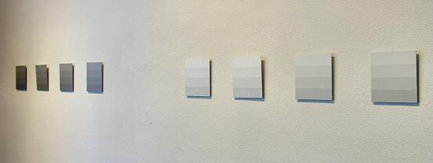
Progression 48.17 - 57.04 12/11/03 and Progression 94.75 - 96.66 11/22/03
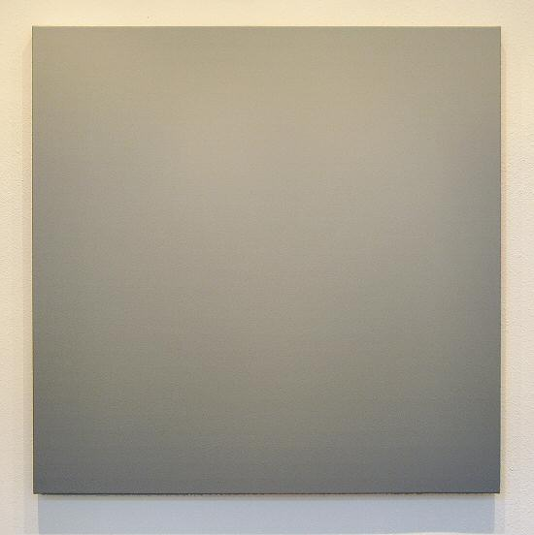
61.14 04/07/01, 2001
Acrylic on canvas, 40” x 40”, JH0014
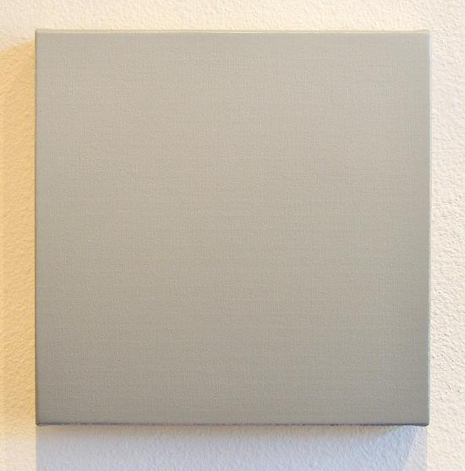
Progression 83.80 - 90.25 07/01/02, 2002
Acrylic on canvas, 10” x 10” ea., JH0011 (one of four)
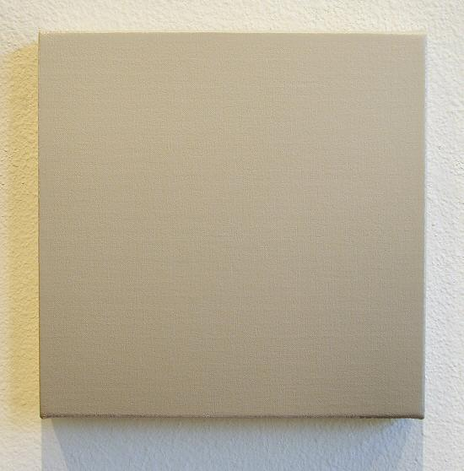
Progression 83.80 - 90.25 07/01/02, 2002
Acrylic on canvas, 10” x 10” ea., JH0011 (one of four)
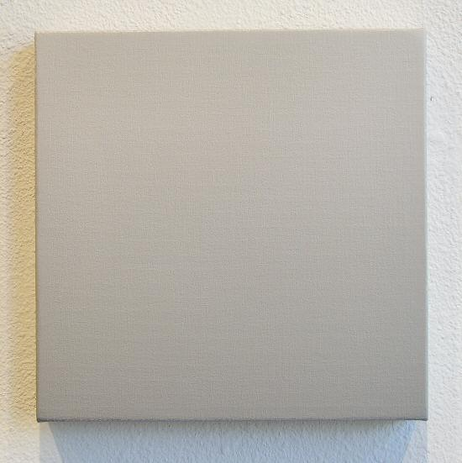
Progression 83.80 - 90.25 07/01/02, 2002
Acrylic on canvas, 10” x 10” ea., JH0011 (one of four)
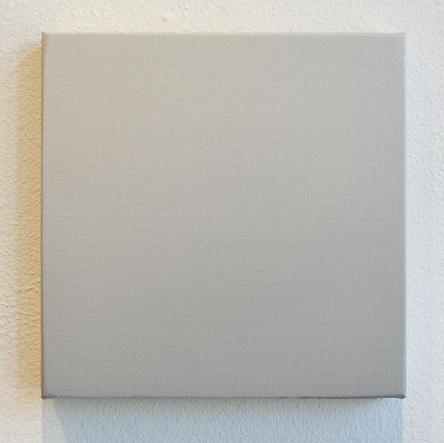
Progression 83.80 - 90.25 07/01/02, 2002
Acrylic on canvas, 10” x 10” ea., JH0011 (one of four)
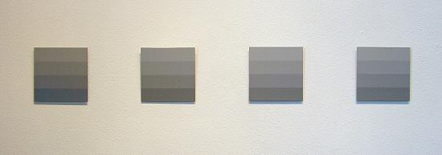
Progression 48.17 - 57.04 12/11/03, 2003
Acrylic on aluminum panel, 6” x 6” ea., JH0010

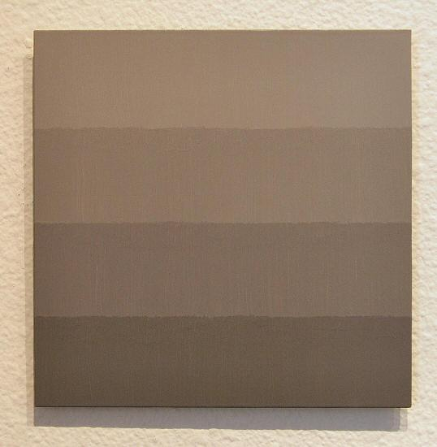
Detail
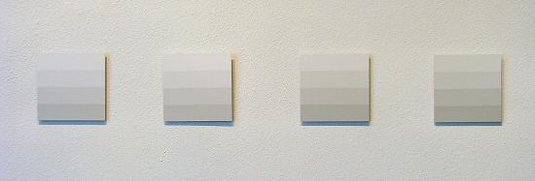
Progression 94.75 - 96.66 11/22/03, 2003
Acrylic on aluminum panel, 6” x 6” ea., JH009

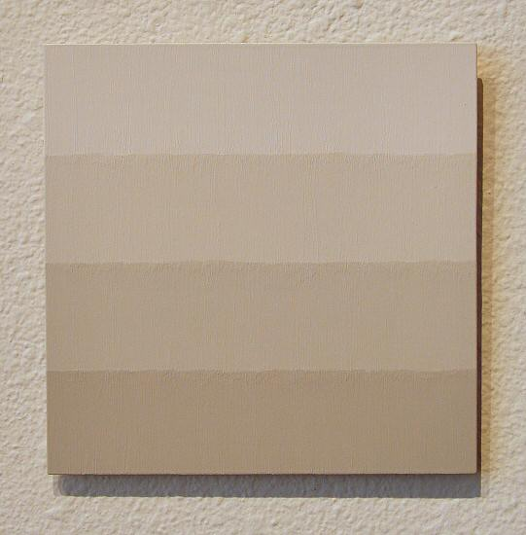
Detail
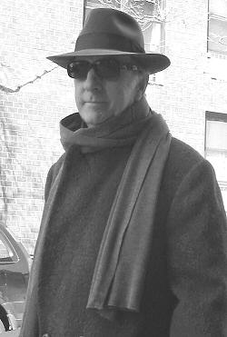


JAMES HOWELL

"In the night all cats are gray," says James Howell, quoting Cervantes. Howell should know, having spent the past eight years developing Series Ten, an intricate progression of paintings based on a mathematically calculated movement of shades of gray, from the most delicate almost-whites to the most intense almost-blacks. Each work in the series has its own upward movement from dark to light, and the series as a whole advances from one extreme to the other.
Howell became enamored of gray after living for several years on a secluded, fog-shrouded island in Washington State, where the land- and seascape were composed mainly of shades of gray. "Getting to gray was a long and gradual process," he recalls. "I remember looking at the sky opposite a sunset and finding that exciting. I like the disappearance of gray. It is mysterious." He notes that a color like red is only one part of the spectrum, but gray involves all the colors balanced with each other.
This professional interest has carried over into his private life as well. He and his wife Joy live a loft in New York -- all gray -- so elegant that it has been featured in architectural and design articles. The other resident of this gray paradise is a gray cat named Pi, whose intelligence and discrimination (and yes, elegance) are legendary among the Howells' friends.
Howell has strayed far from his original career interests. He began with a degree in English Literature from Stanford. Pursuing this field into graduate school, and envisioning himself in tweed, smoking a pipe and supervising students' reading of Chaucer, he found, to his disappointment, that he was drawn more toward the visual arts. He switched to architecture, earning an advanced degree, and went on to design houses in the Northwest. Painting full-time proved to be a stronger interest, however; and he mined the knowledge he had gained from numerous art courses in architecture school, teaching himself the rest of what he needed to know.
Howell painted for several years on the quiet Washington island where he learned to love the subtleties of gray. There was a point at which he realized that he wanted his work to be out in the world. A move to Los Angeles followed, and then in 1989 another move, this time to New York. "Everything happened there," he says. "Everything" included exhibiting widely in the United States and Europe, placement of work in major collections, and the birth and unfolding of his ambitious Series Ten.
© 2004, Charlotte Jackson Fine Art
All Rights Reserved

Charlotte Jackson Fine Art

200 West Marcy Street, Suite 101

Santa Fe, New Mexico 87501

Phone: 505.989.8688
Fax: 505.989.9898

www.charlottejackson.com

Photography and CD production – William Metcalf

