CHARLOTTE JACKSON FINE ART

PRESENTS:

A FLAVOR OF POP
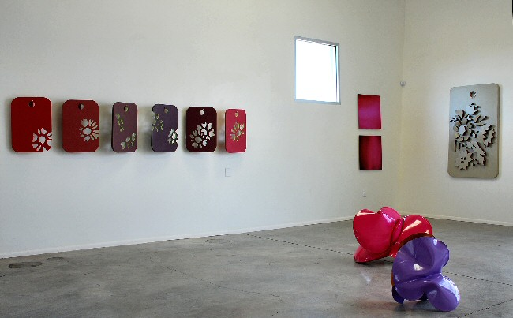

June 28 - July 31, 2008
Have you ever wondered what would happen if you crossed Minimalist art with Pop art? At Charlotte Jackson's Project Space you can find several answers to this question in art created by Tim Jag, Keira Kotler, Yumi Janairo Roth, and Jeremy Thomas.
Tim Jag's newest paintings continue
to refine his favored retro-color palette derived from fabrics, wallpaper and other common household goods from the 1950s and 60s. Unlike his earlier paintings, however, the new works are primarily stripes or color bands that are filled with lush paint and dense, layered surfaces. The works on raised wood panels have a sculptural presence on the wall that makes them reminiscence of Donald Judd's sculptures in their simplicity and elegance of shape. For Jag, the breeding of minimalism and Pop art results in unique works that are lush and simple, colorful and subdued.
A young photographer living in San Francisco, Keira Kotler also produces sculptural works for the wall. Her photographs are mounted on aluminum and they depict sweeping, glowing images of color infused with light. Pop artists utilized photography particularly for their collage works, while the minimalists generally created art using metals and paint. Kotler's work transforms the camera into a tool to capture simple abstractions that make indirect references to the past. Pink, aquamarine, silver and turquoise remind many of the 1950s and 60s and thus Kotler brings together colors, materials, abstraction and sculptural forms to produce a hybrid of styles and influences.
Yumi Janairo Roth, Associate Professor of Art at the University of Colorado, Boulder, trained as a metalworker at SUNY, New Paltz. This background as a metal worker explains her precise use of materials, her careful construction techniques and her attention to the surface of materials. These were also the obsessions of many minimalist artists. But rather than work in traditional sculptural materials, Roth used Formica to produce the art in this exhibition. Her Formica "tags" as she calls them, are meant to reference the small Formica color samples used to help the consumer decide what would look best in their home. Her art is also meant to be taken home and tried out to make sure that it too works with the home décor. Roth's embrace of the decorative, and the domestic, is very much in keeping with earlier Pop artists' interest in the materials of everyday life.
Local sculptor Jeremy Thomas contrasts in his sculptures rusted surfaces and glossy enamel to literally marry two opposites. On the one hand, his popcorn-like shapes are playful and fun underscored by the bright shiny surface. On the other, the rusted metal part of the sculpture pays homage to Richard Serra's use of rusted steel to create imposing, serious sculptures that intimidate the viewer. Playful and serious, Thomas's sculptures perhaps best represent the cross-pollination of two styles of art that once existed in dramatic opposition.
The show was curated by Andy Warhol and Donald Judd, or at least in their memory.

Keira Kotler
Lumina Aquamarine 032005, 2006
LightJet print on aluminum
30 x 30 inches
KK006
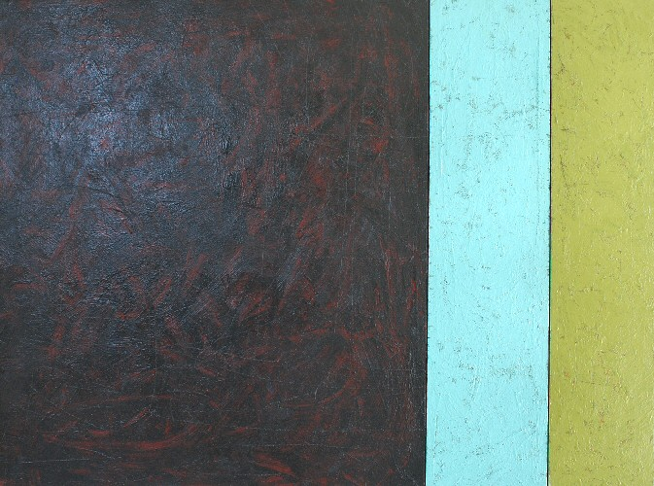

Tim Jag
Cadiz, 2008
acrylic on wood panel
91.44 x 121.92 cm
TJ001
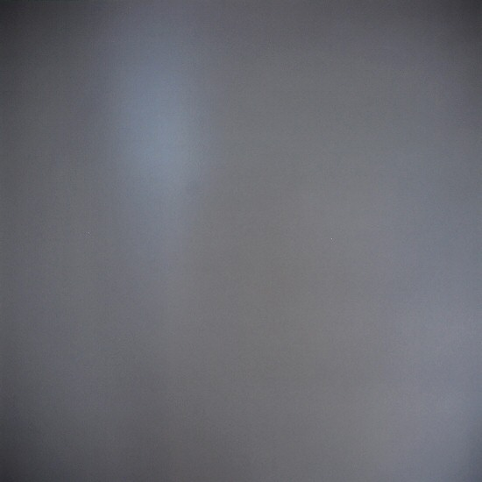

Keira Kotler
Lumina Silver 022006, 2006
lightjet print on aluminum
36 x 36 inches
KK0016
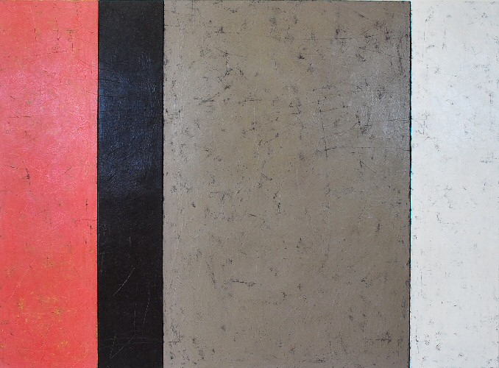

Tim Jag
Torta Chocolat, 2008
acrylic on wood panel
49 x 64 inches
TJ002
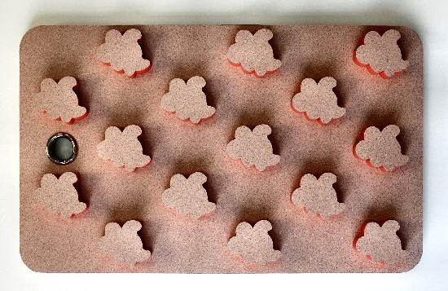

Yumi Janairo Roth
Mocha Glace with Misty Flame,
Formica, wood, and chrome plated copper
60 x 38 x 5 inches
YR002
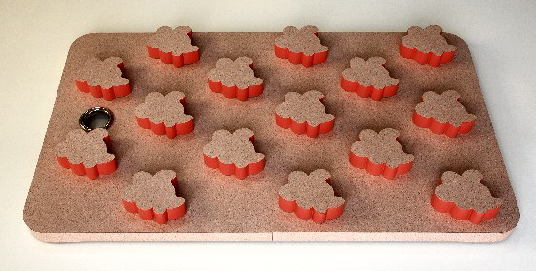

Yumi Janairo Roth
Mocha Glace with Misty Flame,
Formica, wood, and chrome plated copper
60 x 38 x 5 inches
YR002
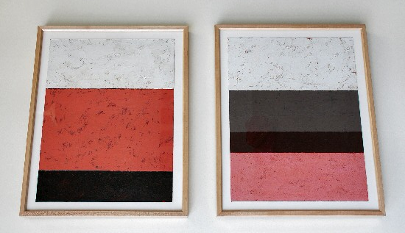

Tim Jag
La Rosa Caliente, 2008
acrylic on paper
18 1/2 x 24 1/2 inches
TJ004 1,600

Tim Jag
Torta Chocolat 2, 2008
acrylic on paper
18 1/2 x 24 1/2 inches
TJ003
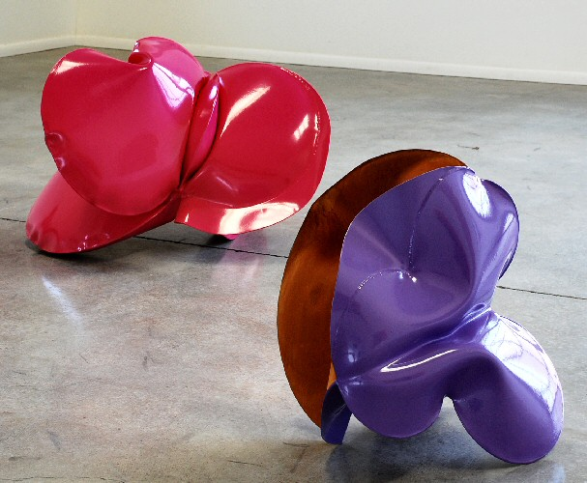

Jeremy Thomas
Pink Allis, 2008
Forged mild steel and powder coat
26 x 26 x 32 inches
JT130

Jeremy Thomas
Purple International, 2008
Forged mild steel and powder coat
21 x 18 1/2 x 23 inches
JT131
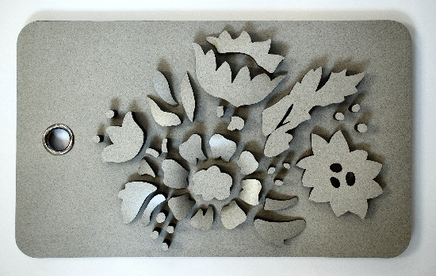

Yumi Janairo Roth
Celery Fiber with Pigeon Isle,
Formica, wood, and chrome plated copper
60 x 36 x 5 inches
YR001
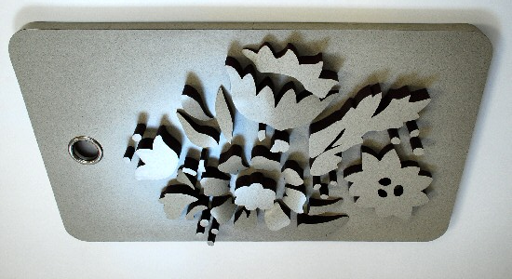

Yumi Janairo Roth
Celery Fiber with Pigeon Isle,
Formica, wood, and chrome plated copper
60 x 36 x 5 inches
YR001
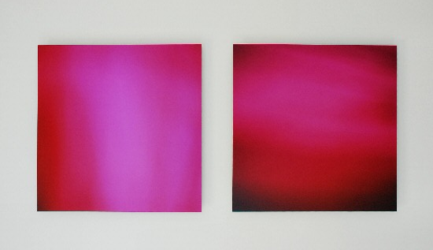

Keira Kotler
Lumina Pink 041108, 2006
lightjet print on aluminum
24 x 24 inches
KK0014

Keira Kotler
Lumina Fuchsia, 2006
lightjet print on aluminum
24 x 24 inches
KK0015
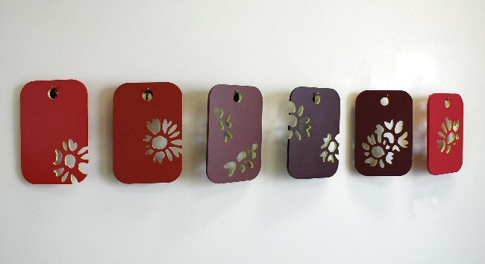
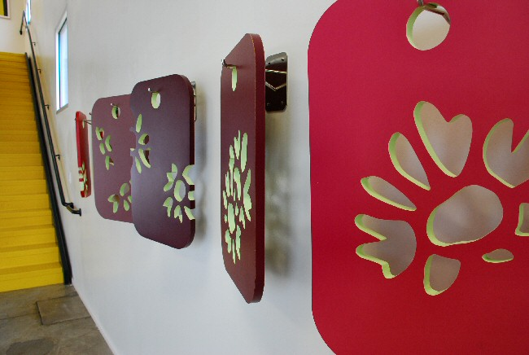

Yumi Janairo Roth
Decorator Colors/Reversible Patterns, 2001
Formica, wood, and chrome plated steel
24 x 16 3/4 inches
YR003
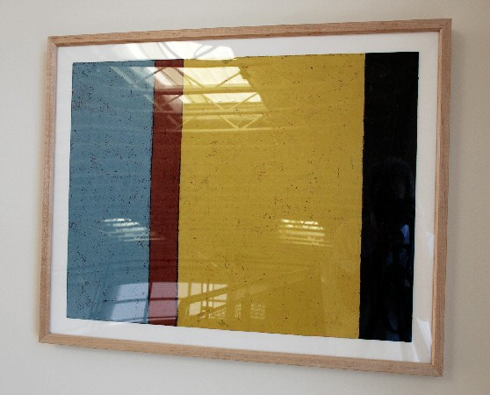

Tim Jag
Soria, 2008
acrylic on paper
19 x 24 1/2 inches
TJ005
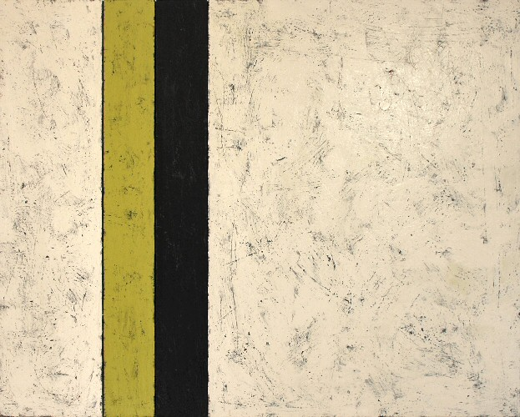

Tim Jag
El Topo, 2008
acrylic on wood panel
32 x 40 inches
TJ006
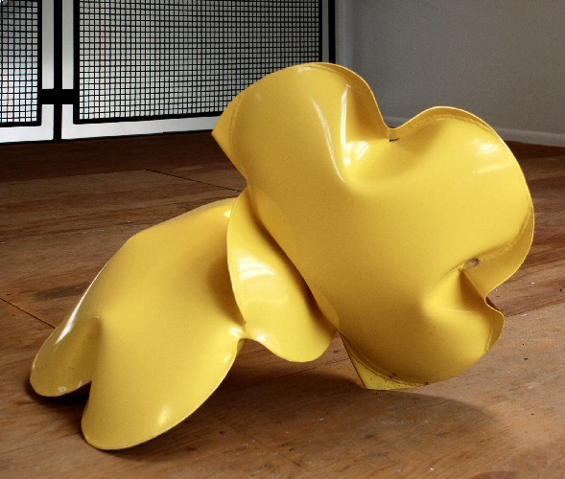

Jeremy Thomas
SFV Yellow, 2007
Forged Mild Steel & Powder Coat
21 x 35 x 21 inches
JT126
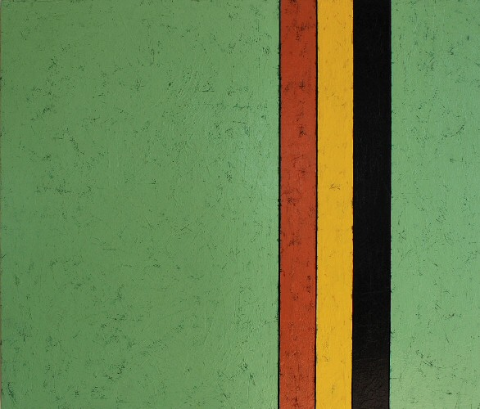

Tim Jag
Victorio, 2008
acrylic on wood panel
40 x 46 inches
TJ007
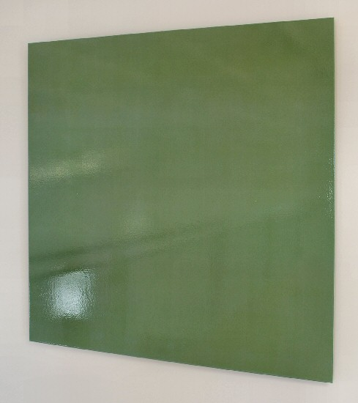

Keira Kotler
Sound of Rain, 2004
Urethane and pigment on aluminum
36 x 36 inches
KK008


Keira Kotler
Lumina Turquoise 020606, 2006
lightjet print on aluminum
20 x 20 inches
KK0013

© 2008

Charlotte Jackson Fine Art, Inc.

200 West Marcy Street, Suite 101, Santa Fe, New Mexico 87501
Telephone: 505.989.8688 Fax: 505.989.9898
cjfa@charlottejackson.com - www.charlottejackson.com

