CHARLOTTE JACKSON FINE ART
PRESENTS:

Ed Moses: Primal and Primary Paintings 1975
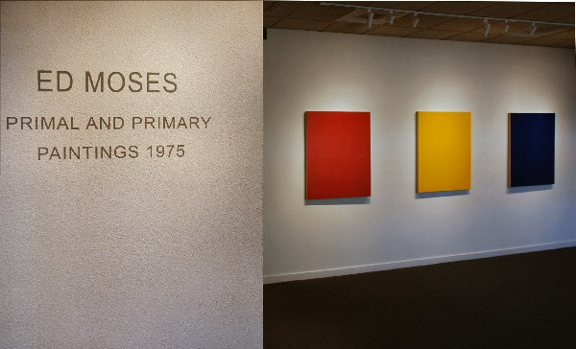
November 9 - December 9, 2007
Ed Moses flatly posits that he is not an artist. "I'm a painter, inventive, activated. An abstract painting is not a reference; it's not a picture; it's a perception of the painting. It goes back to Barnett Newman's Who's Afraid of Red, Yellow, and Blue?" For Moses, his monochromatic paintings "are a conceptual ideal of an abstract painting, existing on a two-dimensional plane. They are not painterly paintings, not painted by hand. They are the physical evidence of an abstract painting as a physical phenomenon. They have no reference nor do they exist as a referent to anything other than how they visually exist. Those paintings were executed in 1975." Today, he works obsessively, over and over, in exploring abstract painting as a physical phenomenon. His "monos" are ephemera-like Newman's, the subject is pure and vibrant color on a surface. However, Moses goes one further, reducing his surfaces to murmured discourses about the nature of painting itself. One could say they are illusions of paintings, and serve to identify a mass of pigment and form upon a two-dimensional scaffold as painting. The difference, as Moses sees it, between being an artist and a painter is one of discernment: He would contend that an artist makes things that look like, or at the very least make allusion to, other things. Moses, on the other hand, sees his job as reducing everything to one color, one surface, one painting. With two assistants keeping him constantly busy in the studio, he works "wet on wet," like a geneticist ever in pursuit of that spark of life that activates our DNA. What is it, Moses would have the viewer ask, that characterizes a painting?
In the 1970s, Moses made what he called his Cubist paintings, inserting diagonal passages of paint, criss-crossing in opposition to the rectangular frame of the canvas in order to emphasize the form that is the armature of a painting. It was an exhibition of his monochromatic red paintings-and their reflected radiance-at the Los Angeles County Museum of Art that led him to "want to remove everything" from the paintings. At LACMA, he put the monochromatic abstract paintings in one room, and the diagonal paintings in another, all in red. The overlapping of the marks implied an illusion of one thing on top of another-in other words, three dimensions. The other paintings, in another room, abstract monochromatic paintings which had no allusion to a third dimension, are included in the current exhibition at Charlotte Jackson Fine Art. Moses says about the earlier Los Angeles show, "My thought was to remove all illusion, including references of the artist's hand." At this time, many of his Venice peers, including Larry Bell and James Turrell, were involved in the Light and Space movement; Moses had stepped unaccompanied into the unknown with his monos, including his white paintings. As Charlotte Jackson notes, this "reductivist deconstruction of the surface was groundbreaking" for that era, and generations have followed in his footsteps, exploring what Jackson calls "the dialog" of the painted surfaces of monochromatic paintings.
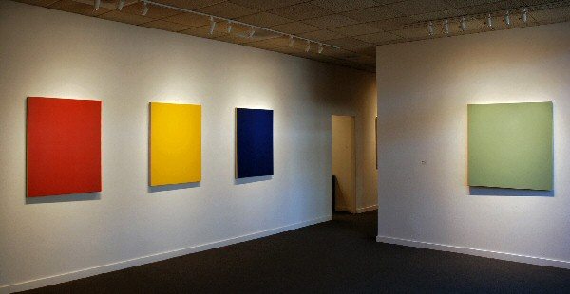
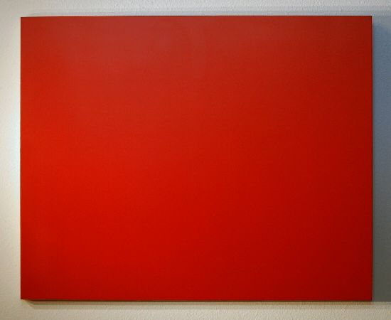
Untitled (Red), 1975
acrylic on canvas 42 x 34 inches EM0021
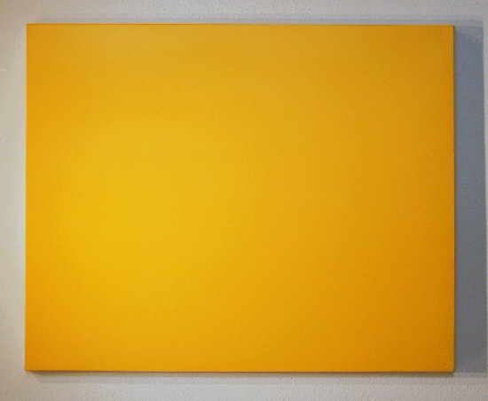
Untitled (Yellow), 1975
acrylic on canvas 42 x 34 inches EM0024
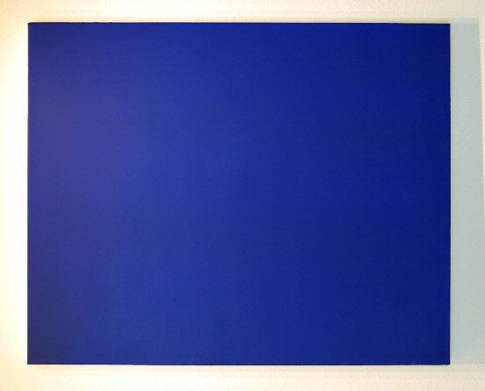
Untitled (Blue), 1975
acrylic on canvas 42 x 34 inches EM0022
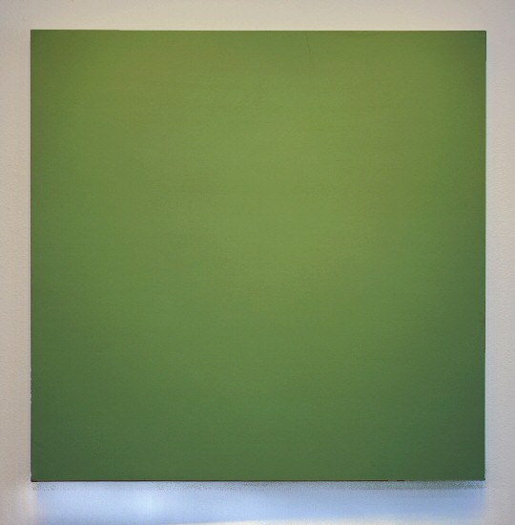
Untitled (Institutional Green), 1975
acrylic on canvas 43 x 43 inches EM0027

Untitled (Institutional Green), 1975
acrylic on canvas 43 x 43 inches EM0027
(detail)
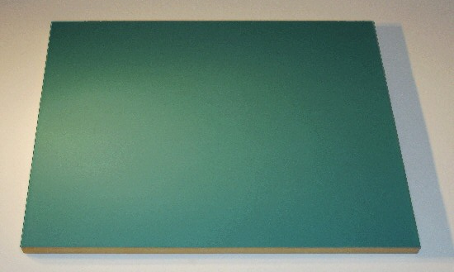
Untitled (Institutional Green), 1975
acrylic on canvas 42 x 34 inches EM0023
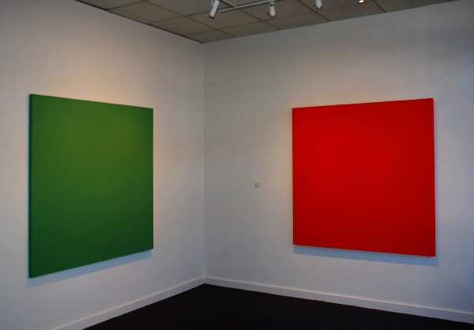
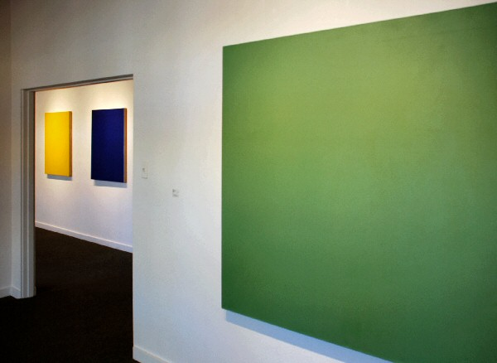
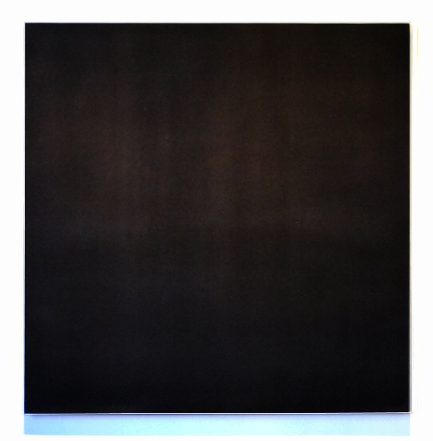
Untitled (black), 1975
acrylic on canvas 60 x 60 x 60 inches EM0014
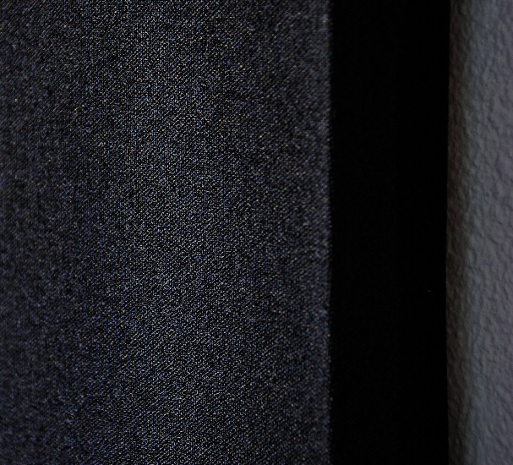
Untitled (black), 1975
acrylic on canvas 60 x 60 x 60 inches EM0014
(detail)
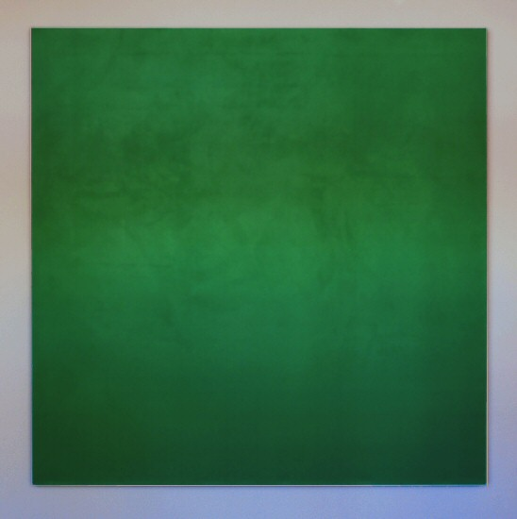
Untitled (Green), 1975
acrylic on canvas 60 x 60 inches EM0016
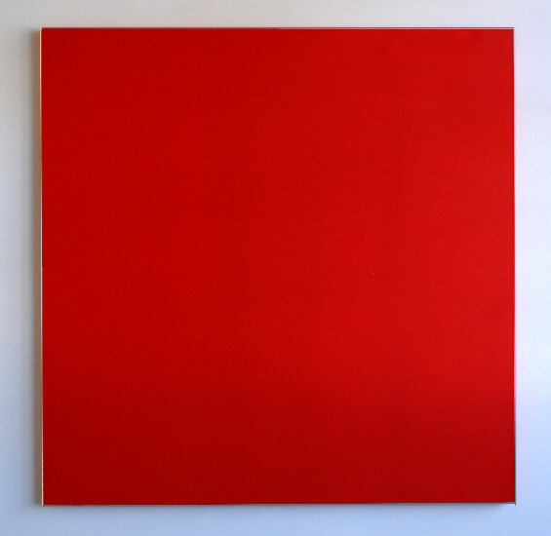
Untitled (Red), 1975
acrylic on canvas 60 x 60 inches EM0015

Untitled (Red), 1975
acrylic on canvas 60 x 60 inches EM0015
(detail)
AT CHARLOTTE JACKSON PROJECT SPACE:

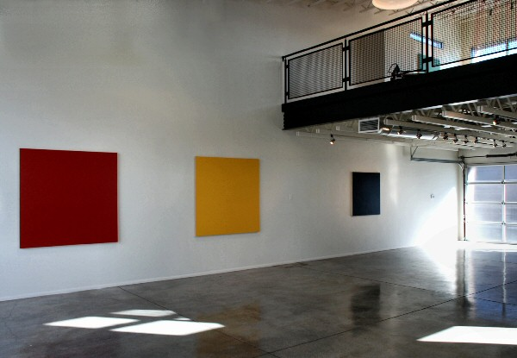
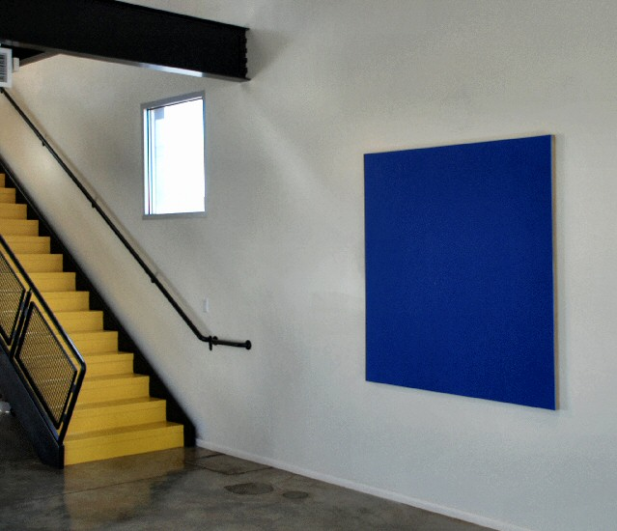
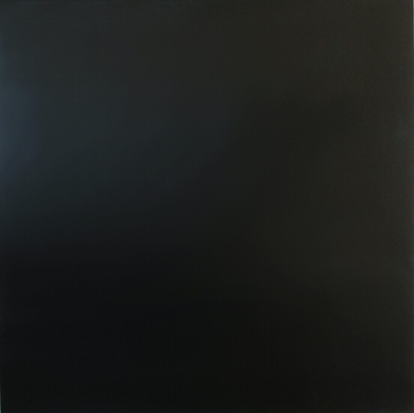
Untitled (Black) 1975
Acrylic on canvas 43 x 43 inches EM0026

Untitled (Yellow) 1975
Acrylic on canvas 60 x 60 inches EM0019

Untitled (Red) 1975
Acrylic on canvas 60 x 60 inches EM0017

Untitled (Blue) 1975
Acrylic on canvas 60 x 60 inches EM0020
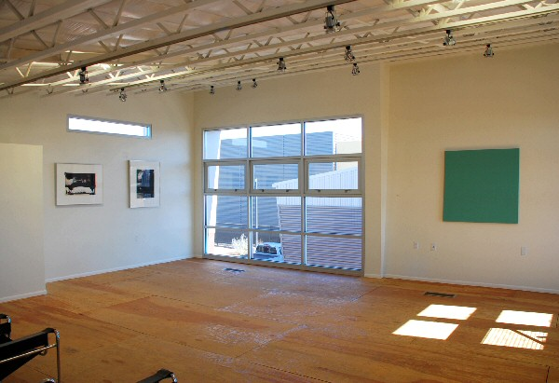
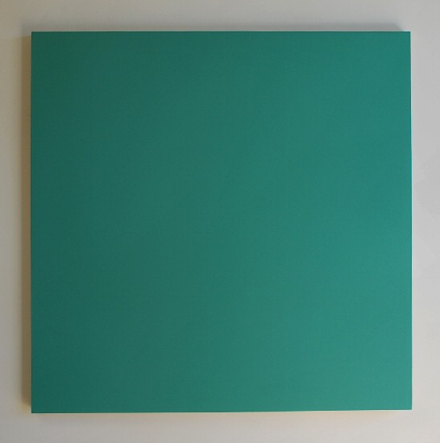
Untitled (Institutional Green) 1975
Acrylic on canvas 43 x 43 inches EM0025
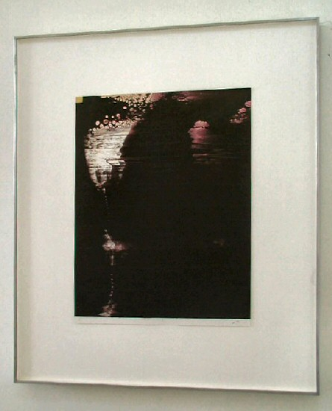
Zoba#1, 2000-2001
Acrylic on paper 22 x 16 3/4 inches EM0012
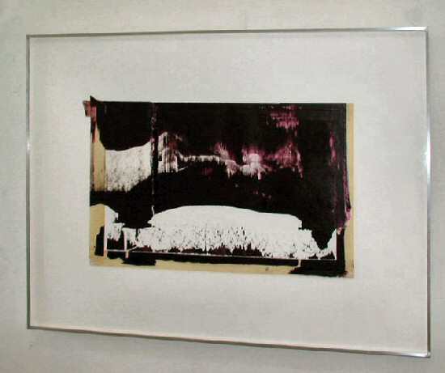
Morat Sade, 2000-2001
Acrylic on paper 15 1/4 x 24 inches EM0013
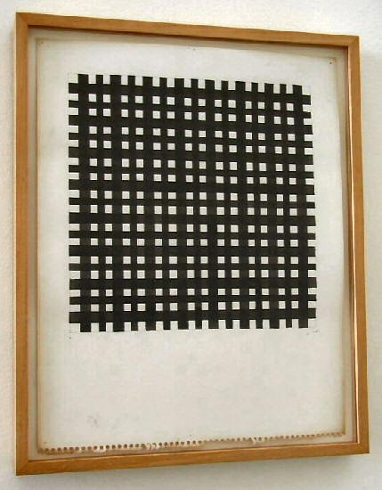
Untitled, 1978
Ink on paper 15 3/8 x 12 1/4 inches EM0011

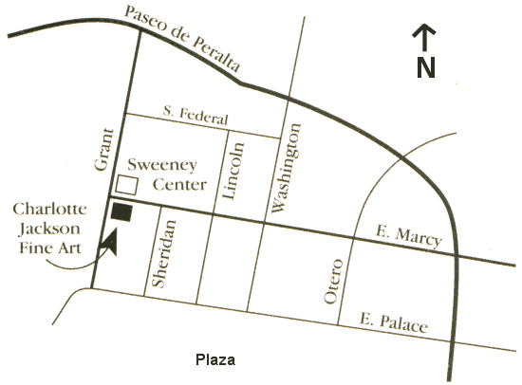
200 W. Marcy Street
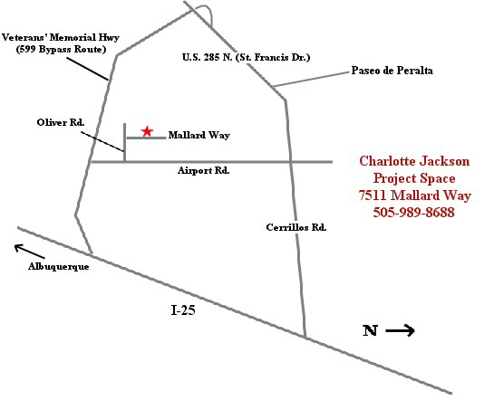

© 2007
Charlotte Jackson Fine Art, Inc.

200 West Marcy Street, Suite 101, Santa Fe, New Mexico 87501
Telephone: 505.989.8688 Fax: 505.989.9898
cjfa@charlottejackson.com - www.charlottejackson.com

