CHARLOTTE JACKSON FINE ART

PRESENTS:

Eric Tillinghast: Colored Panels
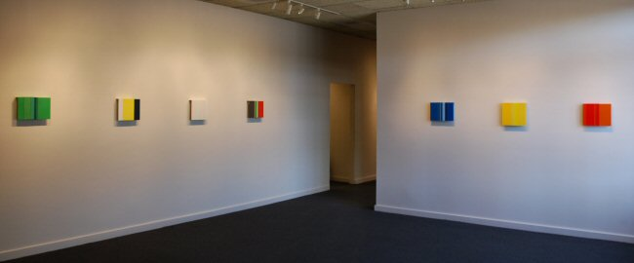
May 4 - May 27
Opening Reception, Friday, May 4th, 5-7 pm

Eric Tillinghast, an artist with a very developed and inclusive interest in artistic questions and possibilities, always has several projects waiting for the chance to come to fruition. One of these projects, a study of color, is featured in this exhibition.
The Hanging Panels, made of multiple overlaid vertical panels of enameled paint on steel do indeed seem the perfect format for what he calls “color constructions”. The varied palette is appealing: sometimes surprising and playful and sometimes intense and subtle. Tillinghast mentions this series is for him a “backdoor” to painting, a way to delve into the ways color does and does not translate from the natural world and to look at how colors effect one another in confluence. Often a collection of book covers, a candy wrapper, or a person’s shirt, will influence combinations and color choices, but sometimes the explorations are more formally planned, for instance creating a hanging panel out of all the various reds he can find.
For the most part the pieces are intimate, on a small scale (generally ranging between 10 and 13 inches), inviting close inspection and familiarity. A few of the works, which will be slightly larger, perhaps 20 x 20 inches, will be in a modular format, with the panels unfixed. This format will allow the artist to arrange the various vertical panels and then rearrange them according to new insights and possibilities. Tillinghast finds this potential intriguing, allowing the work to remain somewhat open-ended and leaving some questions, in a way, unanswered.
The uniting factor in the work of Eric Tillinghast is a precision of execution and sharp insight into intriguing questions of perception and art.

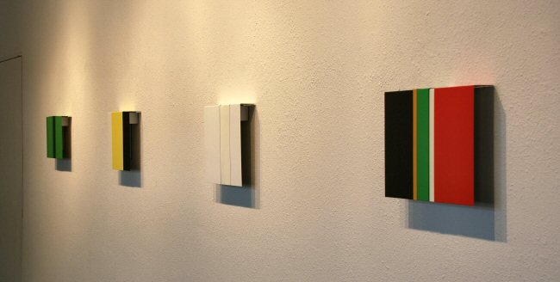
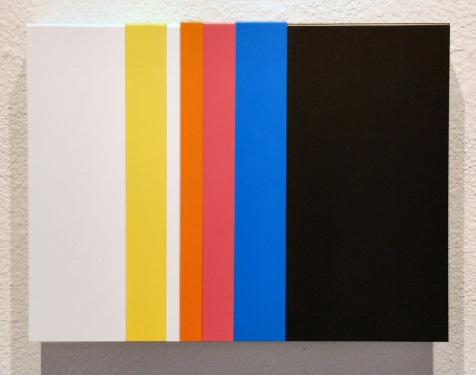
Hanging Panels #33, 2007
painted steel, 11 x 15 x 2 inches ET0058
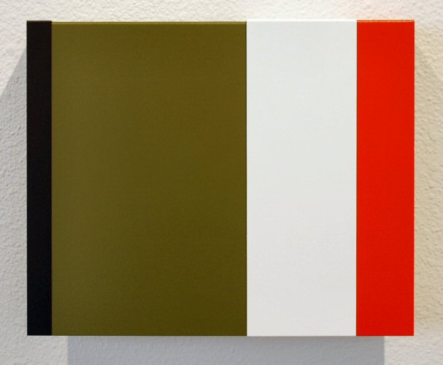
Hanging Panels #31, 2007
painted steel, 10 x 12 1/2 x 2 inches ET0056
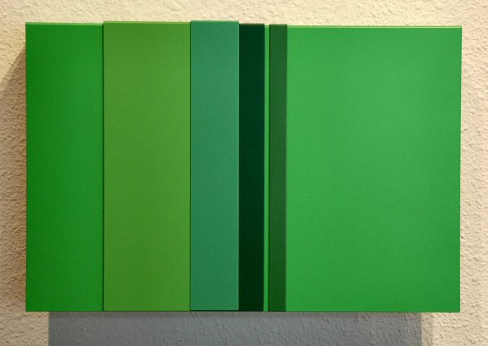
Hanging Panels #19, 2007
painted steel, 9 x 13 x 2 inches ET0044
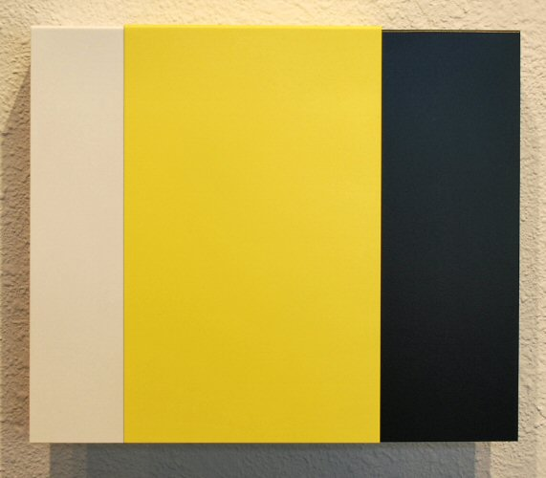
Hanging Panels #29, 2007
painted steel, 10 x 12 x 2 inches ET0054
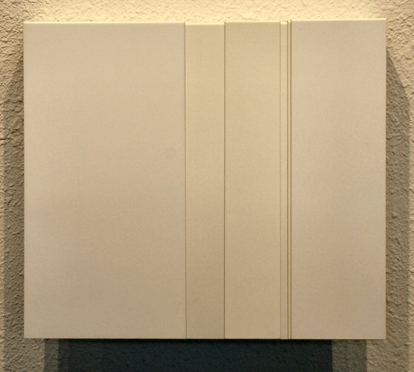
Hanging Panels #17, 2007
painted steel, 10 x 11 3/4 x 2 inches ET0039
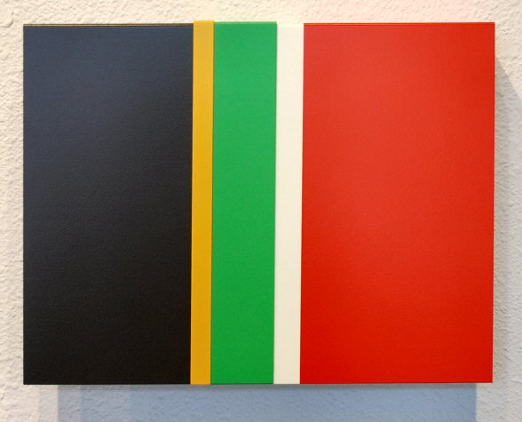
Hanging Panels #25, 2007
painted steel, 10 x 13 x 2 inches ET0050
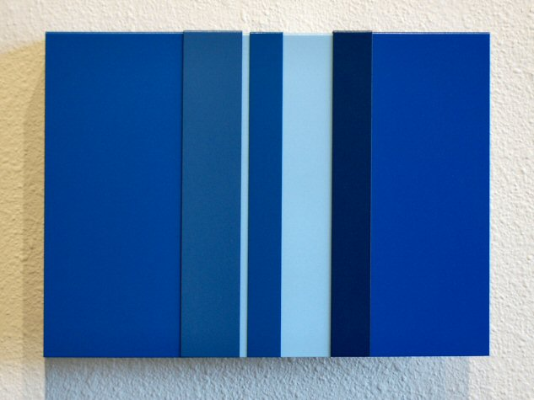
Hanging Panels #21, 2007
painted steel, 10 x 14 x 2 inches ET0046
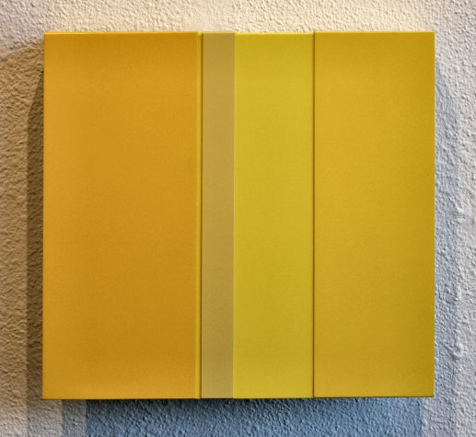
Hanging Panels #7, 2007
painted steel, 11 1/2 x 12 1/2 x 2 inches ET0063
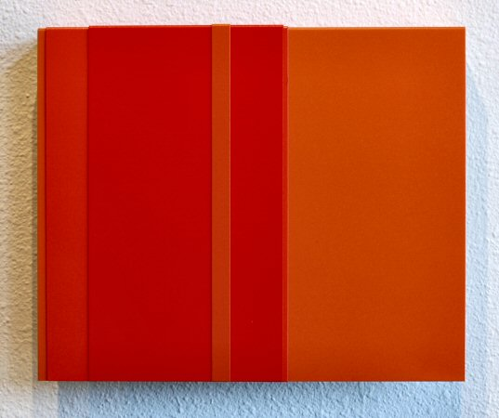
Hanging Panels #22, 2007
painted steel, 10 1/2 x 13 x 2 inches ET0047
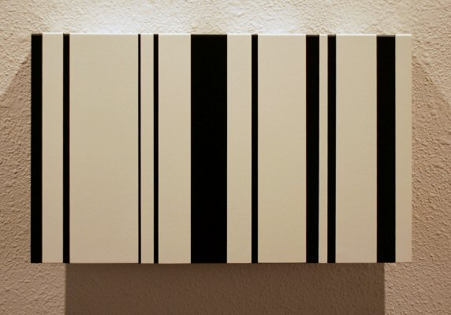
Hanging Panels #38, 2007
painted steel, 10 x 17 x 2 inches ET0062
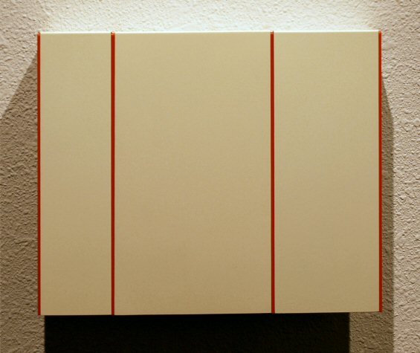
Hanging Panels #10, 2007
painted steel, 9 3/4 x 12 x 2 inches ET0042
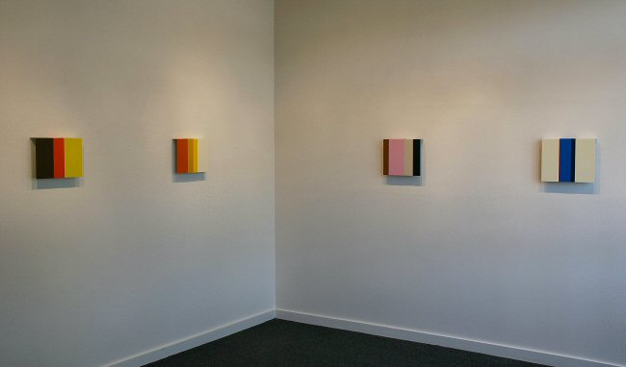

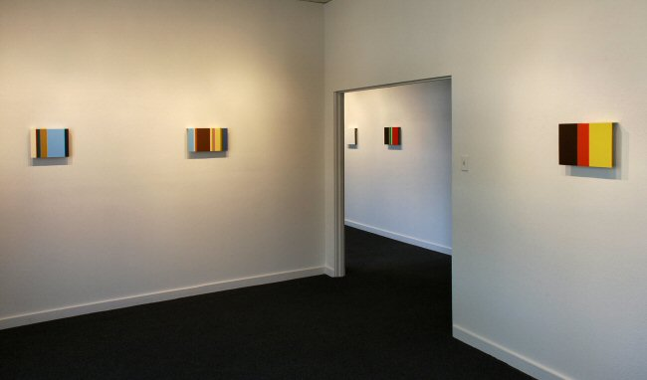
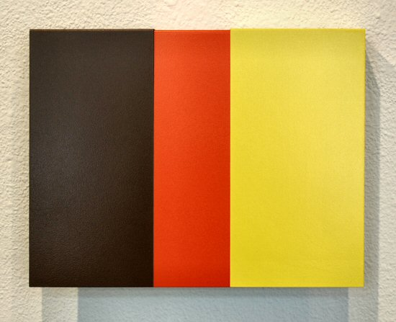
Hanging Panels #34, 2007
painted steel, 9 3/4 x 13 x 2 inches ET0059
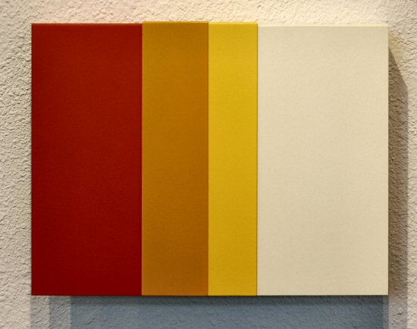
Hanging Panels #23, 2007
painted steel, 10 1/4 x 13 1/2 x 2 inches ET0048
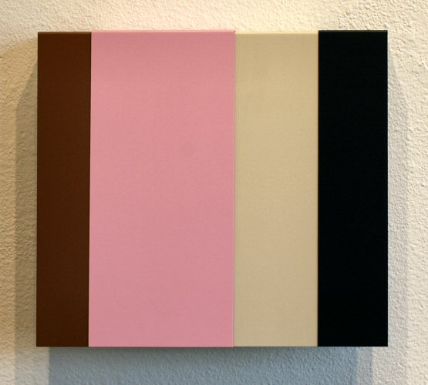
Hanging Panels #27, 2007
painted steel, 11 1/2 x 13 x 2 inches ET0052
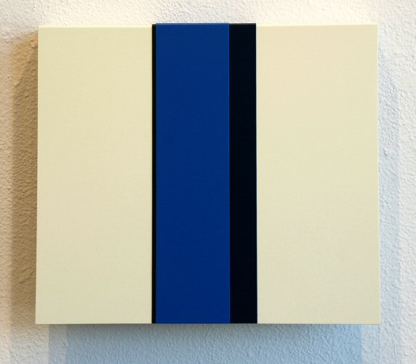
Hanging Panels #32, 2007
painted steel, 12 x 14 x 2 inches ET0057
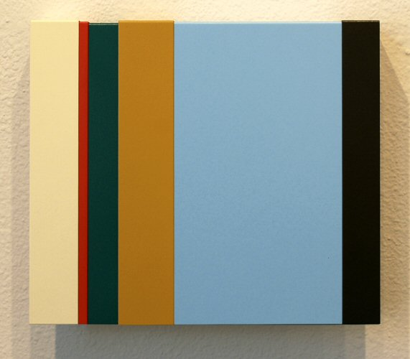
Hanging Panels #18, 2007
painted steel, 9 1/2 x 11 x 2 inches ET0043
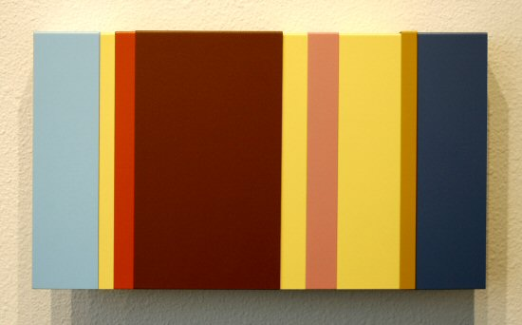
Hanging Panels #14, 2007
painted steel, 10 x 11 3/4 x 2 inches ET0040

© 2007

Charlotte Jackson Fine Art, Inc.

200 West Marcy Street, Suite 101, Santa Fe, New Mexico 87501
Telephone: 505.989.8688 Fax: 505.989.9898
cjfa@charlottejackson.com - www.charlottejackson.com

Photography & CD Production:
William Metcalf

