CHARLOTTE JACKSON FINE ART PRESENTS:

David Simpson

Heaven and Earth: Interference Paintings

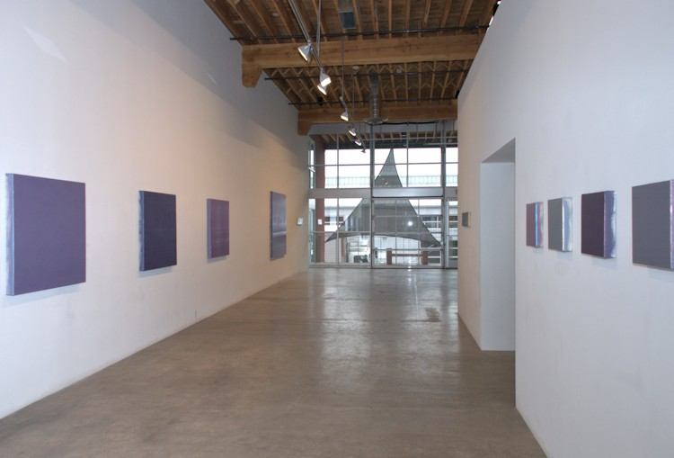

April 4 - May 5, 2014

There is always something to discover in the work of David Simpson because his paintings are never finished becoming. A viewer might stand in front of a large canvas, like Pale Dragon, caught up in a particular shade and tone of deep purple-blue. And then the light in the room will (inevitably) change--the sun moves, a cloud passes, and the color will shift, metamorphose into a pink-violet frosted by silver ice. Morning, noon, night. The passing of seasons and weather, the declination of the sun, all can be read in the ever changing, always different moods of Simpson's canvases.

Those who know Simpson's work well will know that these chimerical pieces, which sometimes shift subtly between tones of one color and at other times radically across the spectrum, are all created using the application of a single (thus monochrome) color of interference paint. It is the microparticles within the paint, coated with silica (mica), which capture light, reflect and refract it from particle to particle, so that the light prisms and the viewer is able to see multiple colors instead of only one. The pieces, so deceptively simple and poetic in their evocation of color, are in fact works of extreme precision and control. The formulas that Simpson has created within the limited range of interference paints have taken decades to master. And the techniques of applying the paints require a strenuous physical labor and meticulous, almost scientific, attention to detail. For all this, though, the final result is always, to a large extent, indeterminate. There is no way for Simpson to control precisely which way those tiny particles of mica will fall, and therein lies the action of chance. As Simpson says, the paintings are, "a constant surprise, like magic."

For viewers, that sense of perpetual discovery is increased with Heaven and Earth: Interference Paintings by the opportunity to view yet another side to Simpson's work with inclusion of four wood panel paintings. These works are at first glance a radical departure from Simpson's more familiar monochrome pieces. However, as Simpson says, "I've always worked in other idioms, but the paper and wood panel pieces are rarely shown."

The four panels included in Heaven and Earth: Interference Paintings are small narrow rectangles which effect the look of strange, imaginary landscapes. The extraordinary forms and patterns are organic and suggestive of places or things that are almost (though never quite) familiar ... always just beyond a definitive point of reference. Simpson says that in addition to using interference paints for these works (of different colors), there is an element of indeterminacy in their making. He never plans or pre-sketches the pieces, instead letting the forms arise spontaneously. Simpson says because these works tend to evoke subject matter (however elusive) they tend to be more topical and he allows his titles (like, After the Rim Fire (a terrible beauty) to directly reference ecological or political situations of the moment.

The genius of Simpson's paintings is not only that they manage to remain indefinite--always becoming something else, always surprising—but that they simultaneously are able to be so unassumingly beautiful. Sky blue tumbles into a pale gold glow—hinting at skies and sunsets the viewer may have known. As with any sunset, their beauty is no less for being mutable.

With Heaven and Earth: Interference Paintings, viewers will have the opportunity to view Simpson's most well-known work, in addition to a rare glimpse at another idiom with his panel pieces.
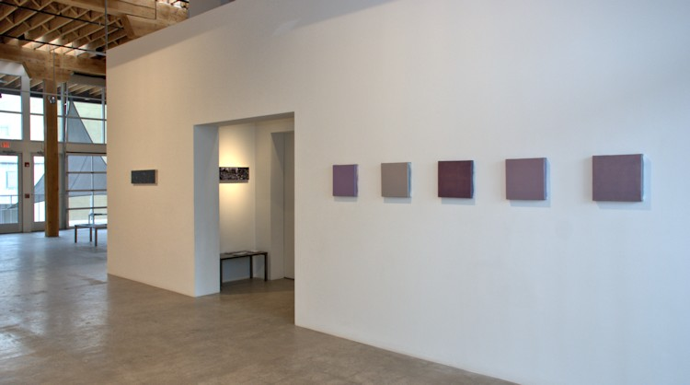

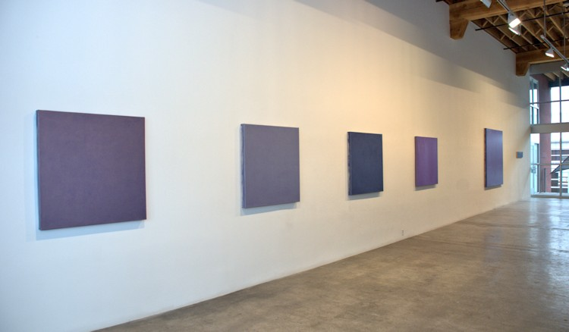
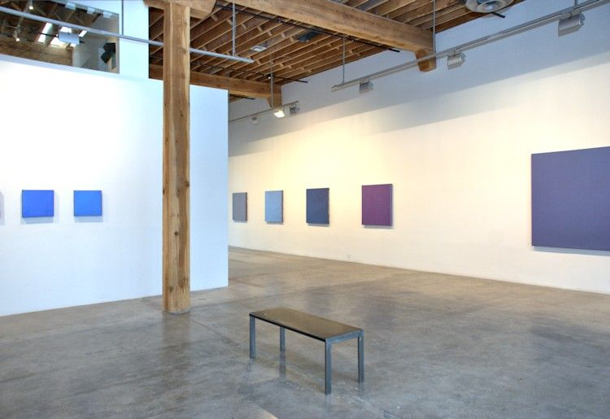

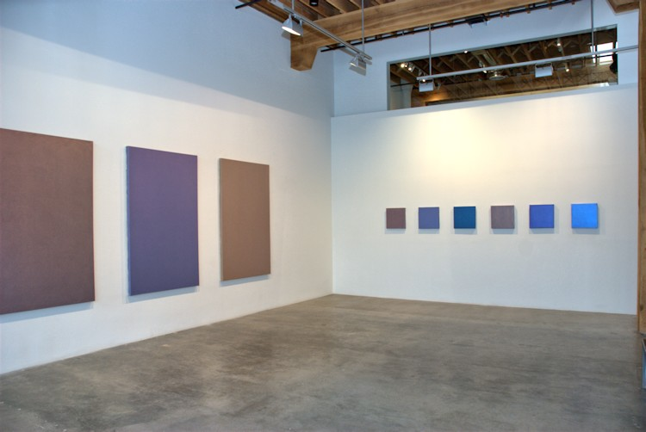
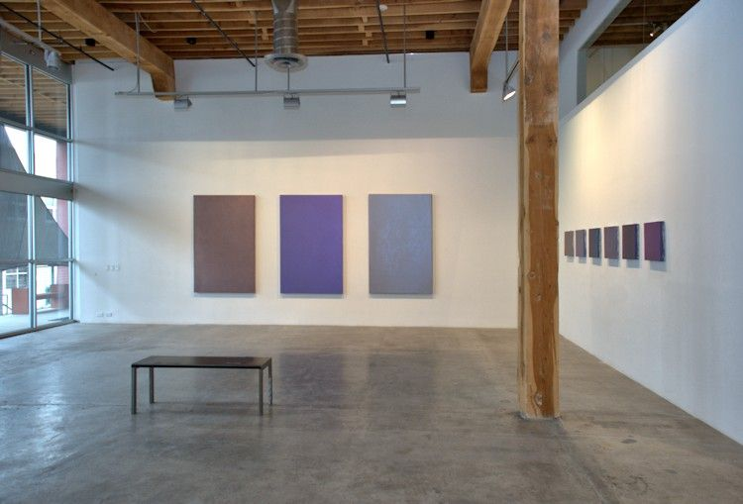

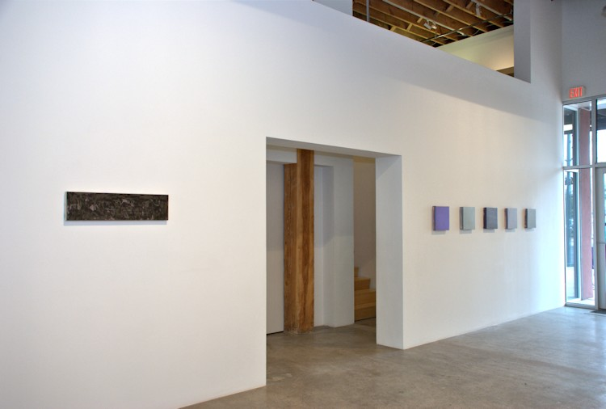
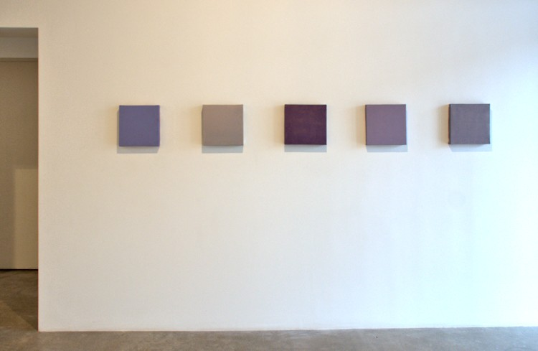

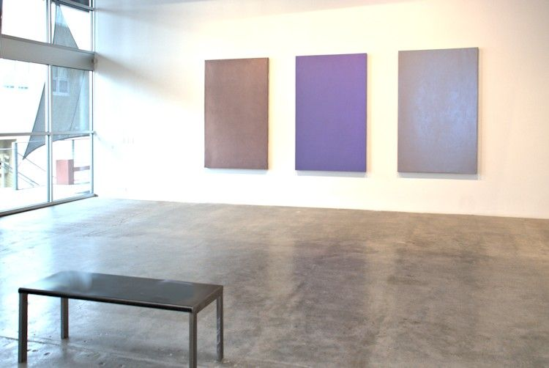
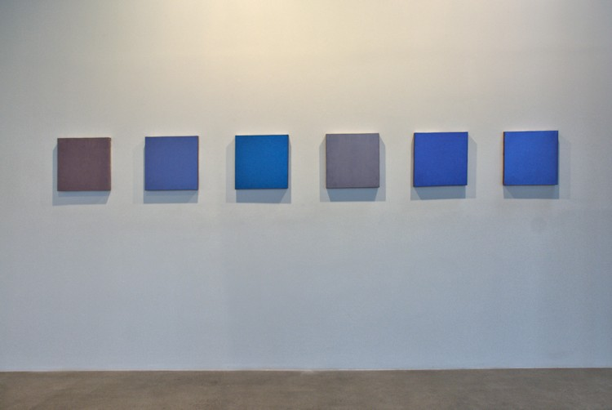

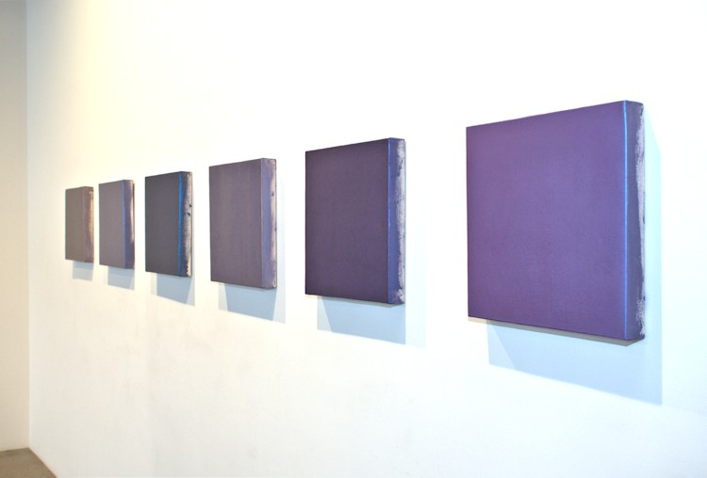
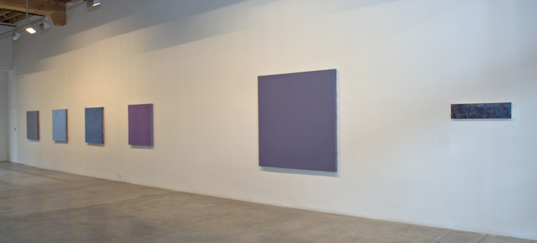
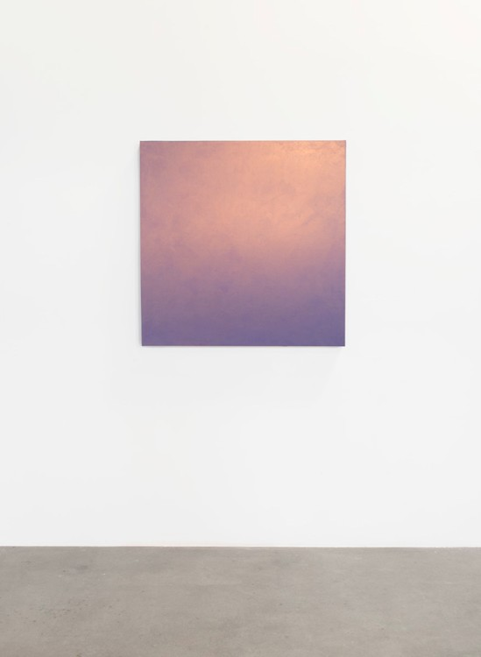
Burnt Offering, 2013
Acrylic on Canvas (interference pigment)
40 x 40 inches
DS190
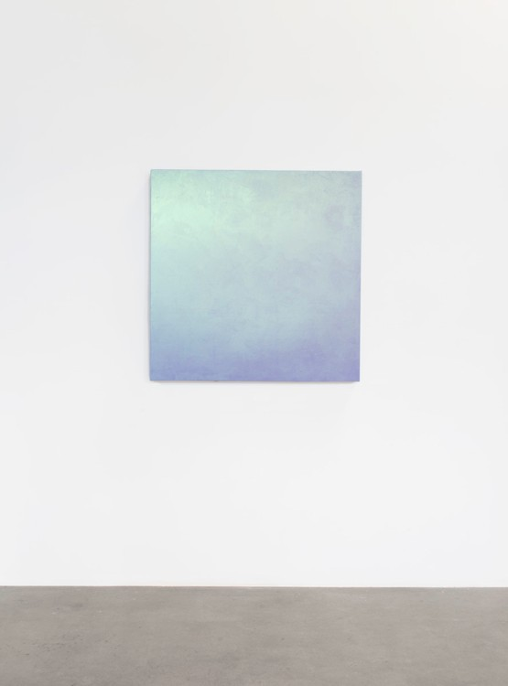
Pale Dragon, 2013
Acrylic on Canvas (interference pigment)
40 x 40 inches
DS191
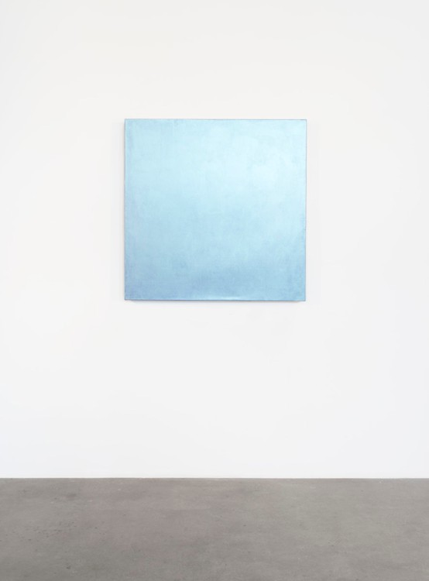
Dragon Fly, 2014
Acrylic on Canvas (interference pigment)
40 x 40 inches
DS188
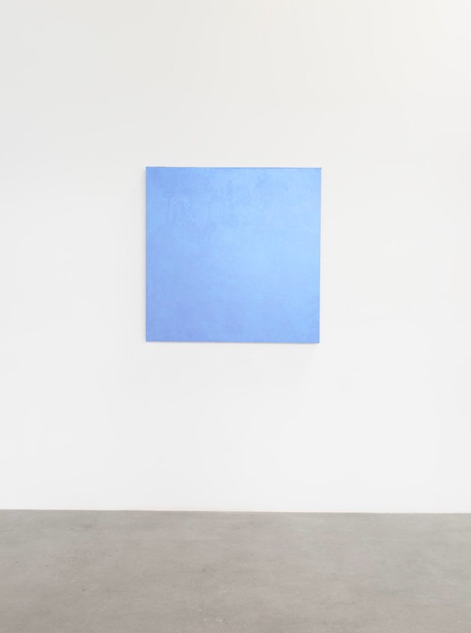
Blue Blood, 2013
Acrylic on Canvas (interference pigment)
40 x 40 inches
DS189
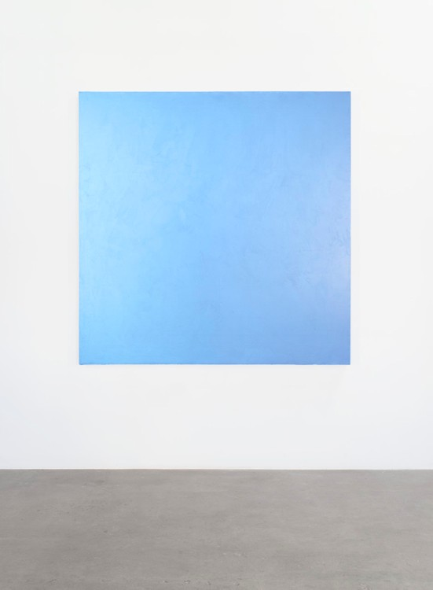
Skylark, 2013
Acrylic on Canvas (interference pigment)
66 x 66 inches
DS192
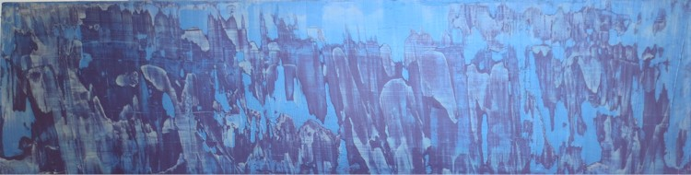

All Hallows Eve, 2013
Acrylic on wood panel (interference pigment)
8 x 31 x 1 1/2 inches
DS209
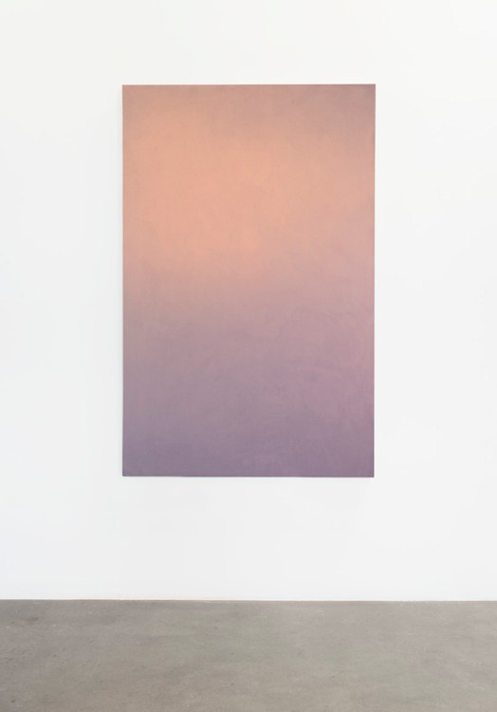
April First, 2012
Acrylic on Canvas (interference pigment)
75 x 48 inches
DS193
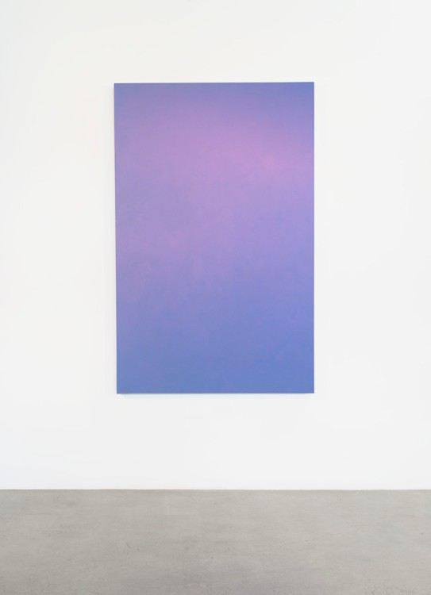
Enthrone, 2013
Acrylic on Canvas (interference pigment)
75 x 48 inches
DS194
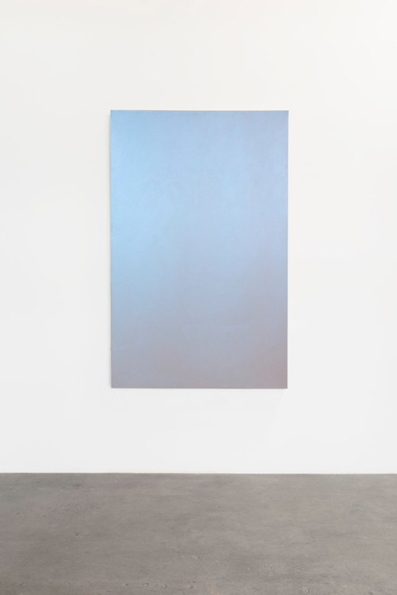
Mississippi, 2012
Acrylic on Canvas (interference pigment)
75 x 48 inches
DS195
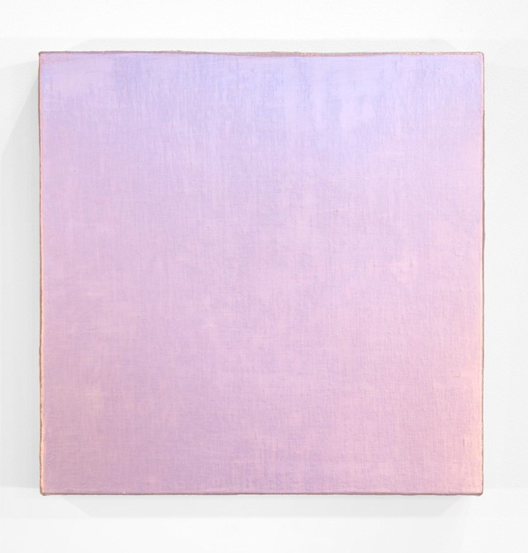
High Sigh, 2013
Acrylic on Canvas (interference pigment)
16 x 16 x 2 inches
DS202
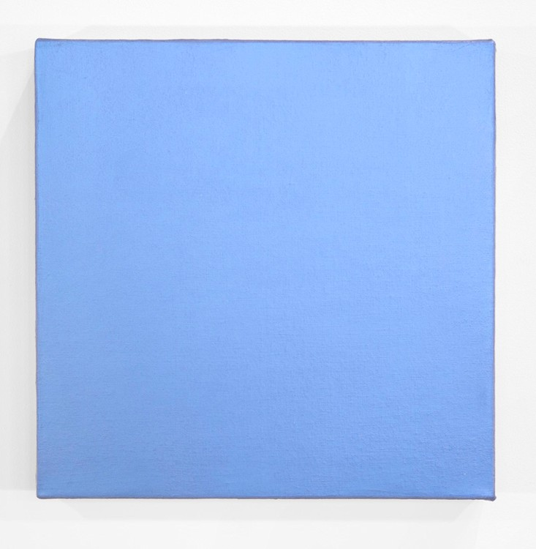
Over Cast, 2013
Acrylic on Canvas (interference pigment)
16 x 16 x 2 inches
DS208
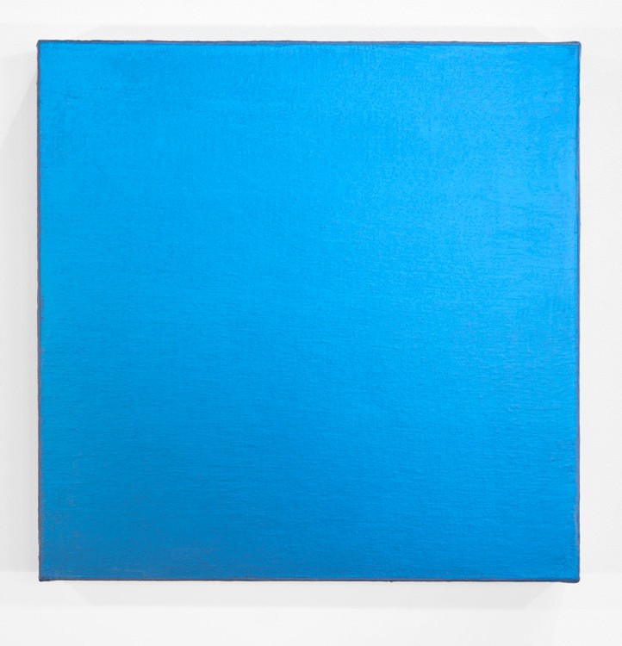
Sky Dusk, 2013
Acrylic on Canvas (interference pigment)
16 x 16 x 2 inches
DS207
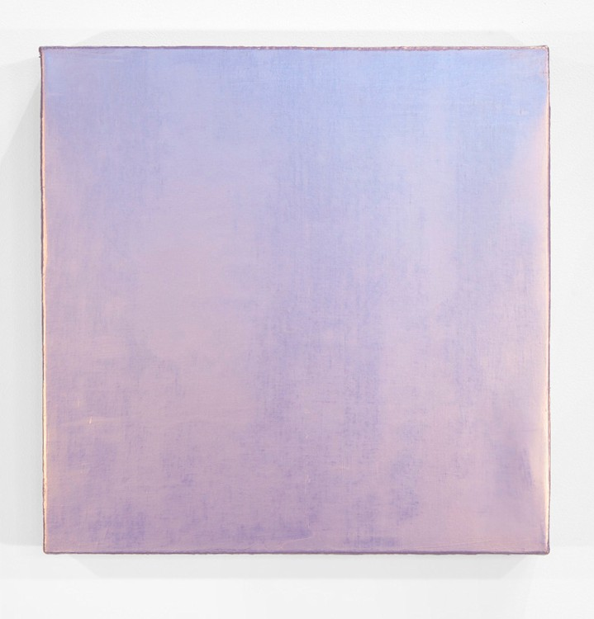
Violet Flight, 2013
Acrylic on Canvas (interference pigment)
16 x 16 x 2 inches
DS203
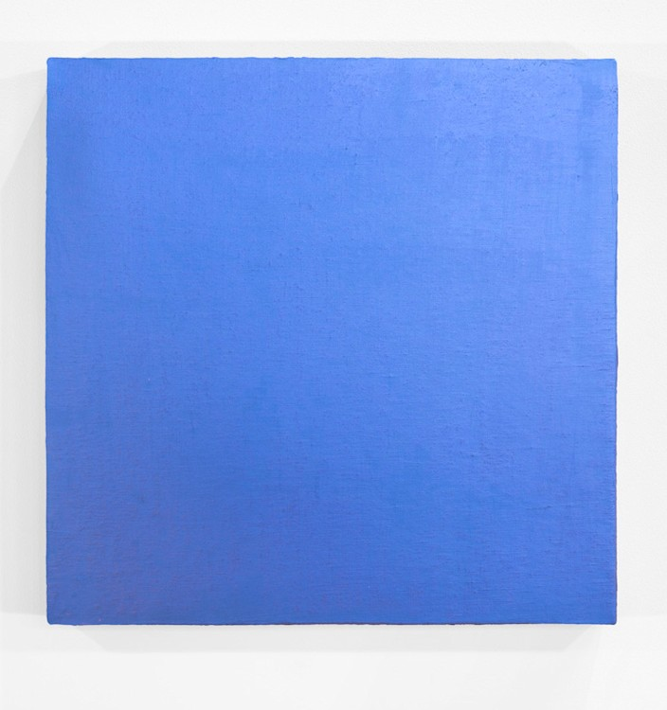
Violet Night, 2013
Acrylic on Canvas (interference pigment)
16 x 16 x 2 inches
DS204
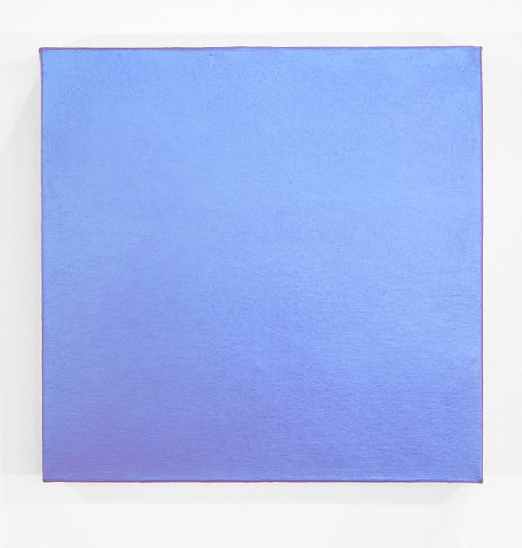
Voila, 2013
Acrylic on Canvas (interference pigment)
16 x 16 x 2 inches
DS206
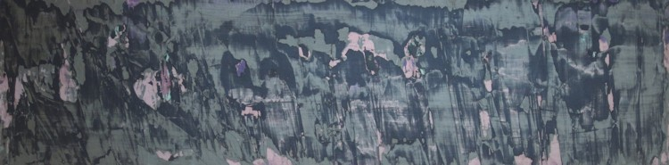
Circa 1908, 2013
Acrylic on wood panel (interference pigment)
8 x 31 x 1 1/2 inches
DS210

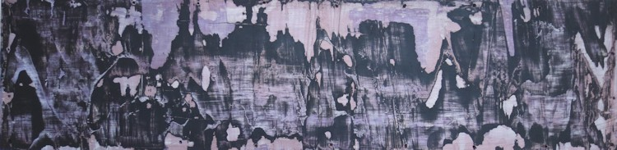
After the Rim Fire (A Terrible Beauty), 2013
Acrylic on wood panel (interference pigment)
8 x 32 x 1 1/2 inches
DS212
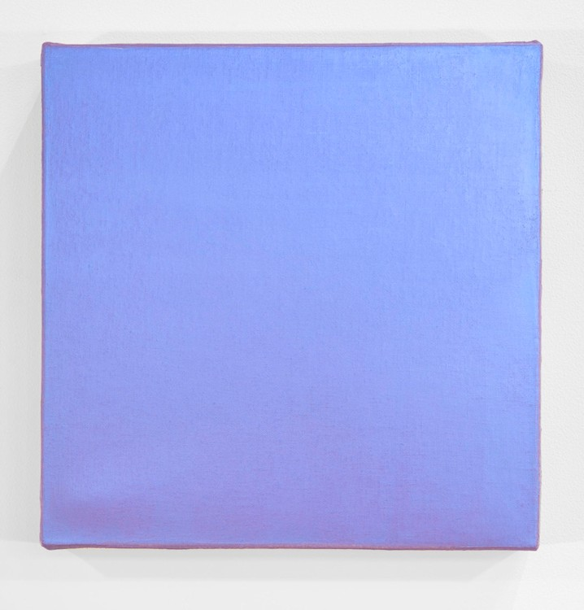
Little Berkeley Blues, 2013
Acrylic on Canvas (interference pigment)
12 x 12 x 2 inches
DS197
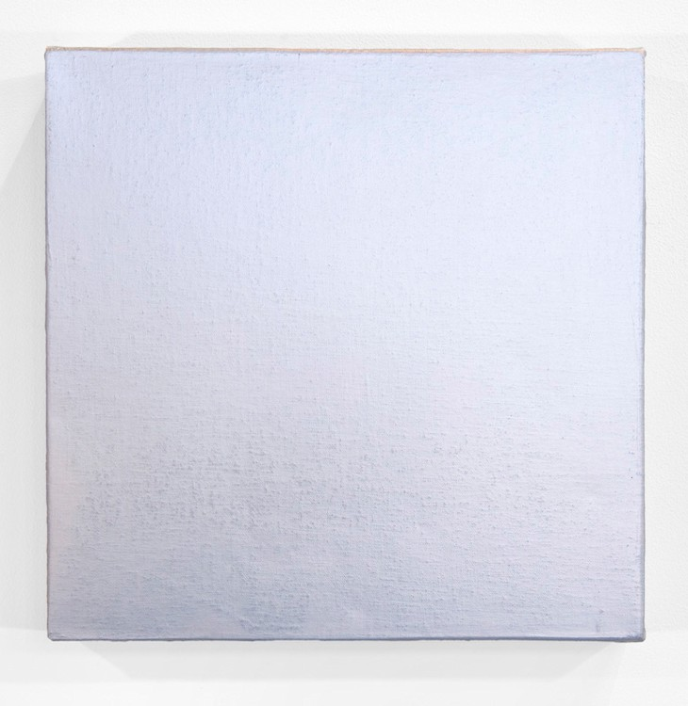
The Small Version, 2013
Acrylic on Canvas (interference pigment)
12 x 12 x 2 inches
DS196
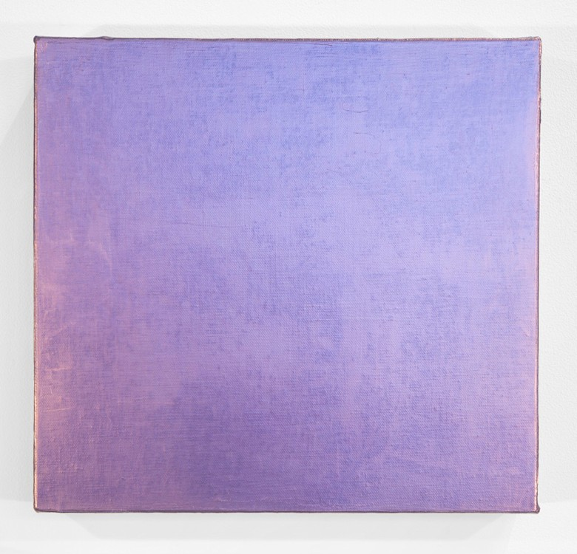
Shrinking Violet, 2013
Acrylic on Canvas (interference pigment)
12 x 12 x 2 inches
DS200
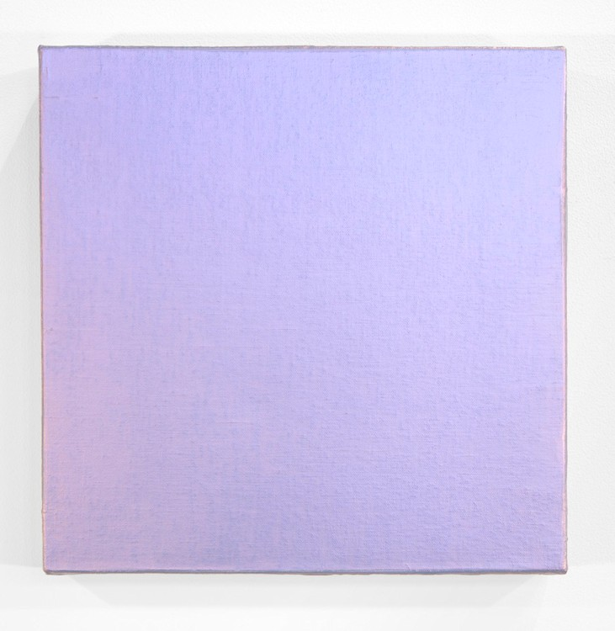
Far Away, 2013
Acrylic on Canvas (interference pigment)
12 x 12 x 2 inches
DS199
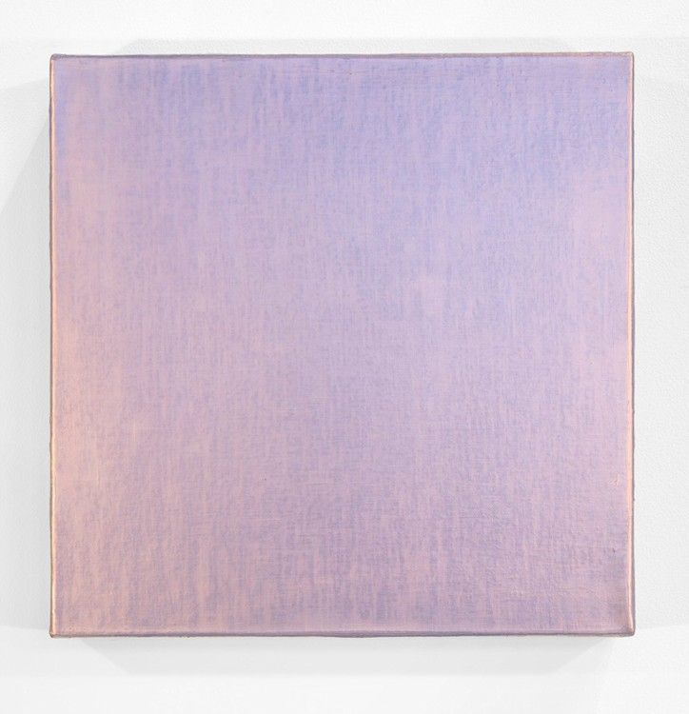
Odd Warm, 2013
Acrylic on Canvas (interference pigment)
12 x 12 x 2 inches
DS198

© 2014

Charlotte Jackson Fine Art, Inc.

In the Railyard at:

554 S. Guadalupe, Santa Fe, New Mexico 87501
Telephone: 505.989.8688 Fax: 505.989.9898
cjfa@charlottejackson.com - www.charlottejackson.com

