CHARLOTTE JACKSON FINE ART PRESENTS:

Tony DeLap: Selected Works from Fifty Years of Making Art

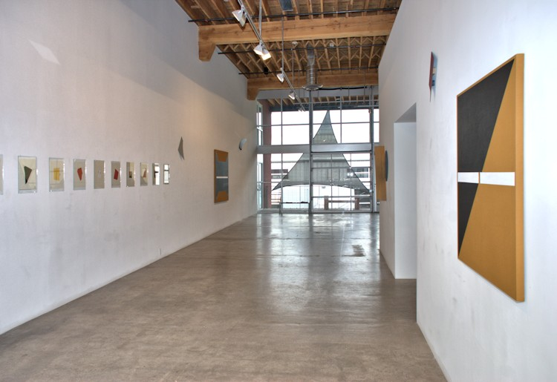

October 17 – November 17, 2014

Film Premier and Book Signing:

Tony DeLap, a book by Art Santa Fe *Presents* and Radius Books

Tony DeLap: A Unique Perspective, a film by Dale Schierholt

Monday, October 20th, 4-6pm, Jean Cocteau Cinema, 418 Montezuma Ave., Santa Fe

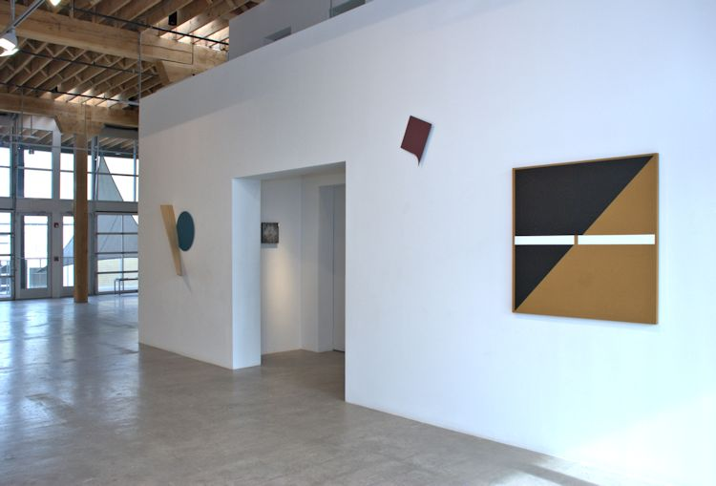

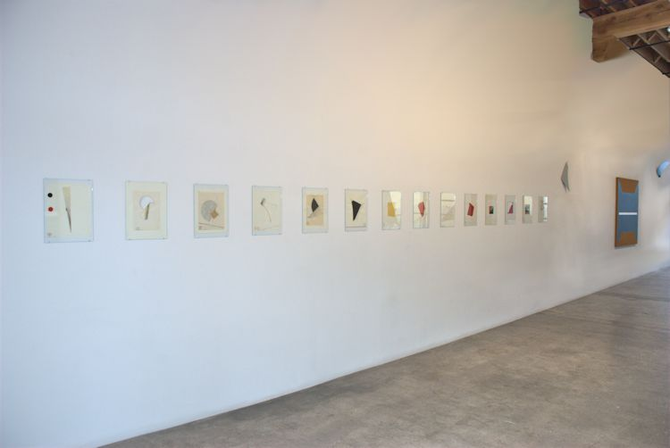

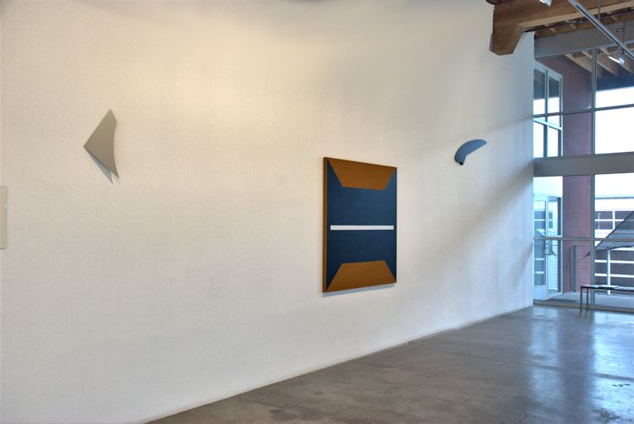

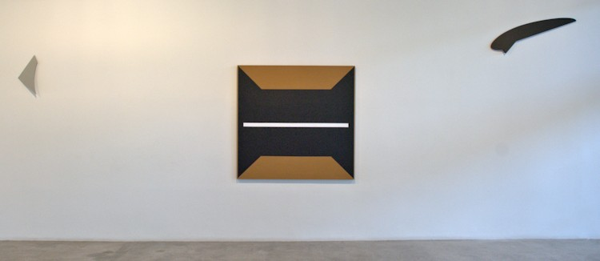

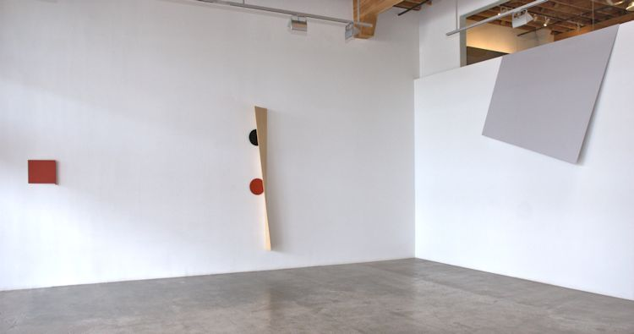

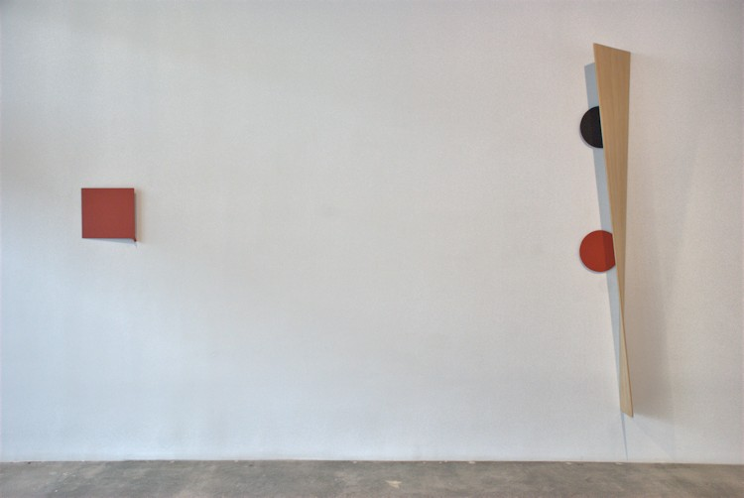

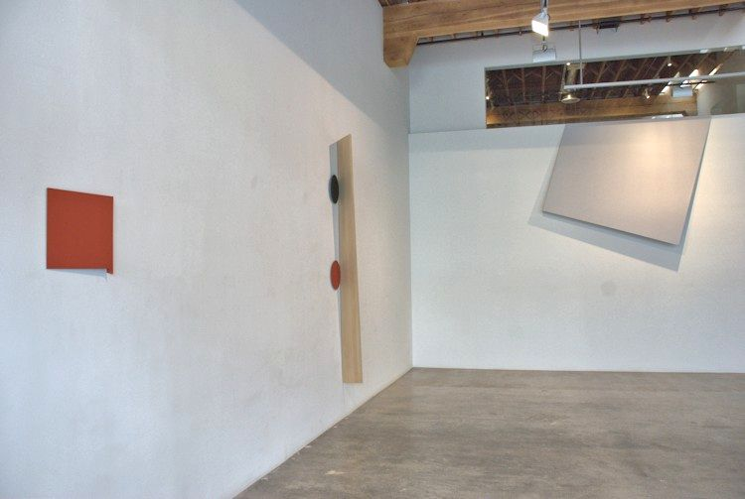

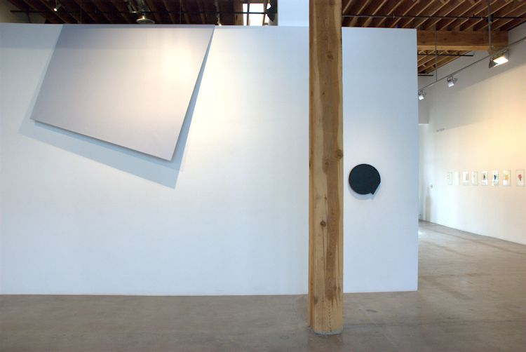

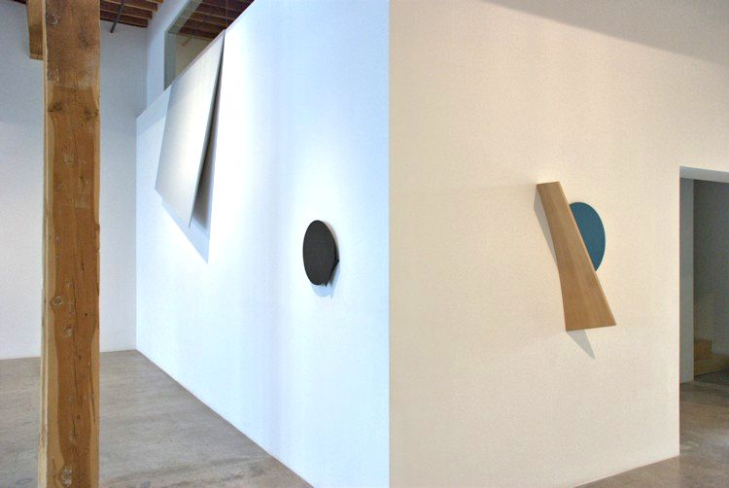

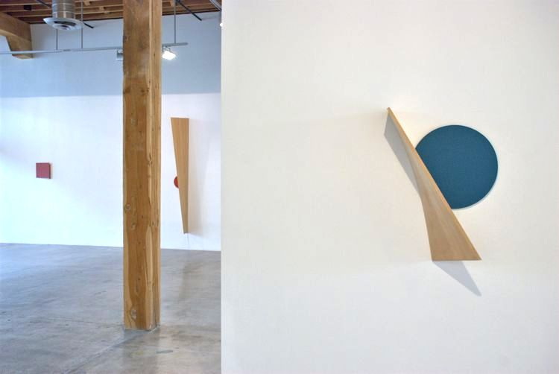

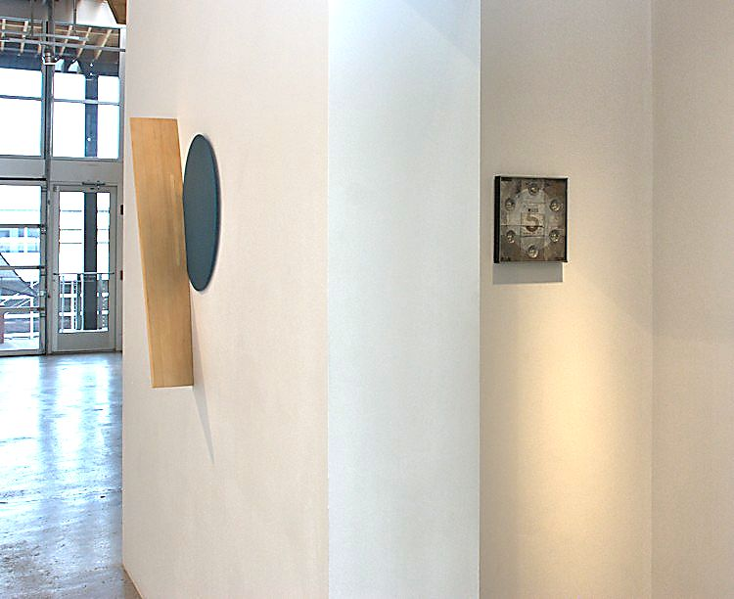

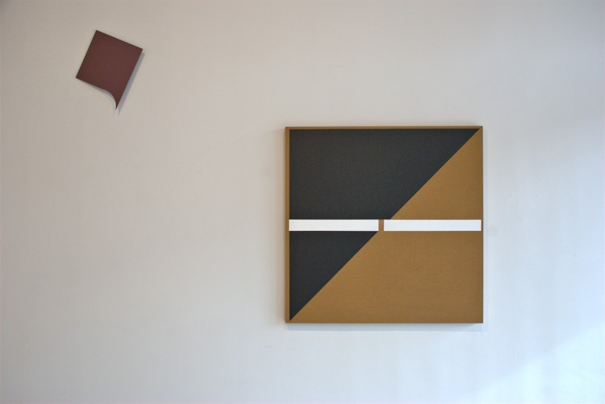

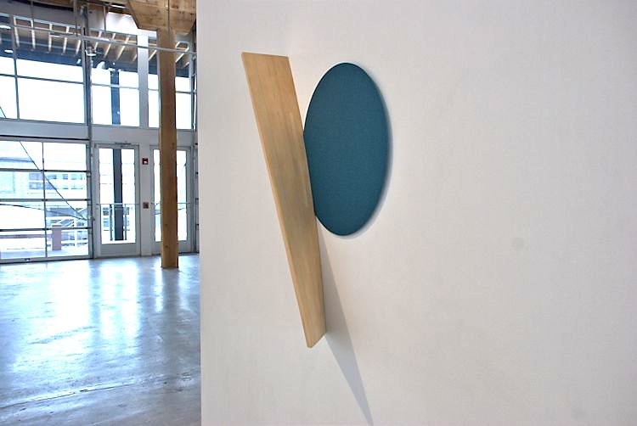

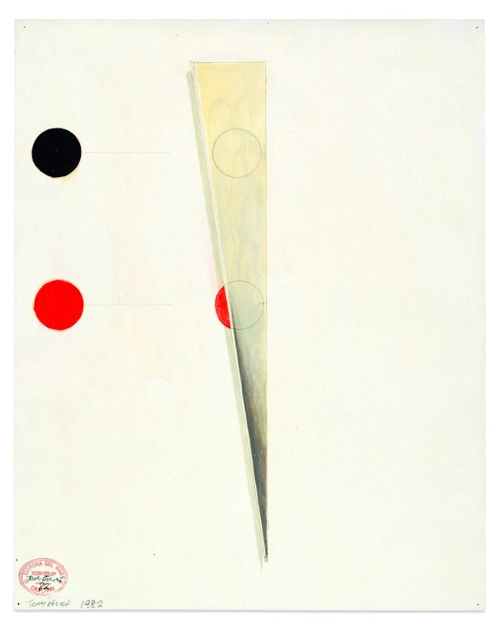

Pips Eclipse, 1982   
watercolor on paper  
14 x 11 inches  
TD0125

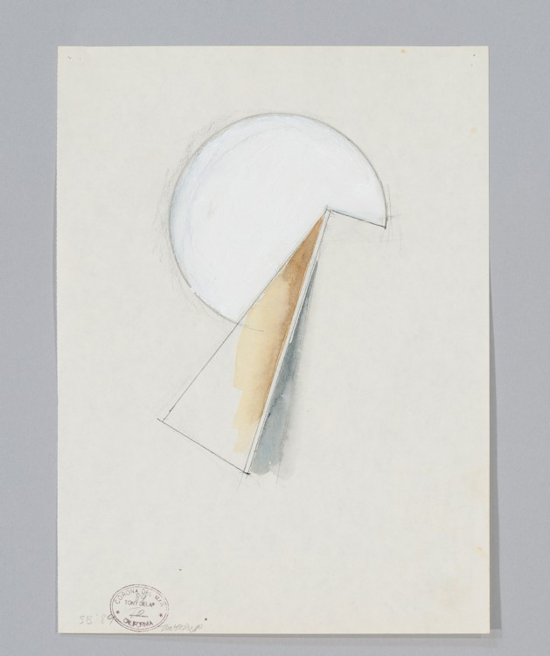

Untitled (SB), 1989   
pencil, collage on paper  
16 x 12 inches  
TD0175

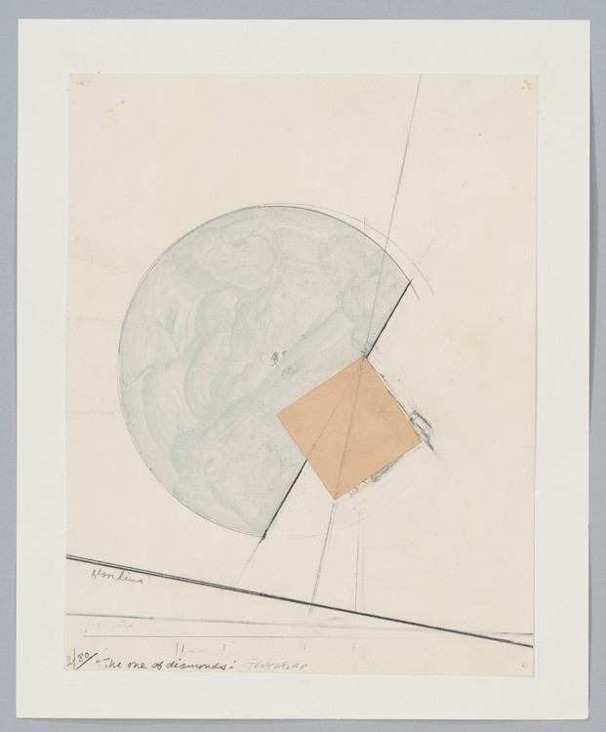

The One of Diamonds Drawing, 1980   
mixed media on paper  
12 x 9 inches  
TD0171

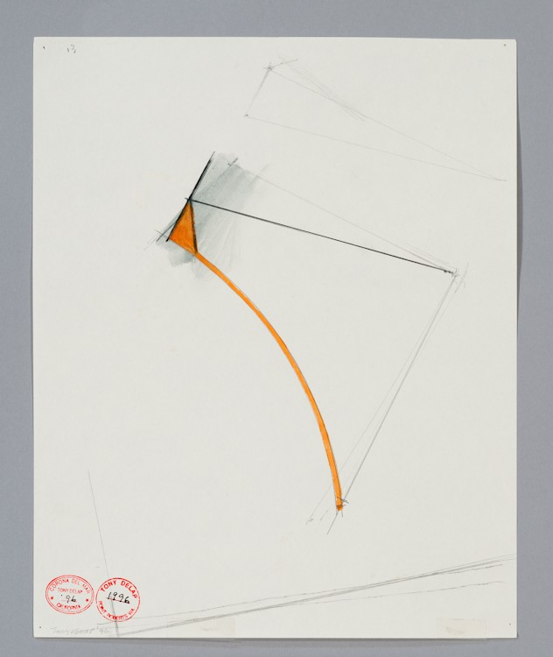

Untitled 13, 1996   
collage on paper  
13 1/2 x 11 inches  
TD0178

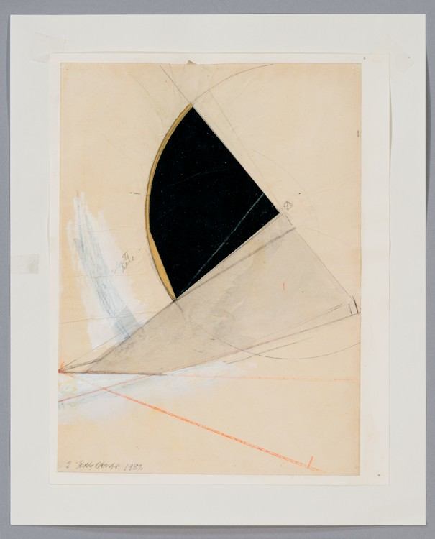

Unttiled #2, 1982   
collage on paper  
13 1/2 x 11 inches  
TD0173

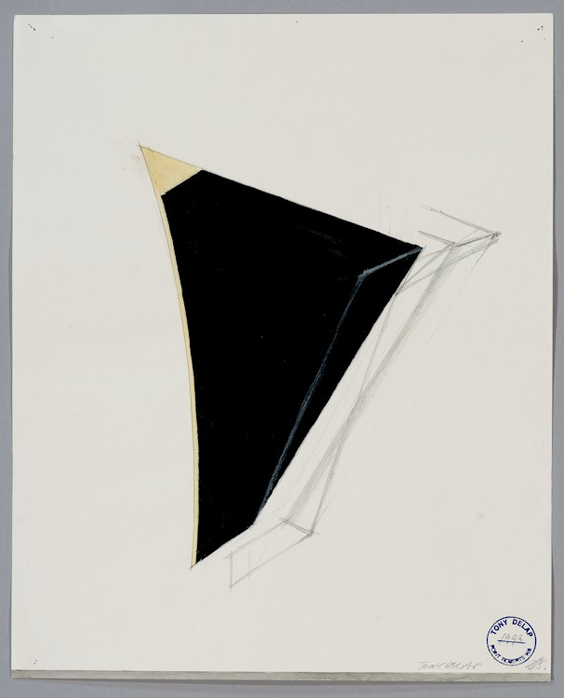

Untitled, 1993   
collage on paper  
13 1/2 x 11 inches  
TD0177

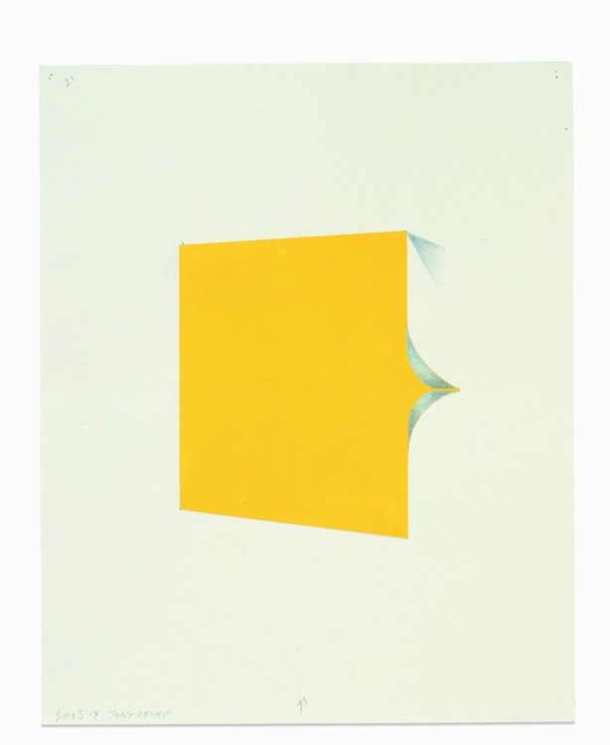

Untitled 21, 2003   
collage on paper  
13 1/2 x 11 inches  
TD0185

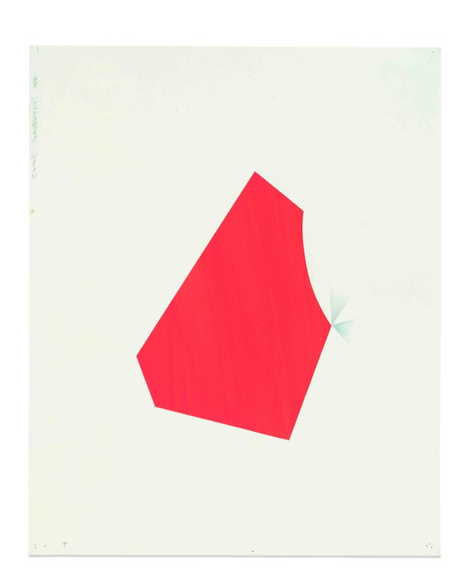

Untitled 9, 2003   
collage on paper  
13 1/2 x 11 inches  
TD0184

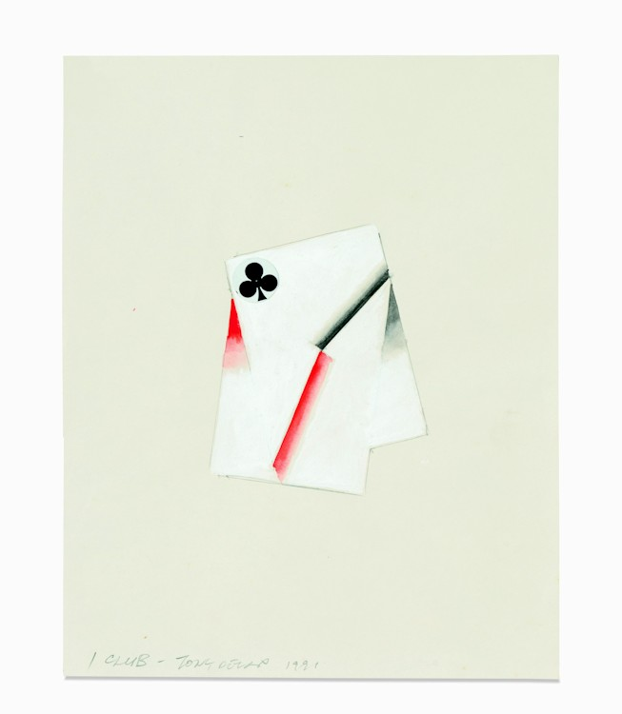

1 Club, 1991   
collage on paper  
10 x 8 inches  
TD0176

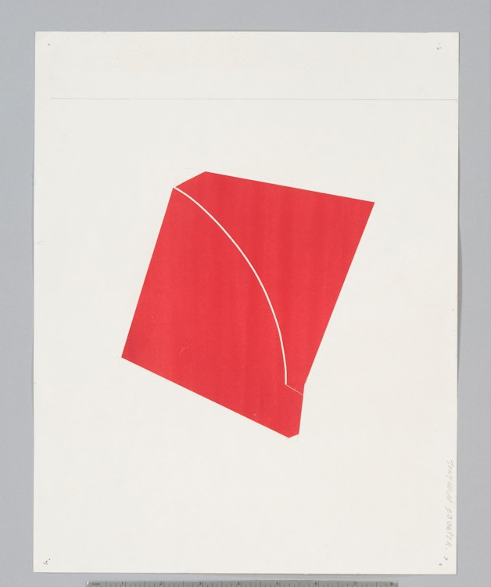

Untitled (PTR), 2006   
collage on paper  
14 x 11 inches  
TD0126

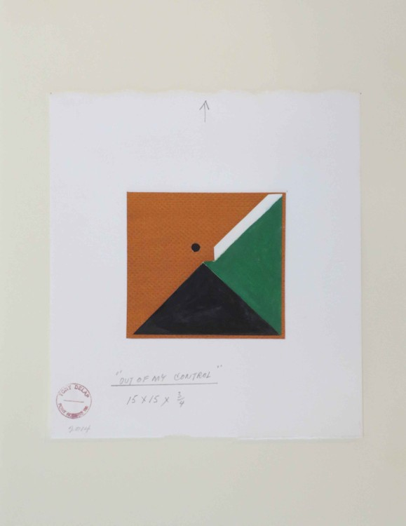

Out of My Control Drawing, 2014   
mixed media on paper  
10 x 9 inches  
TD0151

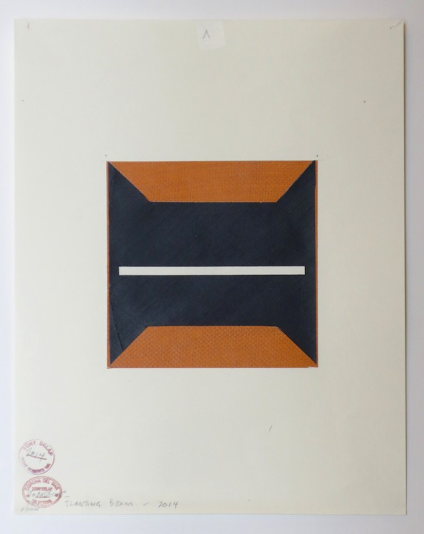

Floating Beam II Drawing, 2014   
mixed media on paper  
14 x 11 inches  
TD0148

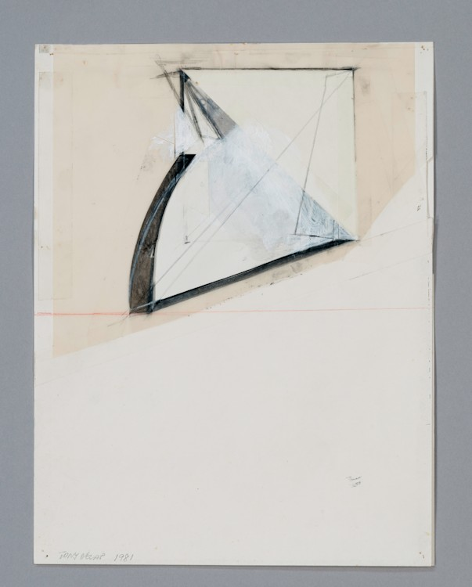

Untitled, 1981   
collage on paper  
16 x 12 inches  
TD0172

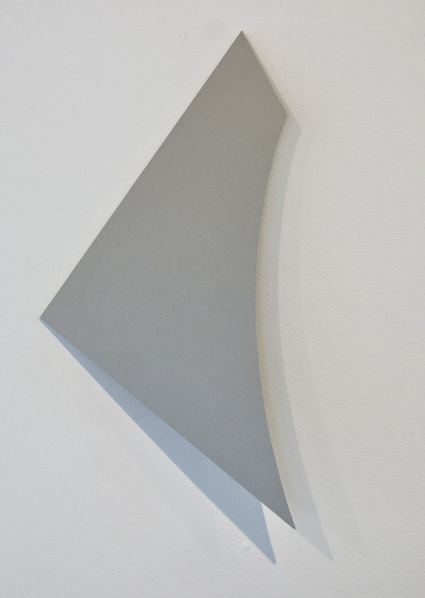

Mister Mirical, 2014   
acrylic on aluminum  
20 3/4 x 10 1/2 x 2 1/4 inches  
TD0134

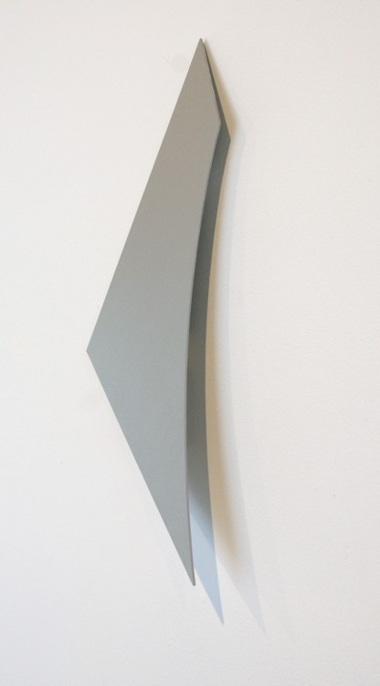

Mister Mirical, 2014   
acrylic on aluminum  
20 3/4 x 10 1/2 x 2 1/4 inches  
TD0134 (Detail)

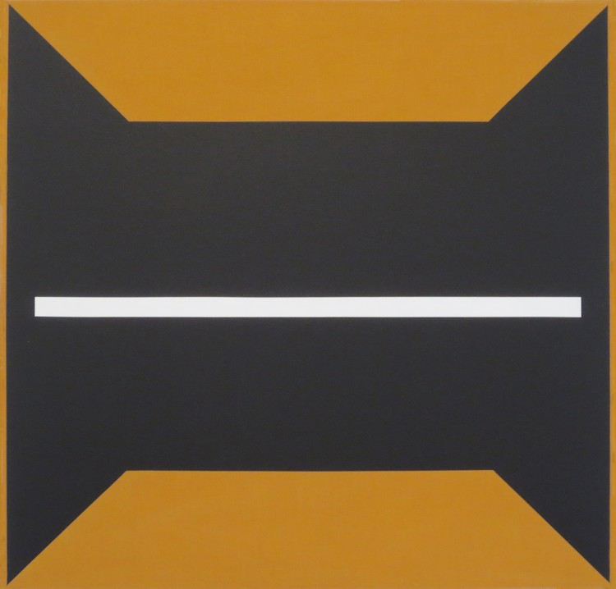

Floating Beam II, 2014   
acrylic on linen  
58 x 60 inches  
TD0147

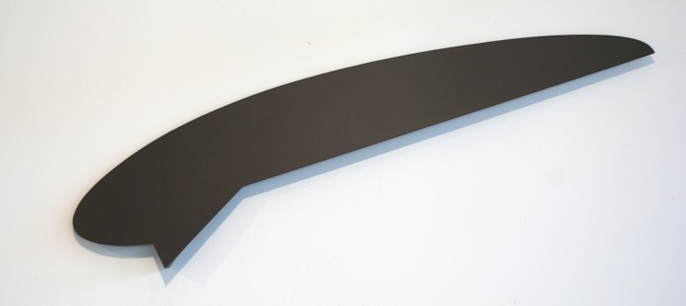

Matoon, 1998  
Aluminum, wood, acrylic paint  
11 x 47 x 2 inches  
TD0133

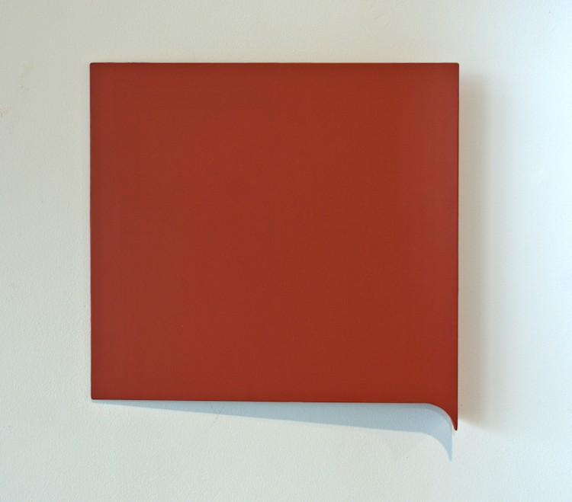

Gaffed In Red, 2012   
aluminum, acrylic paint  
15 x 15 x 1 3/4 inches  
TD0087

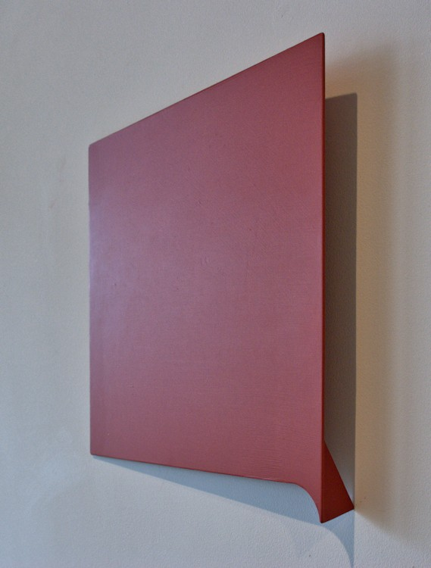

Gaffed In Red, 2012   
aluminum, acrylic paint  
15 x 15 x 1 3/4 inches  
TD0087 (Detail)

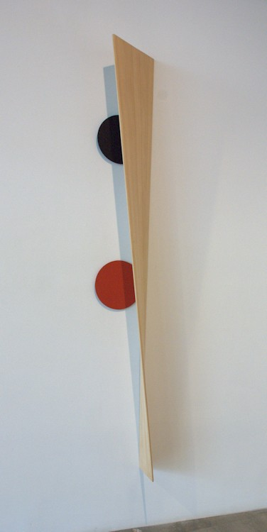

Pips Eclipse, 1993   
aluminum, wood, acrylic  
100 1/2 x 13 x 9 inches  
TD0130

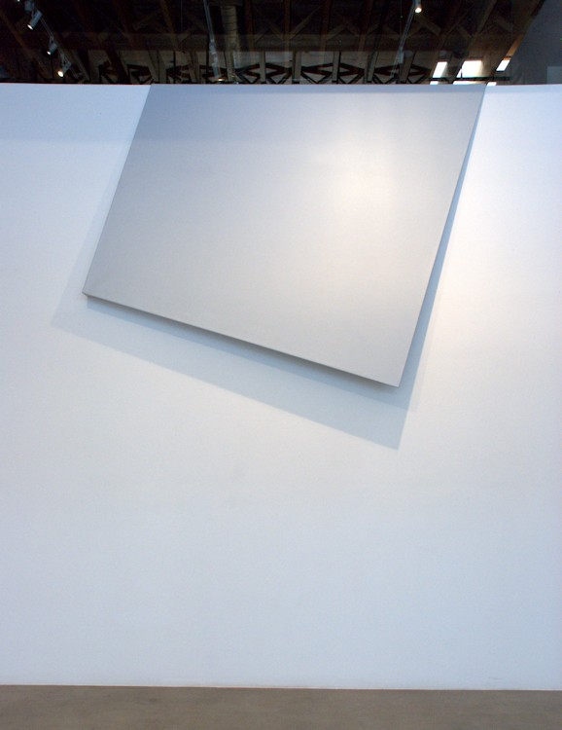

Ectoplasm Is Everywhere, 1993   
acrylic on canvas  
75 1/2 x 99 x 8 inches  
TD0132

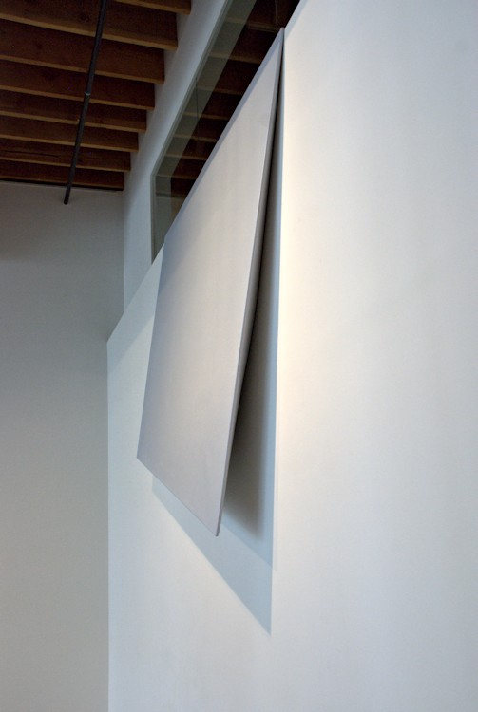

Ectoplasm Is Everywhere, 1993   
acrylic on canvas  
75 1/2 x 99 x 8 inches  
TD0132 (Detail)

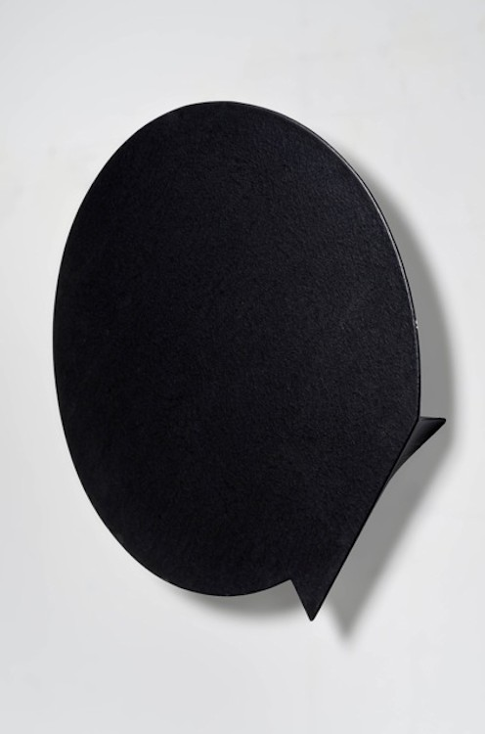

Ghost of a Chance, 1981   
canvas, wood, acrylic paint  
18 x 17 1/2 x 1 5/8 inches  
TD0086

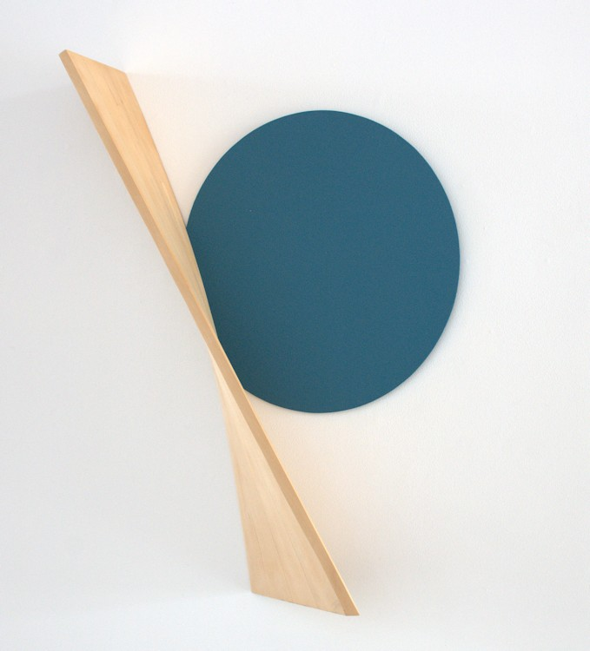

Tatatoto, 1990   
aluminum, wood, acrylic  
43 1/2 x 29 x 7 inches  
TD0131

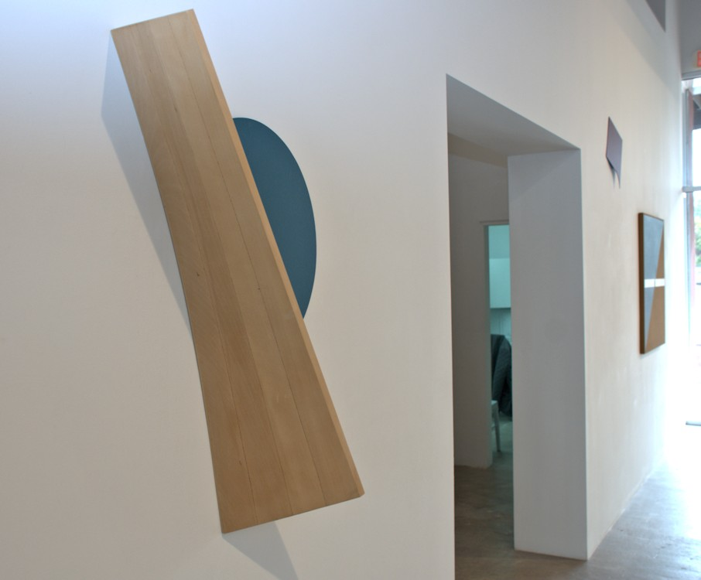

Tatatoto, 1990   
aluminum, wood, acrylic  
43 1/2 x 29 x 7 inches  
TD0131 (Detail)

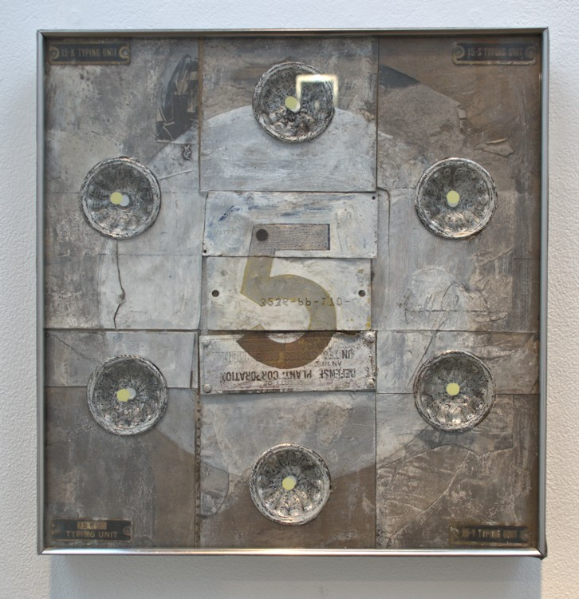

Hello Mr. Machine, 1961   
mixed media  
11 x 10 3/4 x 1 1/2 inches  
TD0145

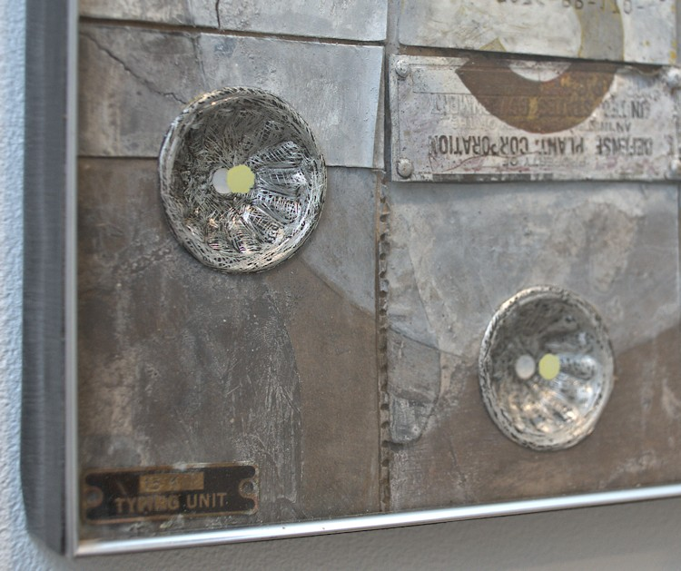

Hello Mr. Machine, 1961   
mixed media  
11 x 10 3/4 x 1 1/2 inches  
TD0145 (Detail)

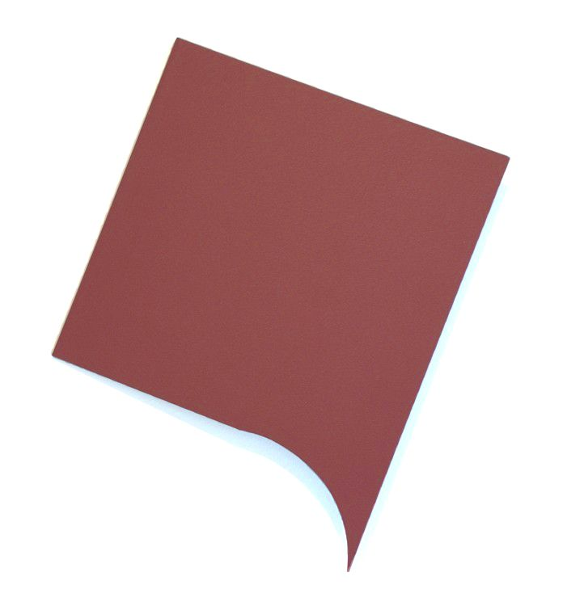

Pseudo Memory, 2014   
acrylic on aluminum  
14 1/2 x 11 3/4 x 1 1/2 inches  
TD0137

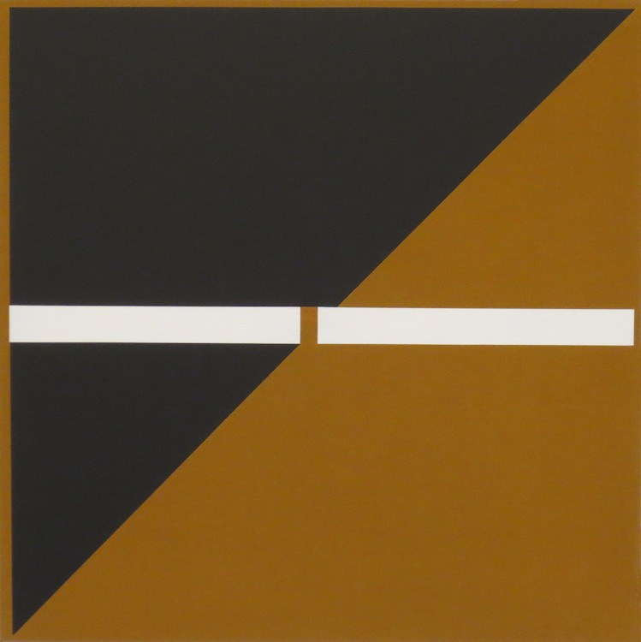

Astral Ace, 2014   
acrylic on linen  
42 x 42 3/4 inches  
TD014

[DeLap Podcast Interview](http://www.santafe.com/the-voice/podcast/50-years-of-artmaking#.VECOIWddXE1)

[Tony DeLap Pasatiempo Preview](http://www.santafenewmexican.com/pasatiempo/art/gallery_openings/art-world-all-rounder-stalwart-tony-delap-defies-categorization/article_5aaf9cc5-2a2a-5041-88e5-279ac3a5aaca.html)

# © 2014

# Charlotte Jackson Fine Art, Inc.

## In the Railyard at:

## 554 S. Guadalupe, Santa Fe, New Mexico 87501

Telephone: 505.989.8688 Fax: 505.989.9898

cjfa@charlottejackson.com - www.charlottejackson.com