CHARLOTTE JACKSON FINE ART

PRESENTS:

Constance DeJong: Shift

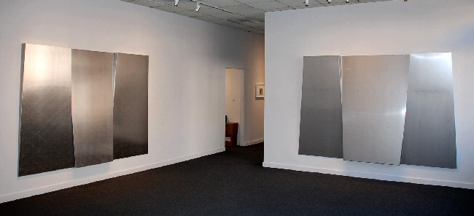

October 3 - 31, 2008
"Shift" is the title that Constance DeJong has chosen for her exhibit. Shifting planes of sheet metal have long been an essential feature of her art, forming the basis of its austere beauty.
This time, the installation itself shifts between two distinct bodies of new work. One room contains two massive, monolithic wall sculptures of blackened copper that take on the character of brooding expressionist paintings. In the adjacent room, virtually the same sculptural forms shift from absorbent black to the dazzling silver of light-reflecting aluminum and stainless steel. In each room, the large works are accompanied by a series of smaller framed pieces that explore the further possibilities of their respective materials and format.
De Jong's black pieces are composed of sheets of burnt and burnished copper. The painterly effect of their blackened surfaces results from a poured chemistry, which darkens into crusty velvet as it interacts with the copper and retains a waterfall's downward drift, lending weight to these moody compositions. Using a mathematical proportion, DeJong has divided the basic rectangle of the monolithic form into three interchangeable sections. She then tapered and tilted the planes, angling them like Egyptian pylons and allowing hints of unstained copper to glow along their wedge-shaped edges. Flares of coppery light also seep through the atmospheric black patina, suggesting an inner fire and recalling the somber romantic paintings of Robert Motherwell, Marc Rothko, and Barnett Newman. DeJong has used similarly treated copper plates to produce her smaller accompanying works. She refers to these too as "paintings," only shifting their scale upward by a factor of ten to achieve her monumental statements.
If the black pieces address painting issues, the silvery metal works in the adjacent room enter into a dialogue with drawing. Indeed, these large steel and aluminum forms are simply the naked understructure that De Jong builds and ordinarily covers with copper sheets. In a sense, they are like an underlying sketch or cartoon. But she has chosen instead to work the surface of this huge understructure, lightly grazing it with a grinder, so that light glints across the feathered texture and radiates outwards. The tiny ranged hairlines left by the grinder are like a draftsman's hatch-marks, scattering the light. In the smaller works in this room, DeJong recreates the effects of exquisite graphite drawings. In an intricate interplay of silver and white, she employs metal plates and sheets of translucent or clear mylar to make subtle surface planes that cast softly graded shadows. Delicate wire screens reproduce a kind of cross-hatching.
Complementary in their approach to light and dark, DeJong's two bodies of work shift between alternative states of the soul: If the black artworks, with their coppery sparks of internal fire, contain the dark and inward brooding of the earthbound mind, then the silvery ghost forms of the second room's burnished metal can imply an altered state, a hovering ephemeral spirit released into transcendent light.
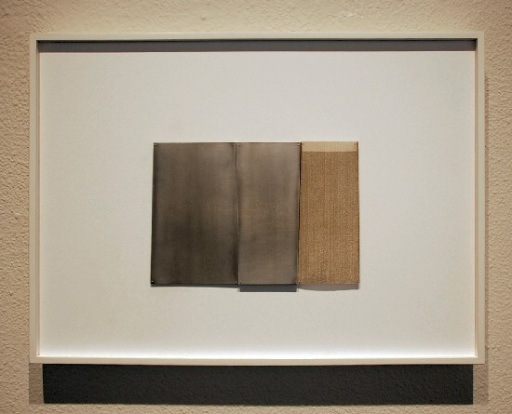
Rendering 2° 8, 2008
aluminum, stainless steel, silver
14 x 19 inches CD042
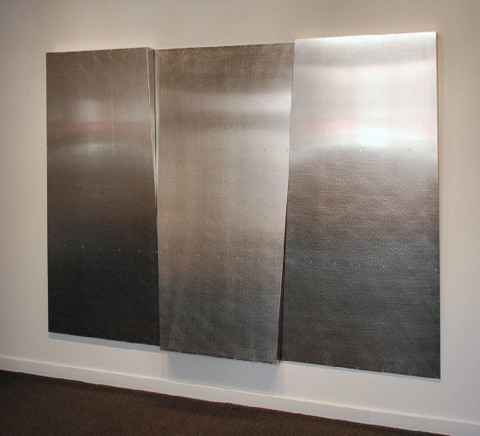
Untitled Aluminum, 2008
aluminum
72 x 104 inches CD080
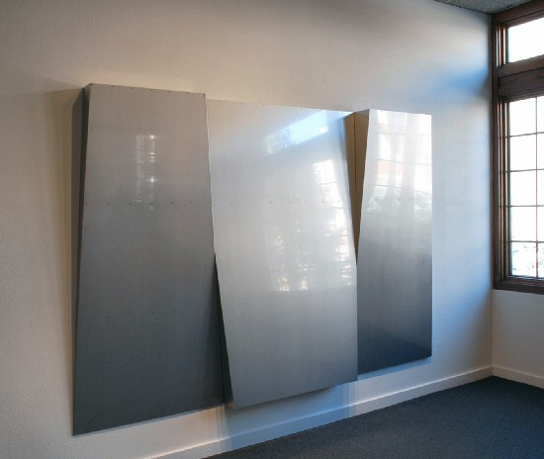
Untitled Stainless, 2008
stainless steel with a mill finish
72 x 114 inches CD079
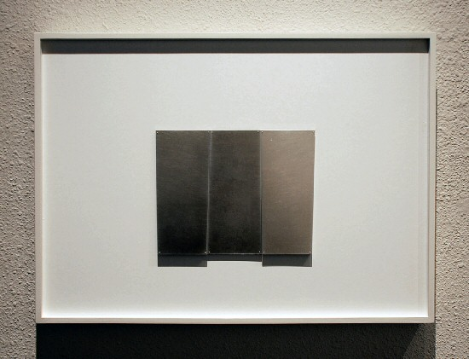
Rendering 2° 3, 2008
aluminum, stainless steel, silver
14 x 19 inches CD037
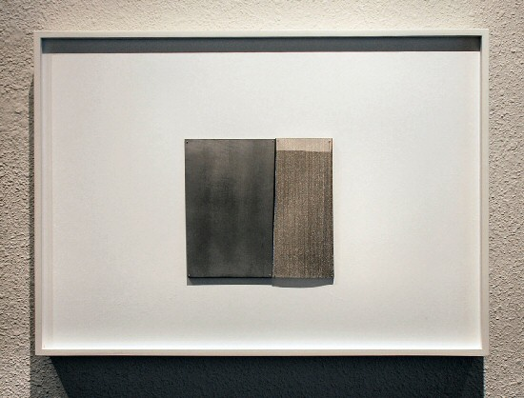
Rendering 2° 1, 2008
aluminum, stainless steel, silver
14 x 19 inches CD035
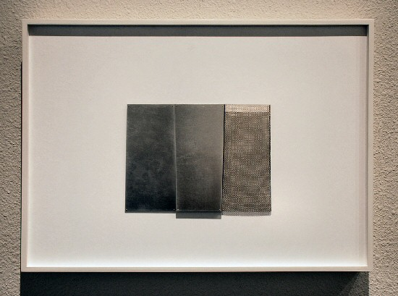
Rendering 2° 2, 2008
aluminum, stainless steel, silver
14 x 19 inches CD036
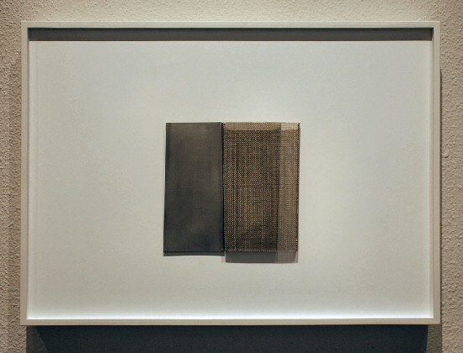
Rendering 2° 6, 2008
aluminum, stainless steel, silver
14 x 19 inches CD040
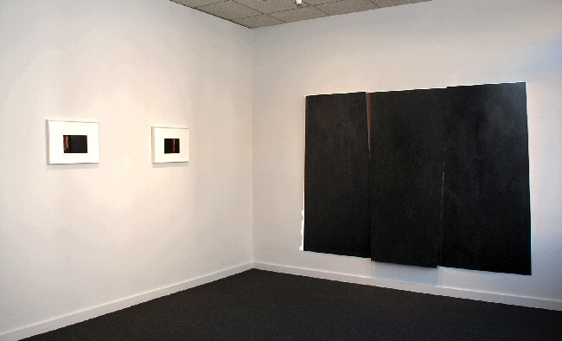

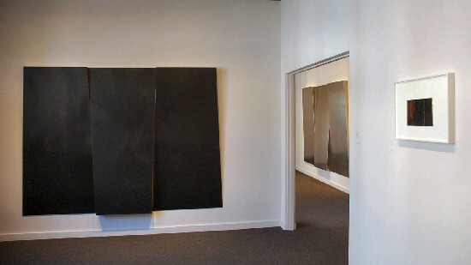
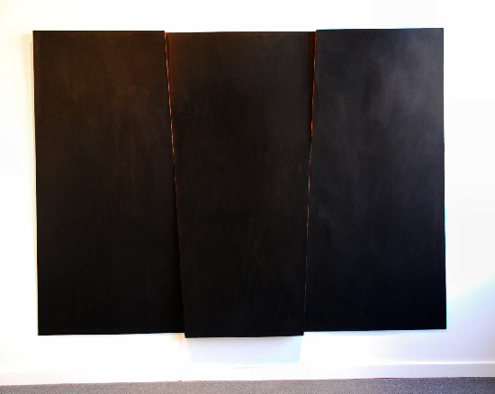
Big Black Work with Three Tilting Planes #2, 2008
copper
72 x 104 inches CD082
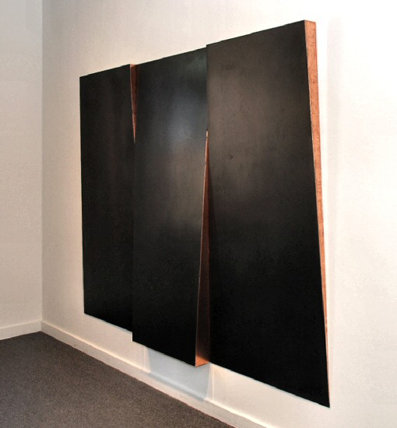
Big Black Work with Three Tilting Planes #2, 2008
copper
72 x 104 inches CD082 (detail)
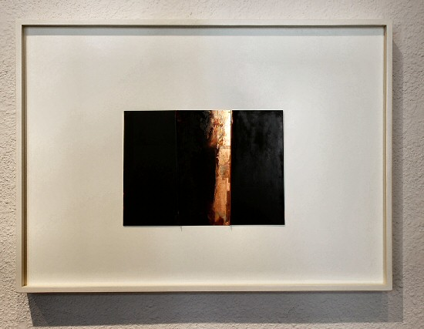
Stained Copper Painting #1, 2008
patina stained copper with varnished acrylic on panel
12 x 19 inches CD078
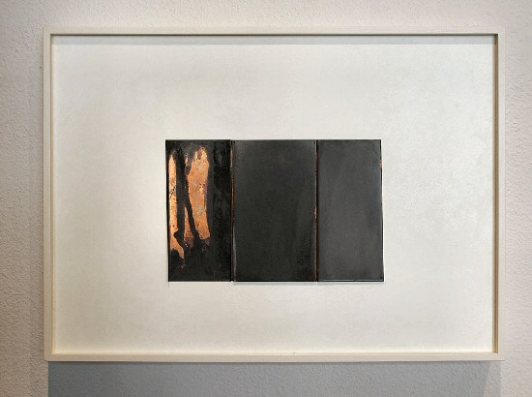
Stained Copper Painting #4, 2008
patina stained copper with varnished acrylic on panel
12 x 19 inches CD077
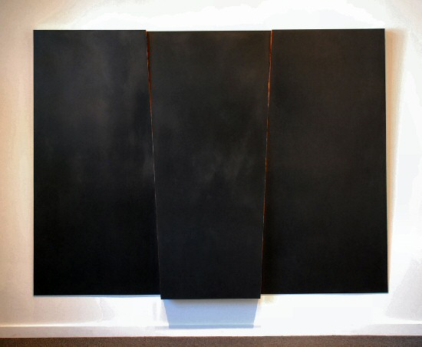
Big Black Work with Three Tilting Planes #1, 2008
copper
72 x 104 inches CD081
AT CHARLOTTE JACKSON PROJECT SPACE:

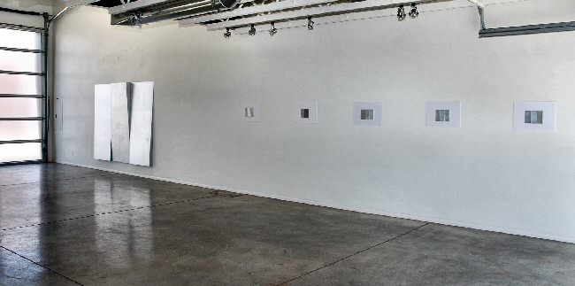

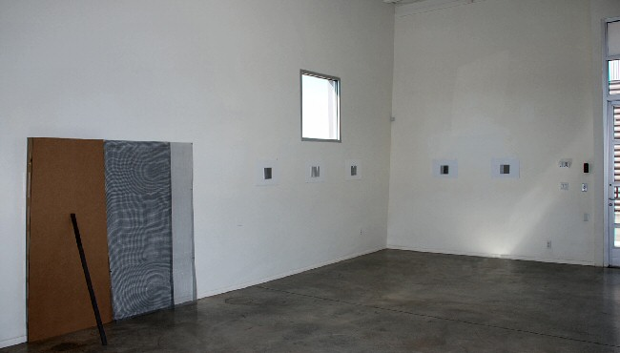
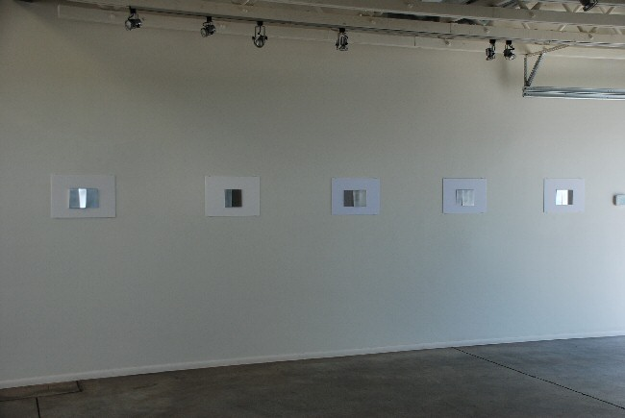

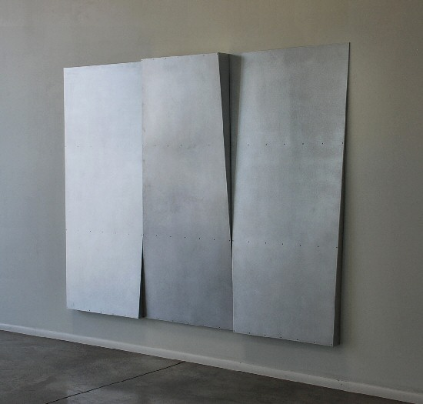
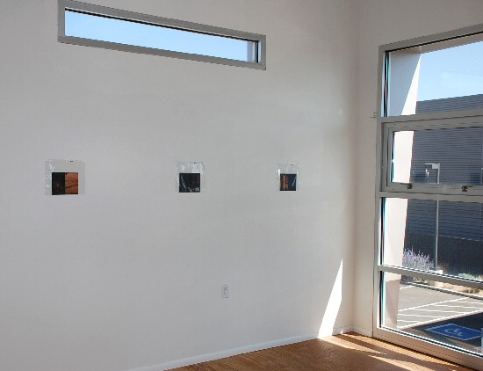

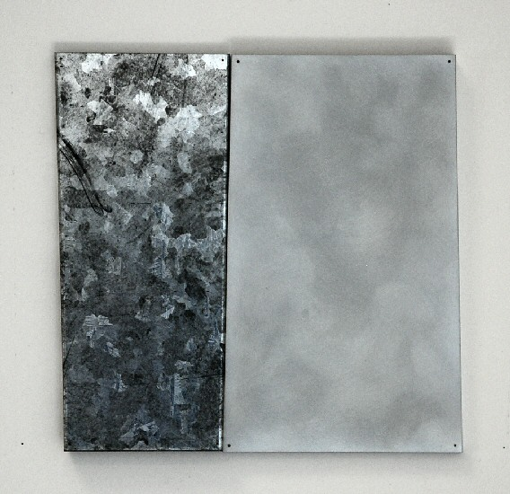
Metal Study #12, 2008
Metal on gatorboard
14 x 19 inches
CD048
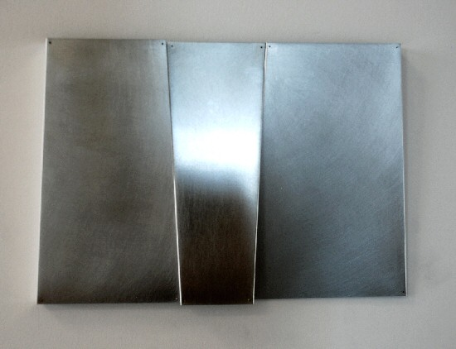
Aluminum Units 1,2,3, 2008
aluminum,
72 x 108 inches
CD043
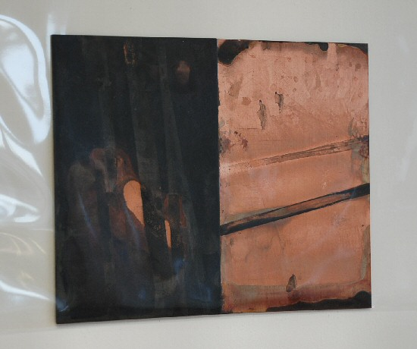
Stained Copper Study #5, 2008
copper on board in vinyl sheet
6 x 7 1/2 inches
CD070

© 2008

Charlotte Jackson Fine Art, Inc.

200 West Marcy Street, Suite 101, Santa Fe, New Mexico 87501

Telephone: 505.989.8688 Fax: 505.989.9898

cjfa@charlottejackson.com - www.charlottejackson.com

