CHARLOTTE JACKSON FINE ART
PRESENTS:

RONALD DAVIS
Pixel Dust Renderings – 2012

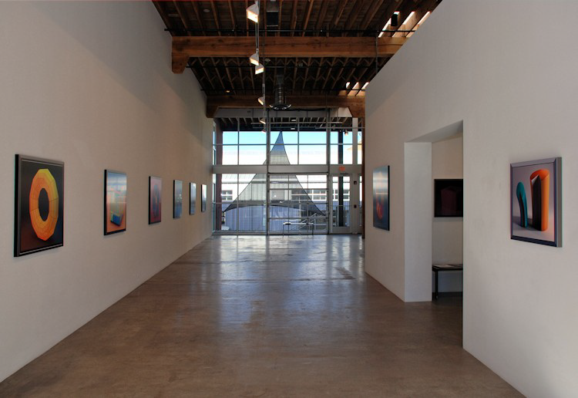

January 25 - February 25, 2013
In the late 1980’s Ronald Davis was one of the very first to create 3-D digital artworks, guaranteeing his place as an innovator in the field of computer-aided fine art. The depicted deep space in his work is inspired by the Renaissance perspective of Paolo Uccello and the perspective studies of Duchamp, the galactic drips and splatters of Jackson Pollock, the striated canyons of Clyfford Still, and the push-pull of Hans Hoffman.

The artworks in the Pixel Dust Renderings series were conceived and executed from mid-2011 through 2012. “Pixel Dust” is the artist’s term for a concept of his medium: Particles of light energy (photons) rendered in a composition and viewed at the speed of light on electronic devices.

They are virtual three-dimensional graphics – not photographs – created using software and hardware similar to that used by Pixar 3-D animators. Each original image is modeled in Maxon Cinema 4D and rendered using VRAYforC4D Rendersystem running on a Mac Pro 8-core Intel Xeon processor (2008). Adobe Photoshop CS6 is used in post-production. The image is then heat-fused in a photographic dye-sublimation print process onto prepared aluminum using 125-year archival pigments, and set into one inch-deep mounting frames.

Davis has been exhibiting his work since 1963 and has had over 65 one-man shows and countless group exhibitions in major galleries and museums worldwide. He continues to live and work at his studio near Taos, New Mexico.
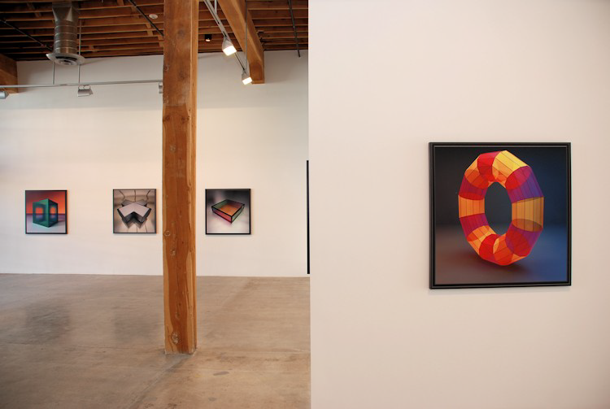

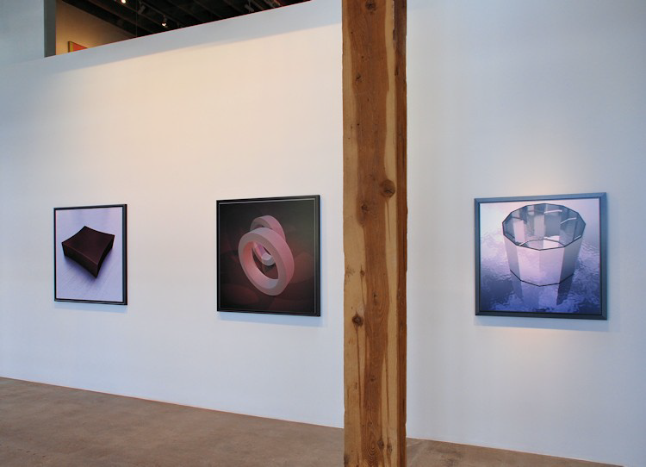
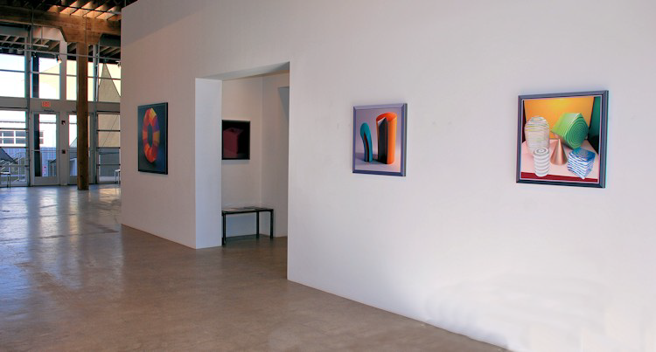

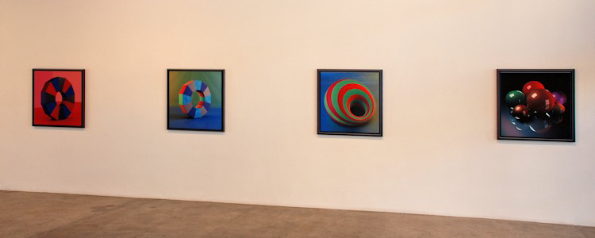

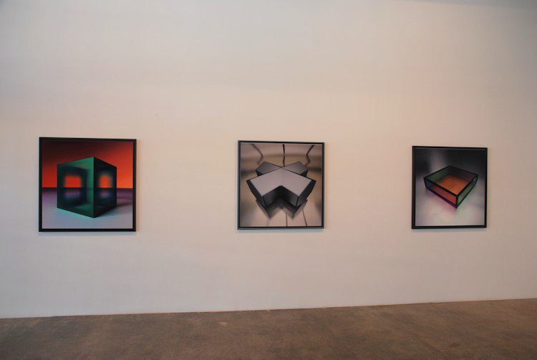

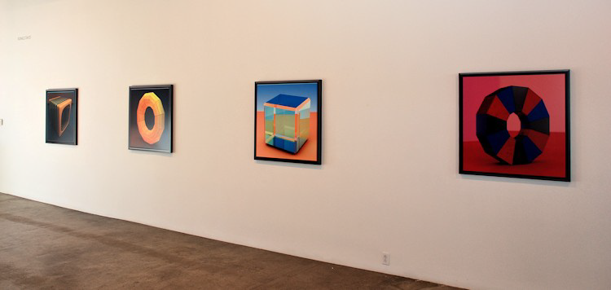
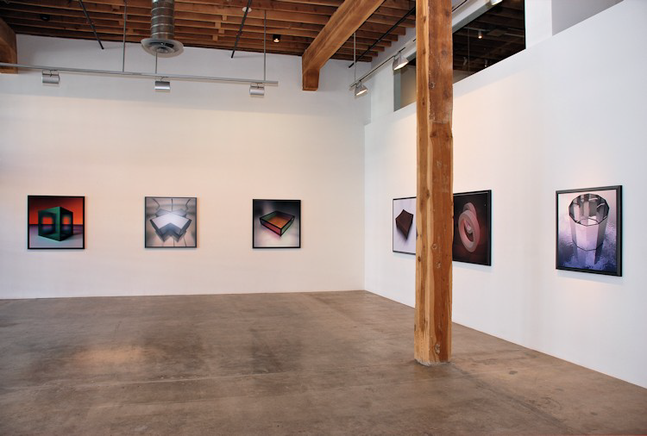

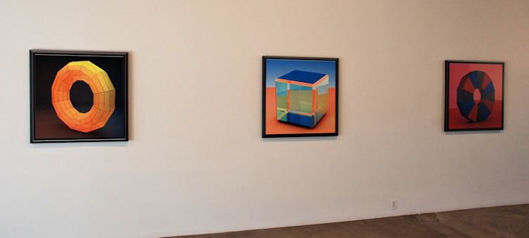
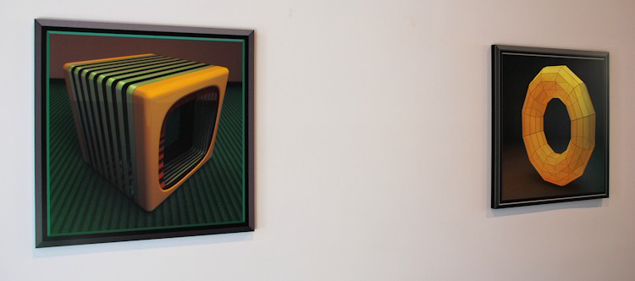

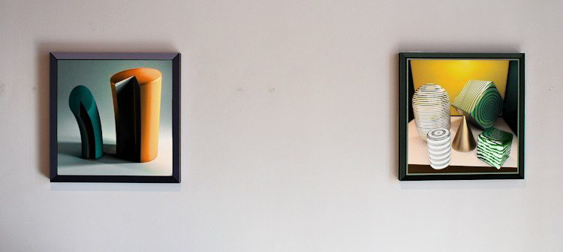
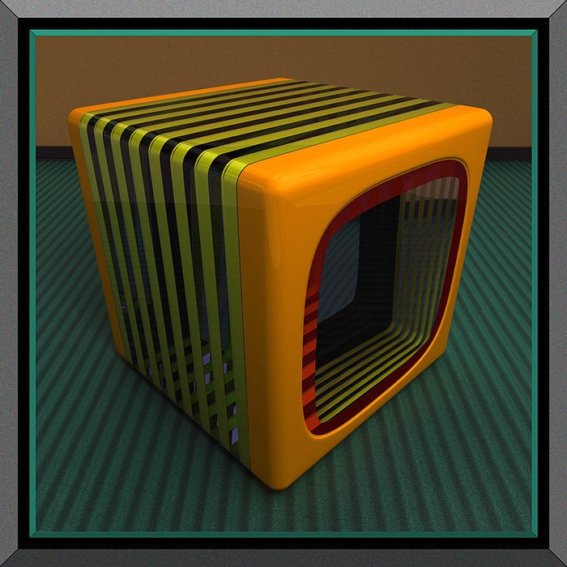

July Cube (1108728N9), 2011
Pixel Dust on Aluminum
36 x 36 inches
ROND080
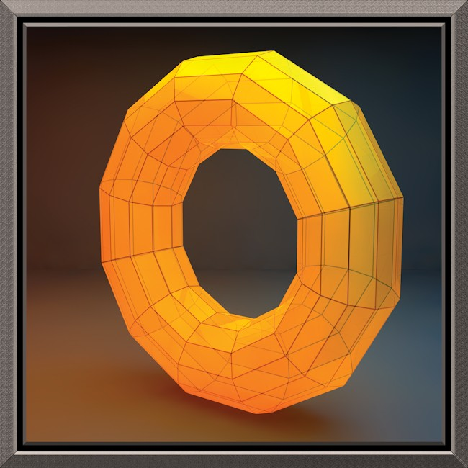

Yellow Mazzochio XII, 2012
Pixel Dust on Aluminum
36 x 36 inches
ROND088
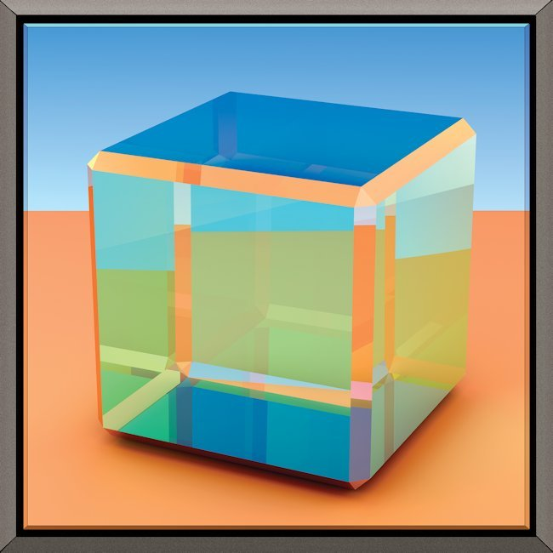

Glass Cube IV (110418d5), 2011
Pixel Dust on Aluminum
36 x 36 inches
ROND083
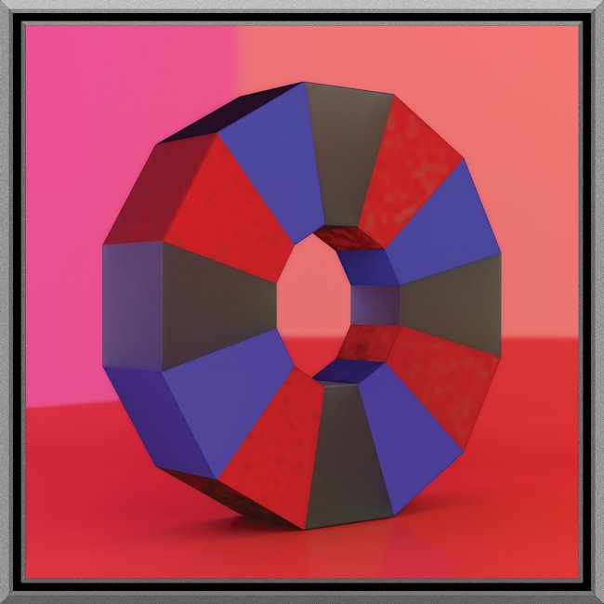

Upright Dodecagon XII, 2012
Pixel Dust on Aluminum
36 x 36 inches
ROND086
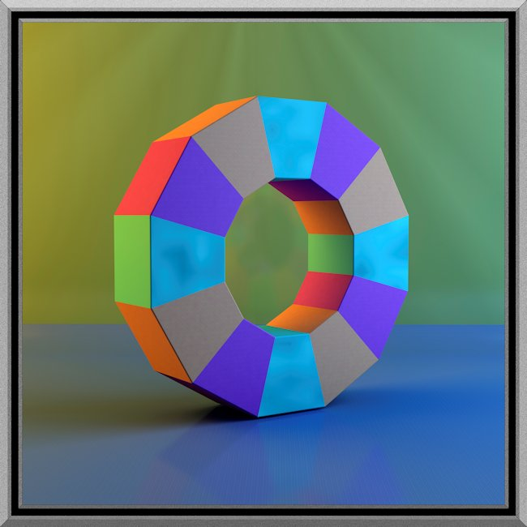

Upright Dodecagon VIII, 2012
Pixel Dust on Aluminum
36 x 36 inches
ROND089
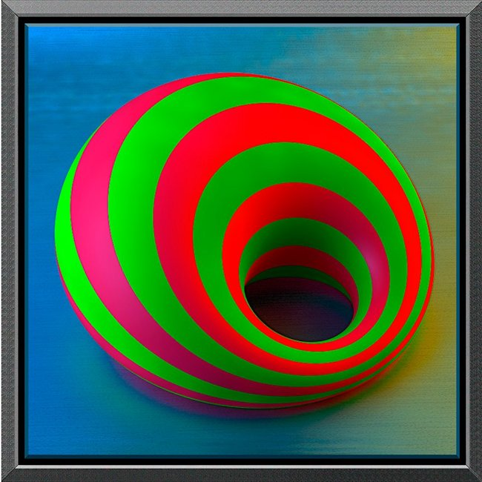

Cycloid Ring (110810P2), 2011
Pixel Dust on Aluminum
36 x 36 inches
ROND081
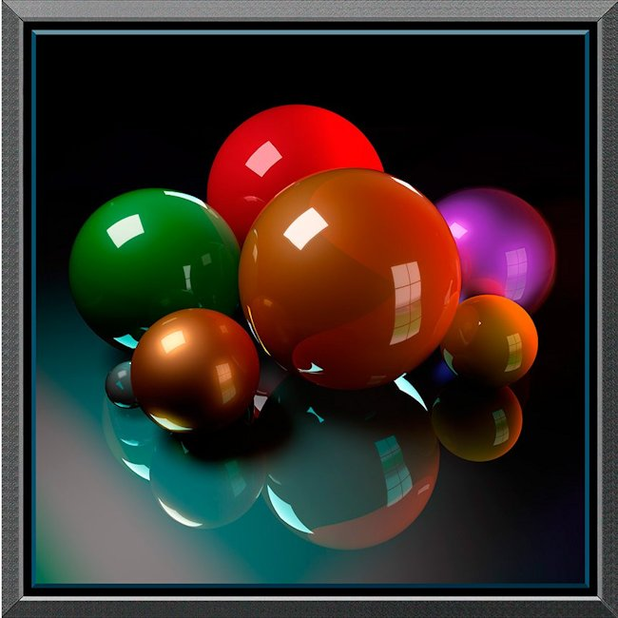

Sphere Studio (111112C3), 2011
Pixel Dust on Aluminum
36 x 36 inches
ROND079
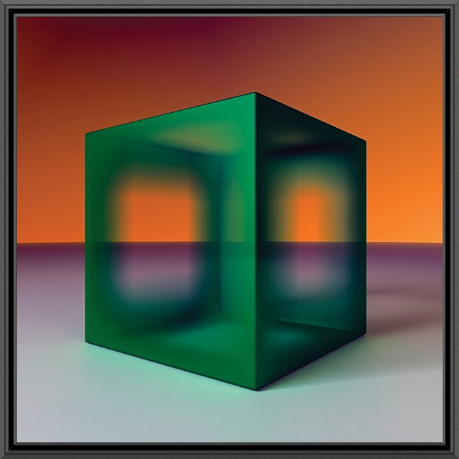

Front Cube, 2012
Pixel Dust on Aluminum
42 x 42 inches
ROND090
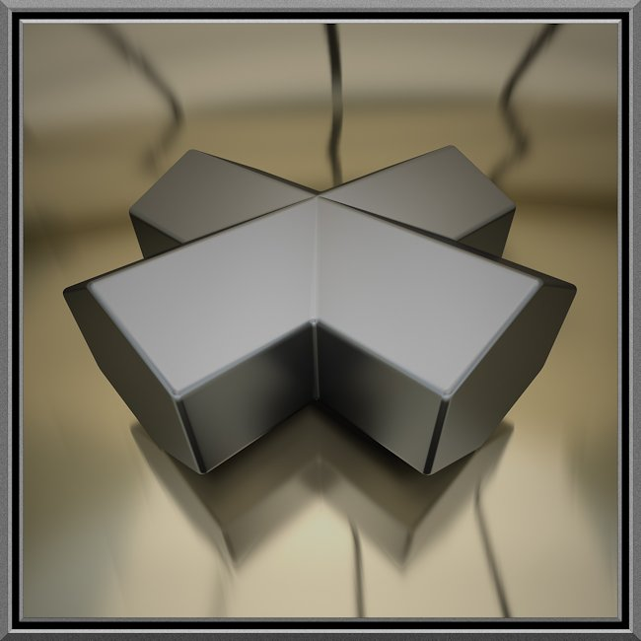

Staurolite III, 2012
Pixel Dust on Aluminum
42 x 42 inches
ROND092
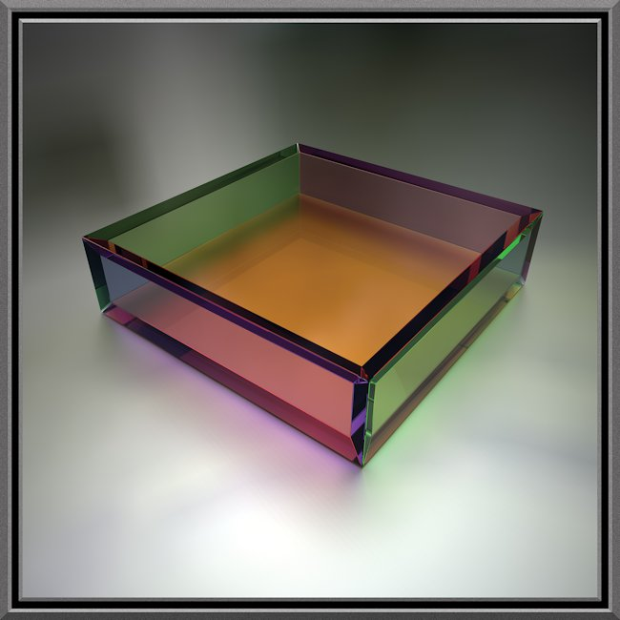

Glass Box III, 2012
Pixel Dust on Aluminum
42 x 42 inches
ROND095
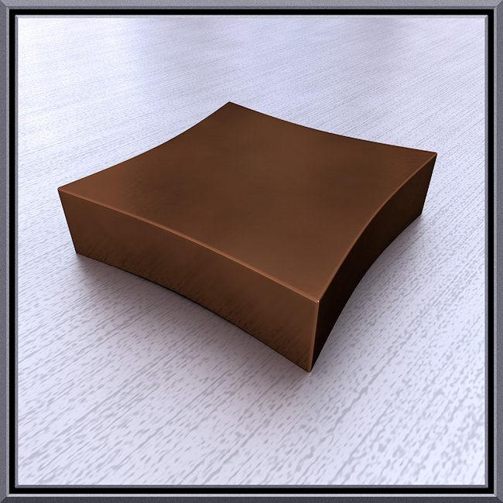

Copper Slab, 2012
Pixel Dust on Aluminum
42 x 42 inches
ROND094
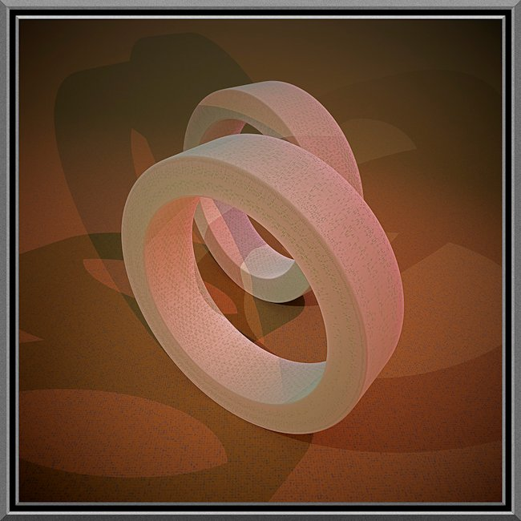

Two Rims, 2012
Pixel Dust on Aluminum
42 x 42 inches
ROND093
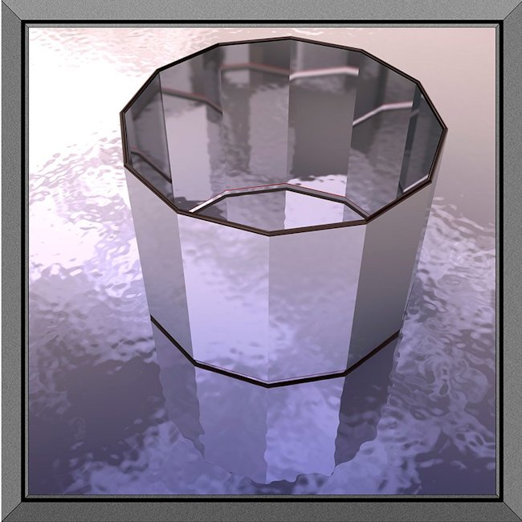

Dodecagon Tube, 2012
Pixel Dust on Aluminum
36 x 36 inches
ROND087
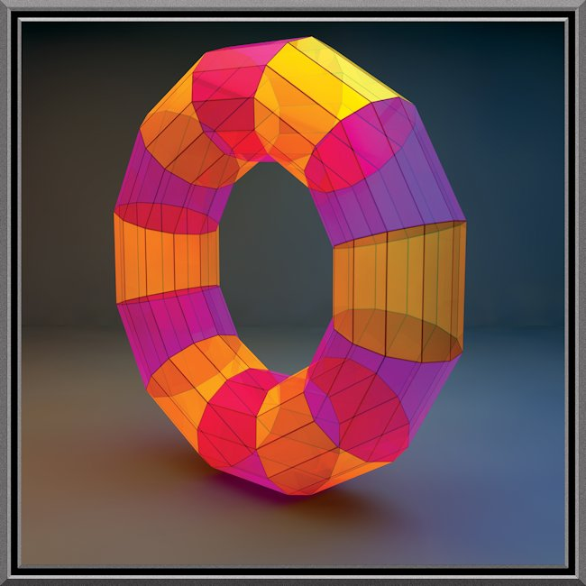

Mazzochio Twelve, 2012
Pixel Dust on Aluminum
42 x 42 inches
ROND091
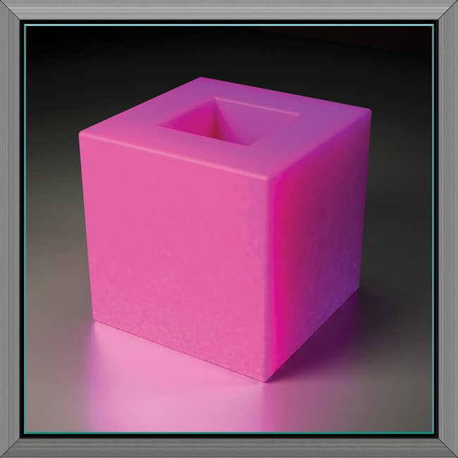

Holed Cube, 2011
Pixel Dust on Aluminum
24 x 24 inches
ROND058
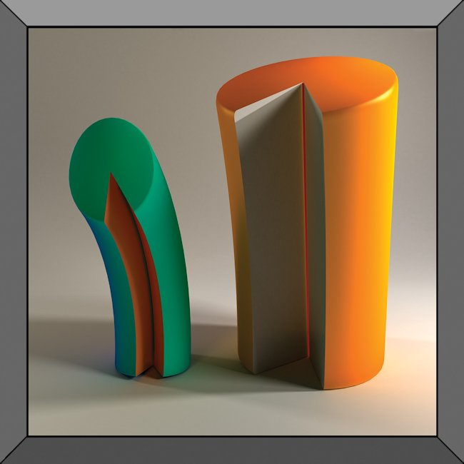

Two Cylinders (110511D1), 2011
Pixel Dust on Aluminum
24 x 24 x 1 1/4 inches
ROND078
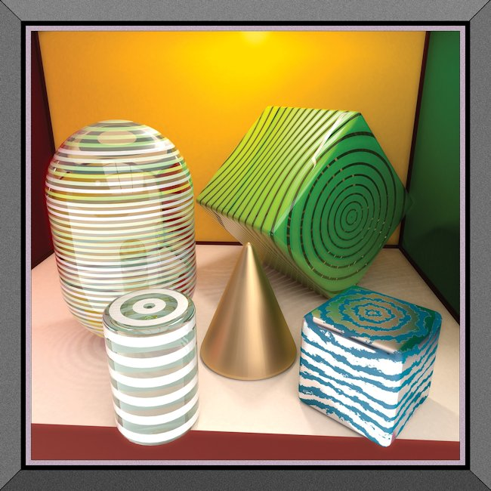

Two Cubes, Three Rounds (110727E2), 2011
Pixel Dust on Aluminum
24 x 24 x 1 1/4 inches
ROND077

© 2013

Charlotte Jackson Fine Art, Inc.

In the Railyard at:

554 S. Guadalupe, Santa Fe, New Mexico 87501
Telephone: 505.989.8688 Fax: 505.989.9898
cjfa@charlottejackson.com - www.charlottejackson.com

