CHARLOTTE JACKSON FINE ART
PRESENTS:

ALFONSO FRATTEGGIANI BIANCHI: UMBRIAN PAINTINGS
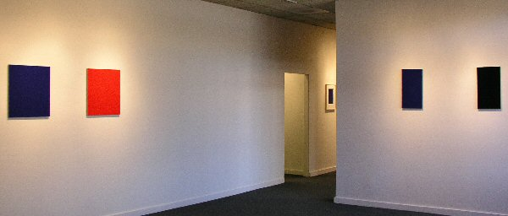
November 10 through December 10, 2006
Hand, color, stone. In the work of Alfonso Fratteggiani Bianchi we encounter painting, and color, at a level of intensity and purity that is irresistible. Fratteggiani Bianchi’s small scale, monochromatic works are pure powdered pigment applied directly onto pietra serena, the Italian limestone native to the Umbrian district where he lives. Pure in this case means that there are no binders, glues, or mediums used to attach the pigment to the stone, only the porousness of the stone itself and Fratteggiani Bianchi’s hand.
There is a sort of magic here, something that pervades the pieces themselves as well as the man who makes them. Originally doing work with music, founding the Institute for Contemporary Music in Perugia in 1986—a place where contemporary artists, both musicians and painters, from around the world came to study, create, and share—when Fratteggiani Bianchi first began to paint, he mixed his pigments with glue, applying them onto medium density board. The experiment did not satisfy him. As he remarks, “The glue dishonored the pigment,” by arresting it into a time, space, and density. When he looked at the pigment on his hands, it was beautiful, yet mixed with the glue it was “blocked, broken.”
And so he made the leap to applying pigment directly to the pietra serena so common in Umbria, used to make roads, steps, windowsills, even used in his own 10th century farmhouse. As renowned art collector Guiseppe Panza di Biumo comments on his work, “Fratteggiani’s discovery is a real event in the history of art. It is a first time in thousands [of] years.”
Those who have worked with powdered pigment may wonder at Fratteggiani Bianchi’s ability to affix color to stone without a medium. When asked how he does it, he smiled and replied, “How does the moon stay up there, without glue?” Although this answer may not satisfy those wanting to know how to do as he does, one feels it is more appropriate and more gratifying that any methodological reply. Here again is magic: though the answer of his own question might have to do with gravity, centripetal force, and the physics of motion, who hasn’t looked up at the night sky and wondered at the moon? The same wonderment is present in Fratteggiani Bianchi’s paintings where the color itself is so vibrant, so resonant, that they seem to move, to breathe, to speak.
Perhaps it is the romance of the Umbrian country-side that pervades the work. Umbria is a region of rolling hills, vineyards, and lovely clear light and was the home of two great artists, Perugino and Piero della Francesca. The works of these artists are present in the churches and cathedrals throughout the region. Fratteggiani Bianchi recalls that some of his earliest memories are of the frescos in his parents’ home. He grew up in an olive oil producing family (his own family still makes olive oil and wine) and speaks of the care and expression that this enterprise represents, with a similar intensity that he does about making art. He applies a similar principle: just as music and art come from the “same mind,” so all productions of human passion arise from the same realm. We come, he says, from “homo faber” the making man, and it is impossible to divide passion from creation.
But without knowing any of this, these paintings will affect you. Deepest red, shocking blue, flame orange, pulsating green—the surfaces of these works are so textured and rich they often appear wet or like forest moss. So intense are the colors that the pieces seem to give off their own light, something originating wholly from the pigment itself. Although perhaps it is more than that. In his pursuit of color, Fratteggiani Bianchi seeks out pigments whenever he travels. When asked about the amazing effects he achieves he comments, “When one painter buys a color in an art store, the color does not yet know how it will end up.” More magic ... in the hand of an artist the pigment finds itself, comes to be. In the case of Fratteggiani Bianchi’s paintings, color awakens.
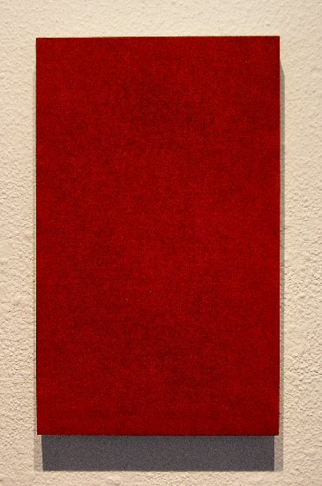
#307 Rosa Lampone (K23410), 2006
Pigment on limestone, 14 3/8” x 8 7/8”, AFB39
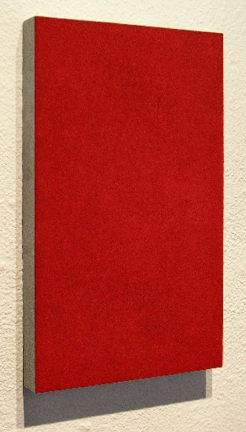
#307 Rosa Lampone (K23410), 2006 (detail)
Pigment on limestone, 14 3/8” x 8 7/8”, AFB39
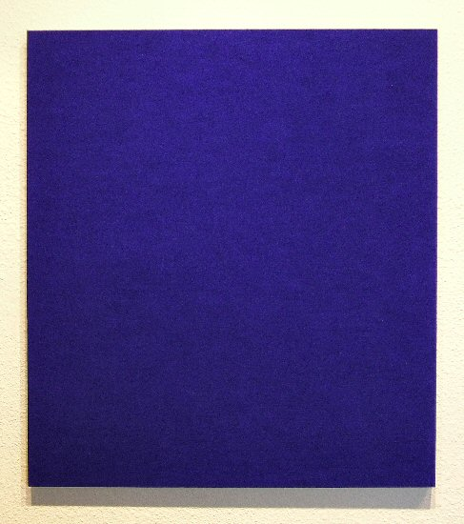
#123 Blu Medio (K23060), 2000
Pigment on limestone, 22 ½” x 20 1/8”, AFB38
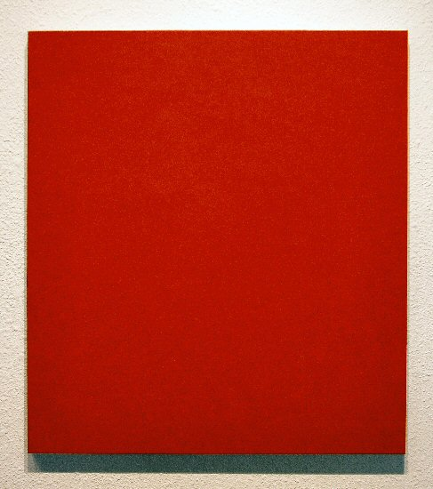
#132b Rosso (K23290), 2002
Pigment on limestone, 22 ½” x 20 1/8”, AFB37
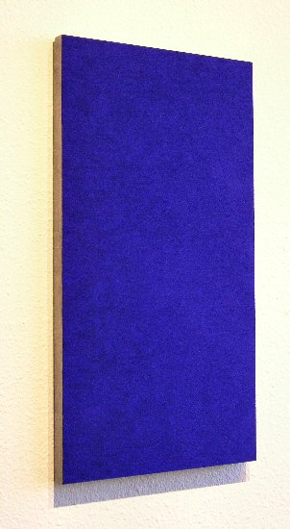
#120 Blu Chiaro, 2003
Pigment on limestone, 21 ¼” x 11 ¾”, AFB35
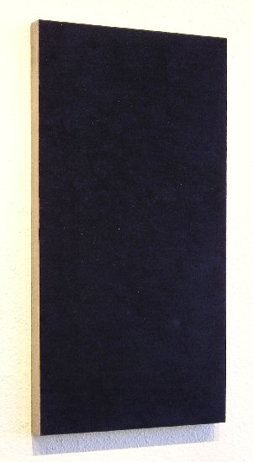
#124 Blu Scuro, 2003
Pigment on limestone, 21 ¼” x 11 ¾”, AFB31
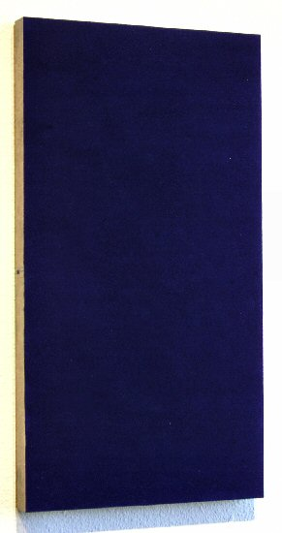
#121 Blu Prussia, 2003
Pigment on limestone, 21 ¼” x 11 ¾”, AFB28
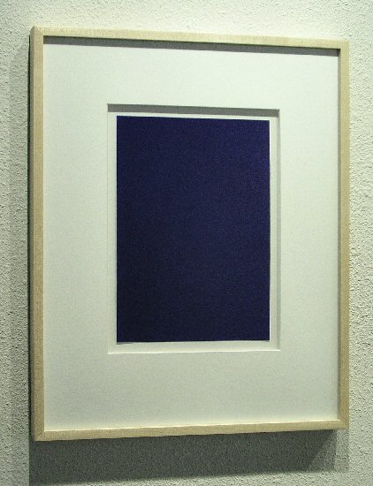
Pigmento su carta (Blue Medio), 2006
Pigment on paper, 21” x 17”, AFB47
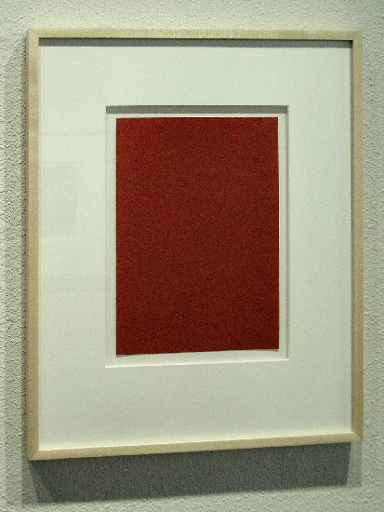
Pigmento su carta (Rosso 23182), 2006
Pigment on paper, 21” x 17”, AFB48
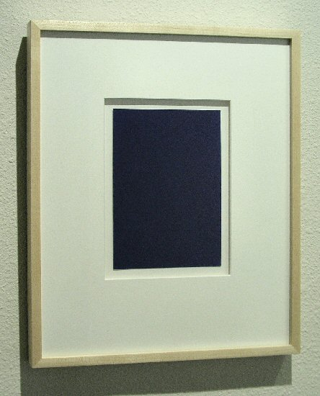
Pigmento su carta (Blu Medio), 2006
Pigment on paper, 17 ½” x 14 ½”, AFB50
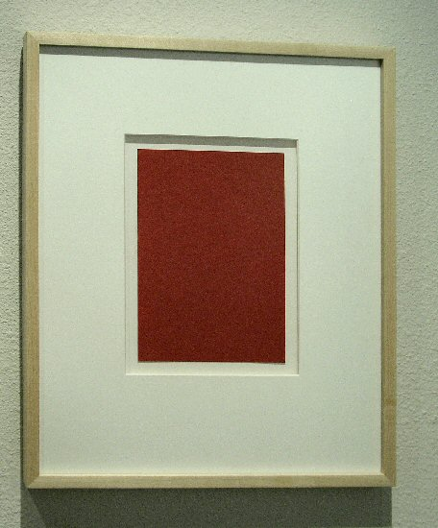
Pigmento su carta (Rosso 23182), 2006
Pigment on paper, 17 ½” x 14 ½”, AFB49
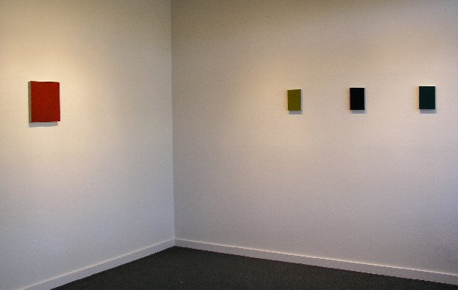
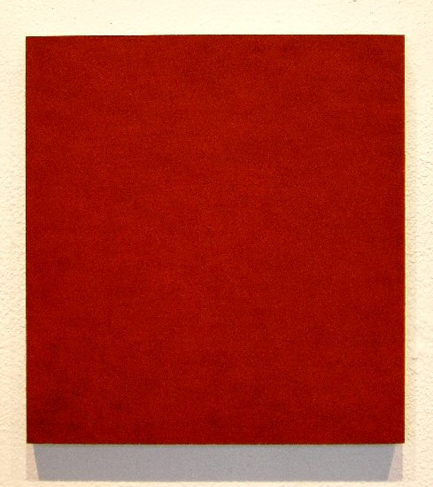
#CAFB0103 Rosso Bruno, 2001
Pigment on limestone, 14” x 13 1/8”, AFB32
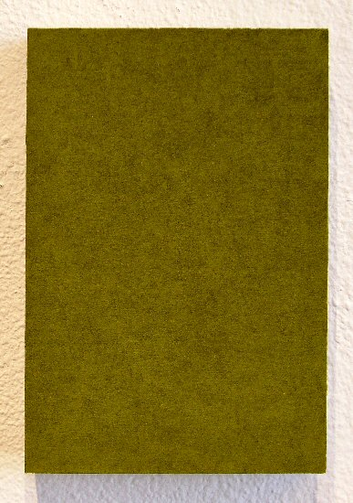
#279 Verde Chiaro, 2006
Pigment on limestone, 8 ¼” x 5 ¾”, AFB30
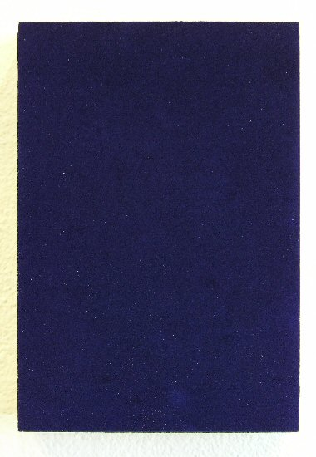
#262 Blu Prussia, 2005
Pigment on limestone, 8 ¼” x 5 ¾”, AFB34
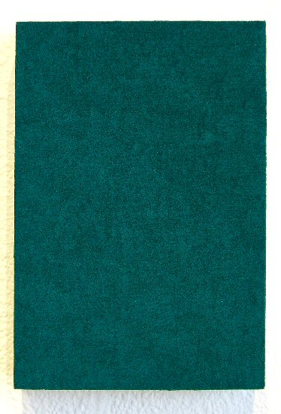
#280 Verde Ve, 2006
Pigment on limestone, 8 ¼” x 5 ¾”, AFB29
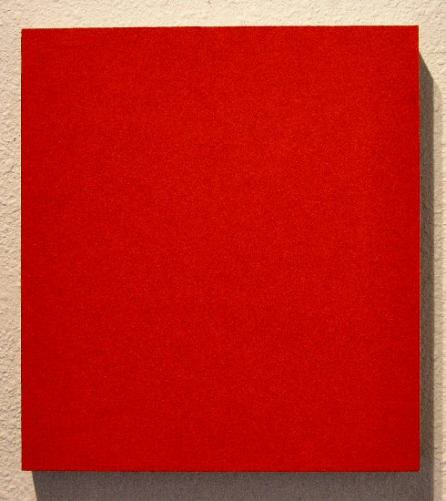
#248 Rosso Ve, 2005
Pigment on limestone, 12” x 10 ¾”, AFB25
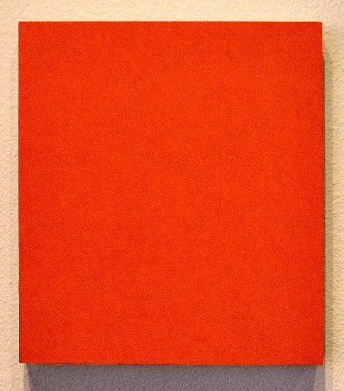
#217 Rosso Arancio
Pigment on limestone, 12” x 11”, AFB006

Alfonso Fratteggiani Bianchi

If you visit the Fratteggiani Bianchi household in Pieve Caina, near Perugia, in Umbria, Italy the first thing you might get invited to do, after stepping for a moment into the 10th century stone farmhouse where the family lives, is to pick some figs from their tree and enjoy eating them while gazing at the Umbrian countryside. And perhaps after a visit to Alfonso Fratteggiani Bianchi’s studio, you could be invited to stay for a leisurely (and exquisite) dinner, cooked by Alfonso himself, which lasts until well on midnight. Possibly Ulrike Brand (Fratteggiani’s gifted wife) will play a John Cage piece on cello.
Originally, Fratteggiani Bianchi’s work was with music. In 1986 he founded the Institute for Contemporary Music in Perugia. Musicians and composers, like John Cage, came from all over the world to meet and study there. It was, as he had intended it to be, a place for contemporary music to flourish and to expand its horizons. Soon visual artists were also brought to Perugia to collaborate and work. Monochrome painter Phil Sims was one of the artists who resided for a time in Perugia.
In 1999, after the institute had been closed for a few years, Fratteggiani Bianchi began to paint. At first he experimented with mixing raw pigment with glue, applying it to medium density board. This did not satisfy him as the colors, fixed into place by the glue, seemed “blocked, broken.” The leap he made, that renowned collector Dr. Giuseppe Panza di Biumo credits as a, “first time in thousands [of] years,” was to discover a way to apply powdered pigment directly only pietra serena limestone without it fading or falling off.
Though perhaps hundreds of painters in the past have rubbed their pigment colored hands against stone to clean them, it took the right eye and the right time for someone to see this as a new direction for art. Fratteggiani’s leap is much like what he credits to Cézanne, on some of whose “unfinished” landscapes can be found a block or section, which is painted one single color. Fratteggiani suspects that this was a movement on Cézanne’s part toward what has become monochrome, rather than a mistake or omission (he believes Cézanne was too accomplished for that). However, during Cézanne’s time the world was not ready for monochrome, perhaps before Fratteggiani Bianchi, the world was not ready to see pure powdered pigment on limestone.
It is lucky for us that the time was right. Fratteggianni Bianchi’s paintings take color to a new level of intensity. The pigment, free of the bonds of a medium, seems glow with its own light, and the packed surfaces achieve a textural complexity and soft, wet or moss-like finish. Fratteggiani does not feel like he is part of any particular movement in art, but rather that knowing art history and growing up in a region filled with masterworks have influenced him. And in fact his own works have hung side by side with some of the masterworks that he admired, such as at the San Sebastian Chapel in Panicale, where Fratteggianni’s intensely colored pieces hung near masterworks of the renaissance painter Perugino. The comparison does credit to both artists.

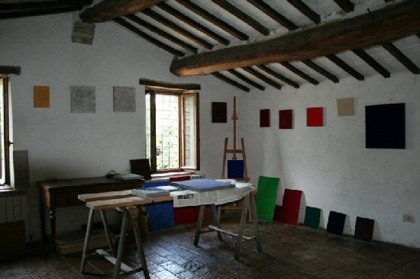
ALFONSO FRATTEGGIANI BIANCHI
Born Perugia, Italy, 1952
Lives and works in Italy
EXHIBITIONS
2005 Palazzo Besta, Valtellina, Italy
Solo exhibition, Artothek Köln, Köln, Germany (catalogue)
2004 Stuart Arends, Alfonso Fratteggiani Bianchi, Bleeker Gallerie, Heemstede, The Netherlands
Palazzo della Ragione, Mantua, Italy
Group exhibition, Palazzo Libera, Villa Lagoria, Rovereto, Italy (catalogue)
2003 Solo exhibition, Renate Schröder Galerie, Köln, Germany
MIART, Galleria Borromini, Mailand, Italy
2002 Girogio Morandi e i Morandiani, Museo di San Donato Milanese, Mailand, Italy (catalogue)
2001 Monocrami, solo exhibition, San Federale Arte, Mailand, Italy (catalogue), Phil Sims, Alfonso Fratteggiani Bianchi, Cantieri
Culturali alla Zisa, Palermo, Italy (catalogue)
PERMANENT COLLECTIONS
Fondo Italiano per l’Ambiente
Panza di Biumo Collection, Villa Panza di Biumo
Universitá Bocconi, Milan
BIBLIOGRAPHY
2004 Mauro Abba, Matthias Bleyl, Pierre-Albert Castanet, Franco Federici, Angela Madesani, Testi sulla pittura di
(Writings on the painting of) Alfonso Fratteggiani Bianchi, Guerra Guru Sri, Perugia. Text in German, Italian, French and English.
2002 Giuseppe Panza di Biumo, Alfonso Fratteggiani Bianchi in the Panza Collection, Skira Edizioni, Milano
2001 Mauro Abba, Phil Sims, Alfonso Fratteggiani Bianchi, Goethe Institut, Palermo,
conversation with Giuseppe Panza di Biumo. Giuseppe Panza di Biumo and Andrea Dall’Asta, Alfonso Fratteggiani Bianchi,
Monochromi, San Fedele Edizioni, Milan

© 2006

Charlotte Jackson Fine Art, Inc.

200 West Marcy Street, Suite 101, Santa Fe, New Mexico 87501
Telephone: 505.989.8688 Fax: 505.989.9898
cjfa@charlottejackson.com - www.charlottejackson.com

