CHARLOTTE JACKSON FINE ART

PRESENTS:

JOHN BEECH
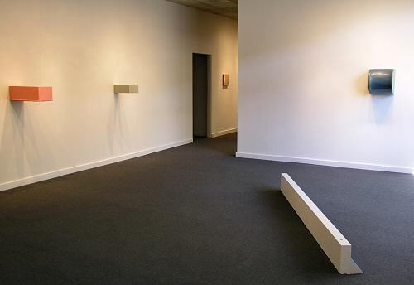
JULY 2 - 24 2004
John Beech is interested in the "every-dayness" of materials and visual content. His eye is drawn to dumpsters, parking bumpers, subway platforms and all manner of objects that most of us look past every day. He is partial to materials that are utilitarian rather than strictly artistic, which has led him to make entire paintings with hardware store glue, and to coat rotating paintings (which contain hardware store moving parts) with house paint. He often positions a piece to expose its back, which reveals raw, lowly plywood as a primary material.
In Beech's hands, these ultra-ordinary objects and substances are transformed into works of art that surprise and delight the viewer. Bursting with vitality and originality, floor pieces such as "rolling platforms" and "obstacles" assume unexpected shapes and sprout casters in unlikely places. Wall pieces include such unusual configurations as "projecting paintings," which may extend out from the wall as much as 100 inches, "articulated barriers," which have been likened to a parking lot barrier that couldn't quite keep itself up, and "rotating paintings," which, as the name implies, turn on ball bearings.
Beech's show features a variety of glue paintings, rotating paintings, rolling platforms and obstacles. Color is an important element. Besides Beech's usual glossy enamels and glue-colored canvases, glue paintings with pigment will provide a new, "more sour-looking" range of colors.
Beech's work has been exhibited twice in the past year by the venerable Albright-Knox Art Gallery in Buffalo, NY, first as part of the Forman Collection, a preeminent collection of contemporary art donated to the museum last year by Santa Fe residents Natalie and Irving Forman, and then as a solo installation.
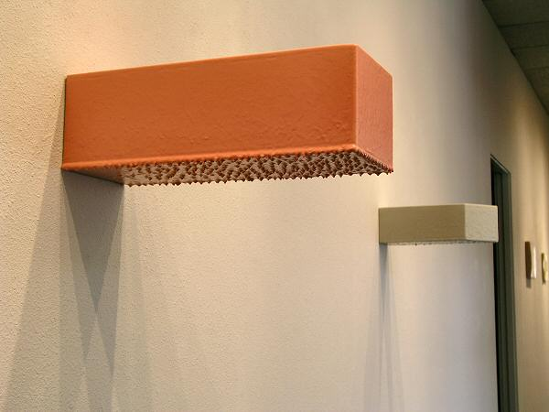
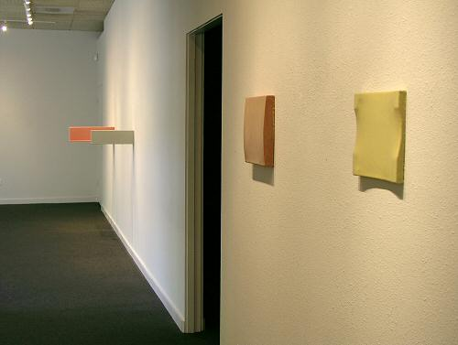
MAIN GALLERY:
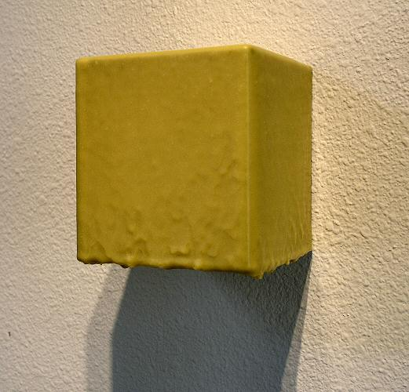
GLUE PAINTING #60, 2004, JB0018
DAP Weldwood, linen, plywood, 5½” x 5¼”x 5¼”
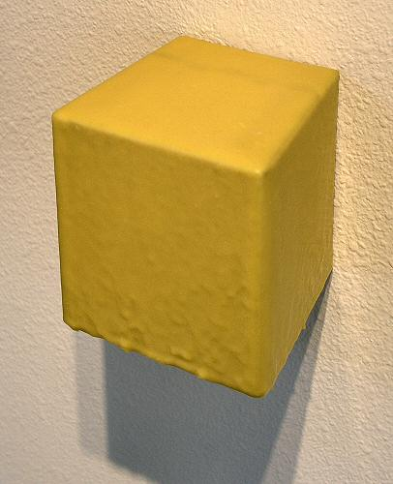
GLUE PAINTING #60, 2004, JB0018 (detail)
DAP Weldwood, linen, plywood, 5½” x 5¼”x 5¼”
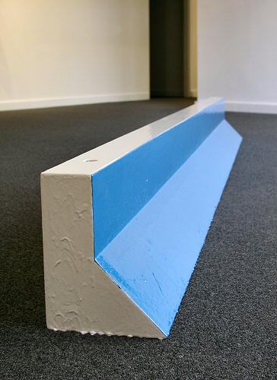
BUMPER #13, 2003, JB0031
Plywood, enamel, metal pipe, 100” x 9” x 7”
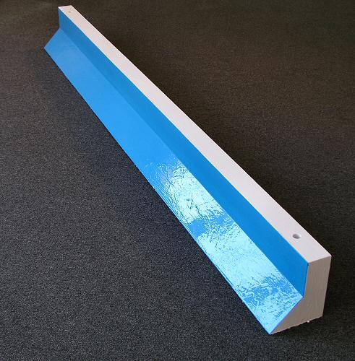
BUMPER #13, 2003, JB0031 (DETAIL)
Plywood, enamel, metal pipe, 100” x 9” x 7”
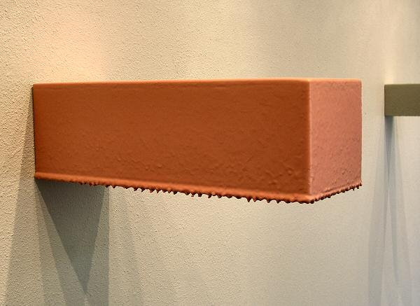
GLUE PAINTING # 82, 2004, JB0020
Latex-tinted Titebond original wood glue, plywood,
7¾” x 9” x 23½”
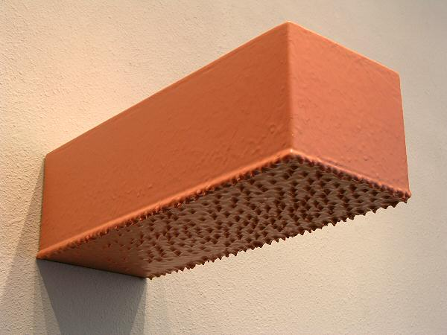
GLUE PAINTING # 82, 2004, JB0020 (DETAIL)
Latex-tinted Titebond original wood glue, plywood,
7¾” x 9” x 23½”
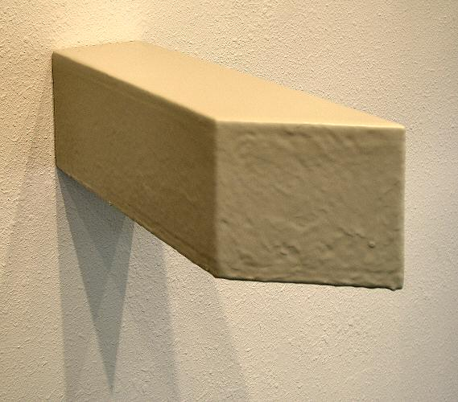
GLUE PAINTING # 83, 2004, JB0022
Latex-tinted Titebond original wood glue, MDF,
5¾ ” x 5” x 17½”
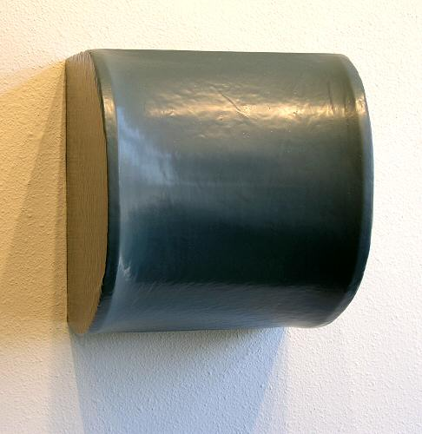
GLUE PAINTING #84, 2004, JB0021
Latex-tinted Titebond original wood glue, MDF, linen,
15½” x 13¾”x 14”
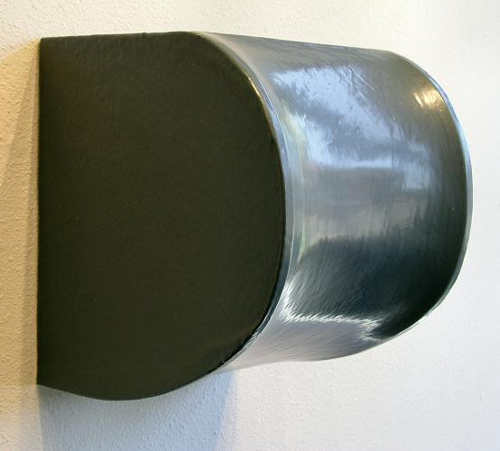
GLUE PAINTING #84, 2004, JB0021 (DETAIL)
Latex-tinted Titebond original wood glue, MDF, linen,
15½” x 13¾”x 14”
HALLWAY:
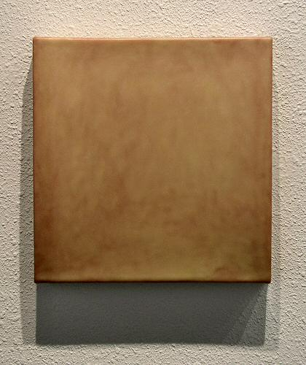
GLUE PAINTING #71, 2004, JB0026
Plasterweld, Elmer's original wood glue, plywood, linen,
11½” x 11½” x 1¾”
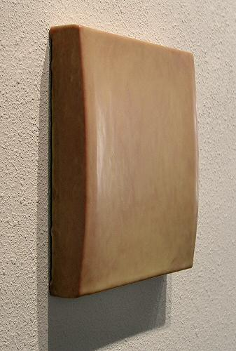
GLUE PAINTING #71, 2004, JB0026 (DETAIL)
Plasterweld, Elmer's original wood glue, plywood, linen,
11½” x 11½” x 1¾”
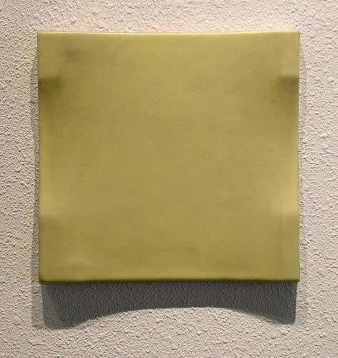
GLUE PAINTING #76, 2004, JB0025
Elmer's original wood glue, linen, plywood,
9½” x 10”
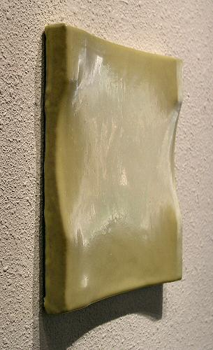
GLUE PAINTING #76, 2004, JB0025 (DETAIL)
Elmer's original wood glue, linen, plywood,
9½” x 10”
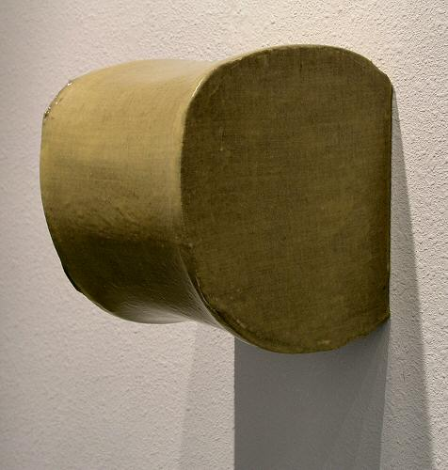
GLUE PAINTING # 79, 2004, JB0027
Titebond original wood glue, linen, plywood, MDF,
9½” x 8” x 8½ ”
GALLERY II:
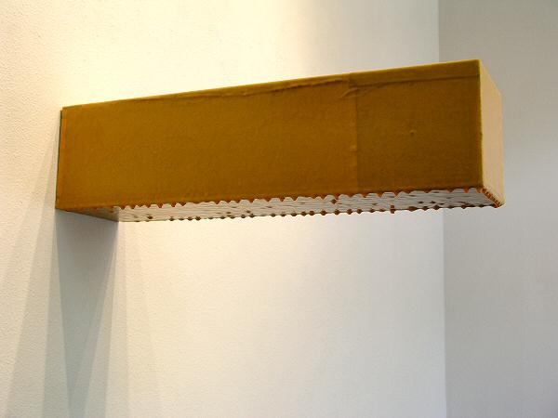
GLUE PAINTING #61, 2003-2004, JB0024
Titebond II wood glue, linen, plywood,
6¾” x 6¾”x 25 ½”
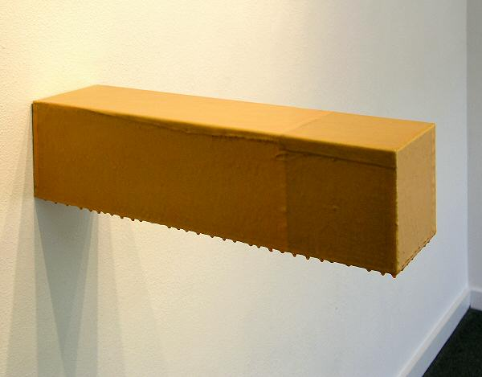
GLUE PAINTING #61, 2003-2004, JB0024 (DETAIL)
Titebond II wood glue, linen, plywood,
6¾” x 6¾”x 25 ½”
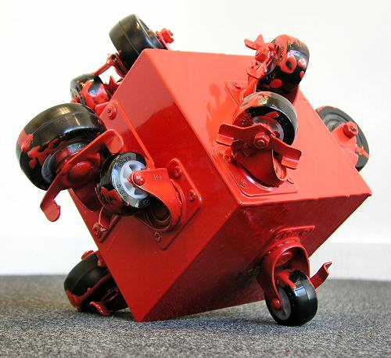
SMALL ROLLING PLATFORM # 56, 2004, JB0023
Plywood, casters, enamel,
13” x 13” x 13”
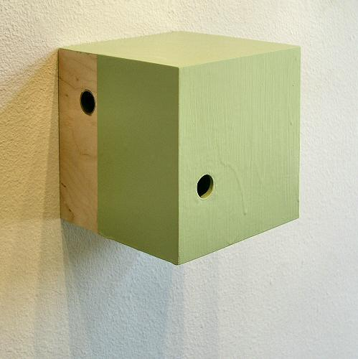
GREEN CUBE, 2000, JB0030
Plywood, enamel, metal pipe,
7½” x 7½”x 7½”
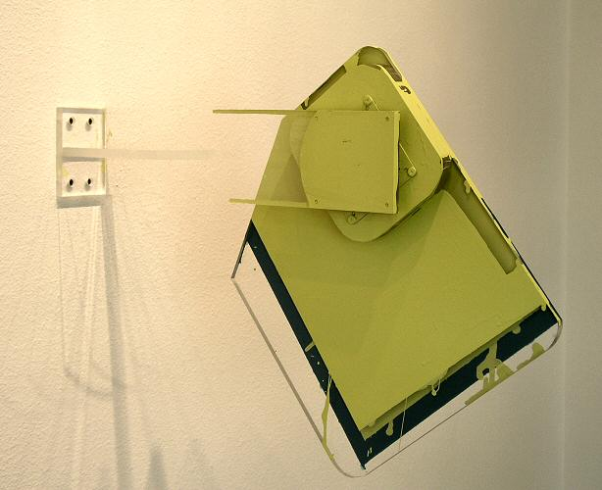
ROTATING PAINTING #141, 2003, JB0029
Plexiglas, enamel, rotating hardware,
15”x13”
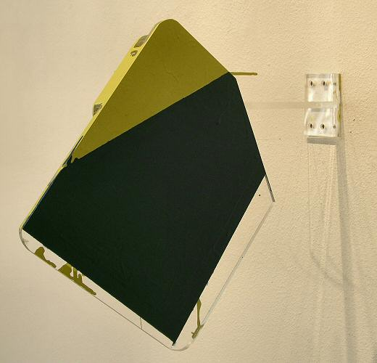
ROTATING PAINTING #141, 2003, JB0029 (DETAIL)
Plexiglas, enamel, rotating hardware,
15”x13”
© 2004, Charlotte Jackson Fine Art
All Rights Reserved

Charlotte Jackson Fine Art

200 West Marcy Street, Suite 101

Santa Fe, New Mexico 87501

Phone: 505.989.8688
Fax: 505.989.9898

www.charlottejackson.com

Photography and CD production – William Metcalf

