CHARLOTTE JACKSON FINE ART

PRESENTS

CHARLES ARNOLDI
ARC PAINTINGS
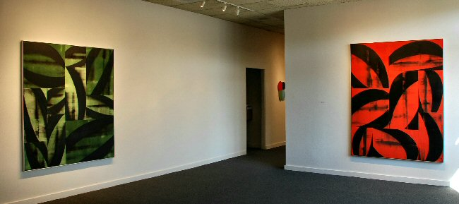
July 6 - July 31
2007
Charlotte Jackson Fine Art is pleased to announce an exhibition of new works by Charles Arnoldi, the Arc Paintings. Arnoldi, in his nearly forty years of art-making, is known widely as an innovator and as an artist whose diverse and yet interconnected visual languages are always as unique as they are bold. From his stick paintings, which used the fluid shapes of sticks and twigs as painted gesture, to his Chainsaw paintings which created gesture from negative space, with lines hashed into wood with a chainsaw—Arnoldi has continued to explore the gamut of artistic medium and visual vocabulary.
As with all of Arnoldi’s work, in the new Arc Paintings there is a mixture of fortuitousness and daring in their conception. This new series began when Arnoldi was commissioned to do a project for a very large space, a wall approximately 40 by 60 feet. The size of the space necessitated the use of multiple canvases, since stretching a single canvas so large would pose many difficulties. As Arnoldi prepared to do the piece he began to experiment with canvas panels of a variety of shapes and sizes and they intrigued him. The use of multiple variously sized panels brought together to form a “single” piece provided an implied geometry—a structure beneath the organic forms of the painting which Arnoldi was interested to explore.
From this start, Arnoldi became fascinated with the possibilities of these works. The canvas panels are painted separately and can then be arranged and rearranged together into the larger framework of the finished piece. The canvases are brought together much like a jigsaw, arranging an assortment of sizes and orientations of canvas to create a single large rectangle or square.
However, the result of these assemblies varies from that of a puzzle in that the arc forms and shapes painted onto each canvas are not arranged to create some sort of coherent picture. Rather the shapes and gestures of a canvas are purposely interrupted in mid-movement and then aligned with something completely different in the next panel over. Sometimes the panels are aligned in such a way that you feel the two panels were painted together as a single piece—and then somehow shifted slightly, like an earthquake knocking one part of a building slightly lower than the rest. This displacement, perhaps contrary to what one might think, serves to create an effect of a greater completeness. The energetic forms in rich and often electrically vibrant colors (orange and red hues, purple on white, brilliant blues and greens) overlaid on that subtle architecture of panels creates patterns within patterns to create a visually complex and substantial whole.
In addition to these multi-panel works on canvas, Arnoldi has created small-scale drawings and gouaches as studies for the larger canvas works. These pieces, of which there will be some examples for the exhibition, are exquisite works in their own right with a vivid and fluid language of color and geometry.
This exhibition brings together a colorful and vigorous exhibition of new works by a consummate West Coast artist.
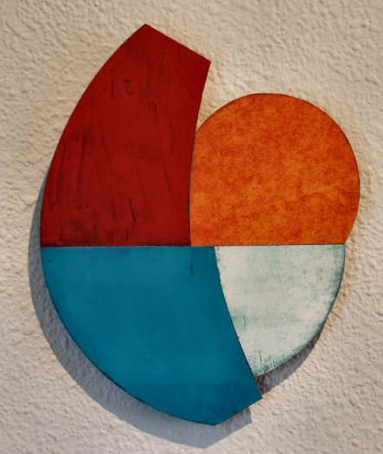
Untitled, 2005
oil on aluminum
8 1/2" x 6 3/4"
CA0028

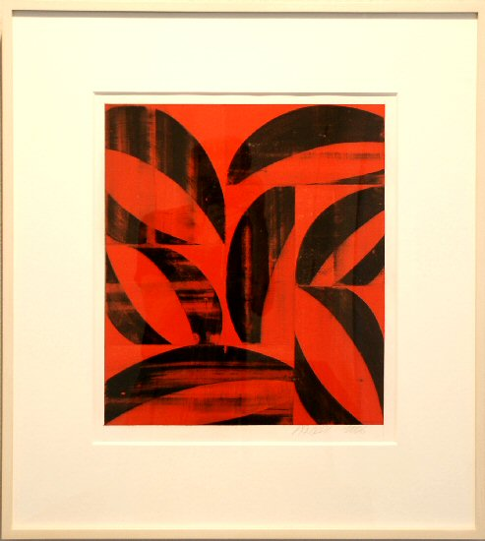
Untitled, 2006
Gouache on paper
26 1/2 x 24 inches
CA0019
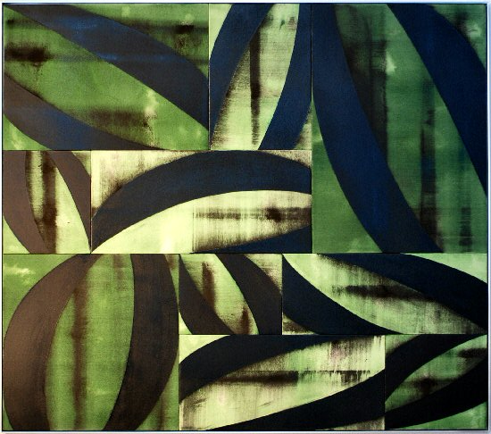
Habitat, 2007
Acrylic on canvas
66 3/4 x 58 3/4 inches
CA0020
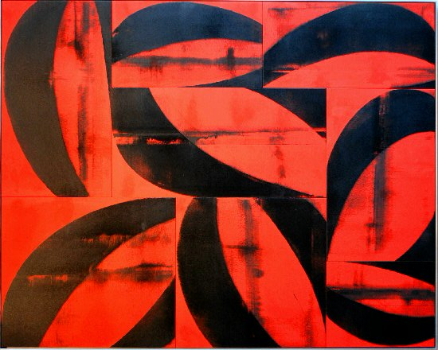
Firewall, 2007
acrylic on canvas
75 x 60 inches
CA0041
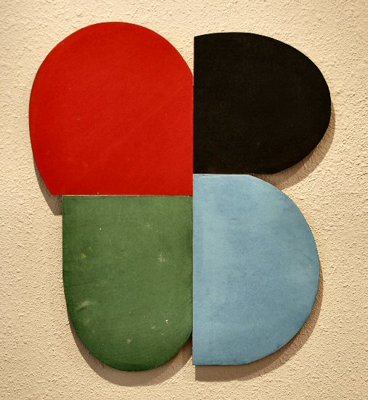
Untitled (Z Series), 2005
oil on aluminum
20 1/2 x 17 3/4 inches
CA0039
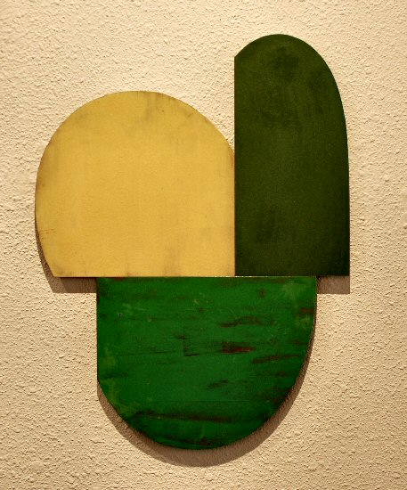
Untitled, 2005
oil on aluminum
20 x 15 1/8 inches
CA0040
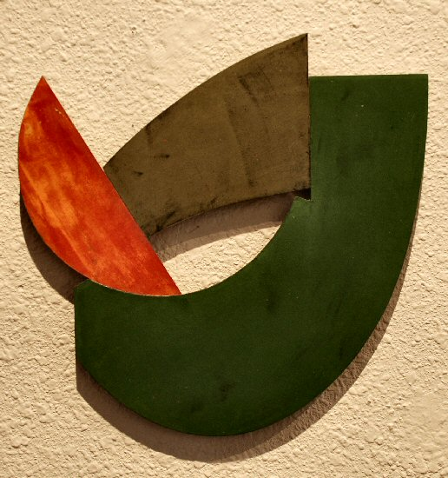
Untitled, 2005
Oil on aluminum
8 1/2 x 6 3/4 inches
CA0026
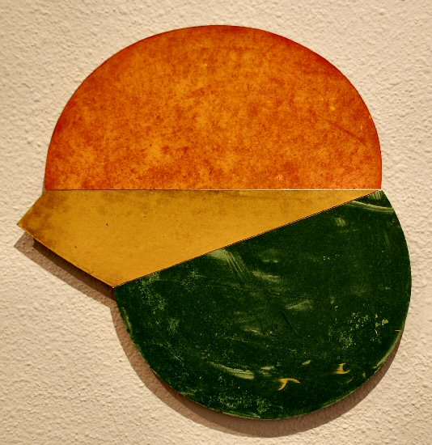
Untitled, 2005
Oil on aluminum
12 x 12 x 1/2 inches
CA002
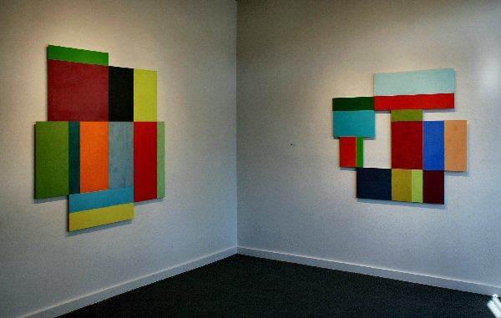

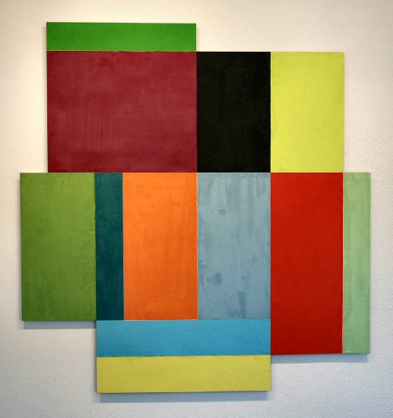
Era, 2007
oil on aluminum
60 x 57 inches
CA0043
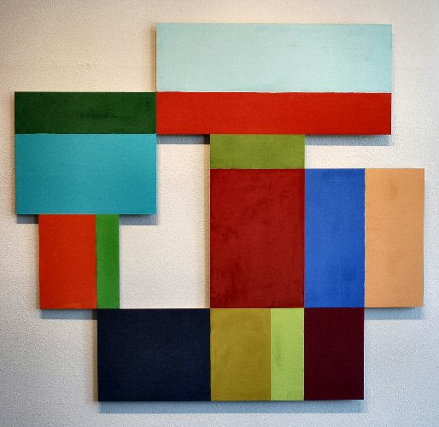
Fourth Corner, 2007
oil on aluminum
50 x 54 inches
CA0036
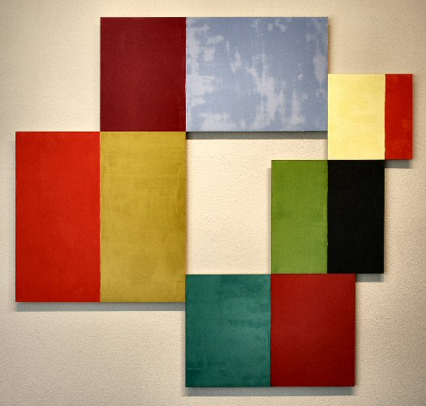
Zig Zag, 2007
oil on aluminum
50 5/8 x 54 5/8 inches
CA0042
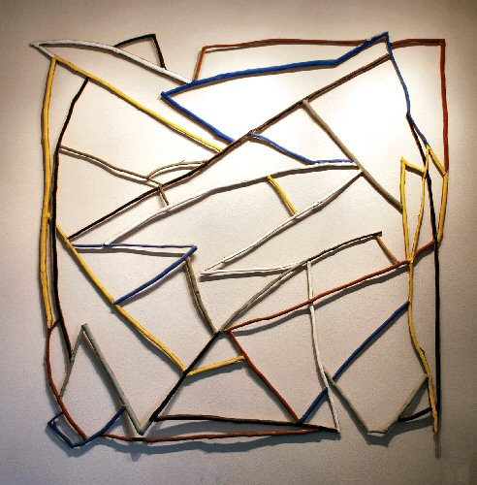
Untitled, 1972
Painted wood construction
72 x 72 inches
CA-OK001
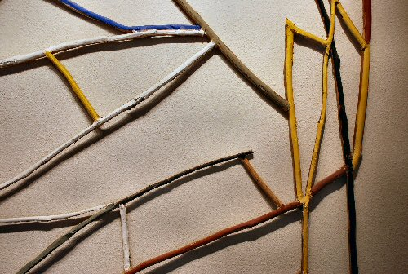
Untitled, 1972
Painted wood construction
72 x 72 inches
CA-OK001 (detail)
CHARLOTTE JACKSON PROJECT SPACE

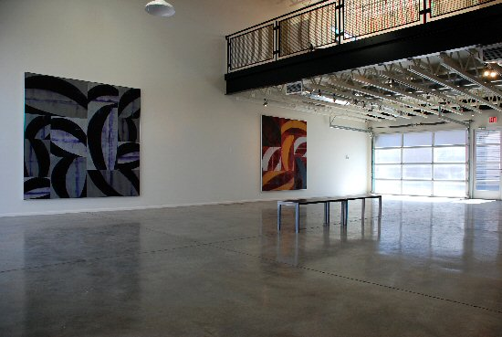

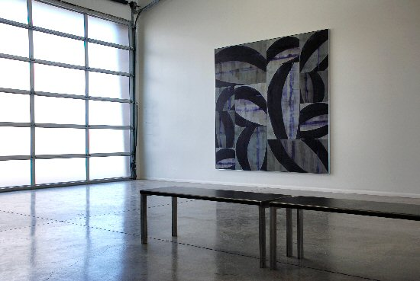
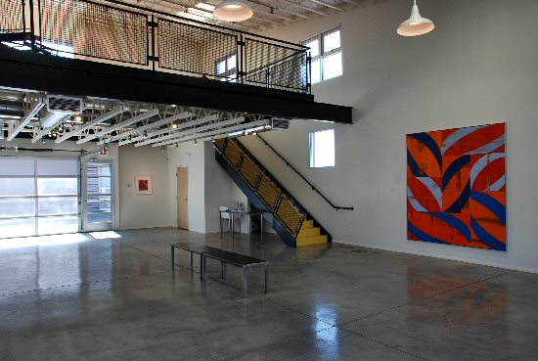

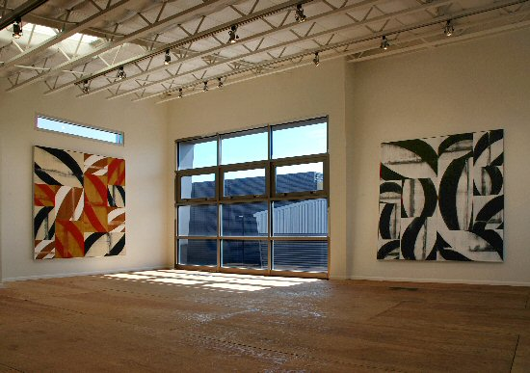
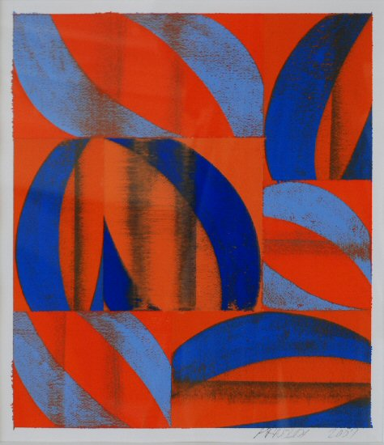
Untitled, 2007
guache on paper
19 x 1 inchesCA0044
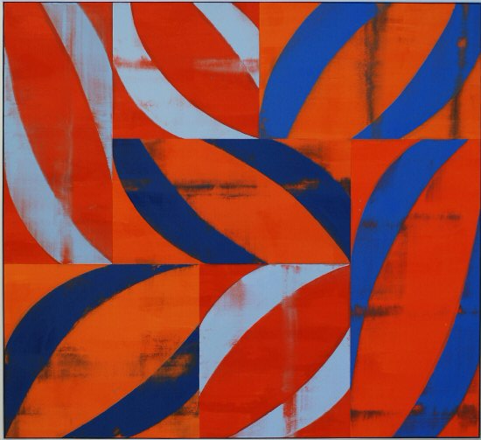
Marks, 2007
acrylic on canvas
88 3/4" x 80 3/4" (framed)
CA0033
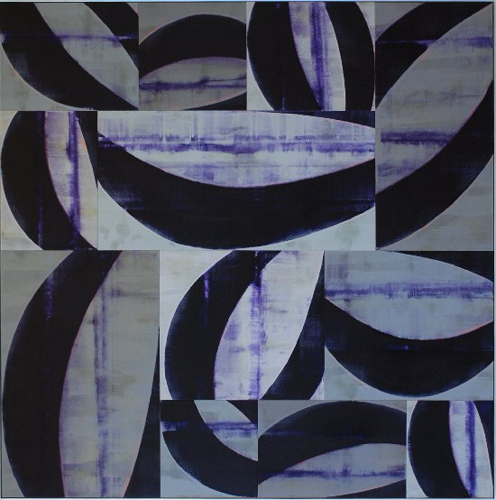
Anecdotes, 2007
acrylic on canvas
96 x 96 inches
CA0035
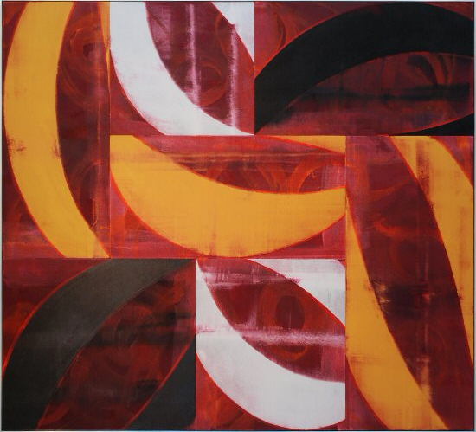
Meteor, 2007
acrylic on canvas
88 x 80 inches
CA0045
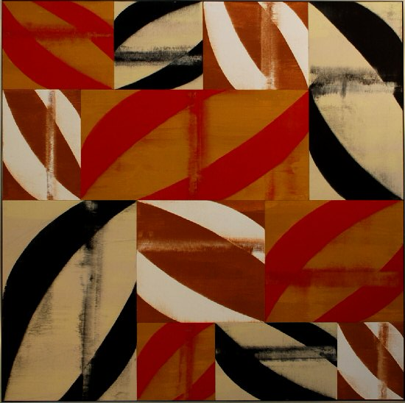
Walking Rain, 2007
acrylic on canvas
72 x 72 inches
CA0038
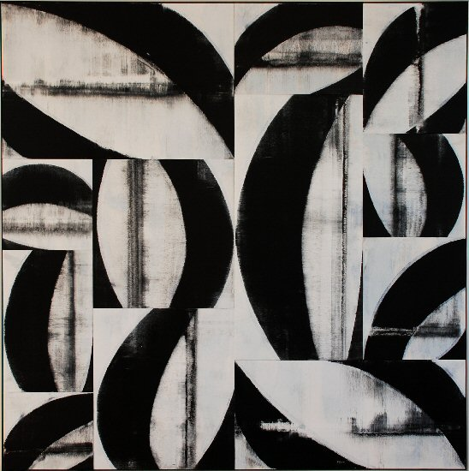
Backbone, 2007
acrylic on canvas
72 x 72 inches
CA0037

© 2007

Charlotte Jackson Fine Art, Inc.

200 West Marcy Street, Suite 101, Santa Fe, New Mexico 87501
Telephone: 505.989.8688 Fax: 505.989.9898
cjfa@charlottejackson.com - www.charlottejackson.com

Photography & CD Production:
William Metcalf

