CHARLOTTE JACKSON FINE ART
Presents:

CHARLES ARNOLDI: Arnoldi Works from 1998-2001

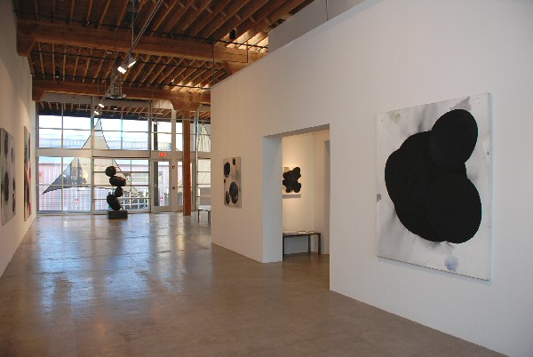

November 5 - December 12 2010
Gallery Talk: Saturday, November 6 at 3 p.m.
Bulky bulbous shapes balance precariously; their solid, swollen forms seem to hang suspended in a moment just before falling. Dark imperfect ovals seep upward on canvas, ghosted by gray shadows that swim behind them. The paintings, sketches and sculptures brought to Arnoldi: Works from 1998-2001, come from the artist’s Potato Series. The exhibition this November will be a rare opportunity for the public to view these works together as a coherent whole.
For Charles Arnoldi stagnation is death of art. Over his forty plus years of art-making his visual vocabulary has ranged and changed widely. Arnoldi is constantly pushing himself to expand, “When I get good at something and people like what I’m doing, then I want to move on.” However, despite the enormous differences in his work, it is impossible not to see how each series is in dialogue with the next. As Arnoldi says “You can’t escape yourself.” It is the will of the artist to break new ground, to not allow himself to settle comfortably into a familiar pattern that gives Arnoldi’s work over time such a powerful sense of mastery and balance, of relentless dynamism. Whether it was the fortuitous genius of seeing brush stroke and gesture in the charred limbs of trees on a Malibu hillside which led to Arnoldi’s famous stick paintings, or the impulse that led him to venture into negative space wielding a chainsaw, Arnoldi is not an artist who is afraid to follow an intuitive lead.
The origins of the Potato Series have a similarly interesting story. A group of school children visiting his studio one morning started it. Looking at a few of his paintings full of voluptuous organic forms, the kids commented on how this or that shape looked like Mickey Mouse, or like Bullwinkle. The associations stuck in Arnoldi’s head and he started to see potatoes in some of the bulbous forms. So, like a true artist, Arnoldi took a trip to his local grocery store and spent hours in the produce department, picking up and examining potatoes, filling his cart with nearly a hundred specimens of all kinds (red, white, russet). It was only at the check-out, when people were giving him odd looks that he realized his cart filled with potatoes might seem a bit strange.
Back in the studio he nailed potatoes to his studio walls, studying their shapes, noting the intriguing shadows they made. He put them into clusters and arrangements and noticed how their odd, asymmetrical forms suggested precarious combinations and wild balancing acts. At first he cast the potatoes in bronze and used black patina, to underplay their potato-ness and highlight their use as formal shapes. From there the series grew, he made sketches with graphite, and then began to expand the size of both the sculptures and later the paintings.

At the time he started the Potato Series, some thought Arnoldi might have gone a step too far. But the work itself quickly undoes that assumption. There is a raw energy and substantial presence to the sculptures that delicately balances with a lightness, almost whimsy in some of the precarious constructions. Pure earthy weight and gross organic volume meet with gravity-defying levity. In the paintings, which present these organic forms in a more atmospheric and painterly way, the black shapes seem to be haunted by their own faint echoes. There is a protean, generative quality inherent in the forms that suggest growth, movement—the beginnings of life underground.
The precision of the balancing act that Arnoldi pulls off with the Potato Series is indeed masterful. There is a freshness to these dense forms which only their organic origins could give, while at the same time the dark palette implies a careful, formal control. With this new exhibition, Arnoldi 1998-2001, the public have a chance to see a truly unique body of work by consummate artist Charles Arnoldi.
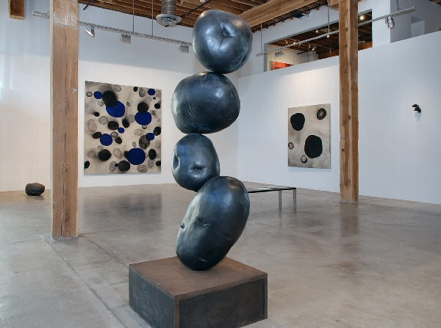

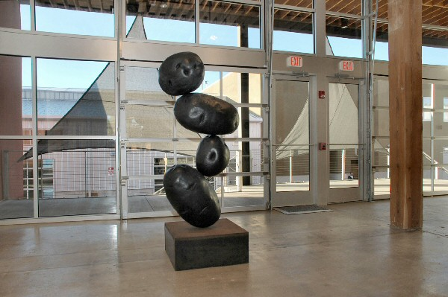

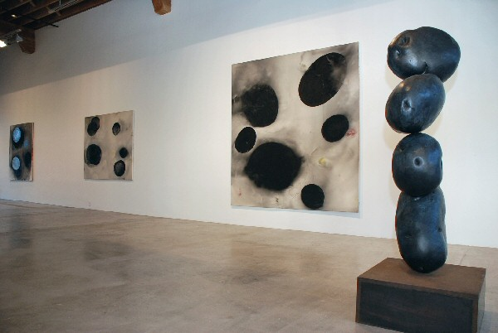
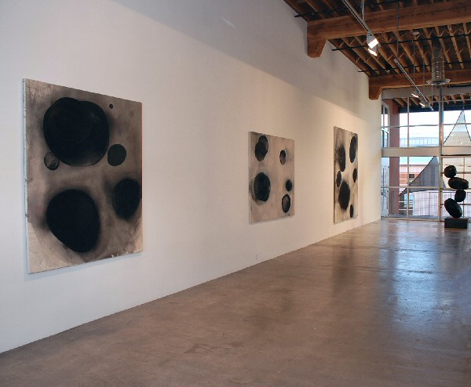
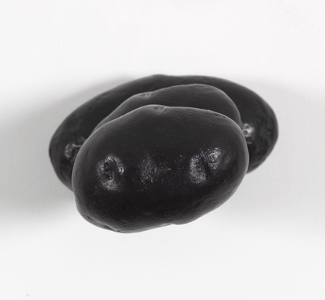
Tasty Spuds #38, 1998
Cast Bronze
8 x 6 ¼ x 3 ½ inches CA0118
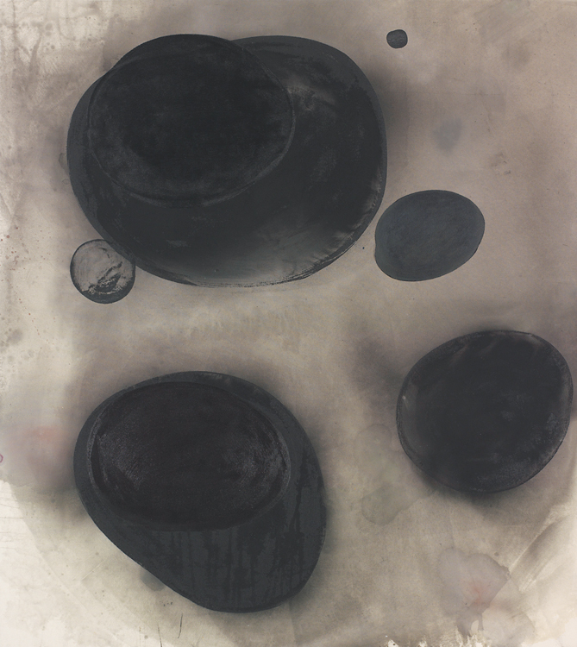
No Question, 1999
Acrylic on canvas
72 x 64 inches CA0103
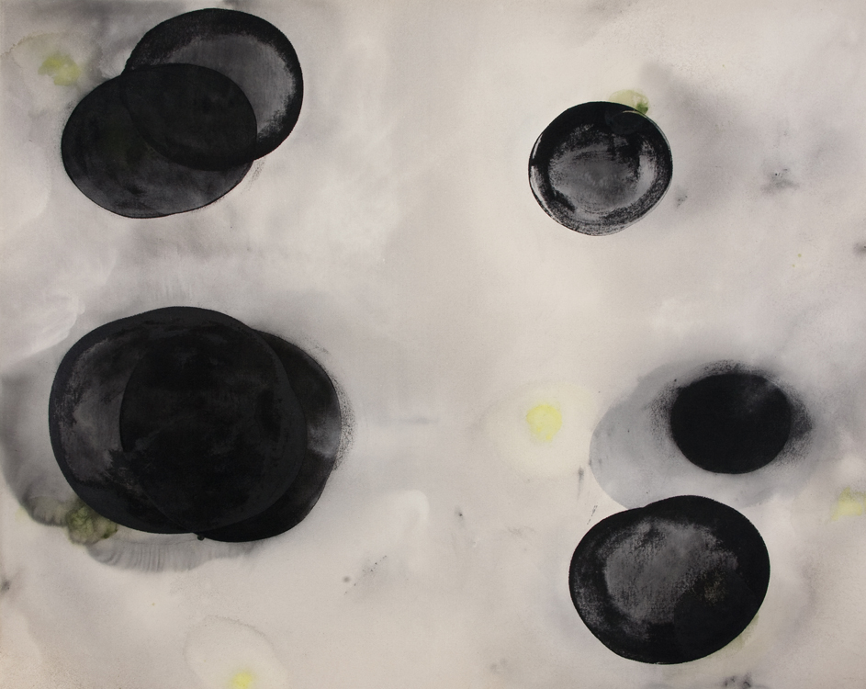
Same Ball Park, 1999
Acrylic on canvas
64 x 80 inches CA0101
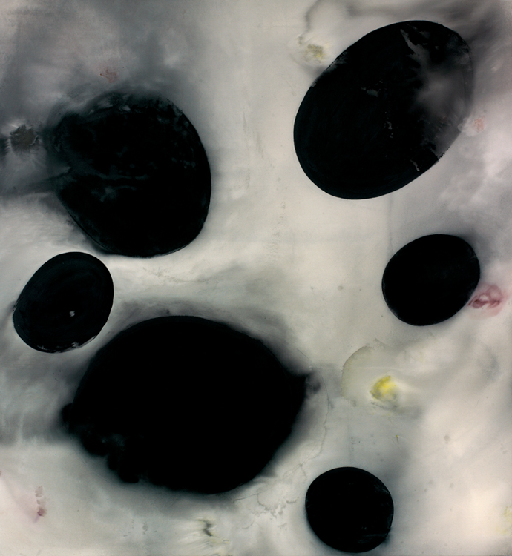
I’m Losing You, 1998
Acrylic on canvas
104 x 96 inches CA0108
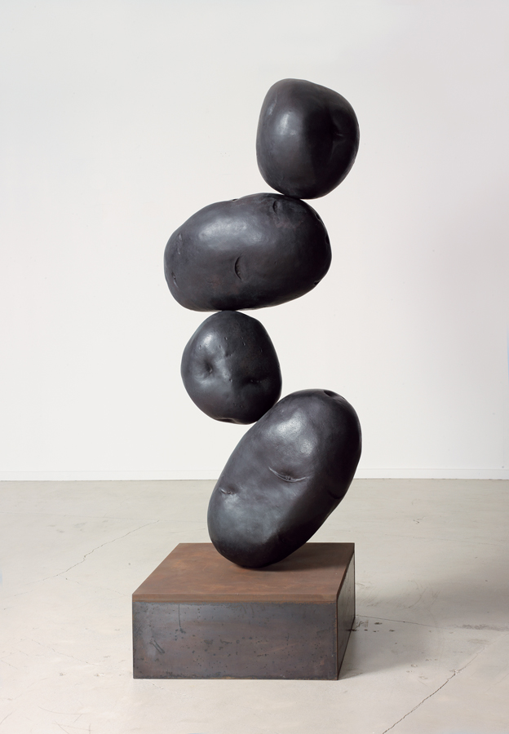
Milestone, 2001
Cast Bronze
67 ½ x 34 x 22 inches CA0110
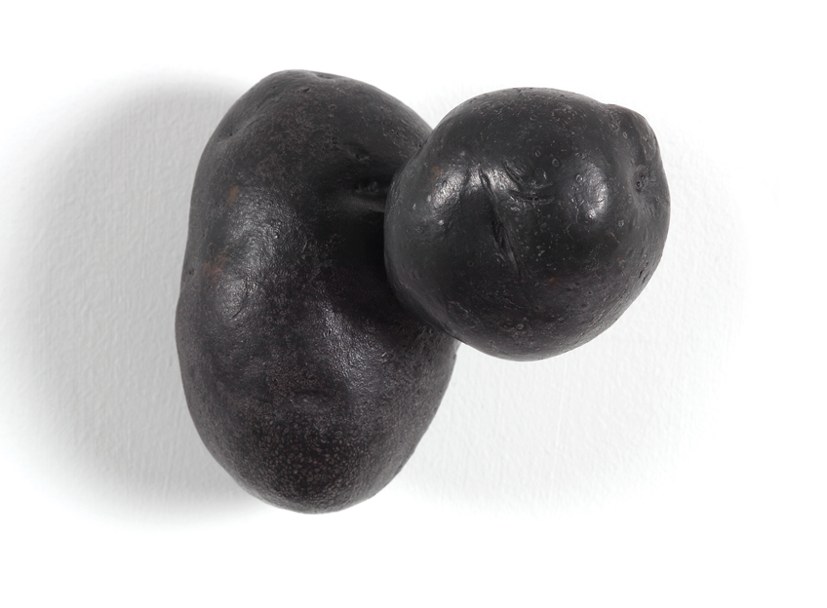
Tasty Spuds #1, 1997
Cast Bronze
5 x 5 x 4 ¾ inches CA0112
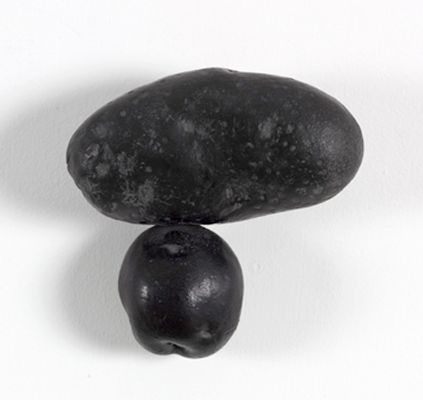
Tasty Spuds #27, 1997
Cast Bronze
6 x 6 x 2 ½ inches, CA0116
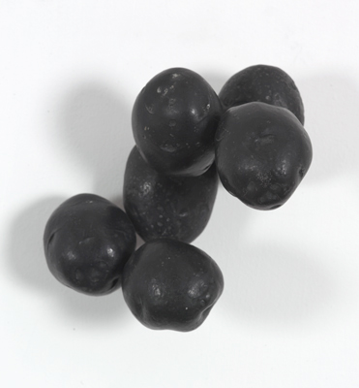
Tasty Spuds #32, 1998
Cast Bronze
9 x 7 ¼ x 4 ¾ inches, CA 0117
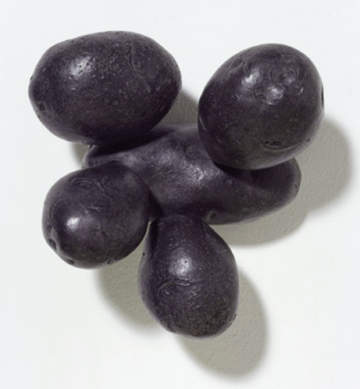
Tasty Spuds #32, 1998
Cast Bronze
9 x 7 ¼ x 4 ¾ inches, CA 0117
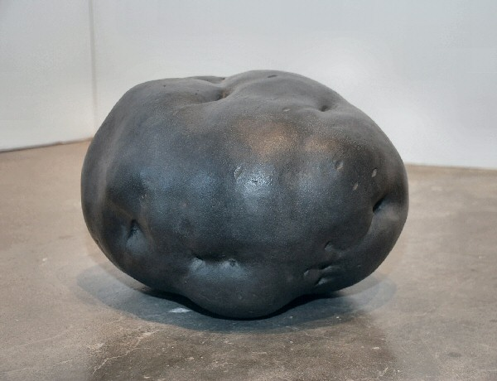
Chakra, 1998
Cast bronze
17 x 14 x 11 inches CA0111
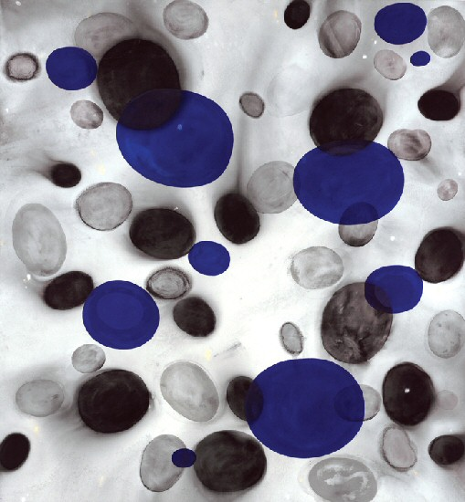
Banger, 1999
Acrylic on canvas
104 x 96 inches CA0102
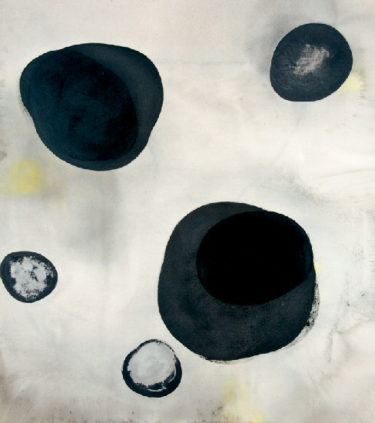
Get Away, 1999
Acrylic on canvas
72 x 64 inches CA0076
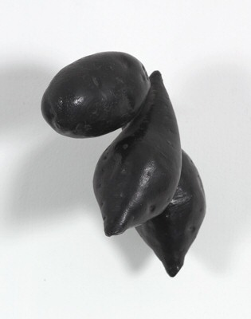
Tasty Spuds #15, 1997
Cast bronze
8 ¾ x 5 ½ x 6 ¼ inches CA0115
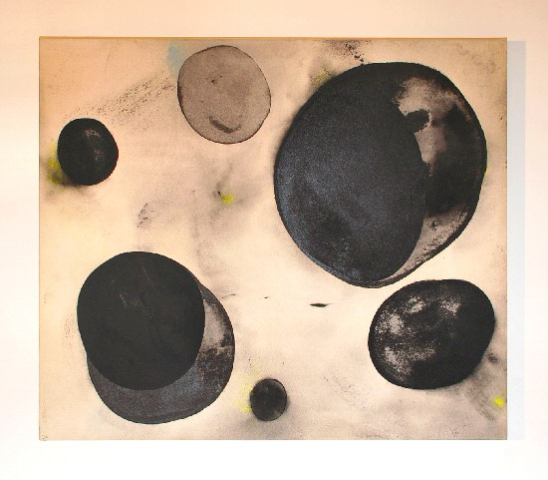
High Pressure, 1999
Acrylic on canvas
40 x 34 inches CA0104
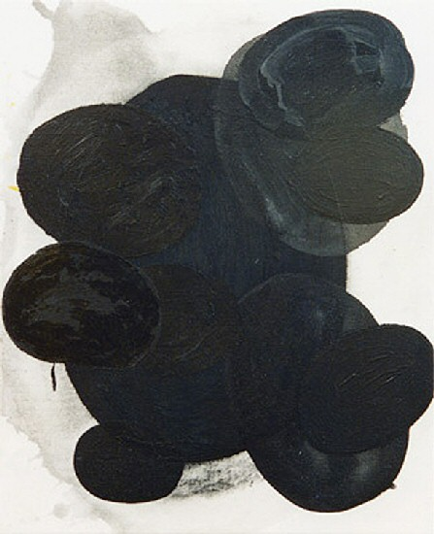
ZZZT, 1998
Acrylic on canvas
22 ½ x 18 ¼ inches CA0105
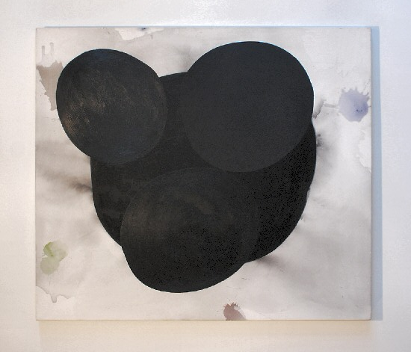
Punish the Wicked, 1998
Acrylic on canvas
66 x 58 inches CA0107
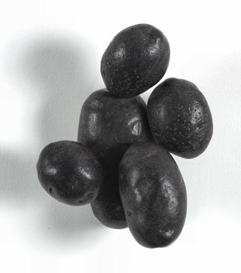
Tasty Spuds #11, 1997
Cast bronze
9 x 7 ¼ x 4 3/4 inches CA0114

© 2011

Charlotte Jackson Fine Art, Inc.

In the Railyard at:

554 S. Guadalupe, Santa Fe, New Mexico 87501
Telephone: 505.989.8688 Fax: 505.989.9898
cjfa@charlottejackson.com - www.charlottejackson.com

