CHARLOTTE JACKSON FINE ART

PRESENTS:

Charles Arnoldi: Fractured Arc Paintings
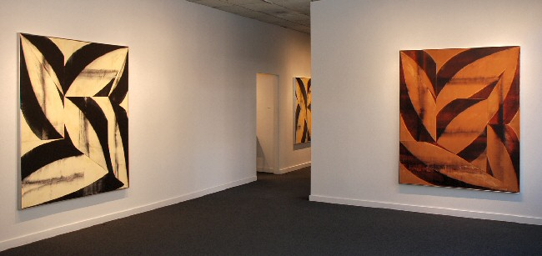
November 7 through 29
2008

Charlotte Jackson Fine Art is pleased to present the opening of the exhibition Fractured Arc Paintings, a commanding new series of multiple-panel paintings by Los Angeles artist Charles Arnoldi. On the same evening, the gallery hosts a book signing in honor of the release of the exquisite text, Charles Arnoldi, with a foreword by architect Frank Gehry and an essay by Dave Hickey.
Some 40 years ago, a band of artists whose paths crossed in art schools, museums, and studios on both coasts were questioning the status quo of the art of the New York School. There, Rauschenberg and Johns were selling combines and bronze beer cans in Leo Castelli’s gallery while Warhol was merging popular visual culture and commercialism to produce an art that has been known ever since as “Pop.” Something was happening, all right, in New York, but a stolid Modern Art maintained its monarchic hold over the city. Challenging the formalism of Post-Painterly Abstraction, on the one hand, and the grid, on the other, were a raucous bunch of artists in Los Angeles, where, as one of them put it, it didn’t matter what you did because no one was paying attention.
One of those artists was Charles Arnoldi (b. 1946). In the din of a drumbeat that rolled out the death knell of painting, Arnoldi looked at ruined, charred tree branches from a Malibu fire and began his “stick” paintings. Next, his chain saw roared; Arnoldi made wall reliefs of rough-hewn lumber. Highly architectural in their construction and considerations, it is no coincidence that his neighbor and best friend remains today Frank Gehry, the Frank Lloyd Wright of the contemporary era.
Continuing to explore the gamut of artistic mediums and visual vocabulary, Arnoldi began making Arc paintings, multiple canvases placed in squares to form a monumental whole, covered in broad, bold gestural strokes of color. Reminiscent of both the chain saw and stick constructions, the Arc series was, for the artist, “more emotional, more human.”
Now, Charlotte Jackson Fine Art in Santa Fe is pleased to present an exhibition of recent Fractured Arc Paintings by Charles Arnoldi. Comprising multiple-panel paintings in a wide range of sizes, Arnoldi has done away with 90-degree angles in this latest series. This, he says, “allows for a greater level of perspective and the illusion of varying picture planes” within each painting. A look at N.S.E.W., for example, reveals a greater sense of organic, even biological, form; while the piece pictured below, Fight, swirls in a pinwheel of action and quietly exploding sensation.
Along with the exhibition, Radius Books and ART Santa Fe Presents announce the publication of a long-awaited volume, Charles Arnoldi, with a forward by Gehry, an introduction by art writer Hickey, and conversations with artist Gregory Amenoff, art historian Fred Hoffman, museum director Michael Zakian, and Arnoldi’s Santa Fe gallerist Charlotte Jackson. The artist will be present for the reception and book-signing event on November 7 at Jackson’s downtown Santa Fe location.
Charles Arnoldi attended the Chouinard Art Institute in the late 1960s—a dynamic era for Los Angeles artists that produced the likes of Arnoldi, Larry Bell, Ed Ruscha, John Baldessari and Judy Chicago, to name but a few. Arnoldi’s work is represented in major international collections, including The Metropolitan Museum of Art, The Art Institute of Chicago, the Guggenheim Bilbao, the Norton-Simon collection, the Albright-Knox Gallery, the National Gallery of Art in Sydney, the Menil Foundation in Houston, New York’s Museum of Modern Art, and many others.
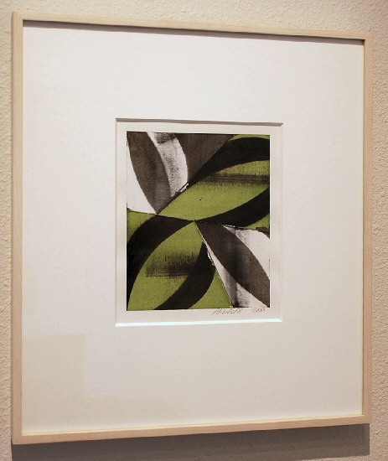
Untitled, 2008
Gouache on paper
17.5” x 17.25” (framed)
7” x 7.25” (image size) CA0064
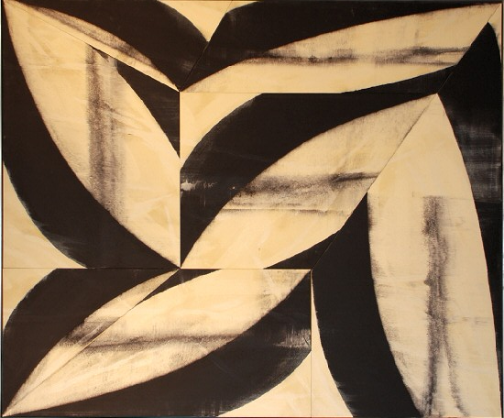
Stalker, 2008
Acrylic on canvas
72” x 60” CA058
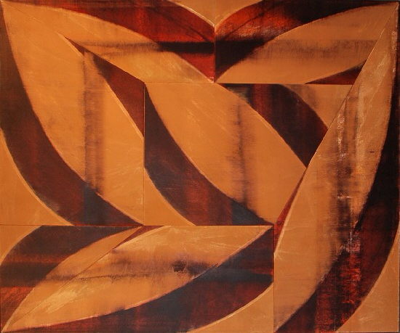
Fight, 2008
Acrylic on canvas
72 .75” x 60.75” CA0059
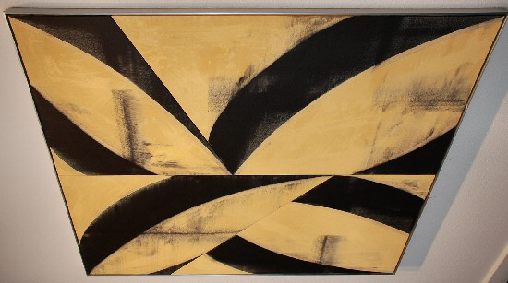
Mission, 2008
Acrylic on canvas 56” x 48” CA0061
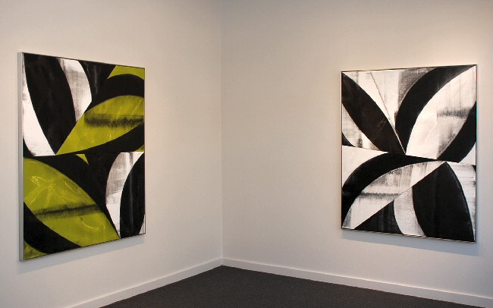
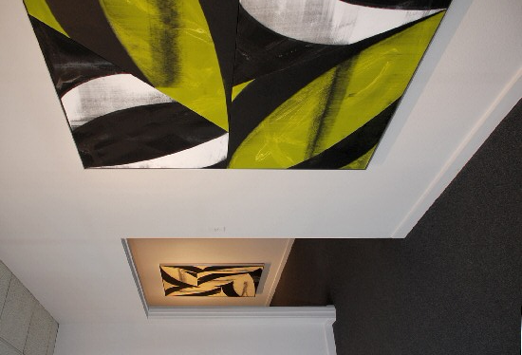
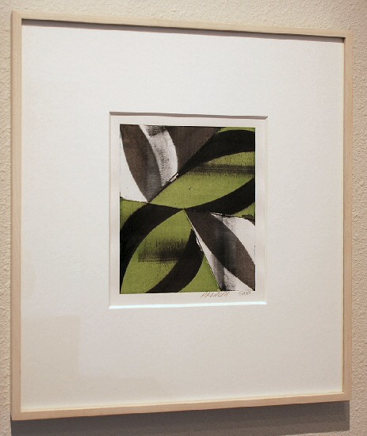
Untitled, 2008
Gouache on paper 18.5” x 16.75”
18.5” x 16.75” (framed)
8” x 6.75” (image size) CA0066
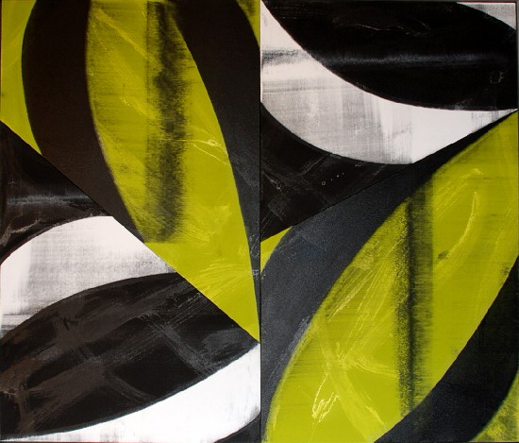
N.S.E.W., 2008
Acrylic on canvas 60” x 51” CA0057
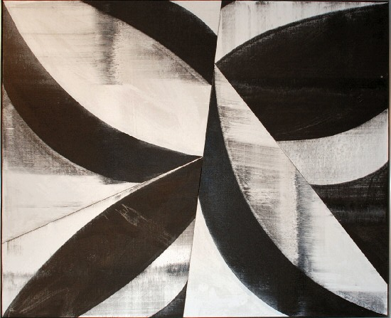
Double Diamond, 2008
Acrylic on canvas 60.75” x 51.75” CA0062
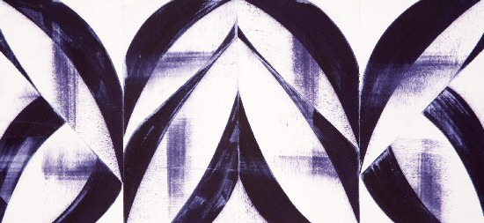
Untitled, 2008
gouache on paper
9” x19” (image size)
20 x 29 1/4 inches (framed) CA0065
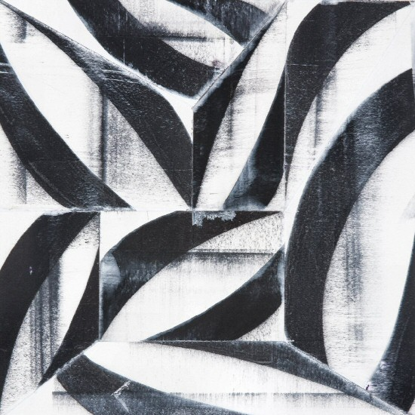
Untitled, 2007
gouache on paper
8 x 8 inches (image size)
18 1/2 x 18 inches (framed) CA0063

© 2008

Charlotte Jackson Fine Art, Inc.

200 West Marcy Street, Suite 101, Santa Fe, New Mexico 87501
Telephone: 505.989.8688 Fax: 505.989.9898
cjfa@charlottejackson.com - www.charlottejackson.com

