CHARLOTTE JACKSON FINE ART

PRESENTS:

APERTURE AND ARCHITECTURE
Virginia Beahan
Laura McPhee
Steven Day
Michael Eastman
Andrew Ty Lee
Sze Tsung Leong
Andre Naggar
Robert Polidori
Sean Scully
Michael Wolf
In cooperation with Brenda Edelson Artworks.

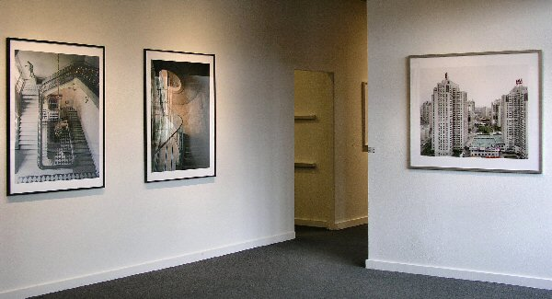

Friday, June 2 through June 23, 2006
You might walk by and not see it. You might sleep, eat, or work in it and not know it. Architecture, the built environment, surrounds and informs our daily lives. It is the physical manifestation of who we are, what we were, and sometimes a template for what we are becoming. This is as true of a street in Brooklyn as it is of an ancient, echoing palace. And for all this, what do we see? Like fish in water we rarely know the texture of the world around us in our rushing daily lives.
In this group exhibition, Charlotte Jackson Fine Art features the work of photographers whose focal point is architecture (both interior and exterior spaces). The perspective and subject matter of the photographers in this show is varied, from the bygone splendor of Versailles to the reconstruction of Beijing, but all have in common an ability to create images that capture our attention. An angle of a building, an empty room, shadows, patterns, aureoles of light: the eye of the photographer captures an intimate part of a world that is rapidly changing. This piece of the world in turn enables the viewer to see what is there, to see differently. An unexpected perspective cuts through preconception and allows for a flash of awareness where seeing can happen.
These diverse images from all over the world (China, Italy, New York, Los Angeles, France) form a kind of conversation of cultures and histories, of time and change. They speak to each other as well as to the viewer, allowing both an interior and exterior dialogue. But do not mistake that these images are only documentary, the act of framing, of catching light and field, go far beyond recording into the realm of art. Viewers are able to interact with the image, to engage it and take from it a changed relationship with the world around them.
MAIN GALLERY:
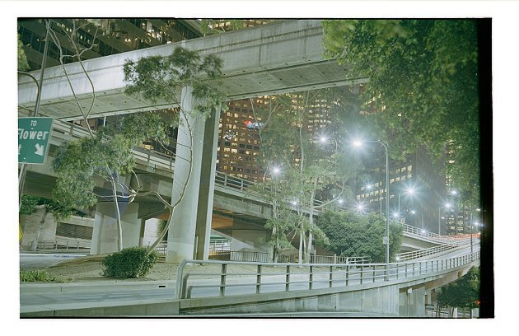
ANDREW TY LEE
Flower Street, 2005
C-Print on aluminum, 1/9, 25” x 38” ATL001
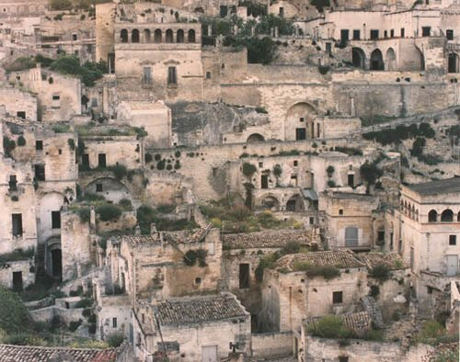

VIRGINIA BEAHAN & LAURA MCPHEE
Caves used as dwellings since prehistoric times, modified with tufa facades, now under construction. Matera, Italy, 1994
C-Print, Edition of 10, 42” x 50”, BEP001
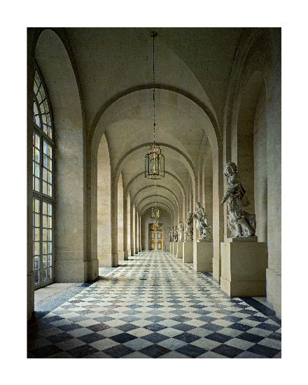
VIRGINIA BEAHAN & LAURA MCPHEE
Caves used as dwellings since prehistoric times, modified with tufa facades, now under construction. Matera, Italy, 1994
C-Print, Edition of 10, 42” x 50”, BEP001
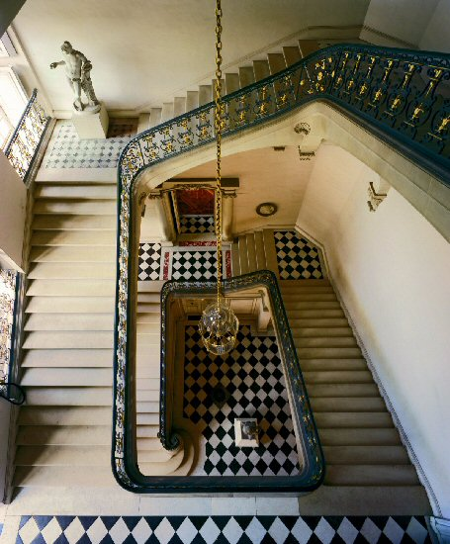

ROBERT POLIDORI
Stairway in the Royal Opera, Chateau de Versailles, 1985
C-Print, 1/10, 50” x 40”, BEP006
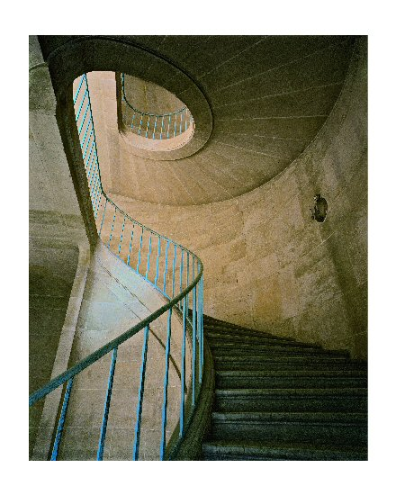
ROBERT POLIDORI
Questel Staircase, Chateau de Versailles, 1985
C-Print, 1/10, 50” x 40”, BEP005
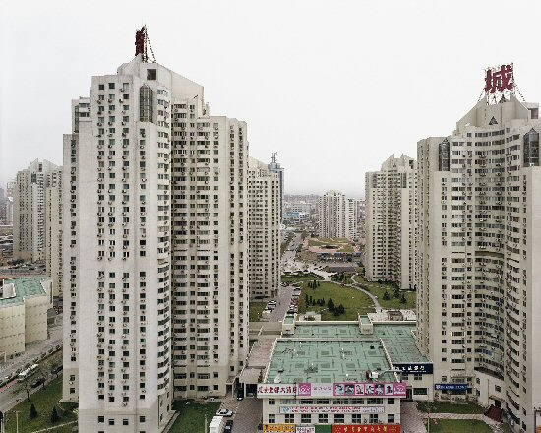

SZE TSUNG LEONG
Wangjing Xincheng, Chaoyang District, Beijing (New City), 2003
C-Print, 2/10, 40” x 48”, BEP002
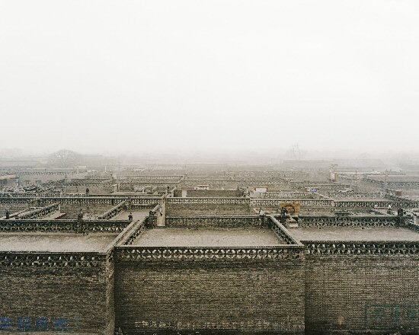

SZE TSUNG LEONG
Beicheng Xin Cun, Pingyao, Shanxi Province (Rooftops), 2004
C-Print, 7/10, 40” x 48”, BEP003
HALLWAY:
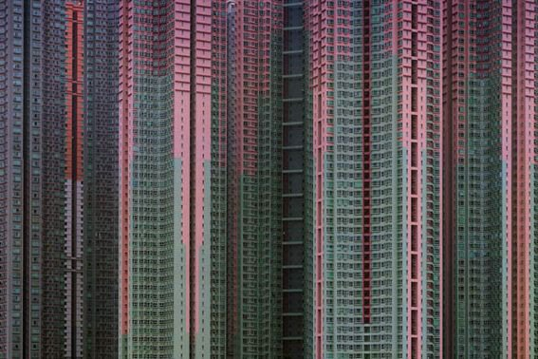

MICHAEL WOLF
Architecture of Denisty #39, 2005
LightJet Print, 2/9, 25” x 37 ½”, MW001
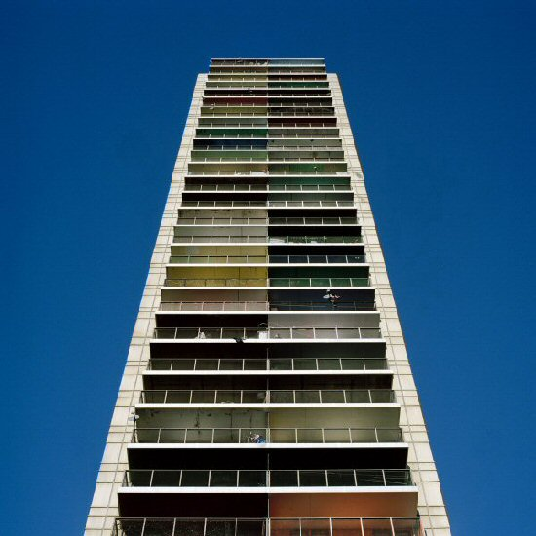

STEVEN DAY
Upper City, Terrace, 2006
C-Print, 1/7, 24” x 20”, SD005 (through 08)
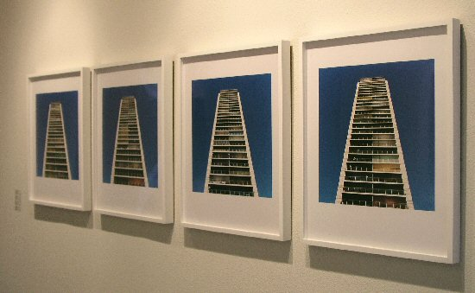

STEVEN DAY
Upper City, Terrace 01 (through04), 2006
C-Print, 1/7, 24” x 20”, SD005 (through 08)
GALLERY II:
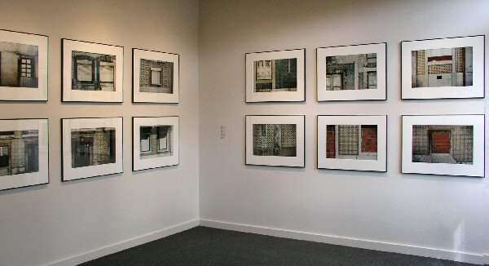

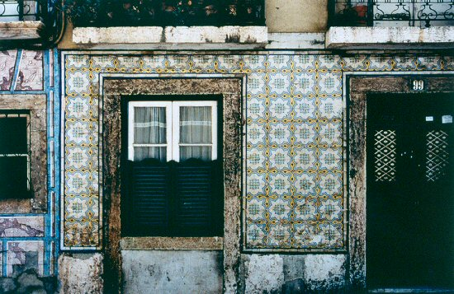

SEAN SCULLY
Grey Lady, 1998
Set of 12 C-Prints (edition of 12, see above), 23 ½” x 31”
BEP007-1
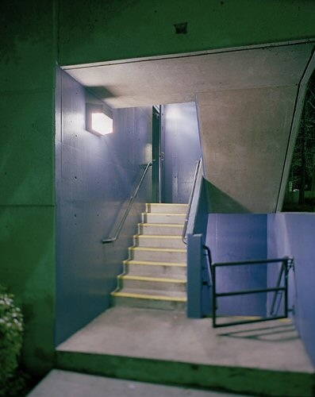

ANDREW TY LEE
Pasadena Staircase, 2005
C-Print on aluminum, 1/9, 23” x 19” ATL002
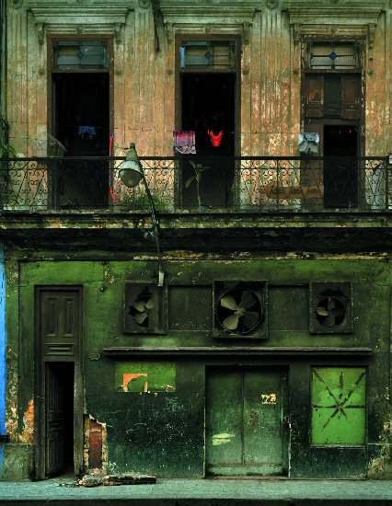

MICHAEL EASTMAN
Three Fans, 2000
C-Print, 45” x 37”, ME0041
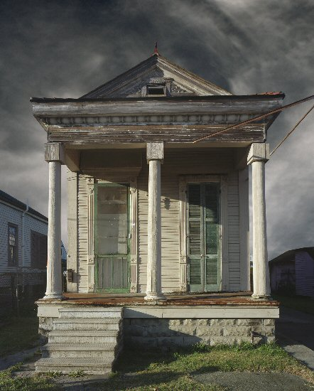

MICHAEL EASTMAN
Shotgun House, New Orleans, 2005
C-Print, 45” x 37”, ME0081

© 2006

Charlotte Jackson Fine Art, Inc.

200 West Marcy Street, Suite 101, Santa Fe, New Mexico 87501
Telephone: 505.989.8688 Fax: 505.989.9898
cjfa@charlottejackson.com - www.charlottejackson.com

Photography & CD Production:
William Metcalf

