CHARLOTTE JACKSON FINE ART PRESENTS:

ALFONSO FRATTEGGIANI BIANCHI

“ T R I P T Y C O N ”

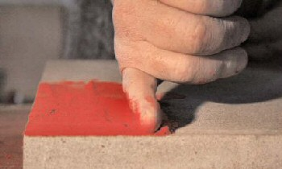

Feb 24, - Mar 24, 2012

Entering a gallery of paintings by Alfonso Fratteggiani Bianchi you feel as if you are walking into an ancient circle of standing stones, or the great cave at Lascaux with its pre-historic paintings of bison and horses, or perhaps even onto a crowded railroad platform. You are entering a different world with a different orientation. Despite their small scale, these paintings with their mind-piercing and vivid reds, blues, oranges, claim the attention and absorption of a large scale mural. Each painting, or constellation of paintings, is a presence—solid, unique, and resonant—the way a monolith or a human face might be.
The reference to stone circles and cave paintings does not mean that Fratteggiani Bianchi’s work is in any way primitive. On thecontrary, these pieces are elegant, fiercely radical monochrome works which have taken their place in galleries alongside the cutting edge of contemporary art. Rather the connection is one of intensity and directness. As renowned art collector Giuseppe Panza di Biumo has said, “Fratteggiani’s discovery is a real event in the history of art. It is a first time in thousands [of] years.” The genius of Fratteggiani Bianchi’s paintings is that there is nothing here that intercedes between artist and pigment, between viewer and color. Here is the quintessence of art-making, the candor of a human hand rubbing pigment into stone, experienced through the matrix of thousands of years of intervening human history, thought, art, and theory. Complex and simple simultaneously.
Fratteggiani Bianchi uses pure powdered pigments which he hunts for during his travels around the world. He applies this pure color directly onto cut pietra serena limestone without the use of any medium: No glue, no acrylic, no oil. Fratteggiani Bianchi uses only the palm and side of his hand to press and pack the powder into the porous limestone which is native to his Umbria region in Italy. Unhindered by the usual binders, the pigment is allowed to remain unfixed and alive, and therefore to breathe and radiate its full force of color. Although he has been perfecting and refining his technique for years, Fratteggiani Bianchi says, “I always find(whether because I search them or because they show themselves) new qualities in the different pigments and their handling, application. Every painting is a new challenge.”
With Triptycon Fratteggiani Bianchi adds another dimension by creating three-panel pieces, triptychs of stone and stunning color. These triptychs are carefully planned to explore relationships between the characteristics of the pigments, stone, and formats. If a single Fratteggiani Bianchi piece—perhaps a rich, velvety, shockingly deep red—is like a single star, radiating color and light, fixing and arresting the gaze, then the triptychs are like constellations. As Fratteggiani Bianchi says, “… each part shines by its own, but observing it together with other stars a relation comes out, a depth which implies wider views and hypothesis.” In Triptych # 020, #021, #022, for example, three astonishing blues come together: clear aqua, deep navy, and pure sky blue. Each alone suggests a quality of sky or water, of light in summer twilight or the color in a curling wave. Together they do something more by reminding us of how each single color is present within the others—how a bruised evening sky also holds within itself the hues of morning.
As Fratteggiani Bianchi says, color is matter. The brilliance of color within these paintings is capable of piercing straight through the eye into the heart and mind. It awakens, it opens. But more than that, it is solid. It affects and appeals to us directly, in the same way Ezra Pound’s famous poem, In a Station of the Metro does: “The apparition of these faces in the crowd; petals on a wet, black bough.” With Fratteggiani Bianchi’s paintings the metaphor cycles backward, with the “petals” of color becoming the haunting faces of a crowd.
In Fratteggiani Bianchi’s latest exhibition, Triptycon, colors so saturate and vibrant that they are unmistakably alive and absolutely real remind us that we, too, are vividly alive and real.

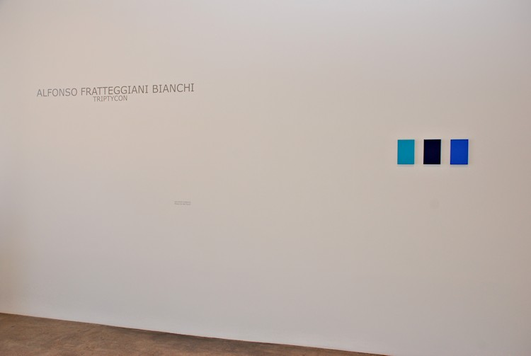
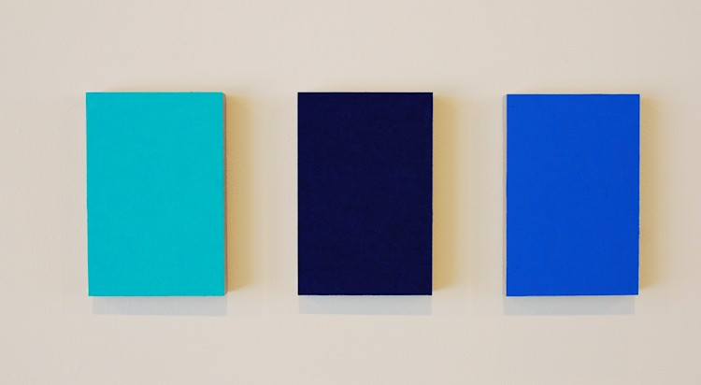

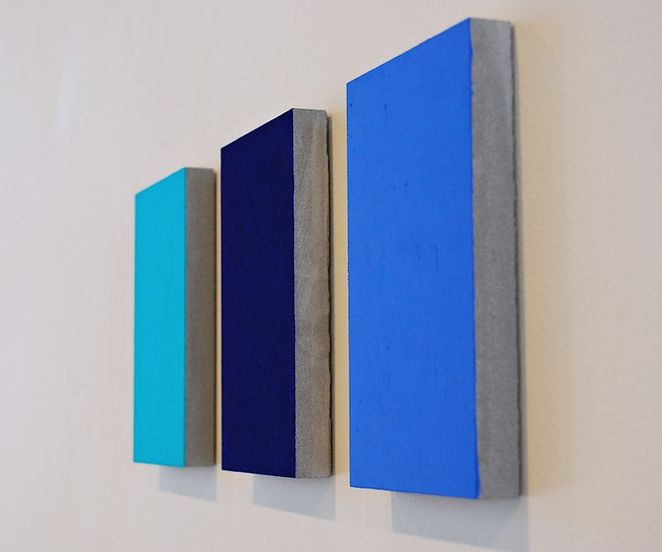


#020; Blu, 2011
Pigment on limestone
8.5" x 5.5" x 1"
AFB070

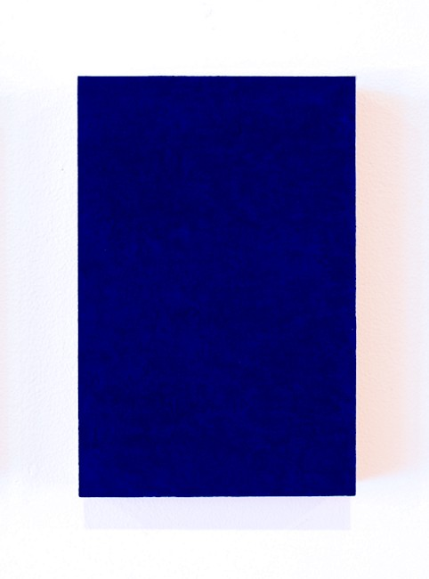
#021; Blu, 2011
Pigment on limestone
8.5" x 5.5" x 1"
AFB071

#022, Blu, 2011
Pigment on limestone
8.5" x 5.5" x 1"
AFB072
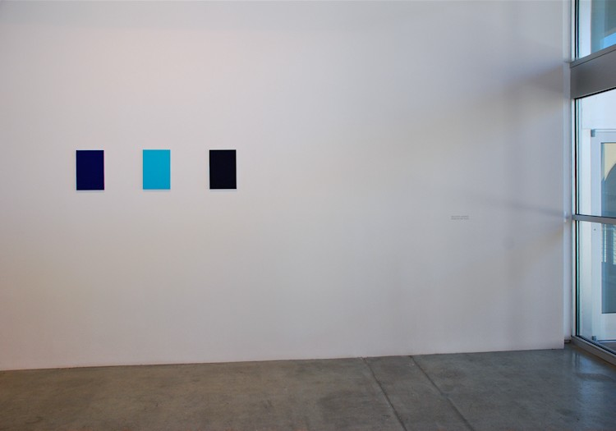

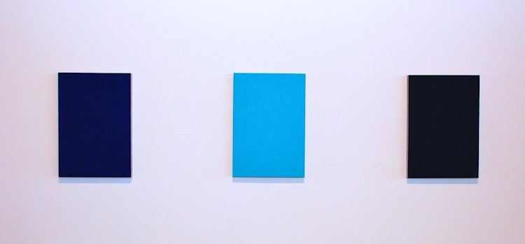
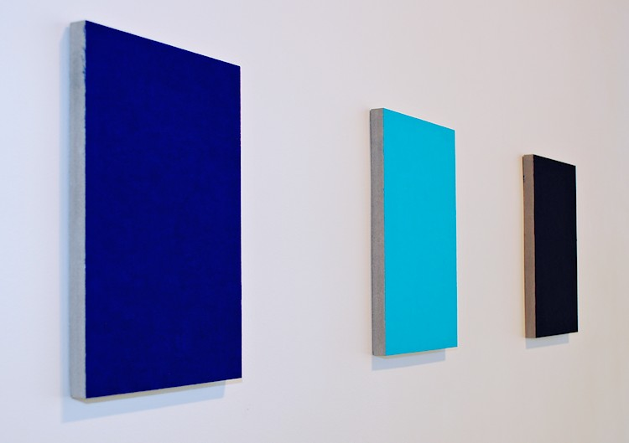

#029 Blu, 2011
Pigment on limestone
14 x 10 x 1 inches
AFB075
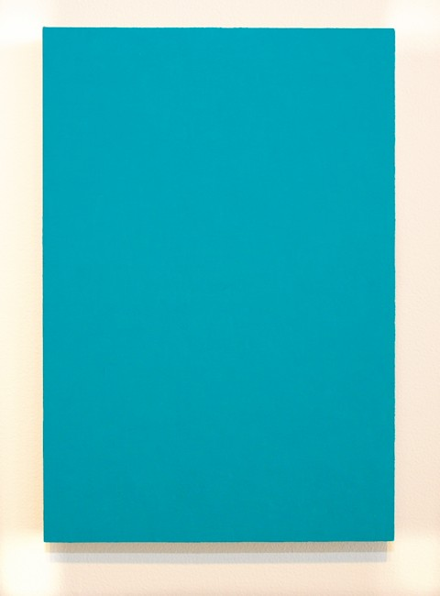
#027 Blu, 2011
Pigment on limestone
14 x 10 x 1 inches
AFB073

#028 Blu, 2011
Pigment on limestone
14 x 10 x 1 inches
AFB074

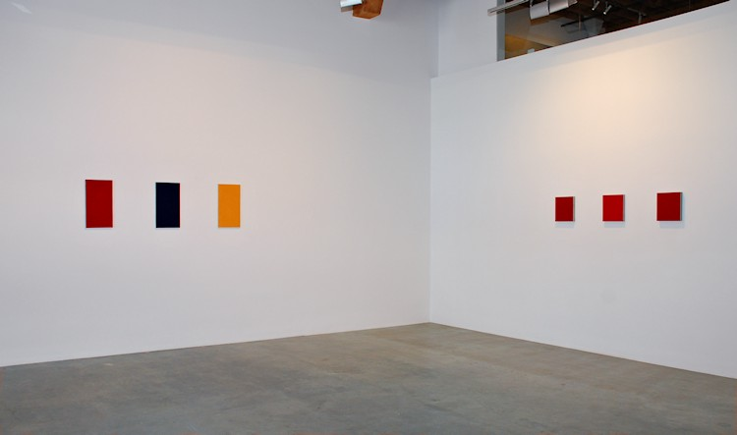

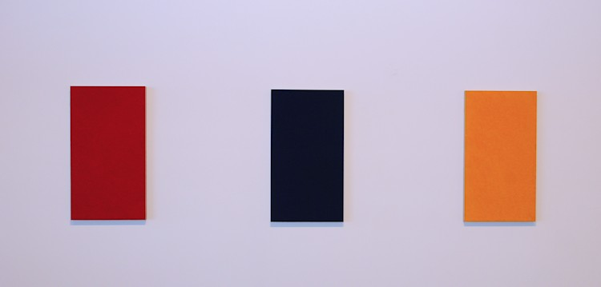
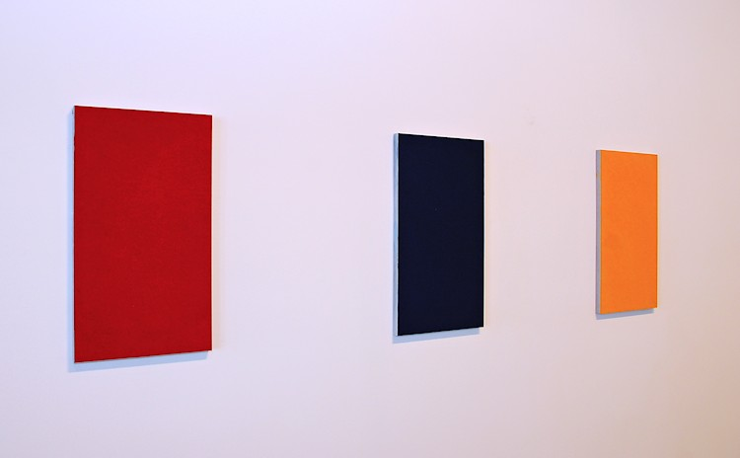
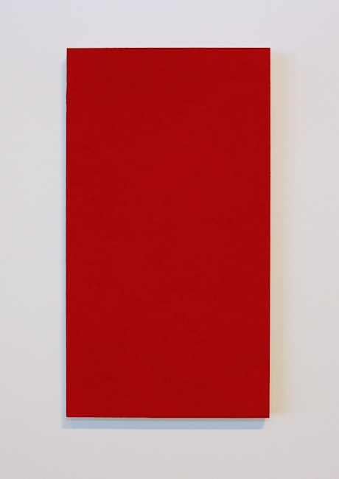
#128 Roso, 2011
Pigment on limestone
20 x 11 1/2 x 1 inches
AFB079

#113 Blu, 2011
Pigment on limestone
20 x 11 1/2 x 1 inches
AFB081

#130 Giallo, 2011
Pigment on limestone
20 x 11 1/2 x 1 inches
AFB080
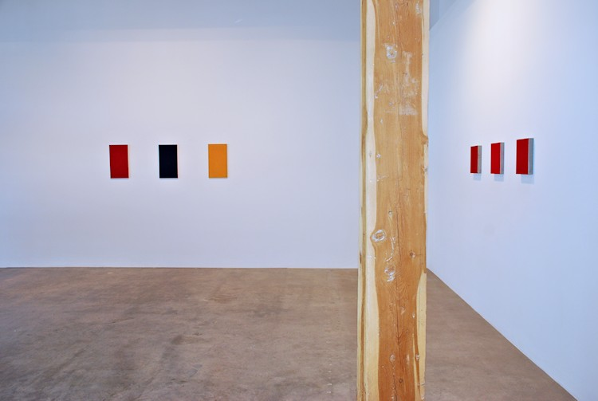

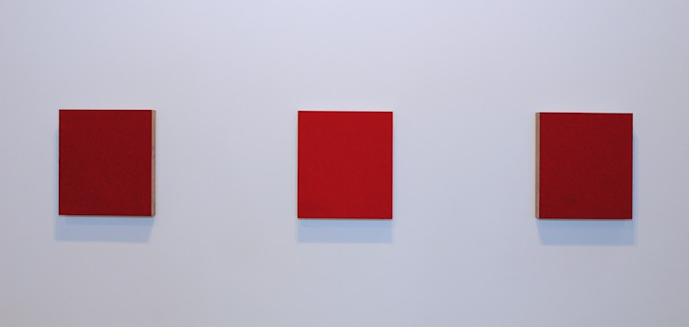
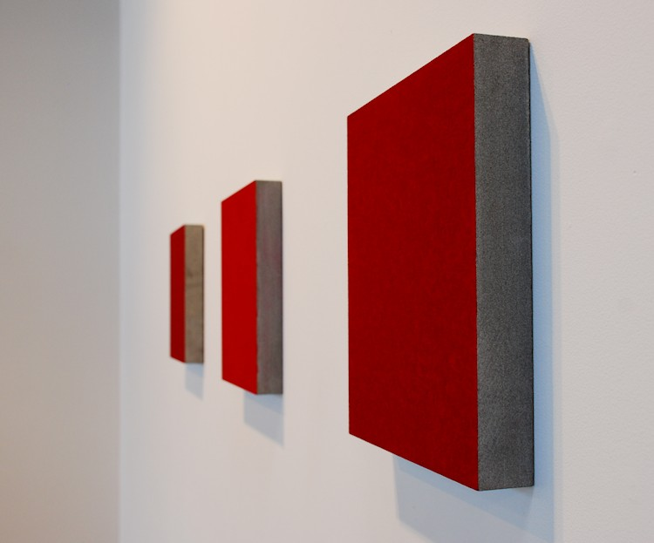
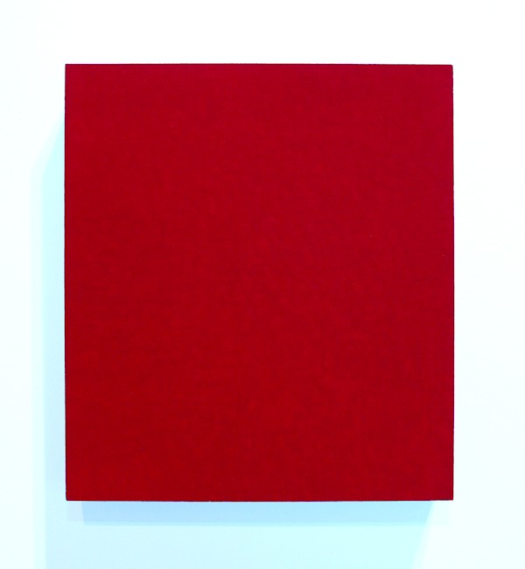
#030 Roso, 2011
Pigment on limestone
12 x 11 x 2 inches
AFB076
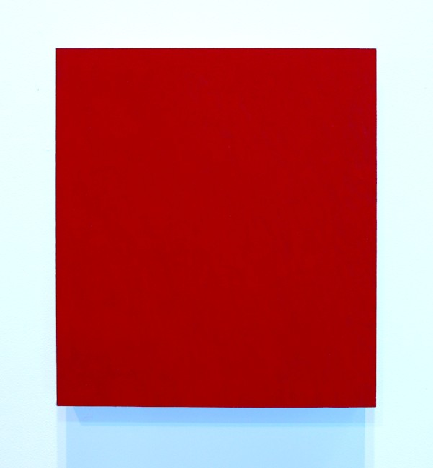
#031 Roso, 2011
Pigment on limestone
12 x 11 x 2 inches
AFB077
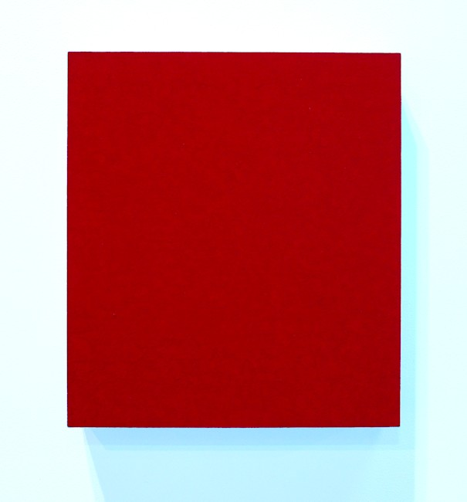
#032 Roso, 2011
Pigment on limestone
12 x 11 x 2 inches
AFB078

© 2012

Charlotte Jackson Fine Art, Inc.

In the Railyard at:

554 S. Guadalupe, Santa Fe, New Mexico 87501
Telephone: 505.989.8688 Fax: 505.989.9898
cjfa@charlottejackson.com - www.charlottejackson.com

