CHARLOTTE JACKSON FINE ART
PRESENTS:

4 from New York
A Group Exhibition Guest Curated by John Beech
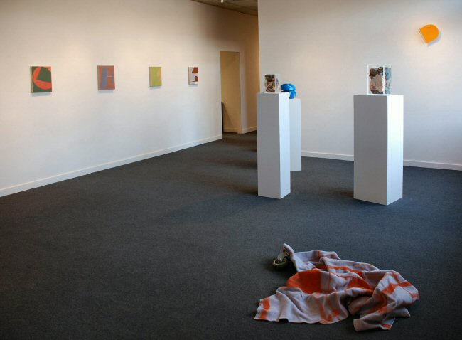

February 9 through March 4, 2007
Gallery artist John Beech brings the work of three fellow New York artists, Joyce Kim, Christopher Lesnewski, and Michael Voss to Santa Fe for this exhibition. In keeping with Beech’s own interest in materiality and the de-contextualizing of the everyday, the works of each of these artists, although visually very different, share a concern with the physical properties of materials used in their construction. Works in this exhibition will include painting and sculpture in a variety and blending of techniques from collage and painting to construction and printing.
John Beech’s own work defies one particular description because he creates so many different kinds of art objects. From his photographs of dumpsters painted over with acrylics, to his glue paintings which project from the wall, to his rotating sculptures constructed with various types of wheels and rotating hardware, one of the elements present in all of Beech’s work is a proletarian view and use of everyday materials. Most of Beech’s works are made of items that can be picked up in any hardware store. For example, one piece featured in this exhibition is made of a painted fleece blanket attached to a wheel. The works themselves, constructed of familiar materials achieve a dissonance whereby the viewer is forced to see both art and the “ordinary” world in a new way.
This sense of the familiar, set slightly askew, is present in the works of the other artists in this exhibition. Joyce Kim’s paintings incorporate not only numerous media (some are made with layers of enamel, latex, plastic, and acrylic paint on canvas) but also different techniques, painting with a brush, pouring, collage, sometimes even stencil and spray. Her palette tends toward the pastel, harmonious with the mostly shiny and even plastic mixed media surfaces. Abstract forms, media, and sometimes words interact in paintings which sometimes include elements that stretch out from beyond the canvas.
Christopher Lesnewski is also a “mixed-media” artist. His works in this exhibition will include sculpture as well as prints. The prints, which are not editions but unique pieces, incorporate several techniques, including relief printing, silk-screen, and drawing. The sculptures are constructed of many materials. The works, both prints and sculptures, are filled with information, a layering of forms, patterns, and materials. As Beech notes, despite their complexity they, “possess a clarity in the face of such accumulation of information.” Lesnewski’s interest in dynamism and interaction of materials to create not immediately digestible work comes through in these visually arresting pieces.
The work of Michael Voss is perhaps the most “traditional” in the sense that his work is oil, or oil and wax, on linen. However, here again the material quality of the work is important to the artist’s conception. Voss’ current works are small scale, vertical pieces generally about 14 x 12 to 16 x 13 inches in size. He suggests that in an installation of several pieces the slight variations help to emphasize the insistence on this smaller scale. The work, consisting of simple interactions of forms, explores what Voss calls “a vocabulary of structural elements”. The understated colors are satisfyingly consistent with the subtlety of the pieces themselves.
In all, the multiplicity of materials and media of 4 from New York promises an intriguing opportunity for dialogue between the works on many different levels. Tactile and urban in their physicality, 4 from New York presents stimulating works of playfulness and precision.

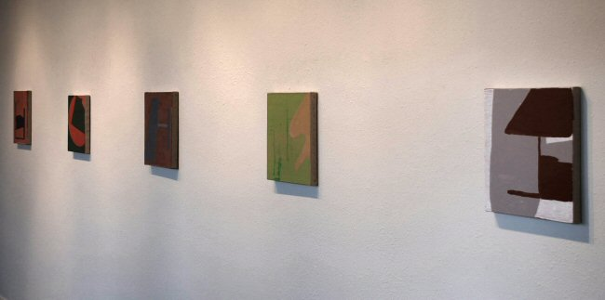

JB0059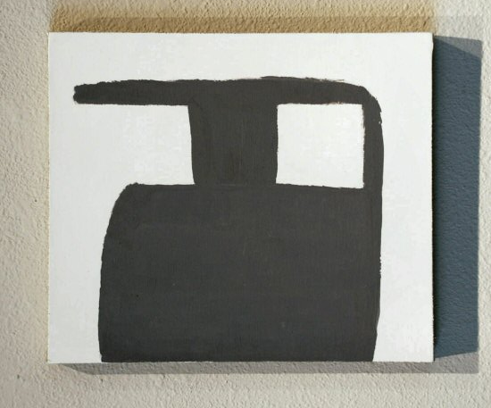
MICHAEL VOSS
Untitled (gray shape on pearl white), 2006
Oil, wax on acrylic on linen, 15” x 13”, MV004
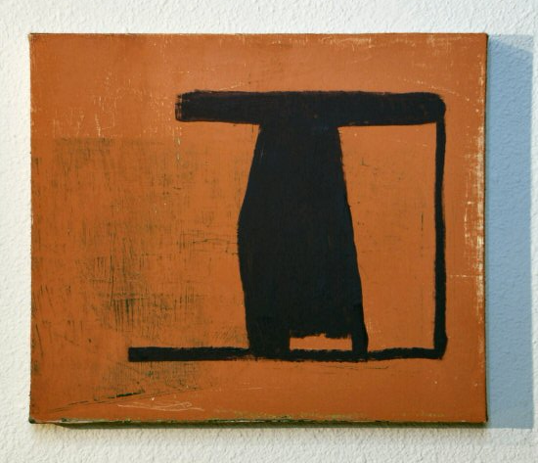
MICHAEL VOSS
Untitled (blue container shape), 2006
Oil, wax on linen, 15 1/2” x 13”, MV001
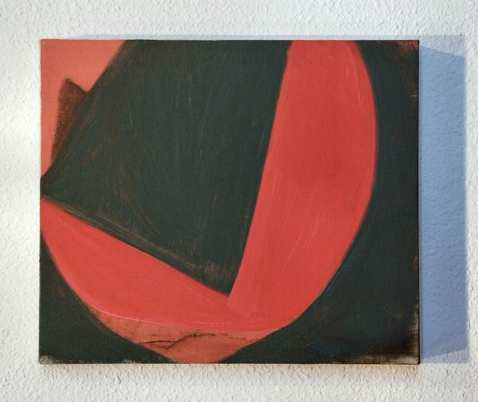
MICHAEL VOSS
r.p. (rotation), 2003
Oil on linen, 12” x 14”, MV003
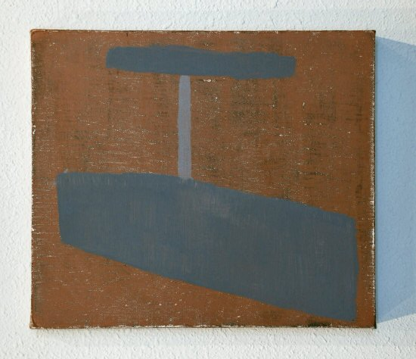
MICHAEL VOSS
Untitled (grey on brown), 2006
Oil, wax on linen, 15” x 13”, MV002
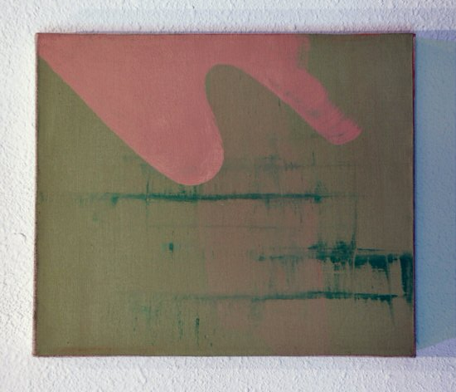
MICHAEL VOSS
Copa, 2005
Oil, wax on linen, 14” x 12”, MV005
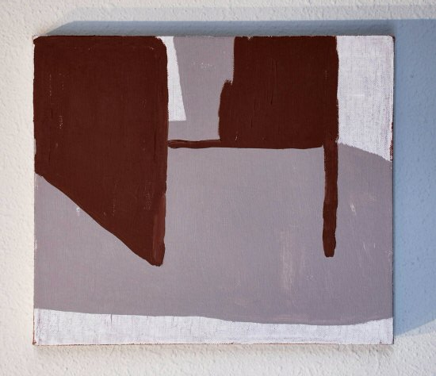
MICHAEL VOSS
Untitled (brown on gray on white), 2006
Oil, wax on linen, 14” x 12”, MV006
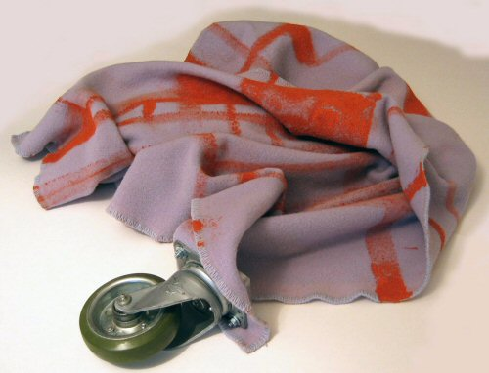
John Beech
Painted Rolling Blanket, 2007
Paint, blanket, rolling hardware
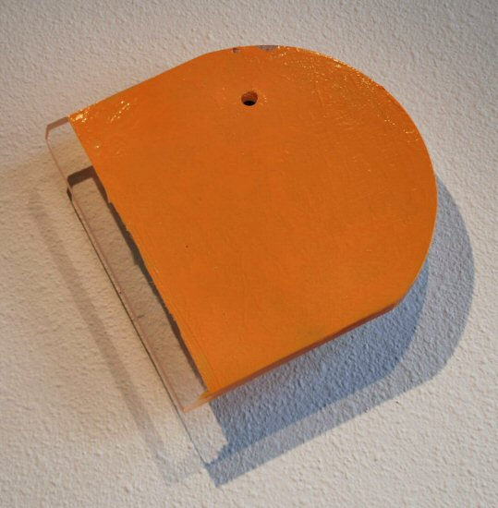
JOHN BEECH
Rotating Painting #177, 2005
Enamel, plexiglass, rotating hardware, JB0062
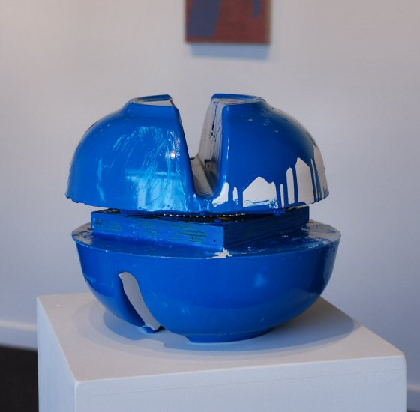
JOHN BEECH
Turning Object #44, 2006
Plaster, enamel, plywood, rotating hardware, JB0060
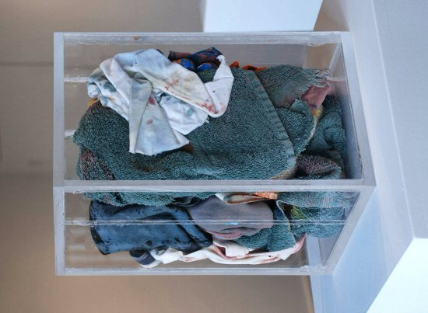
JOHN BEECH
Rag Case #3, 2007
Enamel, rags, Plexiglass, JB0061
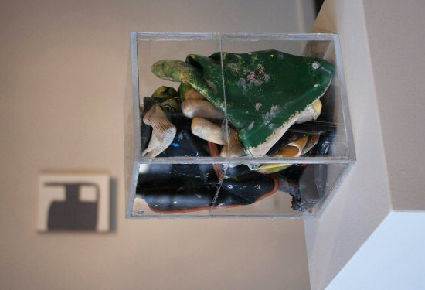
JOHN BEECH
Glove Case #2, 2007
Gloves, enamel, Plexiglass, JB0064
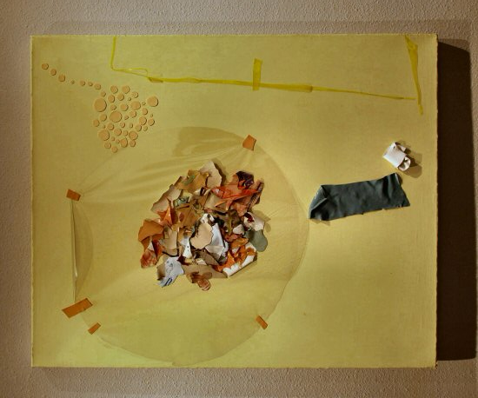
JOYCE KIM
Dole, 2003
Mixed media on canvas, 36” x 30”, JK001
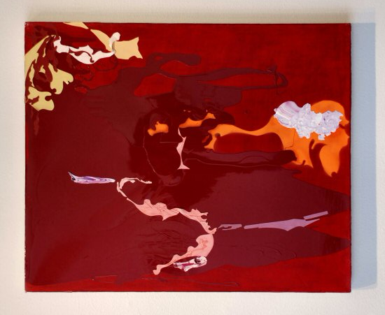
JOYCE KIM
Untitled, 2002
Mixed media on canvas, 36” x 30”, JK002
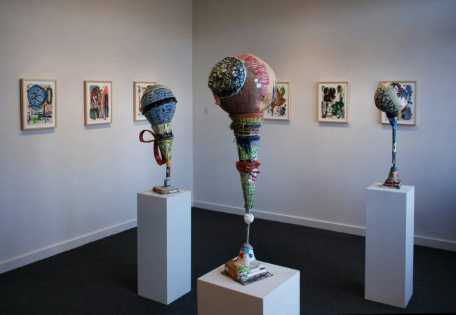

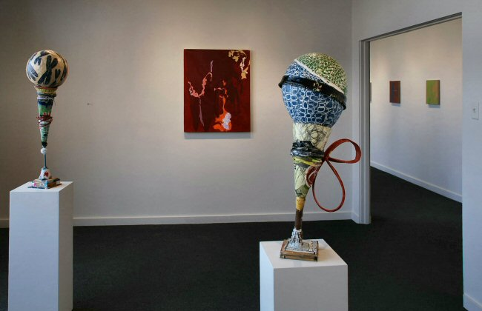
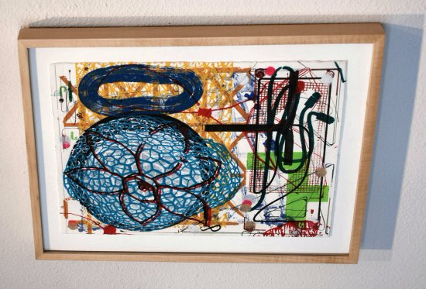
CHRISTOPHER LESNEWSKI
Untitled #1, 2006
Mixed media (painting, drawing, print), 14 ½” x 18 ¼”, CL001
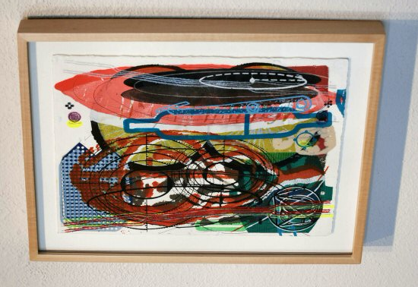
CHRISTOPHER LESNEWSKI
Untitled #2, 2006
Mixed media (painting, drawing, print), 14 ½” x 18 ¼”, CL002
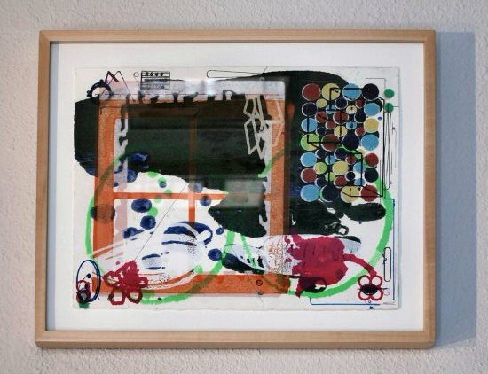
CHRISTOPHER LESNEWSKI
Untitled #3, 2006
Mixed media (painting, drawing, print), 14 ½” x 18 ¼”, CL003
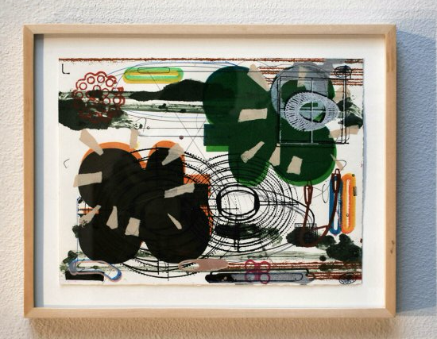
CHRISTOPHER LESNEWSKI
Untitled #4, 2006
Mixed media (painting, drawing, print), 14 ½” x 18 ¼”, CL004
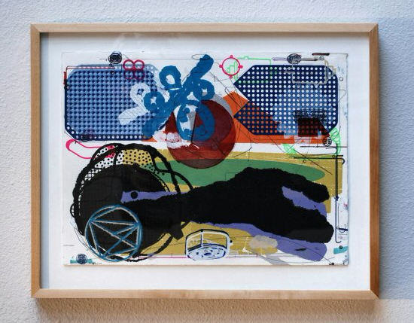
CHRISTOPHER LESNEWSKI
Untitled #5, 2006
Mixed media (painting, drawing, print), 14 ½” x 18 ¼”, CL005
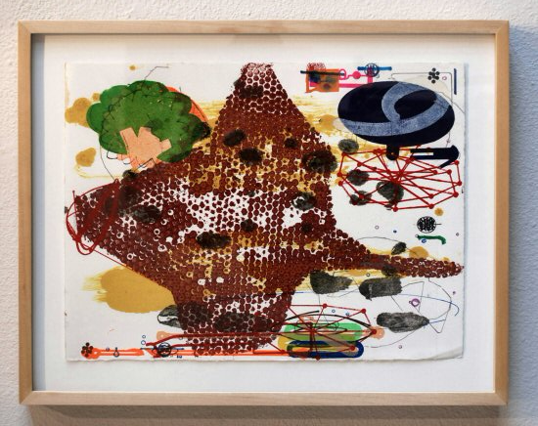
CHRISTOPHER LESNEWSKI
Untitled #6, 2006
Mixed media (painting, drawing, print), 14 ½” x 18 ¼”, CL006
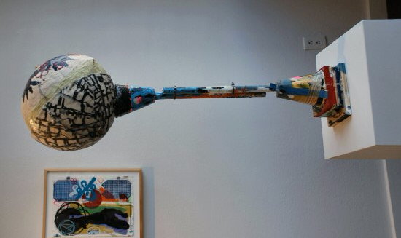
CHRISTOPHER LESNEWSKI
The Coil Method, 2004
Mixed media (sculpture), 34” x 12” x 12”, CL007
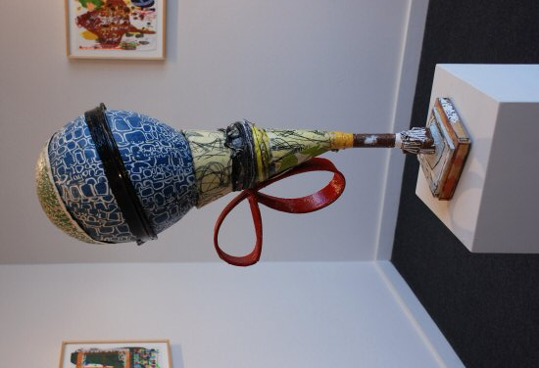
CHRISTOPHER LESNEWSKI
8 mm, 2005
Mixed media (sculpture), 33” x 14” x 12”, CL008
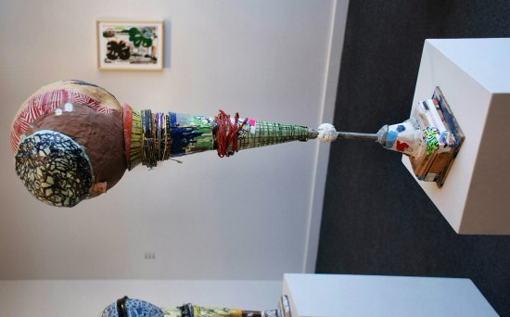
CHRISTOPHER LESNEWSKI
Kit, 2005
Mixed media (sculpture), 33” x 11” x 12”, CL009

© 2007

Charlotte Jackson Fine Art, Inc.

200 West Marcy Street, Suite 101, Santa Fe, New Mexico 87501
Telephone: 505.989.8688 Fax: 505.989.9898
cjfa@charlottejackson.com - www.charlottejackson.com

Photography & CD Production:
William Metcalf

